**Comparison of my Linkedlist and embedded Linkedlist performance**

At the fist picture you can see the performance features for two lists with 14 elements. It’s clear that their execution time is less than 1 s, embedded list is insignificantly faster, but takes up more memory.

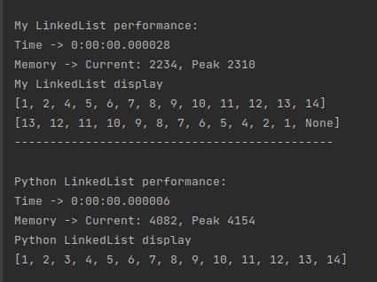

Another situation is observed by executing lists with 100 000 elements. Here there is a distinct difference between my list and embedded in 5 minutes and 34 seconds, but memory ocuppation is insighnificant.

