STTHK2133 MODELING & SIMULATION
A252 – Group Assignment #3
Agent-Based Modeling, Digital Twins & Opinion Dynamics in a Social Network
Instructor: Assoc. Prof. Dr Azizi Ab Aziz | Submission: 27 June 2026
Group Members: ____________________ (Matric: __________) | ____________________ (Matric: __________)

PART ONE — Theoretical Section

Q1. How micro-level agent rules lead to macro-level system behaviour
In Agent-Based Modeling (ABM), each agent follows simple local rules using only local information (its own state and the states of neighbours it interacts with). No agent has a global plan. When many agents act and interact simultaneously, their local decisions aggregate and feed back on one another, producing large-scale, organised patterns that none of the individual rules explicitly specify. This is called emergence — the macro pattern is a property of the interacting population, not of any single agent.
Example: in a flock, each bird only matches the heading of nearby birds and avoids collisions, yet the whole flock moves as a coherent shape. Why this matters in ABM theory:
- it explains how order, norms and collective outcomes arise bottom-up without central control;
- it lets us study how changing an individual rule or parameter reshapes the whole system;
- it captures real social/biological/economic systems that cannot be derived by simply summing individual behaviour (the whole is more than the sum of its parts).

Q2. Why ABMs are nonlinear systems even when agent rules are simple
Nonlinearity means the output is not proportional to the input — doubling a cause does not double the effect. ABMs are nonlinear because:
- Interaction and feedback: an agent changes its neighbours, who then change it back. These coupled feedback loops multiply effects rather than adding them.
- Thresholds and conditional rules: rules such as ‘adopt only if a fraction of neighbours adopt’ create sudden jumps (tipping points).
- Heterogeneity and network structure: effects depend on who is connected to whom, so identical rules give different aggregate results.
- Path dependence: small differences in initial conditions or random ordering can be amplified into very different outcomes (sensitivity to initial conditions).
Hence even linear-looking individual rules combine through interaction into a globally nonlinear system whose behaviour (consensus, polarization, cascades) cannot be predicted by analysing one agent in isolation.

Q3. A simple ABM for traffic congestion in a big city
- a) Agents: individual vehicles (cars, buses, motorcycles). Each has a position, current speed, desired speed, destination/route, and a driver behaviour type (aggressive, cautious, average).
- b) Environment: the road network represented as a grid/graph of road cells, lanes, intersections and traffic lights, with capacity limits, speed limits and signal timing. The environment also holds dynamic states such as cell occupancy and queue length.
- c) Rules of interaction: (i) accelerate toward desired speed if the cell ahead is free; (ii) brake/keep safe distance if a vehicle is ahead (car-following); (iii) stop at red lights and queue at intersections; (iv) change lanes or re-route when the current path is congested; (v) random slowdown to model human reaction. Congestion (a macro jam) emerges when local braking propagates backward as a stop-and-go wave.

Q4. Emergent behaviour + three real-world examples
Emergent behaviour is a coherent, system-level pattern that arises from the local interactions of many agents and is not programmed into, nor reducible to, any single agent’s rule. It appears only at the collective level.
- Traffic jams / stop-and-go waves emerging from individual braking, even with no accident or bottleneck.
- Flocking of birds, schooling of fish, or herding — global coordinated motion from simple local alignment rules.
- Market crashes / bubbles and segregation in neighbourhoods (Schelling) — large social patterns from individual buy/sell or relocation decisions.

Q5. Why ABMs become computationally expensive + scalability strategies
Cost drivers: every time step each agent evaluates its rules and queries neighbours, so cost grows with the number of agents × interactions × time steps. Pairwise interaction can approach O(N²); many runs are also needed for stochastic averaging and parameter sweeps, and rich agent state increases memory use.
Common scalability strategies:
- Spatial partitioning / neighbour indexing (grids, quadtrees, cell lists) to avoid O(N²) neighbour search.
- Parallel and distributed computing (multi-core, GPU, clusters) since agents update largely independently.
- Model simplification / abstraction: fewer agent attributes, super-agents, or meta-models / surrogate models.
- Adaptive time-stepping and event-driven updates instead of updating every agent every tick.
- Efficient data structures, vectorisation, and reducing the number of replications via smart experimental design.

Q6. What is a digital twin? How it differs from a simulation model
A digital twin is a dynamic, virtual replica of a specific real-world physical asset, process or system that is continuously synchronised with its physical counterpart through live sensor/IoT data, mirroring its current state in (near) real time and often feeding decisions back to it.
Difference from a simulation model:
- A simulation model is generally static and offline: it represents a generic/average system, is run on assumed or historical inputs, and is used for what-if analysis or design.
- A digital twin is tied to one specific real instance, is continuously updated by real-time data, lives over the asset’s lifecycle, and supports two-way interaction (monitor → predict → act). In short: a digital twin contains/uses simulation models but adds a live data link to a unique physical twin.

Q7. How real-time data integration changes a digital twin’s behaviour
With real-time data streaming in, the digital twin continuously re-calibrates its internal state and parameters to match the actual asset. It stops being a fixed-input model and becomes adaptive: it detects drift, anomalies and changing conditions as they happen, and updates its predictions accordingly (data assimilation).
Theoretical advantage over static simulation models:
- Higher accuracy and relevance — predictions reflect the true current state, not assumed initial conditions, reducing the gap between model and reality.
- Enables live monitoring, early warning, predictive maintenance and closed-loop control / optimisation, whereas a static model can only give one-off, condition-independent answers.

Q8. Two real-world applications of digital twins
- Engineering – jet engines / wind turbines (e.g., GE): a twin fed by live sensor data predicts wear and remaining useful life, enabling predictive maintenance. Decision-making improves because operators service parts just before failure, cutting unplanned downtime and cost instead of relying on fixed schedules.
- Healthcare – patient / organ twin: a twin of a patient’s heart or physiology, updated from monitoring data, lets clinicians test treatments virtually before applying them. Decision-making improves through safer, personalised therapy choices and early detection of deterioration. (Urban-planning twins of a city similarly test traffic or flood interventions before real deployment.)

Q9. Feedback loops: definition with one positive and one negative example
A feedback loop exists when the output of a process is fed back as an input that influences future behaviour of the same process, creating a self-reinforcing or self-correcting cycle.
- Positive (reinforcing) feedback: the output amplifies the change, pushing the system further from equilibrium — e.g., a viral social-media post: more shares → more visibility → even more shares (or compound interest, disease outbreaks). In our opinion ABM, influencers create reinforcing loops that drive polarization.
- Negative (balancing) feedback: the output counteracts the change, pulling the system back toward stability — e.g., a thermostat turning off heating when the target temperature is reached. In our ABM, the expert-correction term is negative feedback that damps extreme opinions toward a balanced view.

Q10. Main limitations of ABMs and digital twins
- Data: both need large amounts of accurate, timely data; behavioural rules and trust/parameter values are hard to measure and validate, and digital twins fail if sensor data is missing, noisy, biased or delayed. Privacy and data-governance issues also arise.
- Computation: large agent populations and real-time synchronisation are computationally heavy, limiting scale, resolution and speed; real-time twins need substantial infrastructure.
- Uncertainty & validation: results are stochastic and sensitive to assumptions, initial conditions and parameter choices; emergent outcomes are hard to validate against reality, models can be over-fitted, and human behaviour is intrinsically unpredictable — so outputs should guide, not dictate, decisions.

PART TWO — Practical Section: Opinion Dynamics in a Social Network

1. Model Design
We build an Agent-Based Model of how public opinion about Ministry-of-Education AI learning assistants evolves as citizens, influencers and experts interact on a social network. Opinion is a continuous value O ∈ [−1, +1] where −1 = strongly against AI, 0 = neutral, +1 = strongly support AI.
Agents (roles):
- Citizens (N = 150, range 50–200): main population; each has an opinion Oᵢ, trust Tᵢⱼ in others (0–1) and low individual influence. They update their opinion through interaction.
- Influencers (M = 6, range 4–10): high connectivity (many followers), strong persuasive strength Sₗ, and extreme opinions (half pro-AI at +0.9, half anti-AI at −0.9). They spread opinions quickly.
- Education experts (K = 3, range 2–5): high credibility (citizens place high trust in them), moderate reach, and balanced evidence-based opinions (≈ 0). They stabilise opinions and reduce extremism.
- Network: a random (Erdős–Rényi) graph connects citizens (edge probability p = 0.06). Influencers and experts are linked to a large fraction of citizens. Trust values are assigned per link.

2. Equations
At each step a citizen i updates its opinion by combining four influence terms plus small noise, then clamps the result to [−1, +1]:
Oᵢ(t+1) = clamp[ Oᵢ(t) + Δdirect + Δavg + Δexpert + Δinfluencer + ε , −1, +1 ]
1) Direct (dyadic) influence from one connected like-minded neighbour j:
Δdirect = α · Tᵢⱼ · ( Oⱼ − Oᵢ )
2) Averaging effect — social pressure toward the mean opinion of like-minded neighbours Cᵢ (echo chamber):
Δavg = β · ( mean_{j∈Cᵢ} Oⱼ − Oᵢ )
3) Education-expert correction toward the experts’ balanced view E_k (negative feedback, unconditional):
Δexpert = γ · mean_k [ Te_{k,i} · ( E_k − Oᵢ ) ]
4) Influencer persuasion from connected influencers l, weighted by virality strength Sₗ (selective exposure):
Δinfluencer = δ · mean_l [ Sₗ · Ti_{l,i} · ( Iₗ − Oᵢ ) ]
Bounded confidence: the peer and influencer terms only act on sources whose opinion lies within a confidence threshold ε of citizen i (|O_source − Oᵢ| < ε), modelling selective exposure. The expert term is unconditional because experts are credible/corrective. ε ~ N(0, σ²) is small random noise. This bounded-confidence mechanism is what allows the same model to settle into consensus, polarization, fragmentation or echo chambers.
Outcome metrics: final mean (overall stance), final standard deviation (spread), % strongly pro-AI (>0.4), % strongly anti-AI (<−0.4), and the number of opinion clusters. Classification: Consensus (std < 0.18), Polarization (substantial groups at both poles), Fragmentation (≥3 clusters or very high spread), otherwise Mixed / Echo chambers.

3. Experiments (Simulation Setup)
Common setup: N = 150 citizens, M = 6 influencers, K = 3 experts, T = 80 time steps, initial opinions uniform in [−1, +1], identical random seed across scenarios for a fair comparison. Parameter sets:
Parameter | S1 Baseline | S2 Strong Influencer | S3 Strong Expert | S4 Low Trust
α direct | 0.08 | 0.08 | 0.08 | 0.08
β averaging | 0.10 | 0.10 | 0.10 | 0.10
γ expert | 0.04 | 0.03 | 0.30 | 0.04
δ influencer | 0.08 | 0.34 | 0.07 | 0.05
ε confidence | 0.45 | 0.45 | 0.55 | 0.20
trust multiplier | 1.0 | 1.0 | 1.0 | 0.30
noise σ | 0.012 | 0.012 | 0.012 | 0.030

- S1 Baseline: moderate, balanced influence — do opinions converge or stay mixed?
- S2 Strong Influencer: raise influencer strength δ — does society polarize or align quickly?
- S3 Strong Expert: raise expert effect γ and reach — do experts reduce polarization and stabilise opinions?
- S4 Low Trust: reduce trust across all agents — does fragmentation or instability occur?

4. Results
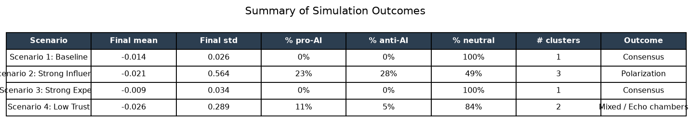
Table 1. Summary of final outcomes across the four scenarios.
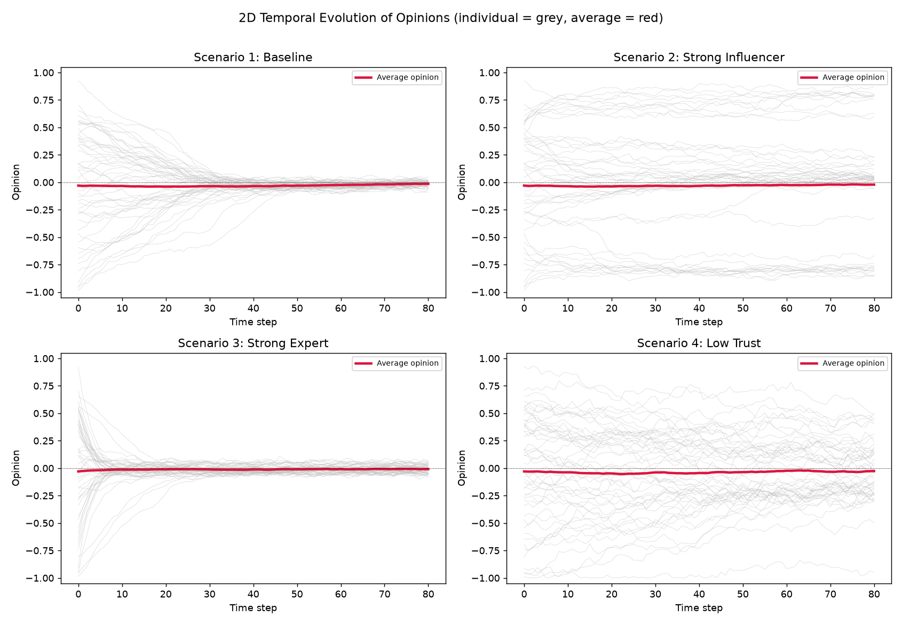
Figure 1. 2D temporal evolution: grey = individual citizens, red = population average.
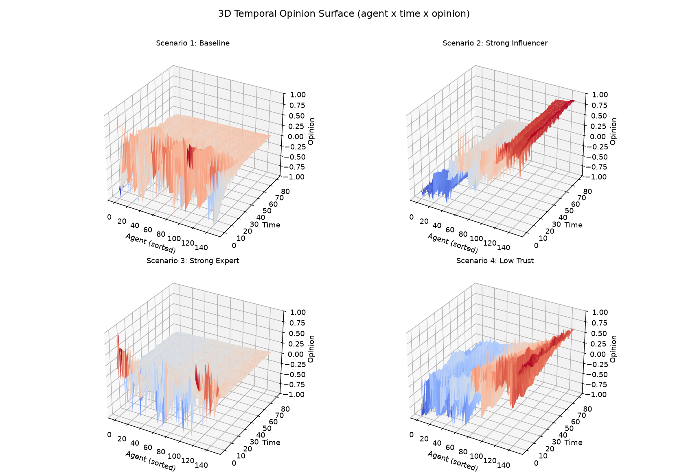
Figure 2. 3D temporal surface (agent × time × opinion); agents sorted by final opinion.
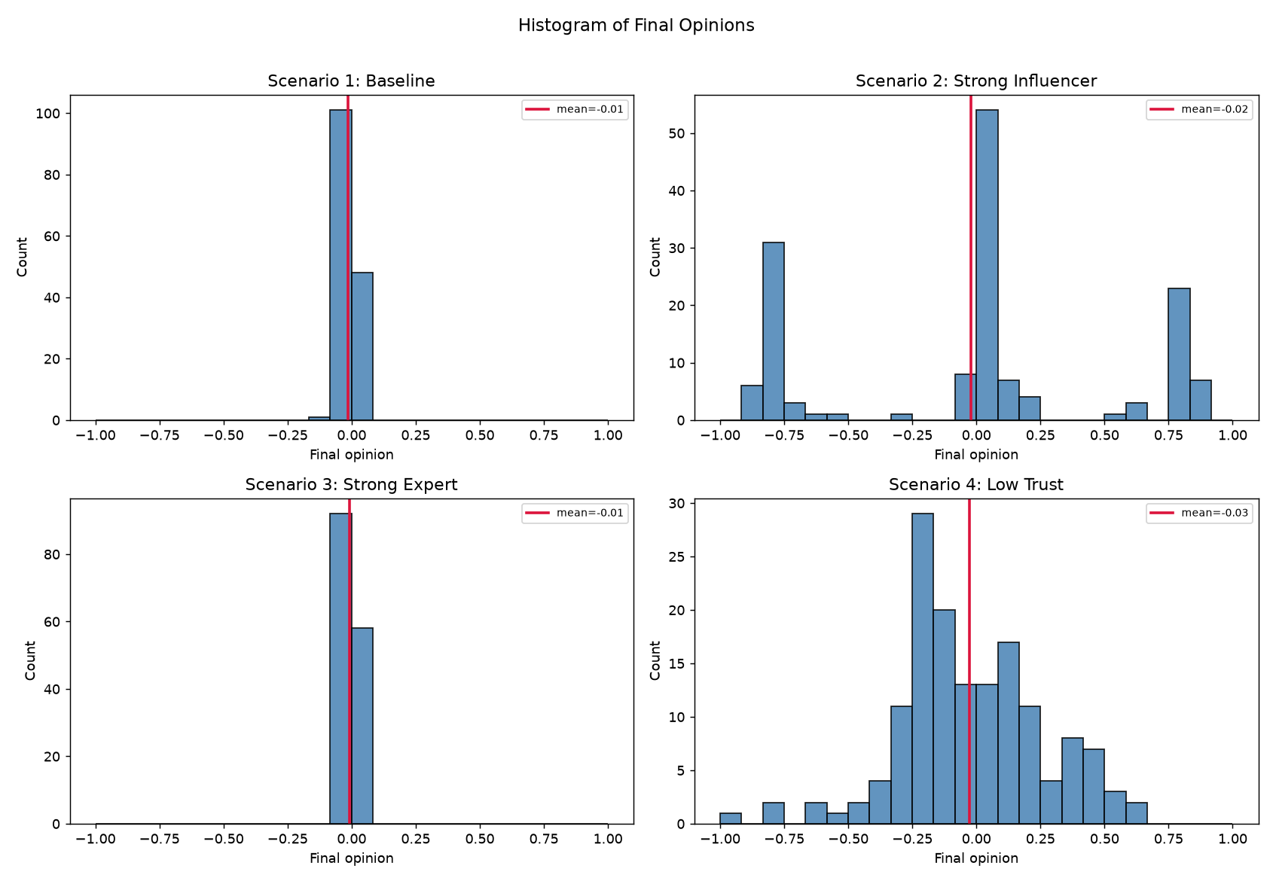
Figure 3. Histograms of final opinions per scenario.
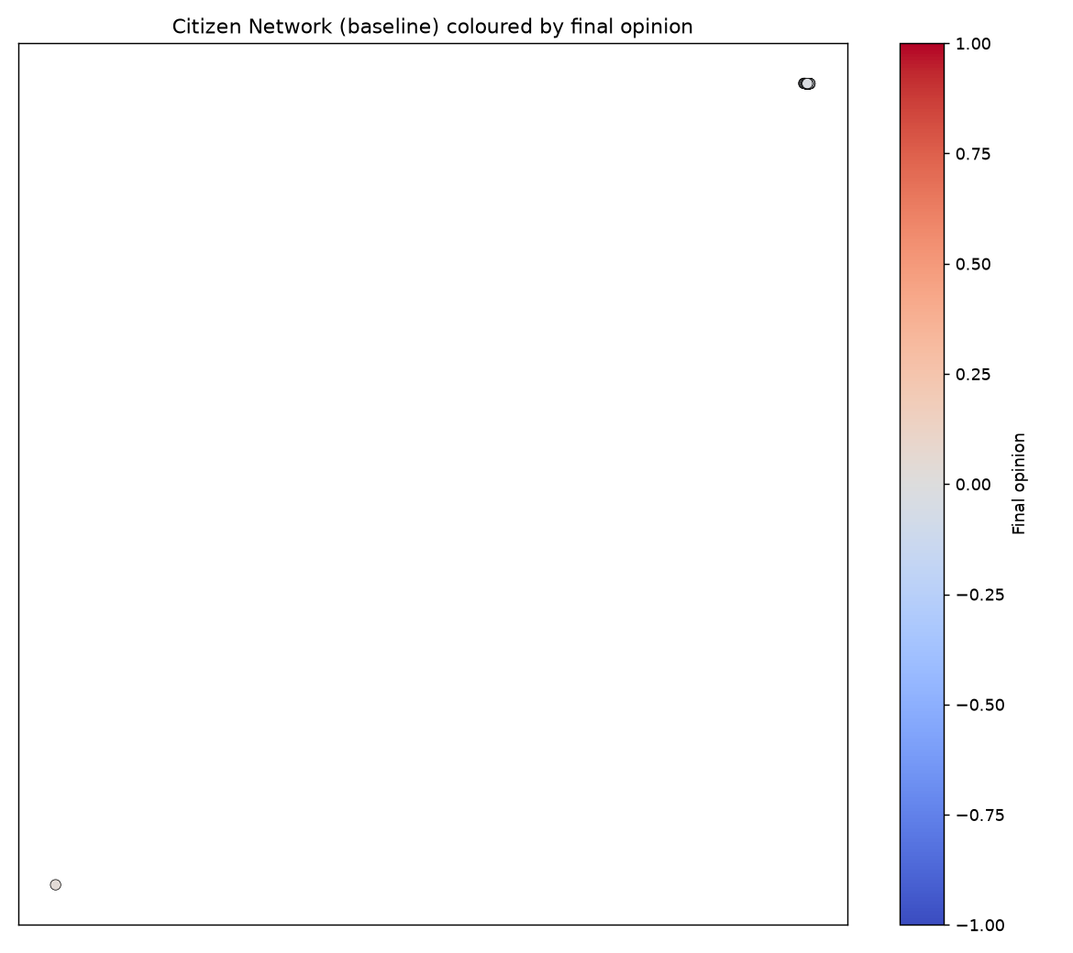
Figure 4. Baseline citizen network coloured by final opinion (optional visualisation).

5. Analysis and Discussion
Per-scenario behaviour (consensus / polarization / fragmentation / echo chambers, role impact, stability):
- S1 Baseline → Consensus: with balanced forces, averaging plus the mild expert correction pulls citizens together; opinions converge to a stable, near-neutral consensus. Roles are balanced; the system is stable.
- S2 Strong Influencer → Polarization: strong influencers at opposite extremes, combined with selective exposure, split citizens into a pro-AI and an anti-AI camp (with a shrinking middle). Influencers dominate; the system is stable but divided.
- S3 Strong Expert → Consensus / moderation: a strong, credible expert correction acts as negative feedback, damping extremes and producing a tight, stable consensus near the balanced view. Experts stabilise the system.
- S4 Low Trust → Fragmentation / echo chambers: low trust and a narrow confidence threshold mean agents rarely influence each other, so opinions stay scattered in several small clusters; the system is the least stable and shows no clear consensus.
Answers to the analysis questions:
- (2) Can a few influencers dominate public opinion? Yes. In S2 only six influencers reshaped 150 citizens into two polarised camps, because high connectivity + strong persuasion + selective exposure give them disproportionate reach.
- (3) Does more expert influence always give consensus? Not always. In S3 it did, but consensus also needs citizens to actually trust and be exposed to experts. If trust is low (as in S4) or confidence is narrow, even strong expert content is filtered out and consensus fails.
- (4) What if the averaging effect is very strong? Opinions collapse rapidly toward the local/neighbourhood mean, giving fast consensus or rigid echo chambers. Partly realistic (social pressure, ‘what most people think’), but unrealistic if too strong because it erases the genuine diversity and stubbornness seen in real societies.
- (5) Most important factor against polarization? Trust (and the credibility channel it powers) is the most decisive: without trust, neither experts nor network structure can move opinions. Trusted experts are the strongest stabiliser; network structure mainly modulates speed.
- (6) As a policy maker, how to use experts to stabilise opinion? Invest in expert credibility and reach: ensure trusted, balanced experts are widely connected (broad exposure), deliver evidence-based corrective messaging early and consistently, counter misinformation, and avoid amplifying extreme influencers.

6. Conclusion
The ABM shows that public opinion on AI learning assistants is highly sensitive to the balance of social forces. A balanced baseline converges to a stable, near-neutral consensus; strong influencers drive polarization; strong, trusted experts restore a moderate consensus; and low trust causes fragmentation and instability. The key policy lever for the Ministry of Education is to build and use trusted, well-connected experts — supported by adequate public trust — to counter influencer-driven polarization and misinformation and to steer society toward an informed, stable acceptance of the technology.

