Learn Claude Code by Building
a Medium-Article RAG Assistant
A hands-on use-case study — from the files you have now to a deployed system
Claude Code desktop app · project: medium-rag

Contents

Part 0 — Orientation

What Claude Code is
Claude Code is an agentic coding assistant. You describe a goal in plain language; it reads your project, edits files, runs commands in the terminal, checks the results, and reports back — pausing to ask permission before anything risky. You are working in the Claude Code desktop app, so this all happens in one window: a chat panel where you type requests, and a view of your project where you watch changes appear.
The loop is always the same: you ask → it plans → it acts (edit/run) → it checks → it reports. Your two jobs are to shape its context (so it knows the project’s rules) and to drive it in small steps (so you stay in control and catch mistakes early).

Where you are now, and what you’ll build
You currently have nine project files sitting flat in one folder. Claude Code will organize them into the correct structure and create everything that is still missing — the two missing modules, the API handlers, and all the infrastructure files. By the end you will have a complete, deployable repo.
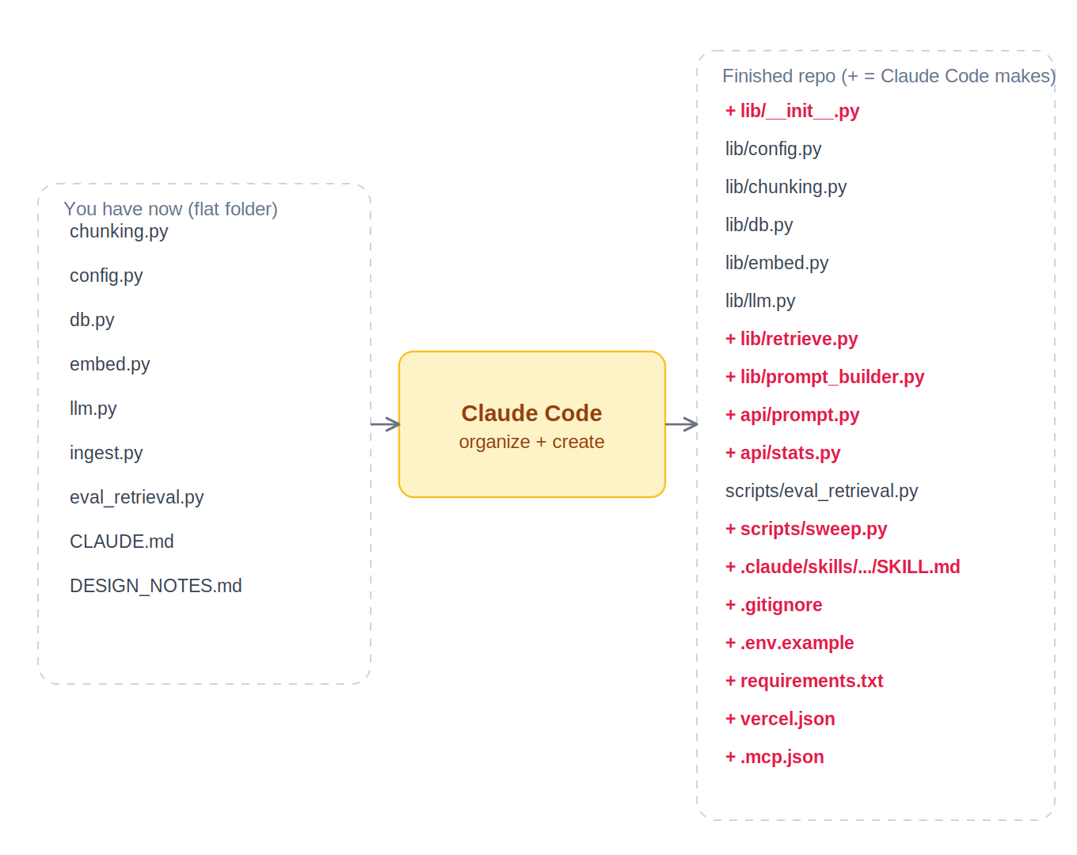
Figure 1 — Your starting files (left) and the finished repo Claude Code produces (right; + marks files it creates).

How we’ll work
- One phase per step. Each phase is a single, reviewable request to Claude Code. You read the diff, test, then move on.
- Small batch first. We embed only 50 articles before the full ~7,600. This validates the whole pipeline for a fraction of a cent and protects your $5 budget.
- Test at every gate. Before adding the language model, we prove that retrieval returns the right passages. That way, if an answer is wrong later, you know whether it’s a search problem or a generation problem.
Why this matters — Building in small, tested steps is the single most important habit with an agent. A big “build the whole app” request gives you a wall of code you can’t verify; small steps keep you in the driver’s seat and make every mistake cheap to undo.

Part 1 — Open the workspace
First, get your folder into a clean git repo on your PC and on GitHub. The full git walkthrough is a separate guide; the short version: clone your empty Nat-Saf/medium-rag repo, drop your current files into it, and you’re ready. You do not need the folders organized yet — that’s Claude Code’s first job.

Open the project in the desktop app
- In the Claude Code desktop app, open your medium-rag folder as the project (the app works on one project folder at a time).
- The app shows your files and a chat prompt. Everything you type acts on this folder.
- Warm up with a read-only request so you can see how it behaves before it changes anything:
▶ Paste this into Claude Code
Summarize this project: list the files you see, read CLAUDE.md and
DESIGN_NOTES.md, and tell me in your own words what this project does and
what is still missing. Don't change anything yet.
Why this matters — Starting with a read-only prompt teaches you the rhythm safely and confirms Claude Code has correctly absorbed CLAUDE.md before it writes a single line.

Part 2 — Set up the infrastructure (context & capabilities)
Before building features, you give Claude Code its “brain settings.” Three things shape what it knows; two extend what it can do. You already have the most important one.

CLAUDE.md — the always-on rules (you have this)
This markdown file at the repo root is read automatically every session. It holds your architecture contracts, the hard constraints ($5 budget, chunk ≤ 1024, batching), the required system prompt location, and the module boundaries. You don’t run a command — Claude Code finds it.
Why this matters — CLAUDE.md is how you avoid repeating yourself. Instead of re-explaining the rules in every prompt, you write them once; Claude Code re-reads them on every turn and stays consistent.

Permission modes — staying in control
By default Claude Code asks before creating files, editing files, or running commands. Approve each action while you’re learning — read what it proposes, then accept. As you gain trust for a repetitive task (e.g. it’s creating ten obvious files), you can let it auto-accept edits for that stretch, then return to ask-first.
Why this matters — Reviewing each action is how you learn what the agent actually does and how you catch a wrong path early — like it trying to commit a secret or delete the wrong file.

Skill — a reusable procedure (rag-eval)
A skill is a folder .claude/skills/<name>/ containing a SKILL.md that teaches Claude Code a repeatable task. We’ll add a rag-eval skill that standardizes the “check retrieval by hand” step so it runs the same way every time. Have Claude Code create it:
▶ Paste this into Claude Code
Create a skill at .claude/skills/rag-eval/SKILL.md. It should: take a few test
questions, run them through lib/retrieve.py (embed the question, query Pinecone,
dedupe by article), and print each returned chunk's score, title, and a snippet
for me to judge relevance. It must NOT call the chat model — retrieval only. The
description should make it trigger when I say things like "test the retrieval."
Why this matters — Skills turn a procedure you’ll repeat (every time you tune chunk size) into one consistent, named action — and writing one is a core Claude Code skill itself.

MCP server — an extra capability (context7)
MCP servers give Claude Code new powers. We’ll add context7, which fetches current documentation for libraries (Pinecone, the OpenAI SDK, Vercel) so Claude Code reads today’s docs instead of relying on training data. Add it once:
▶ Paste this into Claude Code
Create a .mcp.json at the repo root that registers the context7 MCP server
(npx -y @upstash/context7-mcp). Then tell me how to approve and use it.
Approve the server when the app prompts you (MCP servers can run code, so approval is required). Then you can say: “Use context7 to pull the current Pinecone Python upsert signature.”
Why this matters — Library APIs change. An MCP docs server keeps Claude Code from writing code against an outdated SDK — a common, frustrating source of bugs.

Sessions, checkpoints & /clear — managing the conversation
- Session: each conversation is a session; Claude Code remembers what happened within it.
- Checkpoints: you can rewind to an earlier point if a change went wrong, instead of manually undoing edits.
- /clear: start a fresh context between unrelated phases so old details don’t crowd or confuse the next task.
Why this matters — An agent’s answers degrade when its context is cluttered. Clearing between phases keeps each step focused, and checkpoints make experimentation safe.

Part 3 — Build the project, phase by phase
Each phase below has a motivation, the exact prompt to paste, and how to test before moving on. Run one phase, review, test, commit, then continue. The target architecture you’re assembling:
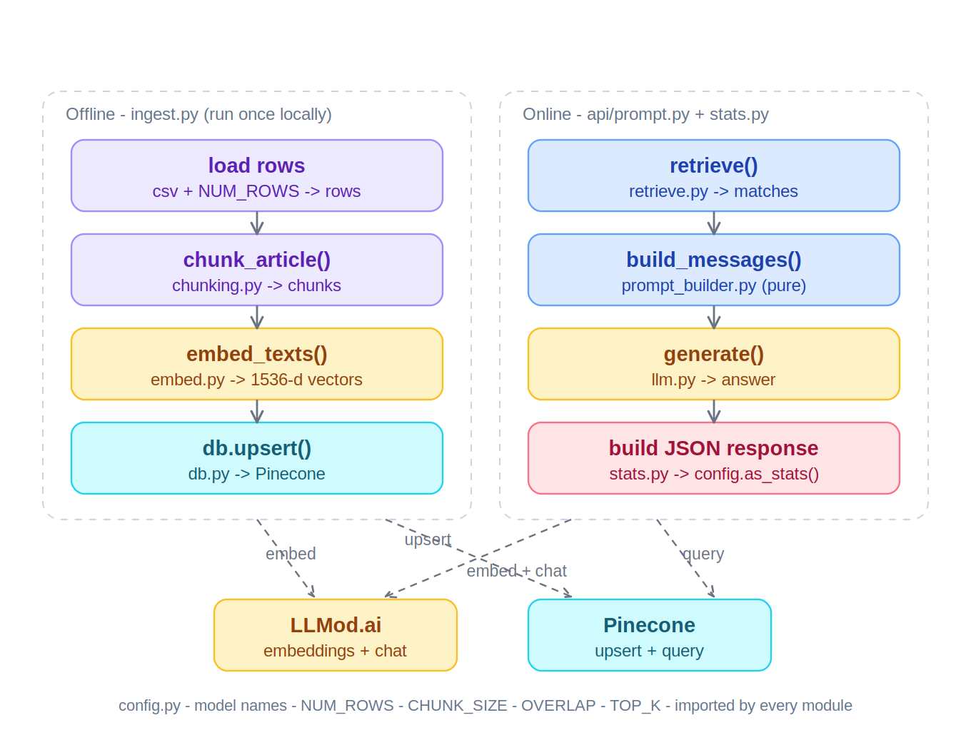
Figure 2 — Target code architecture. Each external dependency lives in exactly one module.

Phase 0 — Organize the structure & create the missing files
Claude Code moves your flat files into packages and creates everything still missing.
▶ Paste this into Claude Code
Reorganize this project to match CLAUDE.md:
1. Create lib/ and move config.py, chunking.py, db.py, embed.py, llm.py into it.
Add an empty lib/__init__.py. Move eval_retrieval.py into scripts/.
2. Create the missing modules per CLAUDE.md and DESIGN_NOTES.md:
lib/retrieve.py (embed question, query Pinecone, dedupe by article_id) and
lib/prompt_builder.py (build_messages -> uses config.SYSTEM_PROMPT, pure).
3. Create api/prompt.py (POST /api/prompt) and api/stats.py (GET /api/stats) as
Vercel Python serverless handlers that import from lib.
4. Create infra files: .gitignore (ignore .env and *.csv), .env.example,
requirements.txt (openai, pinecone, tiktoken, python-dotenv), and vercel.json
that bundles lib/ with the api functions.
Show me each new file before writing it, and keep imports consistent.
Test: ask Claude Code to run python -m py_compile lib/*.py api/*.py ingest.py scripts/*.py. It should report no errors. Then git add . && git commit -m "Phase 0: structure + missing modules".
Why this matters — Getting the skeleton right first means every later phase has a clean home. Letting Claude Code do the move-and-create teaches you how it edits across many files at once.

Phase 1 — Ingest a small batch (50 articles)
With NUM_ROWS = 50 already in config, you embed a tiny slice and write it to Pinecone. This exercises chunking, batched embedding, and upsert end-to-end.
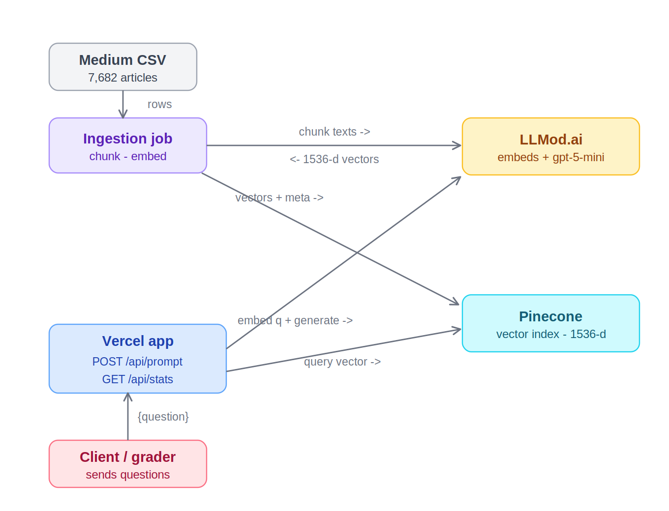
Figure 3 — The offline ingestion path you’re running in this phase (top-left into Pinecone).
Before running: copy .env.example to .env and paste your real keys; create the Pinecone index (name medium-rag, dimension 1536, metric cosine); and place medium-english-50mb.csv in the repo root.
▶ Paste this into Claude Code
Run ingest.py with NUM_ROWS=50. Show me the output (rows read, chunks produced,
vectors upserted). If anything errors, diagnose it and propose a fix before
re-running. Use context7 if you need the current Pinecone SDK syntax.
Test: the output should show ~50 rows, a few hundred chunks, and that many vectors upserted. Confirm in the Pinecone console that the index vector count is non-zero.
Why this matters — Fifty articles cost a fraction of a cent. If chunking or the embedding call is broken, you find out now — not after spending budget on the full corpus.

Phase 2 — Check retrieval by hand (the decision gate)
Before any language model, prove the search works. “By hand” means you read the returned chunks with your own eyes and judge relevance.
▶ Paste this into Claude Code
Use the rag-eval skill to check retrieval on the four assignment example
questions. Show me the top chunks and scores for each. Tell me whether the right
article appears at or near rank 1.
If retrieval is poor, you enter the tuning loop: lower CHUNK_SIZE (e.g. to 384) in config, re-run Phase 1 on the subset, and re-check. Only proceed when the right passages surface.
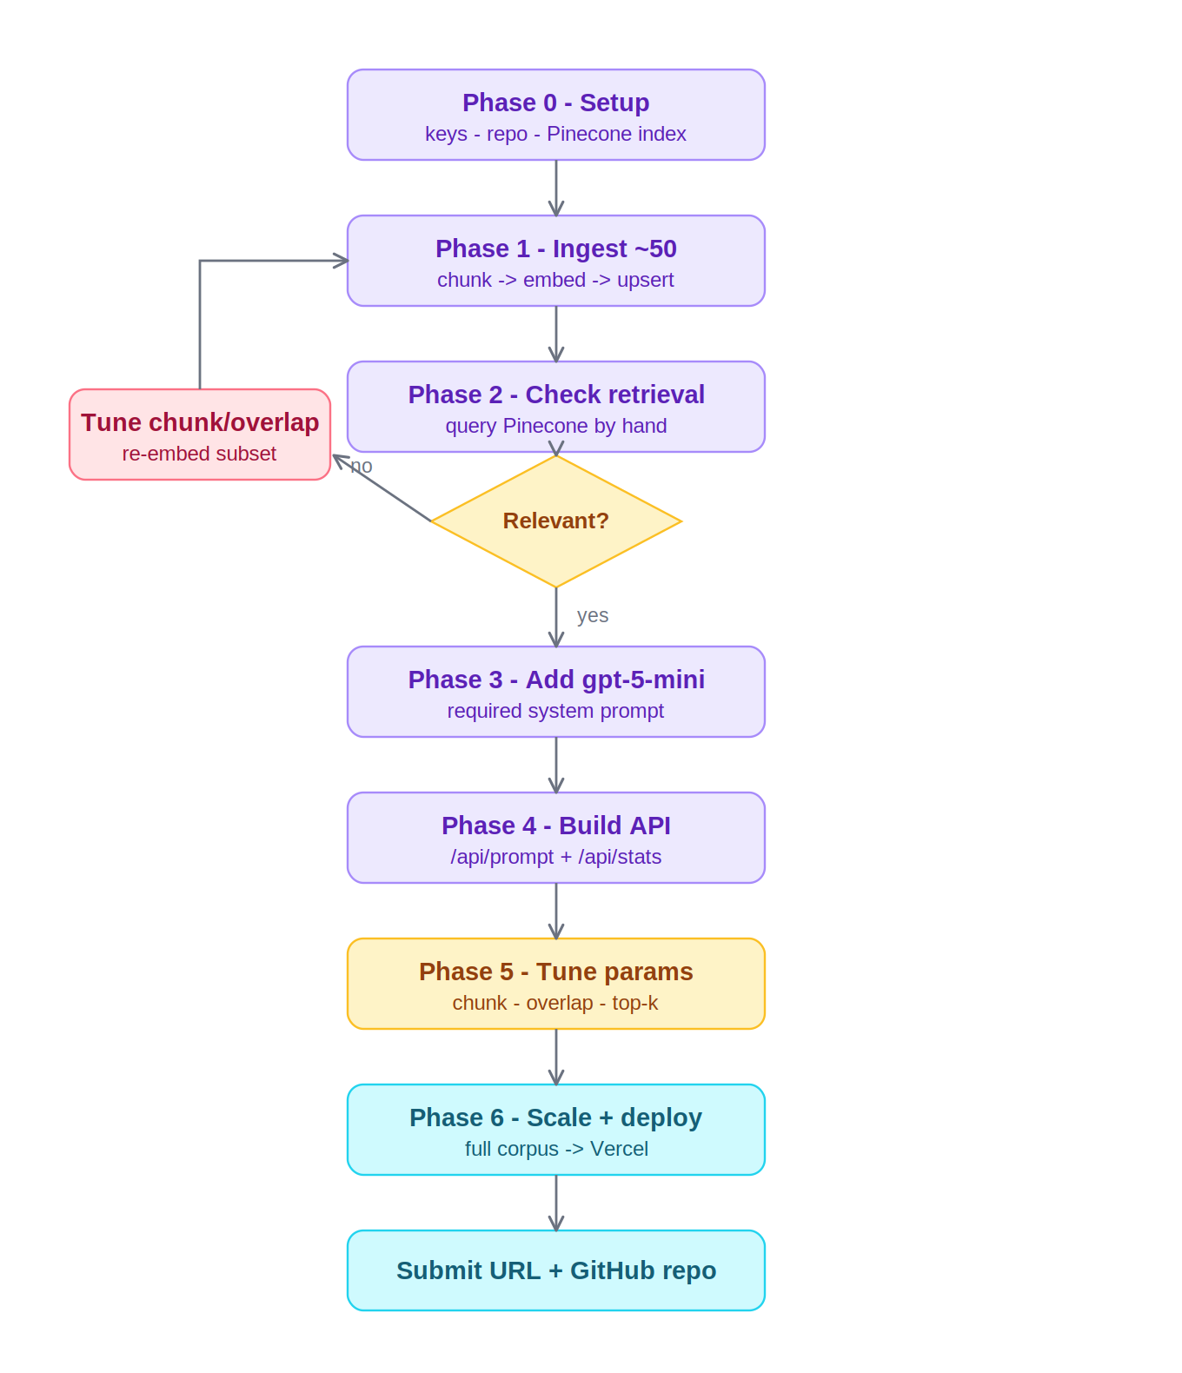
Figure 4 — The build flowchart. The diamond is this gate; the loop back is chunk/overlap tuning on the subset.
Why this matters — Retrieval is the half of RAG that everything else depends on. Validating it in isolation means a later wrong answer is unambiguous: fix search, or fix the prompt — never both at once, guessing.

Phase 3 — Add the language model (gpt-5-mini)
Now layer generation on retrieval you trust. The model must answer only from the retrieved context and say it doesn’t know otherwise.
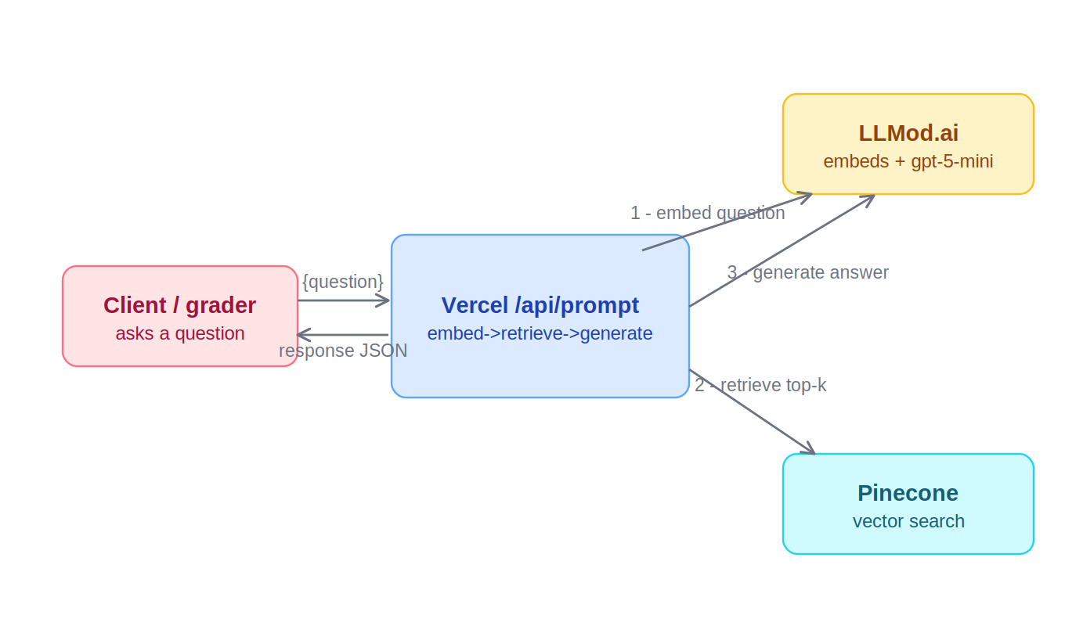
Figure 5 — One online request: embed the question (1), retrieve (2), generate the grounded answer (3).
▶ Paste this into Claude Code
Write scripts/ask.py that takes a question, runs retrieve -> build_messages ->
generate, and prints the answer. Run it on the four example questions and on one
nonsense off-topic question. Confirm the nonsense one returns exactly: "I don't
know based on the provided Medium articles data."
Test: the four real questions get grounded answers; the nonsense one returns the refusal line. If it answers the nonsense question from general knowledge, the system prompt isn’t being applied — check prompt_builder.py.
Why this matters — The refusal test is how you prove your assistant is actually grounded in the dataset and not leaking the model’s background knowledge — the core requirement of the assignment.

Phase 4 — Build & test the API locally
The handlers already exist from Phase 0; now run and test them as real endpoints.
▶ Paste this into Claude Code
Help me run the API locally with `vercel dev`. Then give me curl commands (using
curl.exe for PowerShell) to test POST /api/prompt with each of the four question
types, and GET /api/stats. Show me the JSON responses and confirm they match the
required shape (response, context, Augmented_prompt).
Test: /api/stats returns your current {chunk_size, overlap_ratio, top_k}; /api/prompt returns the answer plus the context and augmented prompt. The “list 3” question should return three distinct article titles.
Why this matters — The API is what the grader actually calls. Testing it locally with curl mirrors exactly how it will be evaluated, so there are no surprises after deploy.

Phase 5 — Tune the hyperparameters
▶ Paste this into Claude Code
Run scripts/sweep.py to compare a few top_k values on the example questions. Then
recommend a final (chunk_size, overlap_ratio, top_k). Remind me that changing
chunk_size or overlap requires re-running ingest.py, and that /api/stats must
reflect whatever I set in config.py.
Why this matters — The assignment asks you to compare settings and report the best. Tuning on the subset keeps it cheap, and config is the single source of truth so /api/stats can never lie about what you used.

Phase 6 — Scale to the full corpus & deploy
- In lib/config.py, set NUM_ROWS = None and run python ingest.py once (full corpus, ~$0.25–$0.35).
- git add . && git commit -m "Full ingest + tuned params" && git push.
- In Vercel: Add New → Project → Import your existing Nat-Saf/medium-rag repo (not the “create new repo” screen). Set env vars LLMOD_API_KEY, LLMOD_BASE_URL, PINECONE_API_KEY. Deploy.
- Smoke-test the public URL with the same curl commands. Confirm Pinecone still shows the index as Ready with a non-zero vector count.
Why this matters — You scale only after every piece is proven on the subset, so the one full-corpus embed (your biggest spend) happens exactly once, with confidence.

Phase 7 — Submit
Submit your public Vercel URL and the GitHub repo link. Keep the Pinecone index alive (don’t delete it) until you’re graded.

Part 4 — The Claude Code skills you practiced
Claude Code concept | Where you used it | What it taught you
CLAUDE.md (context) | Every phase | Encode rules once; the agent stays consistent
Read-only prompt | Part 1 | Inspect safely before editing
Permission modes | Throughout | Review and approve actions; stay in control
Skill (rag-eval) | Part 2 / Phase 2 | Turn a repeated procedure into one named action
MCP (context7) | Part 2 / Phase 1 | Give the agent current library docs
Multi-file edit | Phase 0 | Reorganize and create many files in one request
Run & diagnose | Phases 1–4 | Let the agent run code and fix its own errors
/clear & checkpoints | Between phases | Keep context clean; rewind safely
Git loop | After each phase | add → commit → push as a safety net

Part 5 — Troubleshooting & gotchas
- PowerShell curl. PowerShell aliases curl to its own command. Use curl.exe explicitly when testing endpoints, or use Postman/the browser.
- Vercel imports. If api functions can’t find lib, the fix is the includeFiles entry in vercel.json plus the sys.path insert in the handlers — both already present.
- tiktoken offline. If tiktoken can’t download its vocabulary, chunking.py falls back to a word-based split. On your machine with internet it loads normally.
- Budget. Watch the LLMod dashboard. Embed in batches; tune on the subset; full embed once. You should finish well under $1.
- Never commit secrets/data. Confirm git status never lists .env or the .csv before committing.

Appendix — all the prompts, in order
Copy these in sequence (one phase at a time) to drive the whole build:
Part 1 Summarize this project; read CLAUDE.md + DESIGN_NOTES; don't change anything.
Part 2 Create the rag-eval skill (.claude/skills/rag-eval/SKILL.md).
Part 2 Create .mcp.json with the context7 server; tell me how to approve it.
Phase 0 Reorganize into lib/ api/ scripts/; create retrieve.py, prompt_builder.py,
api handlers, .gitignore, .env.example, requirements.txt, vercel.json.
Phase 1 Run ingest.py with NUM_ROWS=50; show output; fix errors before re-running.
Phase 2 Use the rag-eval skill on the four example questions; judge relevance.
Phase 3 Write scripts/ask.py; test 4 real + 1 nonsense question (refusal line).
Phase 4 Run `vercel dev`; curl.exe test /api/prompt and /api/stats.
Phase 5 Run scripts/sweep.py; recommend final chunk/overlap/top_k.
Phase 6 Set NUM_ROWS=None; full ingest; push; import to Vercel; set env; deploy.

