TP Creator Agent
Design Document
Natural language to validated FANUC TP/LS programs — an independent agent unit
Version 1.3 · July 2026 · caller tier + reg_io_v1 format · companions: Software Architecture, Claude Code Build Guide
Contents
0 Revision notes (v1.1)
1 Purpose and scope
2 System context and contract
2b Intake gate and the clarification loop
2c Missing-scan strategy (table sources)
2d The caller side: tiers and the envelope rule
3 Architecture overview and data flow
4 Module specifications (data in / data out)
4.1 Runtime
4.2 LLM #1 — orchestrator
4.3 Static config
4.4 Reg/IO table store
4.5 RAG service
4.6 Session store (memory)
4.7 Prompt renderer
4.8 LLM #2 — code generator
4.9 Validator
4.10 LLM #1 semantic audit
4.11 Output store
5 The retry handshake (LLM #2 ↔ validator)
6 User-provided example programs
7 Configuration policy
8 End-to-end trace
9 Model deployment options
Appendix A — reg_io_v1 interchange format

0 Revision notes

v1.3 (this revision)
- reg_io_v1 interchange format (Appendix A). The scan is now a five-column CSV relayed verbatim; the contract’s scan field, Section 2c, the table store (4.4) and the validator existence layer (4.9) were updated accordingly, including the new ‘exists but uninitialized’ diagnosis enabled by the initialized flag.
- Caller side specified (Section 2d). Tier model (CLI → console/GUI v0 without any LLM → main orchestrator), the envelope rule that makes a zero-LLM caller sufficient, and the app_config.yaml / rag_config.yaml ownership split. A reference console + GUI implementation exists.
- answers relaxation. answers now accepts {reply: “<raw text>”}; LLM #1, which asked the question and holds it in the session, interprets the raw reply. Structured {key: value} remains valid for tier-3 callers.
- RAG parameters externalized (Section 4.5). rag_config.yaml is the unit-owned home of top-k, score threshold, context cap and chunking parameters, with one profile (and one index) per backend.
- Figure 1 / Section 4.10 retitled. The review box now reads ‘LLM #1 semantic audit’ with the caption stating it is the same LLM #1 instance in a later turn — not a third model.

v1.2
- Two-level rejection clarified (Section 2b). The runtime performs only mechanical contract checks against predefined parameters; scope and sufficiency judgments belong to LLM #1’s intake turn and are returned through the runtime. The runtime never reasons.
- User-facing language rule added (Section 2b). Every string that can reach a human — questions, rejection reasons, advisories — is phrased by LLM #1 in plain, friendly, self-contained language naming the concrete thing needed.
- Figure 1 completed. User block added above the main orchestrator; the example syntax pre-check now has its own dashed arrow from the session store into the validator; the semantic review shows its inputs (params, table notes, program); the output box connects back to the runtime, which returns every response (fixes the dead end).
- Notation. The § section symbol was replaced by the word ‘Section’ throughout.

v1.1
Changes traceable to the first design review:
- Runtime made explicit. It now appears in Figure 1; the scan is persisted by the runtime, never loaded by LLM #1 (fixes the diagram/text mismatch).
- Missing-scan strategy added (Section 2c). Source hierarchy scan → cached table → default index map, with a hard staleness rule and per-program table_source reporting.
- Intake gate added (Section 2b). Clarification loops with the caller before generation; out-of-scope requests are rejected (new status value).
- Validator scope renamed: existence, not correctness. The validator answers only ‘does this index exist’; whether it is the right index is LLM #1’s semantic review, which is now mandatory after every pass (Section 4.9, Section 4.10).
- No-leakage rule stated (Section 4.7). One writer (runtime), read-only readers; the renderer never accepts table/config content from LLM #1 output.
- Embedding outsourced and online-first (Section 4.5). Embedding model + vector DB drawn as an external service; v1 uses the online stack (OpenAI-compatible gateway + Pinecone), local later, routed per request via rag_backend.
- Example .ls placed in the session store (visible in Figure 1) and given a syntax-only pre-check at intake with early user feedback (Section 6).
- LLM #1 sized for local. Short primer only, no RAG reading in its context (chunks route to the renderer); the semantic review is an audit task suitable for a small model (Section 4.2, Section 9).

1 Purpose and scope
The TP creator agent converts a natural-language instruction (“pick a part from the conveyor and place it on fixture A”) into a validated FANUC TP program in .ls source form, ready for human review. It is designed as an independent, self-contained unit with one request/response contract, so that today it can be driven directly from a GUI or CLI, and later it can sit behind a main project orchestrator alongside other tools (robot class, widget creator) without any internal change.
In scope: intent extraction, parameter resolution from cell data, retrieval-grounded code generation, deterministic validation, bounded self-correction, semantic audit, versioned output with a review report.
Out of scope (by design): scanning the robot (the reg/IO table is provided per session by the caller), deploying to the controller (FTP is a future, human-gated step), editing safety limits at runtime, and cross-session learning.
The single design principle: LLMs are used wherever understanding is required (interpret, infer, generate, decide flow); deterministic code is used wherever guarantees are required (parse, check, assemble, store); a human owns anything irreversible on real hardware.

2 System context and contract
The unit exposes one operation: create-or-revise a TP program. Everything crossing the unit boundary is one of the two payloads below. Clarification is expressed as a returned status, never as a direct dialog — this is what makes the unit composable behind any caller.

Request (caller → unit)
{
"prompt": "Pick a part from the conveyor and place it on fixture A. Close the gripper gently.",
"cell_id": "line3_fanuc1",
"scan": "# schema: reg_io_v1\n# cell_id: line3_fanuc1\n# scanned_at: ...\ntype,index,...\nPR,5,conveyor pick,TRUE,...",
// OPTIONAL (Section 2c when absent).
// A reg_io_v1 CSV (Appendix A) relayed VERBATIM -
// the caller never parses it (single-parser rule).
"config_overrides": { "speed": "80mm/sec" }, // optional; DEFAULTS ONLY, never limits
"rag_backend": "online", // "online" (v1) | "local" - set by the caller's config
"example_ls": null, // optional user-provided reference program (full text)
"revision_of": null, // draft_id when the user asks for a change
"answers": {} // replies to a previous needs_clarification.
// {"reply": "<raw user text>"} is accepted: LLM #1
// asked the question and interprets the raw reply.
// {key: value} also valid (tier-3 callers).
}

Response (unit → caller)
{
"status": "ok | needs_clarification | rejected | failed",
"draft_id": "d7f3_v2",
"program_ls": "/PROG PICK_PLACE_A ... /END", // inline text
"file_ref": "out/d7f3/PICK_PLACE_A_v2.ls", // stored copy
"report": {
"scan_used": "2026-07-04T10:42:00",
"table_source": "scan", // scan | cache(<age>) | default_map
"mapping_confidence": "verified", // verified | unverified (default_map runs)
"effective_defaults": { "speed": "80mm/sec", "term": "FINE", "utool": 1, "uframe": 1 },
"positions": { "PR[5]": "note 'conveyor pick'", "PR[8]": "note 'fixture A place'" },
"inferred": [ { "text": "gently", "decision": "gripper settle 1.0s (default 0.5s)" } ],
"retries": 1,
"advisories": [ "no approach move before place; PR[7] is available" ]
},
"questions": [] // needs_clarification only; ALWAYS plain friendly
// language, e.g. "I need a clarification: can you
// load an updated IO and registers map for cell
// line3_fanuc1? The one I have is 3 days old."
}
The caller (today: GUI/CLI; later: main orchestrator) is responsible for relaying questions to the user and re-calling with answers, for presenting the program and report for human review, and for the freshness of the scan it supplies (the timestamp comes from the CSV itself, not from the caller’s honesty). The unit echoes scan_used in every report so the reviewer always knows which mapping the program was built against.

2b Intake gate and the clarification loop
Before any generation, incoming requests pass a two-level gate. The levels differ in who decides — and only one of them can reason:
Level | Decided by | Checks | Nature
A — contract validation | Runtime (code) | request schema well-formed; config_overrides touches no limits key; a usable table source exists per Section 2c | Mechanical accept/reject against predefined parameters. No reasoning, no LLM. Failures return status rejected with a fixed, pre-written friendly message.
B — intake reasoning | LLM #1 (first turn) | in scope (a TP-program request at all)? task family recognizable? required parameters present or safely derivable? | Judgment. Off-scope → rejected with a reason LLM #1 phrases; gaps → needs_clarification with concrete questions. Returned through the runtime — the runtime routes, it never decides.
The clarification loop: the caller relays questions to the user and re-calls with answers; each iteration is a full contract round-trip, so the unit stays stateless toward its caller. Mid-loop clarification still exists as a fallback (an ambiguity can surface only after retrieval), but the intent is front-loading: raw-data misses are caught at intake.

User-facing language rule
Every string that can reach a human — questions, rejection reasons, advisories — must be phrased in plain, friendly, self-contained language that names the concrete thing needed and why. Status codes are for machines; sentences are for people. LLM #1 authors these strings (for level-A rejects, the fixed messages are pre-written by the developer to the same standard).
Not acceptable | Required style
need clarification, requesting scan | “I need a clarification: can you load an updated IO and registers map for cell line3_fanuc1? The one I have is 3 days old.”
ambiguous target: PR[8]|PR[9] | “Which fixture should I place the part on — fixture A (PR[8]) or fixture B (PR[9])?”
rejected: out of scope | “I can only create FANUC TP programs. This looks like a general robot-configuration question — the main assistant can help with that.”

2c Missing-scan strategy (table sources)
The operator will not always provide a fresh scan. The table used for a session comes from exactly one of three sources, in strict priority, never silently mixed:
Priority | Source | Rule | Report marking
1 | Fresh scan in the request | persisted verbatim, timestamped | table_source: scan; mapping_confidence: verified
2 | Cached table (the last reg_io_v1 CSV kept per cell_id) | same cell_id only, and age ≤ max_table_age from static config, measured from the CSV’s own scanned_at header; otherwise refused | table_source: cache(<age>); verified + advisory noting the age
3 | Default index map | dev-owned conventions in static config (e.g. PR[1]=home, RO[1]=gripper); positions cannot be trusted, only indexes | table_source: default_map; mapping_confidence: unverified + mandatory advisory: review mapping before use
If none of the three is available (unknown cell, no cache, no default map), intake returns needs_clarification requesting a scan. The staleness rule exists precisely to prevent the failure the review flagged: an old mapping from a previous session being trusted as if fresh. A cached table never crosses cell_id boundaries, never exceeds max_table_age, and its age is always visible to the human reviewer in the report.

2d The caller side: tiers and the envelope rule
The envelope rule: the caller fills the envelope; the unit reads the letter. The Request schema was filtered by one test — can a program fill this field without reading the prompt? Fields that pass (identifiers, file contents relayed verbatim, held conversation state, configuration) are in the schema; anything requiring understanding (task type, target registers, speeds, intent) was deliberately excluded and pushed inside the unit to LLM #1’s intake. This is why no LLM is needed on the caller side until real multi-tool routing exists.
Field | Auto-filled from | When
prompt | the textbox, verbatim — never parsed, rewritten or ‘prepared’ | every send
cell_id | app setting (chosen once, or per-station config) | session start
scan | reg_io_v1 CSV auto-loaded from a known path; later fetched by the robot class; relayed once, unit persists | first request of a session
config_overrides | the Settings panel — only values the user actually changed from baseline | every send
rag_backend | deployment config; the user never sees it | every send
example_ls | file contents if the user attaches a .ls; else null | when attached
revision_of | held state: last draft_id, cleared by ‘New program’; LLM #1 backstops a forgotten reset | every send
answers | held state: if the last response was needs_clarification, the next message ships as {reply: text} | automatic
Three caller tiers, replaceable behind the same contract:
- Tier 1 — file CLI. One contract call from a JSON file. Enough for tests, useless for conversation.
- Tier 2 — console / GUI v0, zero LLM (current). A conversational shell holding exactly two pieces of state (last draft, pending question) plus configuration. A reference implementation exists (console + tkinter GUI with Chat / Program / Report / Settings tabs) and lives entirely outside the unit, importing nothing but the contract. It also serves as the boundary-enforcement test: the day any caller reaches around the contract into unit internals, the violation is visible.
- Tier 3 — main orchestrator (future). Planner LLM, capability registry, robot class, scan-freshness policy. It replaces tier 2 behind the same contract; nothing in the unit moves.

Configuration ownership on the caller side
File | Owner | Contents | Reaches the unit as
app_config.yaml | caller / GUI | cell_id, scan path, rag_backend, unit transport (direct | http), overridable-defaults baseline | Request fields, mechanically
rag_config.yaml | the unit (GUI may edit it as a developer convenience, ownership stated in the UI) | backend profiles (online: gateway embeddings + Pinecone; local: Ollama + Chroma), chunking and retrieval parameters — Section 4.5 | never in a request; only rag_backend selects a profile

3 Architecture overview and data flow
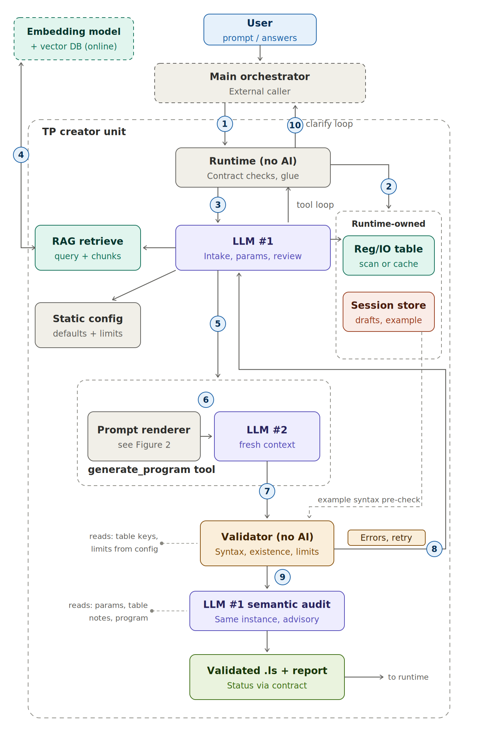
Figure 1 — The TP creator unit (v1.2). The user talks to the main orchestrator, never to the unit directly. The runtime is the entry component, the only writer of stores, and the return path for every response (the output box hands the result back to it). The dashed arrow from the session store to the validator is the example syntax pre-check; small dashed stubs list what the validator and the audit read. The ‘LLM #1 semantic audit’ box is the same LLM #1 instance in a later turn, drawn separately because it is a distinct step. The embedding model + vector DB is an outsourced service. Renderer inputs are detailed in Figure 2.
The numbered flow:
- ① Request in / intake loop — the contract JSON enters the runtime, which performs the mechanical level-A checks (Section 2b). Scope and gap judgments are NOT made here — they happen at LLM #1’s intake turn (step ③) and are returned through the runtime. Clarification may iterate with the caller before generation.
- ② Inputs persisted — the runtime (no LLM) writes the table per the Section 2c source hierarchy and stores the example .ls in the session store; the example gets an immediate syntax-only pre-check (the dashed session-store → validator arrow in Figure 1), and failures are returned as friendly feedback before the loop starts (Section 6).
- ③ LLM #1 intake and params — reads the table (notes) and effective defaults, resolves parameters, applies the gap policy: default / infer / ask.
- ④ Retrieval — LLM #1 authors the query string; the outsourced embedding service embeds it and the vector DB returns top-k chunks (online in v1, Section 4.5). Chunks route to the renderer, not through LLM #1’s context.
- ⑤ Params out — LLM #1 invokes generate_program: params, program name, notes, fix guidance on retries.
- ⑥ Prompt assembled — the renderer builds the LLM #2 prompt from fixed sections (Figure 2).
- ⑦ Draft to validator — LLM #2 returns raw .ls; the runtime hands it to the validator with the table key-set and the limits.
- ⑧ Errors back — a failing verdict returns to LLM #1 for bounded diagnosis and retry.
- ⑨ Semantic review — always — every passing program is audited by LLM #1 for mapping correctness and intent (Section 4.10); a syntactic pass alone is not enough, exactly because the validator checks existence, not correctness.
- ⑩ Store and respond — the output is handed back to the runtime, which returns every response shape — program + report, questions, or rejection — to the caller.

4 Module specifications
For each module: its role, exactly what flows in, exactly what flows out, and what it must never do. “Runtime” below means plain code in the unit — the glue that calls everything else.

4.1 Runtime
Role | Session loop and glue (now explicit in Figure 1 as the unit’s entry component). Receives the request, persists the scan, drives the LLM #1 tool loop, calls the validator after every draft, enforces retry bounds, writes outputs, shapes the response.
In | Contract request; tool-call outputs from LLM #1; drafts from LLM #2; verdicts from the validator.
Out | Contract response; files in the session and output stores.
Never | Makes semantic decisions. If a branch requires judgment, it belongs to LLM #1; if it requires correctness, to the validator.

4.2 LLM #1 — orchestrator
The workflow brain of this unit only (not a general orchestrator). It needs TP literacy, not TP fluency: what a motion instruction is made of, what the register classes mean, which parameters each task family requires. That literacy comes from a ~2-page domain primer in its system prompt plus per-intent parameter checklists and few-shot extraction examples; instruction-level syntax deliberately lives elsewhere (in LLM #2’s assembled prompt).
Role | Extract intent; resolve parameters from the reg/IO table notes and effective defaults; decide ask-vs-default for gaps; author program name and notes; call tools; diagnose validator errors; run the semantic review; decide retry/re-retrieve/escalate.
In | System prompt (domain primer); user prompt; reg/IO table; effective defaults + limits; RAG results it requested; verdict JSONs; session history (previous drafts, decisions); user answers on revision calls.
Out | Structured JSON only: params object, program_name, notes, rag queries, fix guidance on retries, questions for needs_clarification, semantic advisories.
Never | Writes TP code; writes the LLM #2 prompt document; judges code correctness (that is the validator’s job); fills safety-critical gaps silently (positions, payloads → questions instead).
Sized for local: LLM #1 is deliberately kept small-model-capable. Its knowledge arrives as a short system-prompt primer; RAG chunks never enter its context (they route to the renderer); its outputs are structured JSON; and its two judgment tasks — intake triage and the semantic audit — are comparison/extraction work, not generation. This keeps the future fully-local configuration (Section 9) realistic.
Gap policy: safe defaults come from config (speed, termination, frames); inferable values come from table notes (“conveyor” → PR[5] ‘conveyor pick’) with judgment applied to wording (“gently” → longer settle); genuinely missing safety-critical data is returned as a question — never invented.

4.3 Static config
Role | Developer-owned policy file shipped with the unit. Two sections with different rules: defaults (session-overridable) and limits (immutable at runtime).
In | Edited only by the developer, in Git.
Out | Effective defaults → LLM #1 and the renderer’s CELL section; limits → the validator’s layer 3 and the CELL section.
Never | Written by any LLM or by the caller. config_overrides may override defaults per session; nothing overrides limits.
# static_config.yaml
defaults: { speed: "100mm/sec", pick_speed: "50mm/sec", term: "FINE",
utool: 1, uframe: 1, gripper_settle_sec: 0.5 }
limits: { max_speed_mmsec: 250, max_wait_sec: 10 }
retry: { max_attempts: 3 }
table: { max_table_age_hours: 72 } # cache freshness bound (see 2c)
default_index_map: # used ONLY when no scan and no cache
PR: { 1: "home" }
IO: { "RO[1]": "gripper close" }

4.4 Reg/IO table store
Role | The per-session symbol table: registers and IO points with their pendant notes. The unit never scans; the runtime materializes the table from one of the three Section 2c sources (scan / cache / default map), parsing the reg_io_v1 CSV (Appendix A) with the single parser in the system — callers relay bytes. Derived fields (category REG/IO, direction in/out) are computed from type at parse time, never stored in the file, so they can never contradict it. The store records source, the CSV’s own scanned_at, and the resulting mapping confidence.
In | scan object from the request (step ②).
Out | Verbatim register list → renderer CELL section (the whitelist LLM #2 must use); key set → validator layer 2 (membership); notes → LLM #1 (natural-language → address mapping, e.g. PR[5] ‘conveyor pick’).
Never | Edited by an LLM; paraphrased on its way into the prompt (verbatim insertion by code).

4.5 RAG service
The embedding model and the vector database are an outsourced service, drawn outside the unit in Figure 1. Version 1 runs fully online, mirroring the proven medium-rag stack: an OpenAI-compatible gateway for embeddings plus Pinecone for storage/search. A local backend (Ollama embeddings + Chroma) is a planned second profile; the caller’s configuration selects the route and passes it per request as rag_backend — the unit executes whichever route it is told.
Parameters live in rag_config.yaml (unit-owned): retrieval — top_k (default 5), score_threshold, max_context_chars (hard cap on the DOCS text handed to the renderer); indexing — chunk_strategy (logical: one instruction family or one worked example per chunk, preferred for TP docs; fixed: sliding window with chunk_size_chars / chunk_overlap_chars). One profile per backend, each with its own index and its embedding model recorded in the collection metadata.
Two phases, both deterministic code. Offline indexing: the FANUC TP manual and curated .ls examples are chunked by logical unit, embedded, and stored. Online retrieval: LLM #1 authors only the query string; the service embeds it and returns top-k chunks straight to the runtime for the renderer’s DOCS section. Hard invariants: queries are embedded with the same model as the index, and each backend keeps its own index — vectors from different embedding models are incompatible, so online and local never share a collection.
In | Query string from an LLM #1 tool call, e.g. “L motion PR approach RO ON WAIT”; k (default 4–6).
Out | Chunk texts + ids + scores → runtime → renderer DOCS section (verbatim) and back to LLM #1 when it asked for its own reasoning.
Never | Generates text; filters by meaning (that is LLM #1’s call); embeds with a different model than the index.

4.6 Session store (memory)
The unit’s working memory for one program-creation task, kept as plain files. It is deliberately not cross-session learning: it remembers everything about this task and nothing about previous tasks. (The accumulated logs do become a future asset — a corpus for mining few-shot examples or fine-tuning LLM #2 — but that is an offline activity, not runtime memory.)
Contents | drafts/ (v1..vn raw .ls)  verdicts/ (validator JSON per draft)  params_history.json (per attempt)  decisions.log (LLM #1 diagnoses)  example.ls + example_report.json (when provided; shown in Figure 1 inside the runtime-owned stores)
Serves | PREVIOUS + FIX prompt sections on retries  revision_of across contract calls  diffs for user review  the escalation rule: same error class twice → stop retrying, change strategy

4.7 Prompt renderer
Deterministic code (templates), and the most misunderstood block: it is not “a container for a prompt LLM #1 wrote”. LLM #1 authors fields; the renderer authors the document. Same inputs produce a byte-identical prompt — that is what makes retries comparable, tests meaningful, and the register whitelist tamper-proof (it reaches LLM #2 verbatim from the store, never filtered through a model).
No-leakage rule: static config and the reg/IO table have exactly one writer (the runtime) and read-only readers. LLM #1 reads them to decide; the renderer reads them to emit verbatim. The renderer never accepts table or config content from LLM #1’s output — so a stale or paraphrased copy inside LLM #1’s context can at worst mislead a parameter (caught by review), but can never alter the whitelist or limits LLM #2 and the validator see.
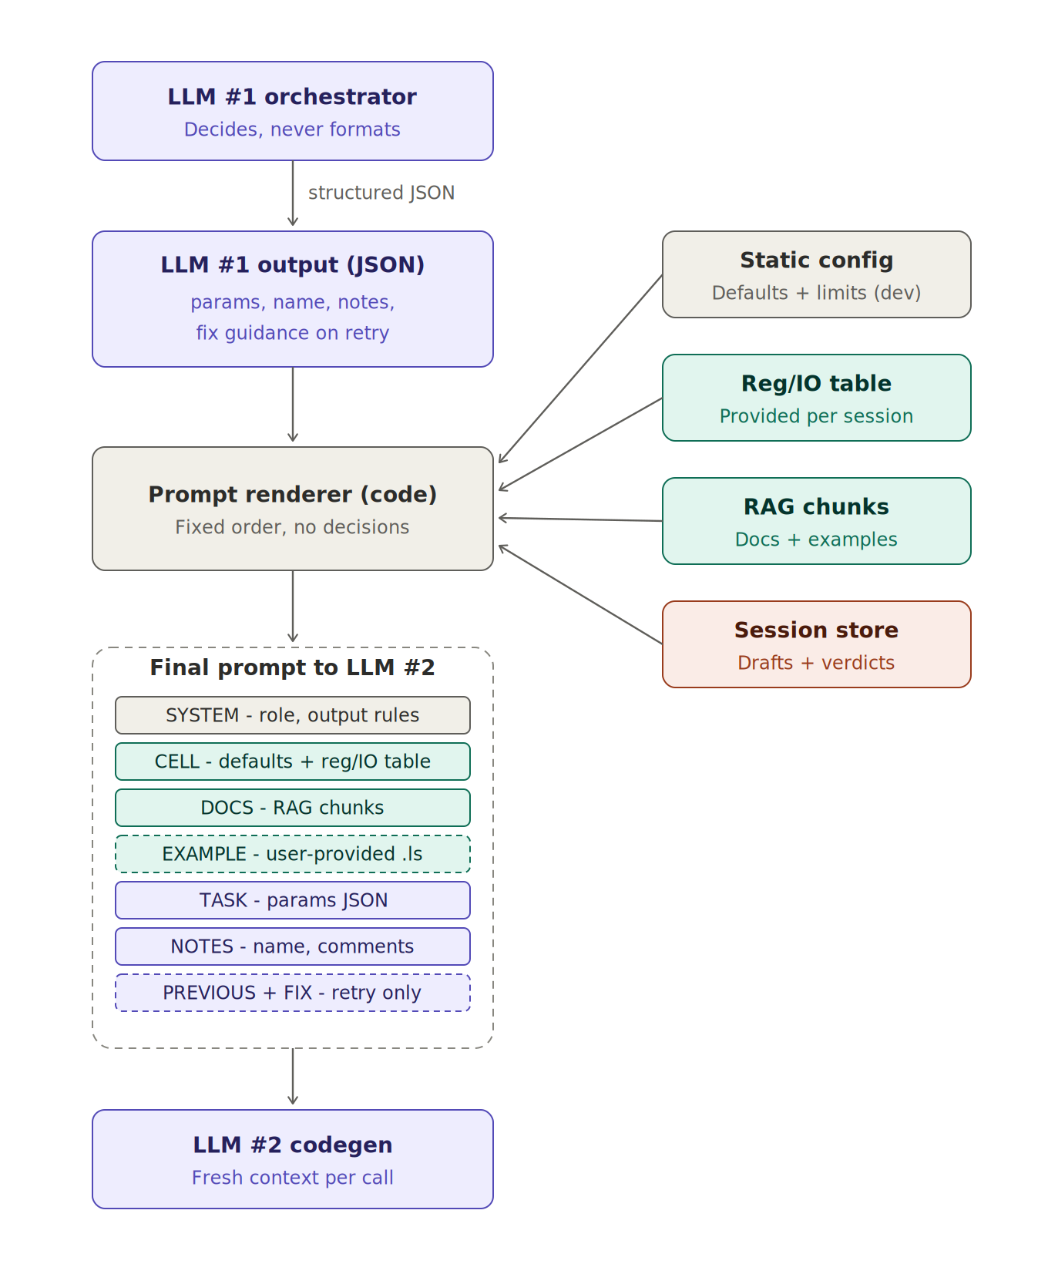
Figure 2 — Prompt assembly. Purple sections are authored by LLM #1, teal sections are pulled verbatim from stores, gray is fixed text. Dashed sections appear only when relevant (example provided; retry).
Section | Source | Content
SYSTEM | fixed text | Role, hard output rules: emit one complete .ls program, no markdown, no commentary.
CELL | config + table | Effective defaults, limits, and the full register/IO whitelist with notes — “use ONLY these”.
DOCS | RAG store | Top-k documentation chunks and examples, verbatim.
EXAMPLE | session store | User-provided reference program, verbatim, with adaptation instructions (only when supplied).
TASK | LLM #1 | The params JSON.
NOTES | LLM #1 | program_name, header comment, per-step comments to embed as /ATTR COMMENT and ! lines.
PREVIOUS + FIX | session store + LLM #1 | Prior draft verbatim + the validator errors + LLM #1’s fix guidance; “change nothing else”. Retry only.

4.8 LLM #2 — code generator
Role | Single-shot TP/LS emission. Stateless by design: fresh context per call, no tools, no memory, no knowledge that a validator exists. All its FANUC fluency arrives in the assembled prompt (CELL whitelist + DOCS chunks + EXAMPLE).
In | The rendered prompt document, nothing else.
Out | Raw .ls text → runtime (which stores it as draft vN and forwards to the validator).
Never | Talks to the validator; sees conversation history; chooses registers outside the CELL whitelist without being caught one step later.

4.9 Validator
Scope, stated precisely: layer 2 answers existence, not correctness. ‘Does PR[8] exist in this cell’s table’ is set membership — mechanical, free, and something an LLM genuinely misses in a 40-line program. ‘Is PR[8] the right fixture for this task’ is semantics — the validator cannot answer it and does not claim to; that judgment belongs to LLM #1’s semantic review, which runs after every pass (Section 4.10). The validator’s table access is therefore read-only key-set access; it never interprets notes.
Deterministic three-layer sieve. It never predicts what LLM #2 meant — all validation is membership testing against closed sets, which is why hallucinations it “cannot anticipate” are caught anyway: everything not in the sets is an error by definition. TP is a closed language: a finite instruction list, a finite grammar per instruction, and a finite per-cell symbol table.
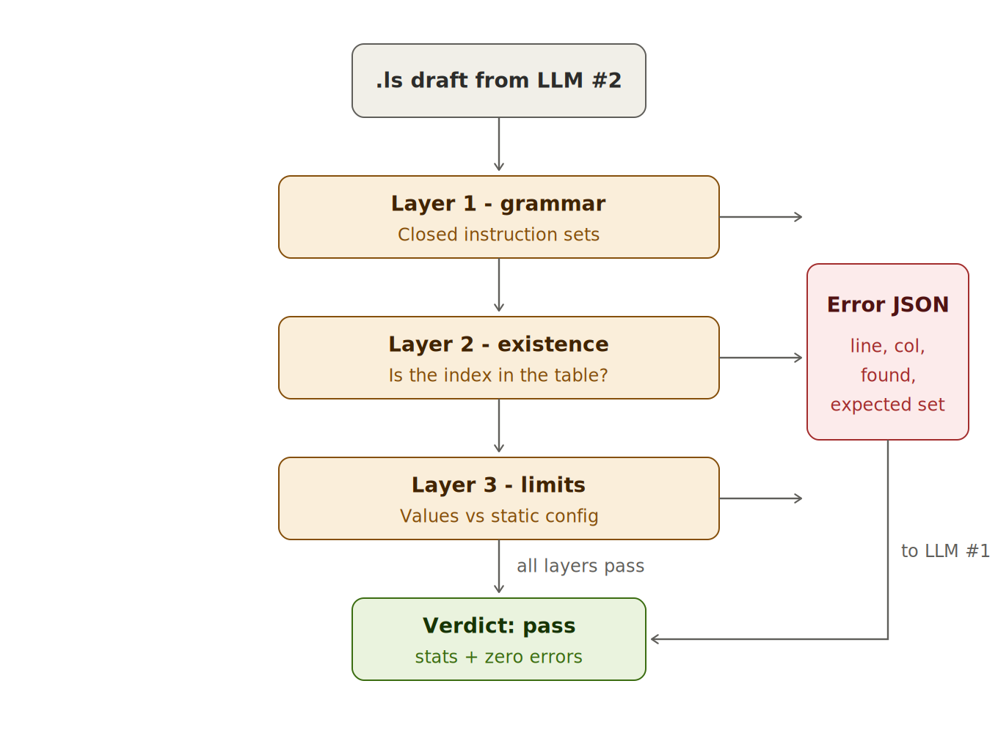
Figure 3 — The three-layer sieve. Layer 2 checks existence only — correctness of the chosen index is LLM #1’s review. Only a draft passing all three layers produces a pass verdict.

Worked examples of “how does it know what was expected”
- Invented instruction. “GRIP_SOFT RO[1] ;” — the first token is looked up in the family dictionary {J, L, C, WAIT, IF, SELECT, CALL, JMP, LBL, R[, PR[, RO[, DO[, UFRAME_NUM, UTOOL_NUM, !, …}. GRIP_SOFT is not a member → error listing the legal keyword set. The validator has no idea what GRIP_SOFT means and does not need to.
- Invented option inside a legal instruction. “L PR[5] 100mm/sec FINE Grip ;” — the motion grammar walks token by token: target matches the PR pattern, the speed unit is in {mm/sec, cm/min, msec, sec, %}, FINE is in {FINE, CNT0–100}; at position 5 the legal continuations are the motion-options set {Offset, Tool_Offset, ACC, TB, TA, …} or end-of-line. “Grip” is in neither → error citing the column and that exact set. At every position of a grammar walk the legal next tokens are enumerable by construction — that is what a grammar is.
- Invented symbol. Every PR[n]/R[n]/RO[n]/DI[n]/DO[n] in the file is regex-extracted and set-differenced against the table keys. PR[10] with table {1,5,6,7,8,9} → error carrying the known set and its notes. The reg_io_v1 initialized flag adds a second, distinct diagnosis: ‘PR[10] exists but is uninitialized and unlabeled — did you mean PR[6]?’ is a different error than ‘PR[10] does not exist’, and LLM #1 repairs them differently. This is why the robot class must dump ALL indexes, including uncommented ones.
- Legal syntax, illegal value. “L PR[5] 400mm/sec FINE ;” parses and resolves cleanly; layer 3 compares 400 against max_speed_mmsec 250 → error.

Error JSON
{ "verdict": "fail", "draft_id": "v1",
"errors": [
{ "layer": "grammar", "line": 8, "col": 9, "found": "1.0sec",
"expected_form": "WAIT <t>.00(sec)", "suggestion": "WAIT 1.00(sec)" },
{ "layer": "symbol", "line": 5, "ref": "PR[10]",
"message": "PR[10] not in reg_io_table (scan 10:42)",
"known_pr": {"1":"home","5":"conveyor pick","6":"conveyor approach",
"7":"fixture A approach","8":"fixture A place","9":"fixture B place"} } ],
"stats": { "mn_lines": 14, "parsed_ok": 12, "limits_ok": true } }

Suggestion policy (bounded on purpose)
- Grammar layer only, and only when the found token has edit distance ≤ 2 to exactly one member of the legal set at that position (mm/s → mm/sec). Ambiguous → field omitted.
- Never for symbols: the validator must not guess which PR the model meant — it supplies the known list with notes and LLM #1 makes the semantic call.
- Never applied automatically. The only consumer is LLM #1, and whatever LLM #1 produces is validated again — so the worst case of a wrong suggestion is one wasted retry, not a wrong program.

4.10 LLM #1 semantic audit
This is the same LLM #1 instance in a later turn of its loop — not a third model; Figure 1 draws it as a separate box only because it is a distinct step with distinct inputs. Mandatory: it runs after every validator pass, unconditionally — a syntactic pass says nothing about whether the mapping is right. LLM #1 performs one audit turn using what the parser structurally cannot see: did the program use the right registers per the notes (PR[8], not PR[9]); did the requested defaults and overrides actually land in the code; is the step sequence sane (grip after arrival, approach before place, no place before pick). Output is a list of advisories in the report. It is an auditor, not a gate: it flags, the human decides. The moment it can silently block or approve, LLM judgment has been reintroduced as ground truth.

4.11 Output store
Role | Terminal artifact storage: out/<session>/<PROGRAM>_vN.ls + report.json. The response carries the program inline and the file reference; the caller decides presentation (the intended flow: the main orchestrator exposes program + report to the user for review).
Audit | Session store + output store together give the full trail: prompt → drafts → verdicts → decisions → final file.

5 The retry handshake (LLM #2 ↔ validator)
The handshake is mediated and asymmetric by design. LLM #2 is stateless — prompt in, text out, gone; it does not know a validator exists. The validator does not know an LLM produced its input. The only shared language is the error JSON, and the only component that interprets it is LLM #1. That seam is a data format, not a relationship — which is why either side can be swapped independently (LLM #2: API model ↔ local model; validator: add layers) with zero impact on the other.
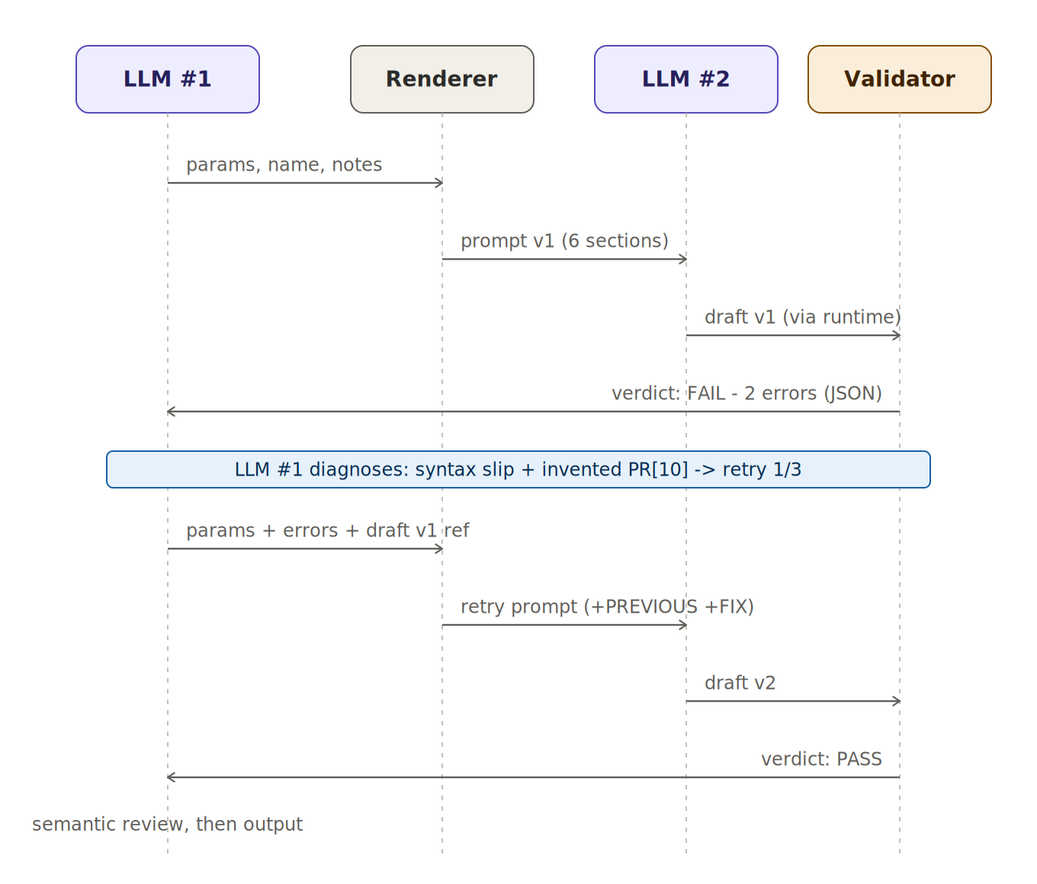
Figure 4 — One failing attempt and one passing retry. All arrows are runtime-mediated calls; LLM #2 and the validator never address each other.
- Bounded: retry.max_attempts (3) from config. Exceeded → status failed with the last verdict attached.
- Escalation rule: same error class twice → LLM #1 stops retrying blindly and changes strategy: re-retrieve documentation for the failing instruction, or return a question. This rule is only possible because the session store remembers attempt 1.
- Reproducible retries: the retry prompt is the original prompt plus exactly two appended sections (PREVIOUS, FIX). Nothing else moves, so a retry differs from its predecessor in precisely the errors being fixed.

6 User-provided example programs
The caller may pass example_ls — a reference TP program the user wants the result to resemble. Handling pipeline:
- Store first. The runtime persists it to the session store before any LLM sees it.
- Syntax pre-check with early feedback. At intake the validator runs over the example in syntax-only mode (grammar layer; symbols and limits are skipped — it comes from a foreign cell). If syntax fails, the unit returns feedback to the user immediately, before the loop starts: fix the example, or confirm it should be used only as a loose style reference.
- Symbol report. On a clean syntax pass, a second run produces the example report: which registers/IOs the example uses and which do not exist in this cell — the input to the mapping step.
- LLM #1 extracts and maps. It reads example + report, extracts the reusable part (structure, ordering conventions, option usage) and maps foreign symbols to local ones via notes (example’s PR[12] ‘pick pos’ → this cell’s PR[5] ‘conveyor pick’), asking via questions when a mapping is genuinely ambiguous.
- Renderer inserts verbatim. The EXAMPLE section carries the stored file text inserted by code — LLM #1 never re-types it, because a model copying 40 lines will occasionally ‘fix’ one silently — with the instruction: match this structure and style; use only the registers in CELL.
- Gates unchanged. The generated output passes the same validator as always. The example influences style; it never bypasses correctness.

7 Configuration policy
Aspect | Defaults | Limits
Examples | speed, pick speed, termination, tool/frame numbers, settle times | max speed, max wait, envelope
Owner | developer baseline; user policy | developer only
Runtime override | yes — config_overrides per session (relayed by the main orchestrator from the user) | never
Read by | LLM #1, renderer CELL section | validator layer 3, renderer CELL section
Reviewable | get_defaults contract query; report echoes effective_defaults per program | visible in reports, not editable
Rationale: defaults are policy the user legitimately owns, so they flow through the front door like data. Limits are the safety floor the validator enforces — a user-editable safety floor is not one, so limits are part of the unit’s identity.

8 End-to-end trace (condensed)
Prompt: “Pick a part from the conveyor and place it on fixture A. Close the gripper gently.”
[0] intake: in-scope; scan present -> table_source=scan; no questions
[1] request in; scan persisted (10:42)
[2] LLM #1: intent pick_and_place; table lookups:
conveyor->PR[5] (unique), fixture A->PR[8] (unique), gripper->RO[1]
"gently" -> settle 1.0s (default 0.5s); all params resolved, no questions
[3] RAG: "J L PR motion RO ON WAIT pick place" -> 4 chunks
[4] generate_program(params) -> renderer -> LLM #2 -> draft v1
[5] validator v1: FAIL
grammar line 8: "WAIT 1.0sec" expected WAIT <t>.00(sec)
symbol line 5,9: PR[10] not in table (known: 1,5,6,7,8,9)
[6] LLM #1 diagnosis (attempt 1/3): syntax slip + invented register;
retry with errors attached, whitelist re-emphasized
[7] renderer: original prompt + PREVIOUS(v1) + FIX(2 errors) -> LLM #2 -> v2
diff: PR[10]->PR[6] (2 lines), WAIT 1.00(sec)
[8] validator v2: PASS (14/14 lines)
[9] semantic review (always runs): advisory - no approach before place; PR[7] available
[10] response: status ok, v2 inline + file_ref + report
(defaults applied, "gently"->1.0s, 1 retry, advisory)
If the user then asks “add the approach via PR[7]”, the caller sends a new request with revision_of = v2; LLM #1 patches one param and the user reviews a two-line diff. The clarification branch works the same way: with an ambiguous “fixture” (PR[8] and PR[9] both match), the unit returns needs_clarification asking, in plain language, “Which fixture should I place the part on — fixture A (PR[8]) or fixture B (PR[9])?” instead of guessing — placing on the wrong fixture is a physical-world error, not a guessable default.

9 Model deployment options
Both LLM roles sit behind narrow interfaces (a tool-calling chat loop; a single-shot completion), so the model choice is configuration, not architecture. On a 32 GB RTX 5090 workstation at Q4_K_M quantization, a 32B dense model costs ~19–20 GB, so two of them do not co-reside; the practical configurations:
Configuration | LLM #1 | LLM #2 | Notes
Hybrid (recommended start) | Claude Sonnet (API) | Qwen2.5-Coder-32B local | Frontier judgment where it matters (tool use, JSON discipline, low volume); local for the high-volume, privacy-relevant codegen. RAG + whitelist carry TP correctness either way.
Fully local, two models | Qwen3-14B (~9 GB) or Qwen3-30B-A3B MoE | Qwen2.5-Coder-32B (~20 GB) | 14B + 32B ≈ 29 GB — fits with KV headroom, tight. Serve via Ollama (simplest) or vLLM (JSON-schema guided decoding for LLM #1’s structured output).
Fully local, one model | Qwen3-Coder-30B-A3B | same model, different prompts | Simplest ops; viable because the validator gates correctness and the renderer constrains inputs. The factory-floor / no-internet configuration.
Note that the design keeps LLM #1’s job inside a small model’s envelope on purpose (short primer, no RAG context, structured output, audit-style review) — so the fully-local rows above are credible, not aspirational.
The mock-LLM #2 integration test (Software Architecture document, tests/test_e2e_mock.py) runs unchanged against any backend — that is how retry-convergence of a local model is benchmarked against the API before committing.

Appendix A — reg_io_v1 interchange format
The wire format between the robot-class scanner (producer), the caller (verbatim relay), and the unit’s runtime (the single parser). CSV was chosen over JSON because the data is flat tabular, human-reviewable in a spreadsheet (mapping review is a first-class activity in this design), trivially producible by a dump loop, and diff-friendly for cache-vs-fresh comparison.

Dialect and rules
- UTF-8, comma delimiter, double-quote quoting, header row required. Lines starting with # are metadata, stripped before CSV parsing. Excel is a viewer for this file, not an editor.
- Metadata header: # schema: reg_io_v1 (missing/foreign → level-A reject with a friendly message), # cell_id, # scanned_at (the timestamp of record — staleness math uses this, not the caller’s word).
- Five columns: type, index, comment, initialized, value. category (REG/IO) and direction (in/out) are deliberately NOT columns — both derive from type in the parser, so file and derivation can never contradict.
- Type enum v1: registers R, PR, SR, PL; IO DI, DO, RI, RO, UI, UO, SI, SO, GI, GO, AI, AO. Unknown types are kept and flagged, not rejected (forward compatibility).
- initialized: TRUE/FALSE for registers (an uninitialized PR shows * on the pendant), ‘-’ for IO. Enables the ‘exists but not targetable’ validator diagnosis.
- Dump ALL indexes, including rows with empty comments — the existence check needs the full index population, and ‘unlabeled’ is a different fact than ‘nonexistent’.
- value: free text, quoted; PR values carry a C: (Cartesian) or J: (Joint) prefix. The unit ignores this column in v1 — it rides along because the scanner gets it for free, and future consumers (envelope checks, RoboGuide layer) will want it. Dropping it later costs nothing; adding it later costs a robot-class change.

Example
# schema: reg_io_v1
# cell_id: line3_fanuc1
# scanned_at: 2026-07-04T10:42:00
type,index,comment,initialized,value
PR,1,home,TRUE,"J: 0.0,0.0,0.0,0.0,-90.0,0.0"
PR,5,conveyor pick,TRUE,"C: 512.3,-104.7,88.0,180.0,0.0,45.0"
PR,6,conveyor approach,TRUE,"C: 512.3,-104.7,188.0,180.0,0.0,45.0"
PR,8,fixture A place,TRUE,"C: 291.0,220.5,95.0,180.0,0.0,90.0"
PR,9,fixture B place,TRUE,"C: 291.0,-220.5,95.0,180.0,0.0,-90.0"
PR,10,,FALSE,
R,3,part counter,TRUE,12
SR,2,"recipe name, active",TRUE,PICKPLACE_A
DI,3,part present,-,ON
RO,1,gripper close,-,OFF
UI,5,,-,ON
F,12,cycle active flag,-,OFF
The example rows exercise the edge cases on purpose: an uninitialized, uncommented PR (10); a comma inside a quoted comment (SR[2]); unlabeled-but-real entries (UI[5]); and a type outside the v1 enum (F) that a compliant parser keeps and flags.

