TP Creator Agent
Software Architecture & Design
From the frozen v1.3 architecture to code: processes, classes, module contracts, and communication
Version 2.1 · July 2026 · synced to Design Document v1.3 · Python 3.11+ / Windows first
Contents
0 Revision notes
1 Scope and reading guide
2 High-level architecture: processes and boundaries
3 Repository layout
4 Layer rules and dependencies
5 Core data model (classes)
6 Component specifications
6.1 contract.py — types + level-A gate
6.2 reg_io.py — the single CSV parser
6.3 runtime.py — session loop
6.4 llm1.py + review.py + prompts/
6.5 renderer.py + templates/
6.6 llm2.py — backends
6.7 validator/ — three layers
6.8 rag/ — profiles
6.9 stores/ — table, session, output
6.10 apps/ — the tier-2 caller
7 Communication: one contract call end to end
8 Data on disk
9 Configuration and environments
10 Testing strategy
11 Prototype-to-target migration map

0 Revision notes

v2.1
- Figure 1 corrected after review. The unit-process view previously chained its components vertically, which wrongly read as a pipeline ending in ‘stores + RAG client’. It now uses a hub topology matching the stated rule (the runtime talks to everything): the RAG client is its own component used pre-generation, and the stores are drawn last only as inventory — with the output store explicitly noted as where the final .ls lands after the validator pass AND the LLM #1 audit.

v2.0
Rewritten against Design Document v1.3. Everything the design added since the first software sketch is reflected in code terms: the runtime’s level-A gate and the two-level rejection model; reg_io_v1 as the scan wire format with the single-parser rule (a dedicated reg_io.py module); the table-source hierarchy with cache and default_index_map in stores/table.py; the answers relaxation ({reply: raw text}); rag_config.yaml as the unit-owned home of retrieval/chunking parameters with one index per backend profile; the mandatory LLM #1 audit turn; the example syntax pre-check (validator mode="syntax_report"); and the tier-2 caller (apps/) with its envelope-assembly logic, for which a working reference implementation already exists and validated the interfaces specified here.

1 Scope and reading guide
The Design Document answers what the system does and why; this document answers how it is built: which processes exist, which modules live in them, the exact interfaces between modules, and what travels across every boundary. Sections 2–5 are top-down architecture (processes → repository → layers → data model); Section 6 is the per-component reference with inputs, outputs and forbidden behaviors; Sections 7–11 cover communication, persistence, configuration, testing and the migration from the existing prototype.
One sentence to keep while reading: intelligence (llm1, llm2) and correctness (validator) never import each other; the runtime is the only module that talks to everything; the caller talks only to contract.py. Every interface below exists to preserve those three rules.

2 High-level architecture: processes and boundaries
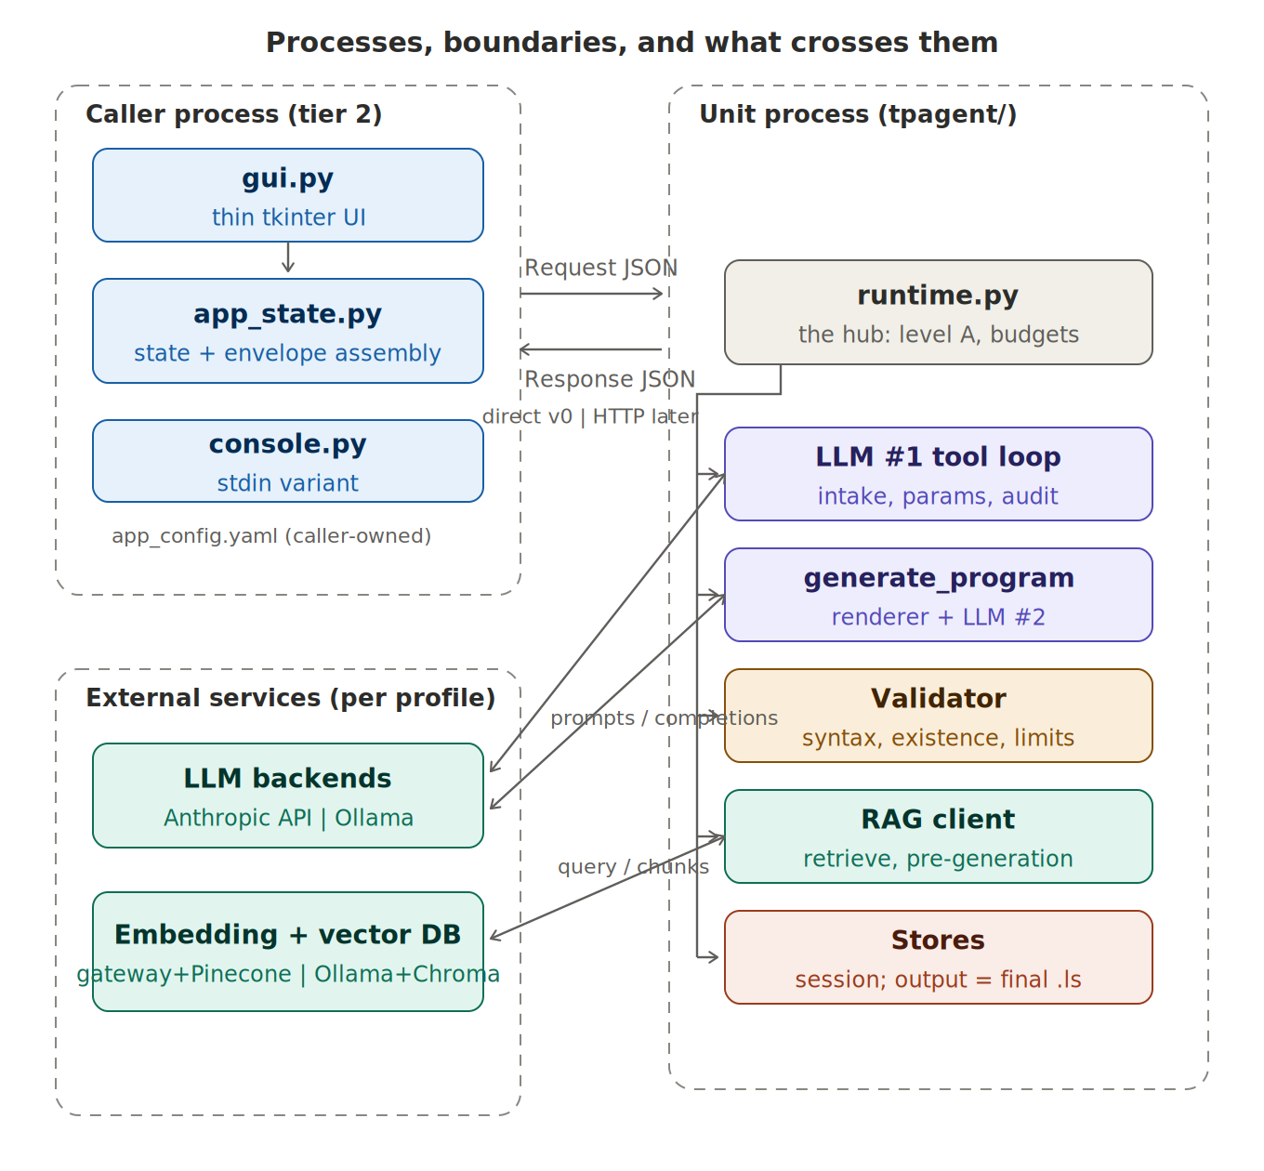
Figure 1 — Two processes plus external services. Inside the unit the topology is a hub, not a pipeline: the runtime calls each component in the flow order defined by Design Doc Figure 1 (RAG retrieval happens BEFORE generation; the output store is written LAST, after validator pass + LLM #1 audit). The contract boundary carries only Request/Response JSON — direct call in v0, HTTP later. External services are selected per rag_backend / TP_LLM* profile.
Three kinds of boundaries, each with a fixed payload:
Boundary | Payload crossing it | Direction | Notes
caller ↔ unit | Request JSON (prompt verbatim, reg_io_v1 CSV verbatim, overrides, flags) / Response JSON (status, program, report, questions, reason) | both | The only coupling between processes. The caller never parses the CSV and never sees unit internals.
unit ↔ LLM backends | rendered prompt → completion (LLM #2); tool-loop messages → structured JSON / tool calls (LLM #1) | both | Vendor SDKs are imported only inside llm1.py / llm2.py; swapping backends is an env change.
unit ↔ embedding + vector DB | query string → embedding → top-k chunks | both | Profile chosen by Request.rag_backend; each profile has its own index (hard invariant).
The caller process is deliberately brainless (Design Doc Section 2d): gui.py is a thin tkinter skin over app_state.py, which holds exactly two pieces of conversation state (last draft, pending question) plus configuration, and assembles the envelope mechanically. console.py is the same brain on stdin. Both import nothing from tpagent/ except contract.py — which makes the caller itself the boundary-enforcement test.

3 Repository layout
tp-creator/
+-- CLAUDE.md # agent rules for Claude Code sessions
+-- config/
| +-- static_config.yaml # defaults + limits + retry + max_table_age + default_index_map
| +-- rag_config.yaml # unit-owned: profiles (online|local), index + retrieve params
+-- tpagent/ # THE UNIT (Design Doc Figure 1)
| +-- contract.py # Request/Response/Report + level-A validate_request()
| +-- reg_io.py # reg_io_v1 parser -- the single parser in the system
| +-- runtime.py # handle(): session loop, budgets, finalize
| +-- llm1.py # orchestrator tool loop (intake, params, retries)
| +-- review.py # the audit turn (same LLM #1 instance)
| +-- prompts/llm1_system.md # domain primer + checklists + few-shots
| +-- renderer.py # deterministic prompt assembly
| +-- templates/ # system.j2 cell.j2 docs.j2 example.j2 task.j2 notes.j2 retry.j2
| +-- llm2.py # single-shot codegen; backends anthropic|ollama|mock
| +-- rag/
| | +-- index.py # offline: chunk + embed + write collection (per profile)
| | +-- retrieve.py # online: embed query + top-k (asserts index model)
| +-- validator/
| | +-- grammar.py # FAMILIES dict + token walks + bounded suggestions
| | +-- existence.py # symbol extraction vs table keys + initialized diagnosis
| | +-- limits.py # numeric checks vs static config
| | +-- verdict.py # Verdict/Err dataclasses; run(text, table, limits, mode)
| +-- stores/
| +-- table.py # 2c source hierarchy: scan > cache > default_map
| +-- session.py # drafts, verdicts, params, decisions, example
| +-- output.py # final .ls + report.json
+-- apps/ # THE CALLER (tier 2) -- outside the unit
| +-- app_state.py # config IO + conversation state + envelope assembly
| +-- gui.py # tkinter: Chat | Program | Report | Settings
| +-- console.py # stdin shell
| +-- app_config.yaml # caller-owned configuration
+-- corpus/ # TP manual sections + curated .ls examples
+-- sessions/ out/ chroma/ # runtime data (gitignored)
+-- tests/ # see Section 10
+-- cli.py # request | chat | validate | index subcommands

4 Layer rules and dependencies
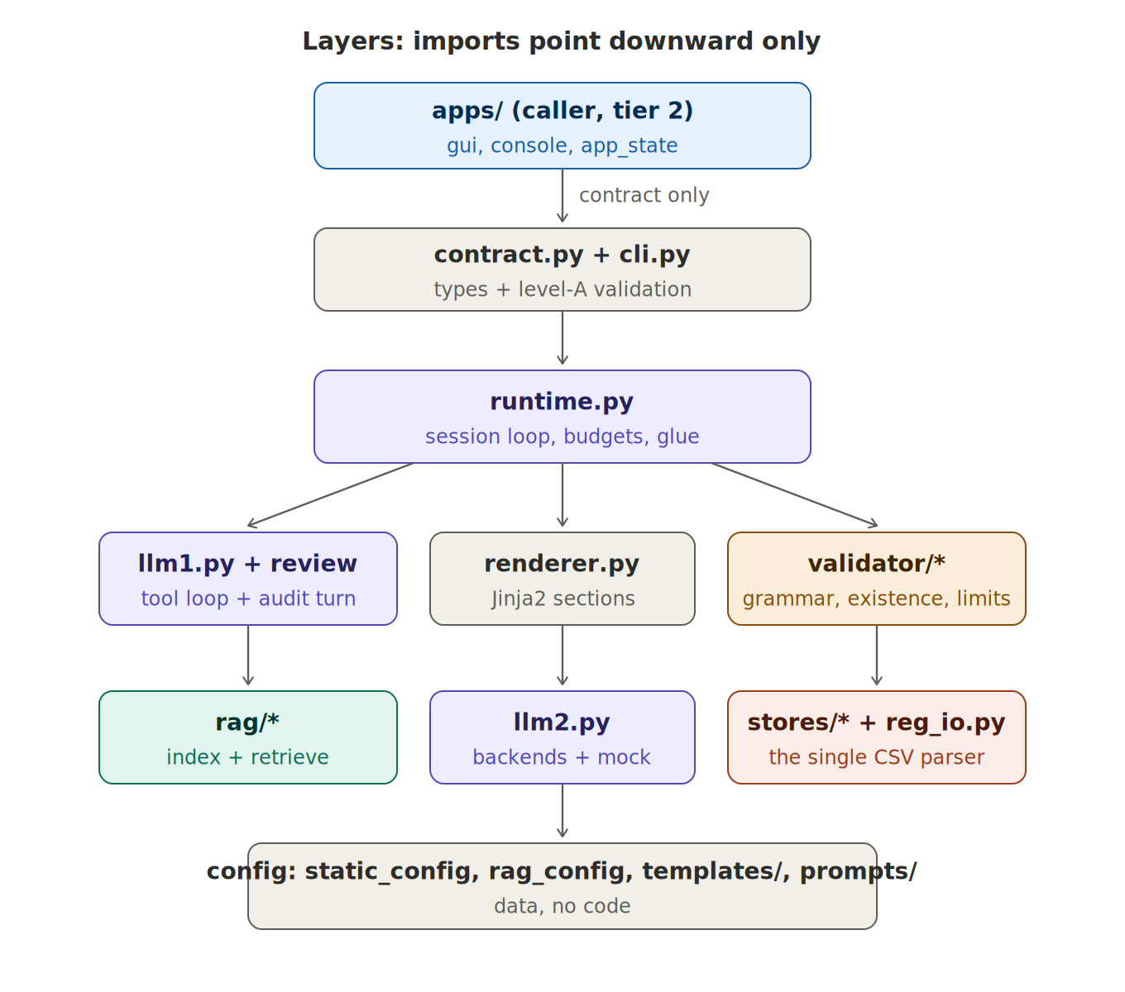
Figure 2 — Imports point downward only. apps/ sees nothing below contract.py; runtime.py is the sole module importing from every layer; llm1/llm2/validator never import each other across branches; reg_io.py lives with the stores because the table store is its only caller.
Rule | Enforced by | Why it exists
apps/ imports contract.py only | code review + the fact that apps/ runs against HTTP later | keeps the caller replaceable (tier 3) and the unit boundary honest
intelligence ↮ correctness (llm1/llm2 ↮ validator) | package structure; no shared modules except dataclasses | the validator must be testable with zero LLMs and immune to model blind spots
reg_io.py has one caller: stores/table.py | import audit in CI (simple grep test) | single-parser rule — derived fields computed exactly once
vendor SDKs only inside llm1.py, llm2.py, rag/ | import audit in CI | model/backend swap = env change, not refactor
templates contain no logic beyond presence checks | renderer snapshot tests | determinism: same inputs ⇒ byte-identical prompt

5 Core data model (classes)
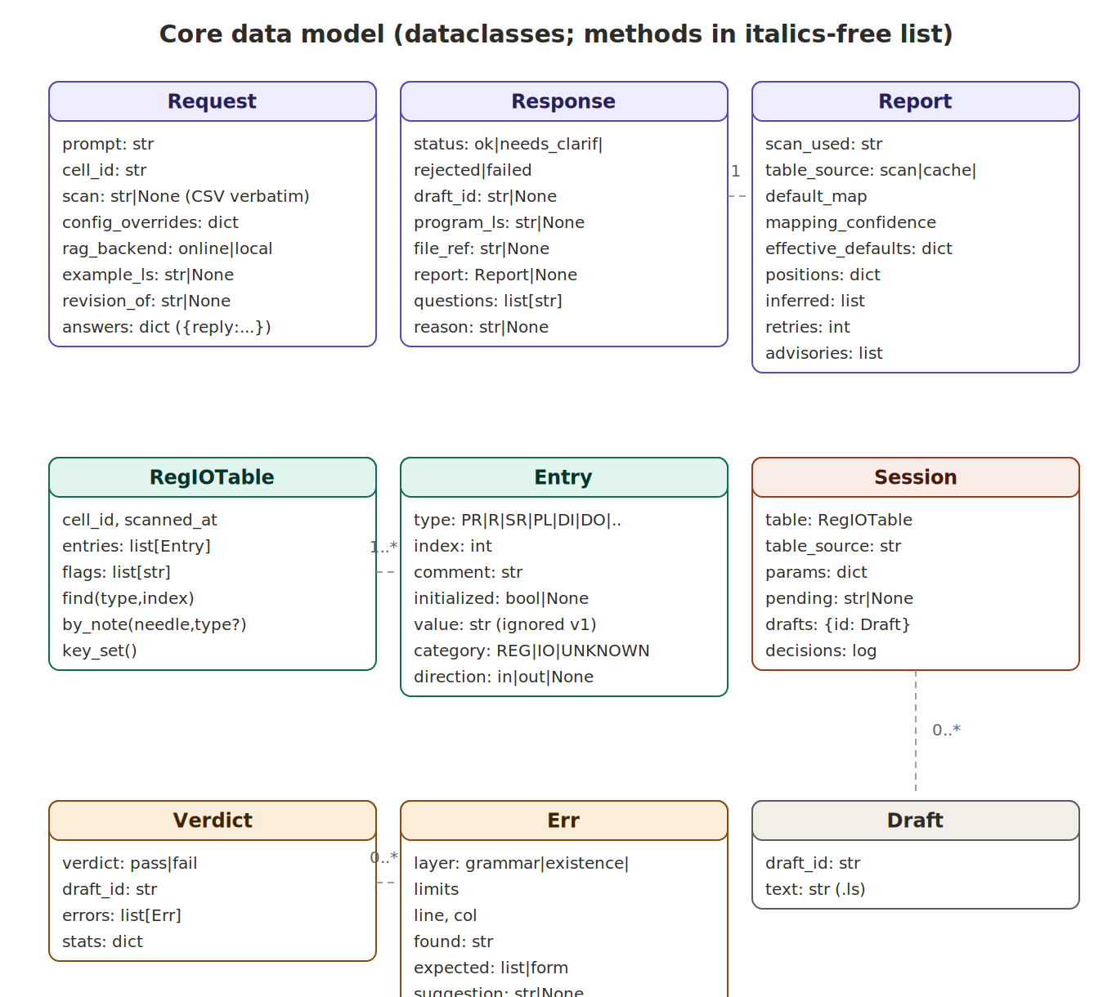
Figure 3 — The nine load-bearing dataclasses. Response owns one Report; RegIOTable owns Entry rows (with category/direction computed at parse time, never stored); Session owns Drafts and the table reference; Verdict owns Err records whose layer values are grammar | existence | limits.
Everything else in the system is behavior over these types. Two deliberate asymmetries: Entry carries the derived category/direction so no consumer ever re-implements the FANUC type decoding; and Err.expected is either a token set (grammar walk position) or a form string (pattern instructions like WAIT), because those are the two shapes “what was legal here” actually takes.

6 Component specifications
Format per component: role · public interface (signatures) · in / out · never. Signatures marked (proto) exist verbatim in the reference implementation and survived the conversation tests; the rest are specified here.

6.1 contract.py — types + level-A gate
Status = Literal["ok", "needs_clarification", "rejected", "failed"]
OVERRIDABLE_DEFAULTS = {"speed","pick_speed","term","utool","uframe","gripper_settle_sec"}
LIMIT_KEYS = {"max_speed_mmsec","max_wait_sec"}

@dataclass Request(prompt, cell_id, scan: str|None, config_overrides={},
rag_backend="online", example_ls=None, revision_of=None, answers={})
@dataclass Report(scan_used, table_source, mapping_confidence, effective_defaults,
positions, inferred, retries, advisories)
@dataclass Response(status, draft_id, program_ls, file_ref, report, questions, reason)

def validate_request(req) -> str | None # (proto) level-A: friendly message or pass
In / out | JSON strings at both ends (to_json/from_json); dataclasses everywhere inside.
Level-A checks | empty prompt; missing cell_id; overrides touching LIMIT_KEYS; unknown override keys; invalid rag_backend. Each failure returns a pre-written friendly sentence (Design Doc Section 2b) — the runtime wraps it as status=rejected.
Never | Reasons about content. Anything requiring judgment is not a level-A check by definition.

6.2 reg_io.py — the single CSV parser
class SchemaError(ValueError) # -> level-A reject upstream
def parse_reg_io_csv(raw: str) -> RegIOTable # (proto)
# - strips '#' metadata lines; requires schema=reg_io_v1, cell_id, scanned_at
# - csv.DictReader over the body; required columns type,index,comment,initialized,value
# - classify(type) -> category REG|IO|UNKNOWN, direction in|out|None (computed, not stored)
# - unknown types / bad rows -> table.flags (kept, flagged, never rejected)
RegIOTable.find(type,index) / by_note(needle,type?) / key_set() # (proto)
by_note filters out initialized=False entries — an uninitialized register is a valid existence fact but an invalid inference target, which is exactly the split the design’s ‘exists but uninitialized’ diagnosis needs. Comment matching trims the trailing whitespace FANUC pads comments with.

6.3 runtime.py — session loop
def handle(req: Request) -> Response:
if (msg := contract.validate_request(req)): return reject(msg) # level A
table, source = stores.table.materialize(req.cell_id, req.scan) # 2c hierarchy
sess = stores.session.open(req.cell_id, req.revision_of)
if req.example_ls:
rep = validator.run(req.example_ls, table, cfg.limits, mode="syntax_report")
sess.save_example(req.example_ls, rep)
if rep.verdict == "fail": # early feedback
return needs_clarification(friendly_syntax_feedback(rep))
loop = llm1.ToolLoop(cfg_effective(req), table, sess) # level B inside
for turn in loop:
if turn.tool == "rag_retrieve":
turn.result = rag.retrieve(turn.query, profile=req.rag_backend)
if turn.tool == "generate_program":
prompt = renderer.render(cfg, table, sess, turn.args)
draft = llm2.generate(prompt); sess.save_draft(draft)
turn.result = validator.run(draft.text, table, cfg.limits)
sess.save_verdict(turn.result)
budget.count(turn.result) # max_attempts + same-class-twice escalation
if loop.outcome.ok:
advisories = review.semantic_audit(loop.program, loop.params, table) # ALWAYS
return finalize(loop.outcome, sess) # ok | needs_clarification | rejected | failed
In | Request; tool intents from LLM #1; drafts; verdicts.
Out | Response; every file under sessions/ and out/ (sole writer of stores).
Budgets | retry.max_attempts from static config, enforced here in code; the same-error-class-twice counter is mechanical (LLM #1 chooses the new strategy, runtime forbids spending more attempts on the old one).
Never | Decides scope or fills gaps (level B belongs to LLM #1); parses prompts; edits config.

6.4 llm1.py + review.py + prompts/
class ToolLoop:
"""Tool-use loop. Tools: rag_retrieve(query),
generate_program(params, program_name, notes, base_draft, errors),
ask_user(questions) -> loop terminal, becomes needs_clarification.
Structured output only: every turn is a tool call or a final JSON;
free text is a protocol error the runtime rejects and retries once."""

def review.semantic_audit(program, params, table) -> list[str] # advisories, friendly
- prompts/llm1_system.md is the whole of LLM #1’s TP knowledge: the ~2-page literacy primer, per-intent parameter checklists, the gap policy (config default / note inference / ask — never invent positions), the user-facing language rule with examples, and 2 few-shot prompt→params extractions. No RAG chunks ever enter LLM #1’s context — they route to the renderer — which is what keeps the small-local-model plan credible.
- Answers handling: on a call with answers={reply: text}, the open question is read from the session store and the raw reply is interpreted against it (the reference implementation demonstrated fixture-letter and PR-index replies). Structured {key: value} bypasses interpretation.
- review.py is the same client, different turn: fresh audit prompt (program + params + table notes), output constrained to an advisories list. It cannot block — the runtime treats its output as report content only.

6.5 renderer.py + templates/
def render(cfg, table, sess, args: GenerateArgs) -> str
# fixed order: SYSTEM -> CELL(cfg, table verbatim) -> DOCS(args.chunks)
# -> EXAMPLE(sess, verbatim)? -> TASK(args.params) -> NOTES(name, comments)
# -> PREVIOUS+FIX(sess.draft(args.base_draft), args.errors)? retry only
# byte-identical for identical inputs (snapshot-tested)
No-leakage in code terms: render() takes the table and config objects from the stores, never from LLM #1’s output — GenerateArgs simply has no field that could carry them. The whitelist reaching LLM #2 is the store’s bytes.

6.6 llm2.py — backends
def generate(prompt: str) -> Draft
# backend by env TP_LLM2 = anthropic:<model> | ollama:<model> | mock:<path>
# post-processing (code): strip markdown fences, normalize CRLF,
# require a /PROG ... /END envelope (else -> synthetic grammar error, not a crash)

6.7 validator/ — three layers
def run(text, table, limits, mode="gate") -> Verdict
# mode="gate": grammar + existence + limits (drafts)
# mode="syntax_report": grammar only (example pre-check)
# grammar.py: FAMILIES dict keyed by leading token; token walk per family;
# suggestion iff edit_distance<=2 AND unique candidate; grammar layer only
# existence.py: regex-extract PR/R/SR/PL/DI/DO/RI/RO/... refs; three outcomes:
# ok | not_in_table (known set attached) | exists_uninitialized
# ("PR[10] exists but is uninitialized and unlabeled - did you mean PR[6]?")
# limits.py: speeds, waits vs static config
existence.py consumes RegIOTable.key_set() plus the initialized flags — read-only, no note interpretation, per the correctness/existence split. The two symbol outcomes produce different Err payloads because LLM #1 repairs them differently (wrong index vs. missing setup).

6.8 rag/ — profiles
# rag_config.yaml (unit-owned): profiles.online / profiles.local
# each: embedding {provider, model}, vector_db {provider, index/collection}
# index: chunk_strategy logical|fixed, chunk_size_chars, chunk_overlap_chars
# retrieve: top_k, score_threshold, max_context_chars
def retrieve(query, profile) -> list[Chunk]
# asserts collection.embedding_model == profile.embedding.model (hard invariant)
# truncates the chunk list at max_context_chars before returning

6.9 stores/ — table, session, output
table.materialize(cell_id, scan_csv|None) -> (RegIOTable, source)
# 1 scan: parse_reg_io_csv; persist CSV as cache/<cell_id>.csv; source="scan"
# 2 cache: last CSV for the SAME cell_id, age(scanned_at) <= max_table_age; "cache(<age>)"
# 3 defaults: static_config.default_index_map -> synthetic table; "default_map"
# (mapping_confidence="unverified" + mandatory advisory)
# else: raise NoTableSource -> friendly needs_clarification upstream
session: drafts/ verdicts/ params_history decisions.log example(.ls,_report)
output: out/<sid>/<PROGRAM>_vN.ls + report.json

6.10 apps/ — the tier-2 caller
AppState.load() # (proto) reads app_config.yaml, auto-loads scan
AppState.build_request(text) -> Request # (proto) the mechanical envelope:
# prompt verbatim; scan once-then-None; overrides = user-CHANGED values only;
# revision_of = last draft unless "New program"; answers={reply:text} iff pending
AppState.apply_response(req, resp) # (proto) updates the two state variables
AppState.set_default(key, value) # (proto) raises on non-overridable keys (limits
# are blocked at the GUI layer AND at level A)
gui.py: Chat | Program | Report | Settings; post_to_unit() switches direct|http
The Settings tab edits both configs but labels their ownership: app_config.yaml values become Request fields; rag_config.yaml edits are a developer convenience over the unit’s file, with the re-index warning shown whenever index/embedding values change.

7 Communication: one contract call end to end
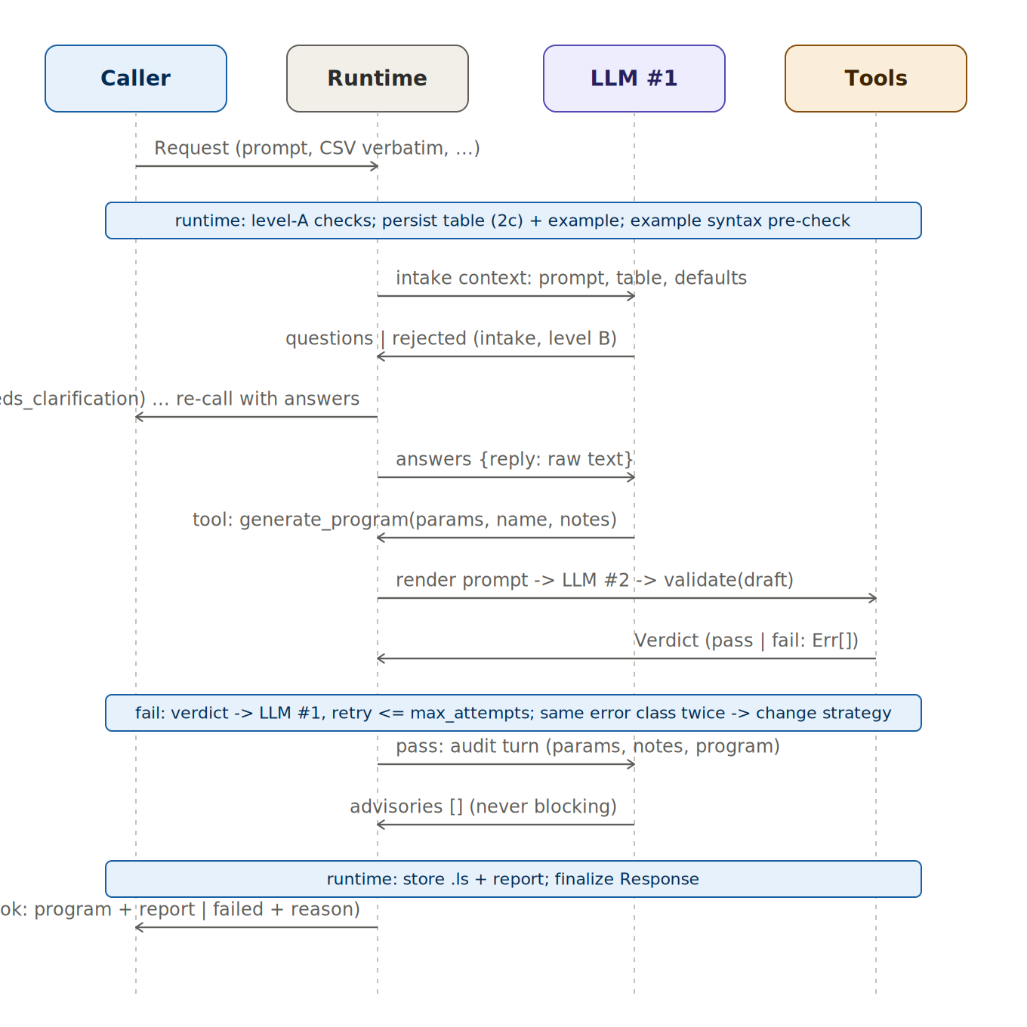
Figure 4 — Class-level sequence of a contract call, including the intake clarification round-trip (a full new Request), the bounded retry band, and the mandatory audit turn. ‘Tools’ is the runtime-mediated renderer + LLM #2 + validator chain; LLM #2 and the validator never address each other.
Hop | Carries | Format
Caller → Runtime | Request | JSON (direct call v0 / HTTP POST later)
Runtime → LLM #1 | intake context: prompt, parsed table, effective defaults, session history | messages + tool schemas
LLM #1 → Runtime | tool calls / final JSON: params, name, notes, questions, fix guidance | structured JSON only
Runtime → LLM #2 | rendered prompt (Design Doc Figure 2) | single completion request
Runtime → Validator | draft text + table key-set/initialized + limits | function call
Validator → Runtime → LLM #1 | Verdict (Err[] with layer, position, expected set, optional suggestion) | dataclass / JSON
Runtime → Caller | Response (one of the four statuses; strings user-ready) | JSON

8 Data on disk
Path | Writer | Readers | Notes
config/static_config.yaml | developer (Git) | runtime, renderer, validator, stores.table | defaults + limits + retry + max_table_age + default_index_map
config/rag_config.yaml | developer (GUI edit as convenience) | rag/index, rag/retrieve | profiles; one index per profile
cache/<cell_id>.csv | stores.table | stores.table | the verbatim last scan; staleness from its own scanned_at
sessions/<sid>/reg_io_table.json | stores.table | llm1, renderer, validator, review | parsed table with derived fields
sessions/<sid>/drafts/ verdicts/ decisions.log example.* | runtime (via session store) | llm1 retry context, diffs, audit | append-only trail
out/<sid>/<PROG>_vN.ls + report.json | stores.output | caller / human review | the deliverables

9 Configuration and environments
# .env (gitignored)
ANTHROPIC_API_KEY=...
TP_LLM1=anthropic:claude-sonnet-4-6 # or ollama:qwen3-14b (structured output enforced)
TP_LLM2=ollama:qwen2.5-coder:32b # or anthropic:... / mock:tests/fixtures/v1.ls
EMBED_GATEWAY_URL=... EMBED_GATEWAY_KEY=... # online profile
PINECONE_API_KEY=... # online profile
OLLAMA_URL=http://127.0.0.1:11434 # local profile
CHROMA_PATH=./chroma # local NTFS path, not a synced folder
File | Owner | Consumed by
app_config.yaml | caller | apps/ only — becomes Request fields
static_config.yaml | unit developer | runtime, renderer CELL, validator limits, table defaults
rag_config.yaml | unit developer | rag/ only — selected by Request.rag_backend
.env | deployment | llm1.py, llm2.py, rag/ (the only vendor-touching modules)

10 Testing strategy
- reg_io parser tests. The Appendix-A template is the fixture: 25 rows exercising the uninitialized/uncommented PR, quoted comma, unlabeled-but-real entries, unknown type kept-and-flagged, metadata extraction, and the SchemaError paths (missing schema/cell_id/scanned_at).
- Validator table-driven tests (no LLM, no network). (line, expected Err) pairs covering the four hallucination classes, the WAIT suggestion, the exists-but-uninitialized diagnosis, mode="syntax_report" skipping existence/limits, and 15 known-good lines producing zero errors.
- Renderer snapshots. First-attempt and retry prompts, byte-identical; a snapshot diff is a deliberate template change or a bug, never noise.
- Retrieval gate (human-judged). Known queries must surface their obvious chunks in top-k per profile before any generation is wired.
- Conversation e2e with mock LLM #2. The scripted dialogue that already runs against the prototype: ambiguity → friendly question → raw-text answer → ok with override visible in the .ls → revision adding the approach → off-scope reject → new task. Assertions on envelope mechanics too: scan relayed once, overrides only-when-changed, inference persisting across the clarification round-trip (a real bug this test caught), limits blocked at both walls.
- Import audits in CI. grep-level tests for the Section-4 rules: apps/ imports contract only; no vendor SDK outside llm1/llm2/rag; reg_io imported only by stores.table.
- Live smoke (manual gate). One real request per backend; compare retries-to-pass across backends on the same request before adopting.

11 Prototype-to-target migration map
A working prototype of the caller side and the conversation protocol exists (tp_creator_console). It is not throwaway — most files move verbatim; the mock dissolves into the real components it stood in for:
Prototype file | Target location | Fate
contract.py | tpagent/contract.py | moves as-is (already level-A complete)
reg_io.py | tpagent/reg_io.py | moves as-is
app_state.py / gui.py / console.py | apps/ | move as-is; post_to_unit() gains the HTTP branch it already stubs
app_config.yaml / rag_config.yaml | apps/ and config/ | move as-is (ownership already correct)
mock_unit.py | dissolves | level-A + session persistence → runtime.py; note-matching intake → LLM #1 + prompts; _emit() → tests/fixtures as the canonical known-good program; the whole file survives as the mock backend for conversation e2e tests
Build order stays as the roadmap defined: deterministic core (validator, renderer, reg_io already done) before intelligence, mock end-to-end before live tokens, and the caller — already built — waiting at the contract the whole time.

