TP Creator — architecture as built (v1.0)
The deployed agent redrawn in the Design Document's Figure-1 language, 2026-08-31. Every numbered step below states whether it matches the original design or carries an owner-approved change.
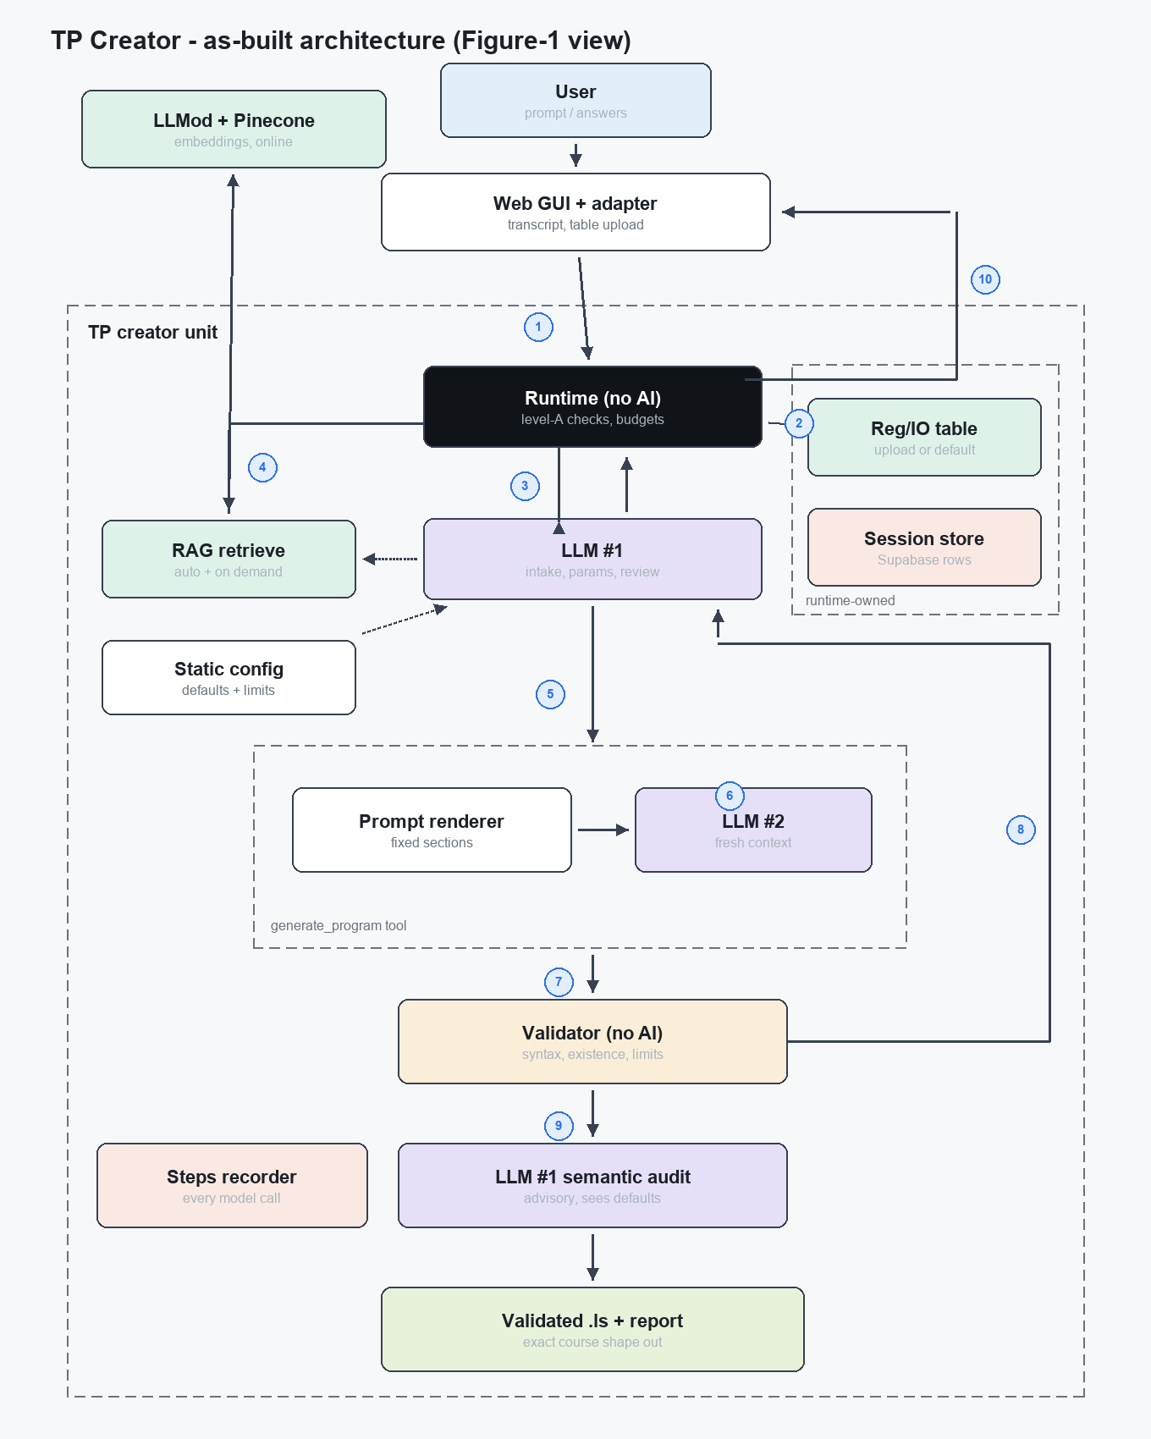
The numbered flow
① Request in [unchanged in role, changed in shape] — The browser GUI sends the whole conversation transcript as the prompt (plus the optional uploaded table CSV); the /api/execute adapter builds the contract Request with the deployment's cell and the runtime performs the mechanical level-A checks. Clarifications iterate through the transcript, not a server-held answers field.
② Table materialized [changed] — No cache and no staleness window any more: the table is the uploaded CSV (bare files get the reg_io_v1 metadata synthesized), else the bundled default_table.csv (parsed once and cached in memory), else the robot is treated as empty. The example .ls pre-check exists in code but is not reachable from the web caller.
③ LLM #1 intake and params [unchanged + hardened] — Reads the table notes and effective defaults, applies the gap policy: default / infer / ask. Hard rules added: ambiguous place words must ask; a missing pick or place position must ask; a loaded table is a complete whitelist - never invent entries.
④ Retrieval [changed - now mandatory] — The runtime always retrieves documentation for the task before the first draft (LLM #1 may add up to two targeted queries, including re-retrieval after a failed draft as an escalation move). Chunks route to the renderer only - never through LLM #1's context.
⑤ Params out [unchanged + pinned] — LLM #1 invokes generate_program: params, program name, notes, fix guidance on retries. The task parameters and notes are pinned to the first attempt, so a retry differs only in what is being fixed.
⑥ Prompt assembled [unchanged + skeleton] — The renderer builds the LLM #2 prompt from fixed sections (system with a canonical program skeleton, cell, docs, task, notes, previous+fix on retries). Deterministic and snapshot-tested; GenerateArgs cannot carry table or config (no-leakage).
⑦ Draft to validator [unchanged + softened once] — Every draft goes to the three-layer validator: grammar token walks, existence against the table (skipped entirely in empty-robot mode; an existing-but-untaught register is a warning, not an error), and limits with every speed unit converted or refused.
⑧ Errors back [unchanged + mechanical stop] — A failing verdict returns to LLM #1 for bounded diagnosis and retry: at most three drafts, and a third consecutive failure on the same layer+offender ends the run mechanically. Failures carry the last verdict's story in the report.
⑨ Semantic review - always [unchanged + defaults] — Every passing program is audited by LLM #1 for mapping correctness and intent; the audit now also receives the effective defaults so it can check the requested values actually landed in the code. Advisory only - it can never block delivery.
⑩ Store and respond [changed shape] — Outputs and the full report persist to Supabase; the adapter maps everything to the exact course shape {status, error, response, steps} - program plus report summary, the friendly question, or the friendly rejection - and the steps recorder guarantees every model call (chat and embeddings) appears in the trace in order.
Not drawn: the legacy tkinter caller (kept under legacy/ for local development) and the dormant contract fields (example_ls, config_overrides, revision_of, answers) that no deployed path exercises.

