TP Creator - Design Evaluation Study
30 live scenarios run through the production pipeline on 2026-08-31; every number was measured from the steps traces, reports and stored session data. No code was changed for this study.
Headline numbers
Outcomes - 23 programs delivered, 5 one-call answers (questions and table edits), 2 failed runs (1 LLM1 protocol failure, 1 hard task that correctly hit the 3-draft budget stop).
Cost - average 5.4 model calls per delivered program; the floor is 4 (intake, embedding, draft, audit). Questions and table edits cost exactly 1 call.
Retrieval - exactly one mandatory retrieval per program (24 total). It always returned the full 5 chunks (top_k ceiling), ~3k characters into the code-generator prompt. LLM #1 requested an EXTRA retrieval only once in 30 runs (its escalation move).
Validator - 75% of first drafts passed all three layers. 6 runs needed retries (9 retry drafts total); the failures concentrated in the deliberately hard scenarios (palletizing arithmetic, SELECT, arcs).
Audit - fired a must_fix on 12 of 23 programs (52%). 8 corrections were applied and re-validated; 4 proposed fixes were themselves rejected by the validator, so the original correct-syntax program was delivered with an advisory.
The measured flow
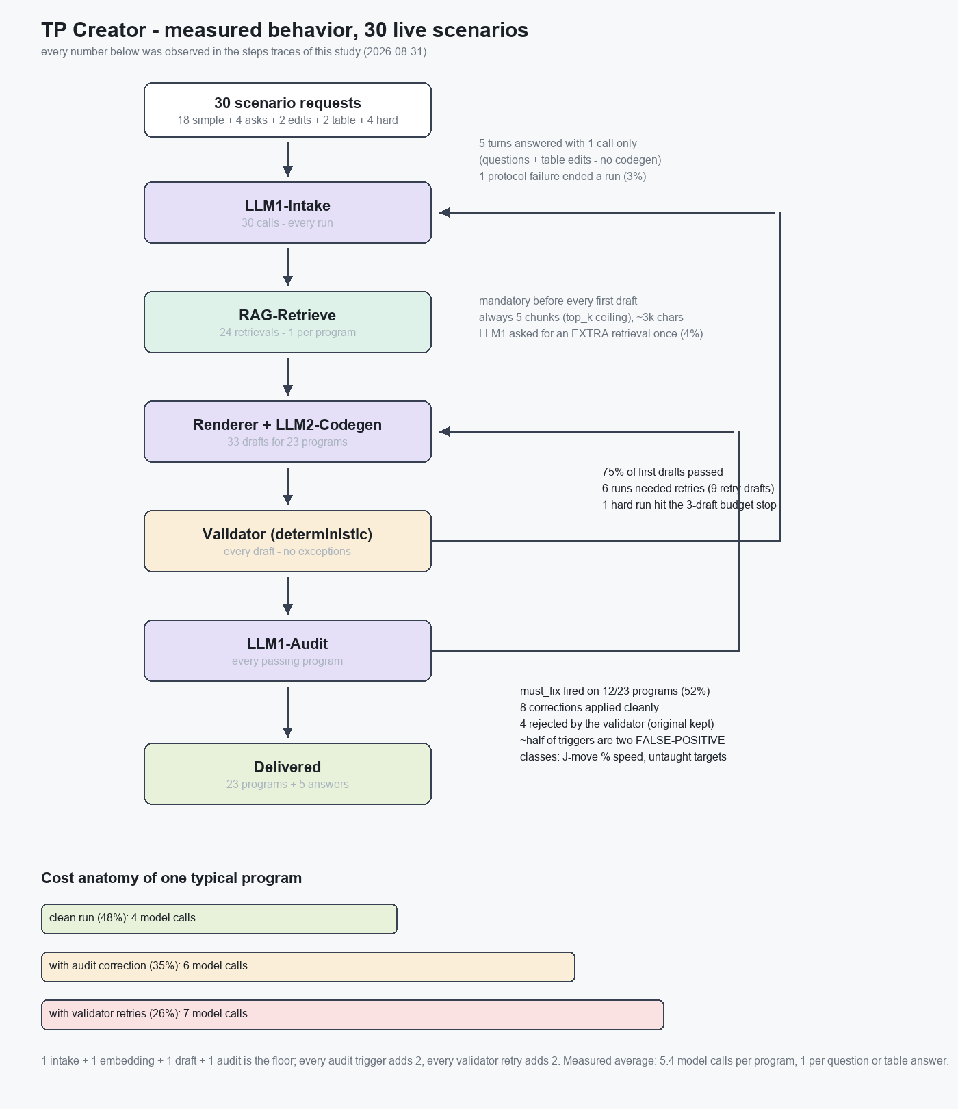
Block-by-block verdict
Runtime (no AI) - earns its place: the budget stop ended the impossible palletizing run at exactly 3 drafts, the protocol retry caught malformed LLM1 replies, and the mandatory edges guaranteed every draft was validated and every program audited. Zero redundant calls originate here.
LLM1-Intake - efficient: five conversational turns (questions, table edits, acknowledgments) were answered with a single model call and never touched the generation half of the pipeline. One protocol failure in 30 runs (3%) is the block's only loss.
RAG retrieval - cheap but statically tuned: one embedding call per program and a fixed 5-chunk payload regardless of task difficulty - the score threshold (0.25) never trimmed anything in this study. Its value overlaps the canonical skeleton that now lives in the code-generator prompt; the two together produced the high first-draft pass rate, but which of them carries the load cannot be separated without an A/B run. LLM #1's own retrieval tool is nearly unused (1 of 30) - as designed, it is an escalation valve, not a workhorse.
Renderer + LLM2-Codegen - deterministic prompt assembly worked as designed: retries stayed pinned to the first attempt's task, and edit turns reproduced unrelated lines byte-identically. The code model is the main consumer of extra calls (retries and audit corrections).
Validator - the strongest block: deterministic, free, and it caught every syntax break including the audit's own bad fix proposals - four times it protected the delivered program from a semantically-motivated but syntactically wrong correction. No redundancy.
LLM1-Audit - the one block that needs calibration. Its real catches are valuable (a release on the wrong signal, a missing timeout, an else-branch that kept holding the part). But roughly half its triggers fall into two systematic FALSE-POSITIVE classes: (1) it flags joint moves written as 'J PR[1] 100%' as 'travel speed not applied' - although percent speed is the only legal form for joint moves; (2) it demands initializing untaught destination registers - fighting the owner policy that the operator teaches them, which the validator rightly blocks. Each false trigger costs 2 extra model calls (~50% of a clean run) and sometimes leaves a misleading 'correct this by hand' advisory.
Is the design efficient?
Yes, with one hot spot. The separation of powers works exactly as drawn: strategy in LLM #1, mechanics in the runtime, syntax in the validator, meaning in the audit - and the study showed each guard actually firing, including the validator overruling the auditor. Conversational turns cost one call, a clean program four. Nothing in the pipeline is dead weight.
The inefficiency is concentrated in the audit's false-positive rate: teaching the audit prompt the two rules it keeps tripping on (joint moves use percent speed; untaught destinations stay untaught) would cut roughly a quarter of all model calls in this study without losing a single real catch. Second priority: the retrieval payload is a fixed 5 chunks - tuning top_k/threshold, or an A/B against the skeleton-only prompt, would show whether it can shrink. Both are calibration changes, not architecture changes - the architecture itself held up well.

