./

Project Report – Stepin_EmbeddedC

Course Code: <CODE>



Version Number:

Team Members :

Team No:

Module: Model Based System Engineering

|  |  |  |  |  |  |
| --- | --- | --- | --- | --- | --- |
| **Ver. Rel. No.** | **Release Date** | **Prepared. By** | **Reviewed By** | **Approved By** | **Remarks/Revision Details** |
| 1 | 21/04/2022 | Natarasan.H |  |  |  |

**Document History**

# 

### PRINCIPLE

This system is basically used to control the temperature inside a vehicle(Car). Whenever the user gets seated inside the car, the button sensor gets activated. After that, the user gets access to turn on the heater. Temperature will be monitored by the temperature sensor and tha analog value will be sent to microcontroller,**Atmega328.**

**Components required:**

* Atmega328 microcontroller
* LEDs
* Heater
* Display
* Potentiometer

**STEP_1:**

**Off-**

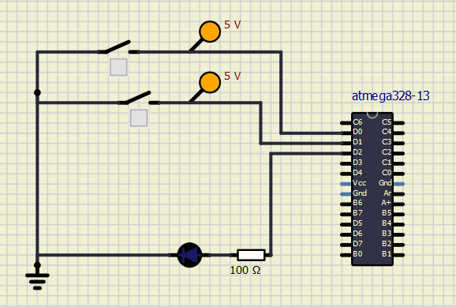

**On-**

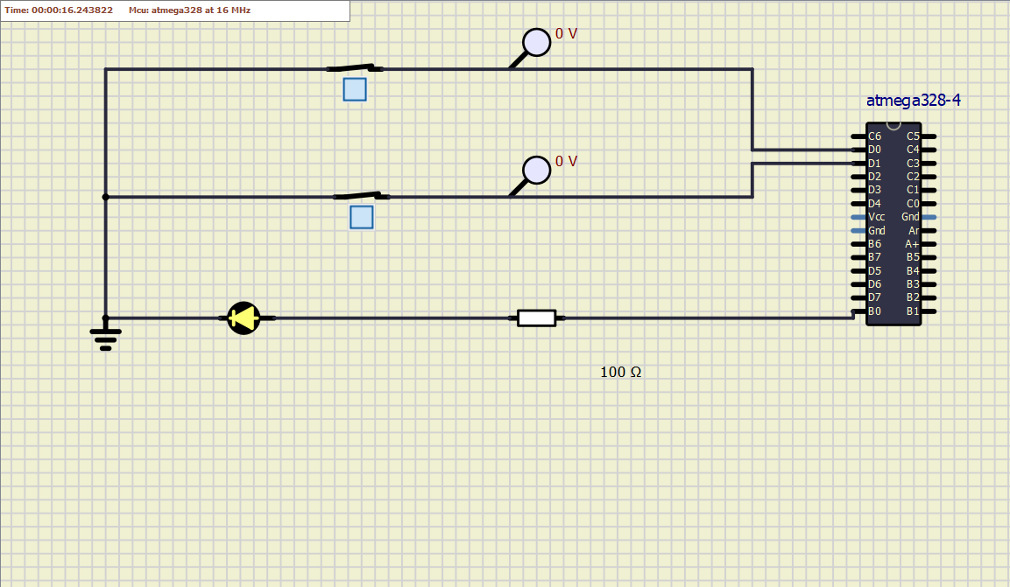

**STEP_2:**

**Off-**

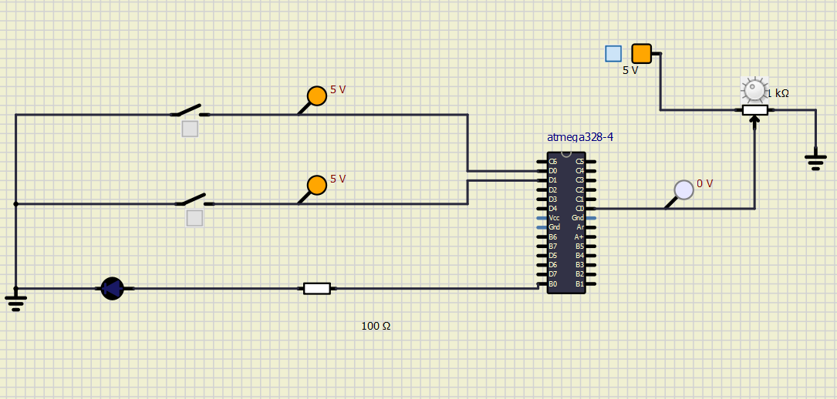

**On-**

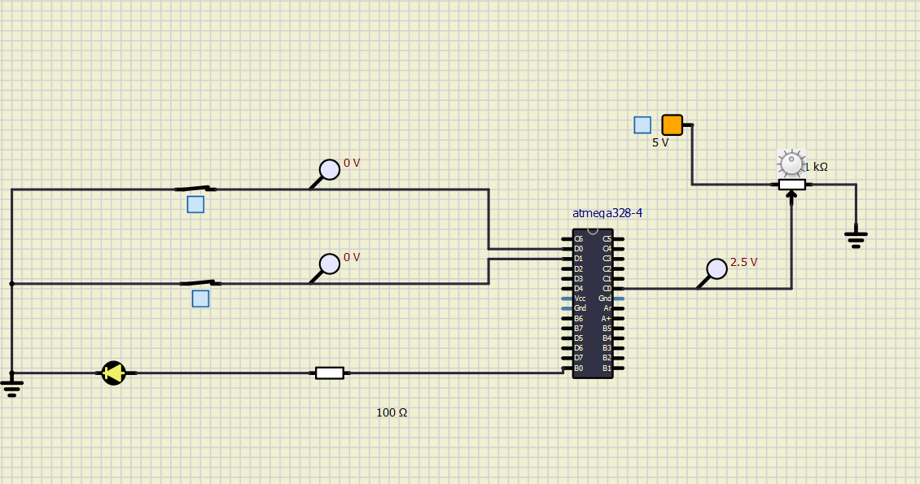

**ACTIVITY_3:**

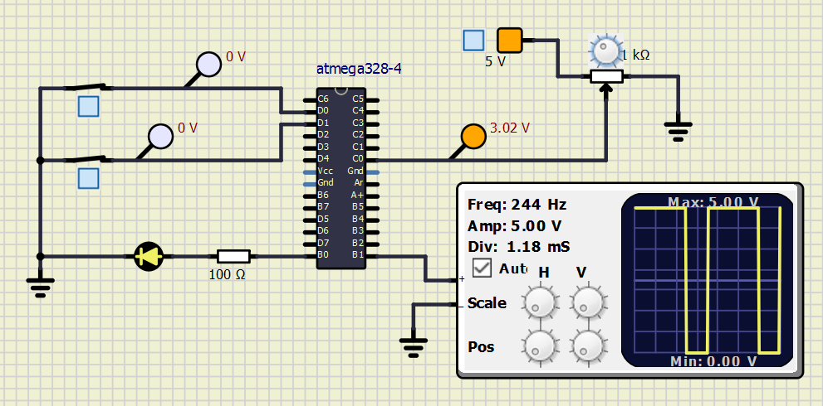

**Conclusion:**

Case Study assigned to me helped me to prove my technical skills in embedded systems from learning about various topics like timers, GPIO and so on to implement a project where various cases of LEDs are studied with different temperature.