Emergency Helper is an inclusivity-focused mobile app that helps users display common emergency phrases in multiple languages while also providing accessibility options such as large text and high contrast mode.
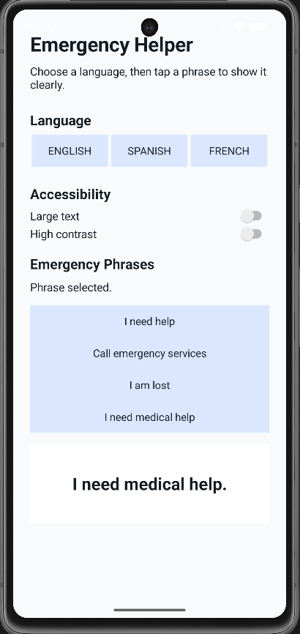
English Button
Changes the app text and emergency phrases to English.

Spanish Button
Changes the app text and emergency phrases to Spanish.
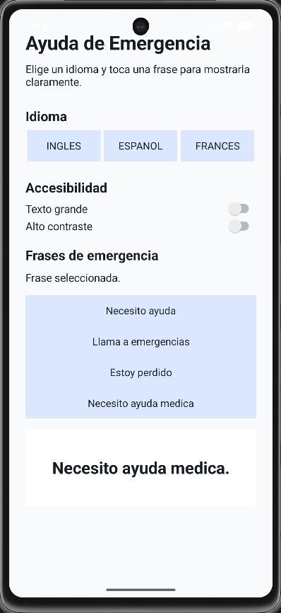
French Button
Changes the app text and emergency phrases to French.
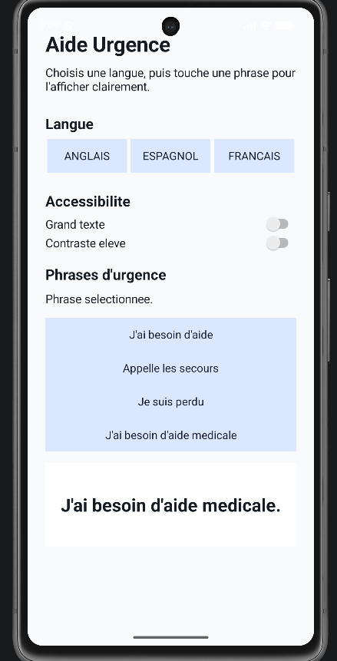
Large Text Switch
Increases the size of the app’s text to make it easier to read.
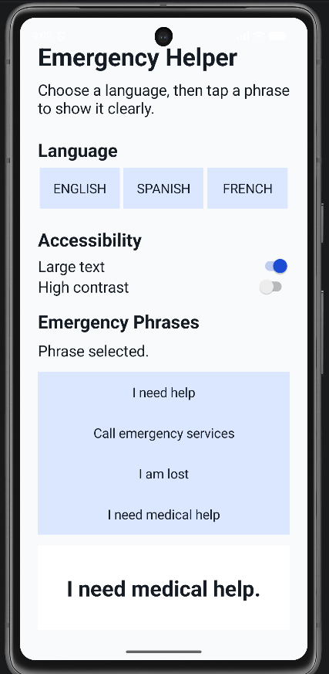
High Contrast Switch
Changes the app colors to improve readability for users who need stronger contrast.
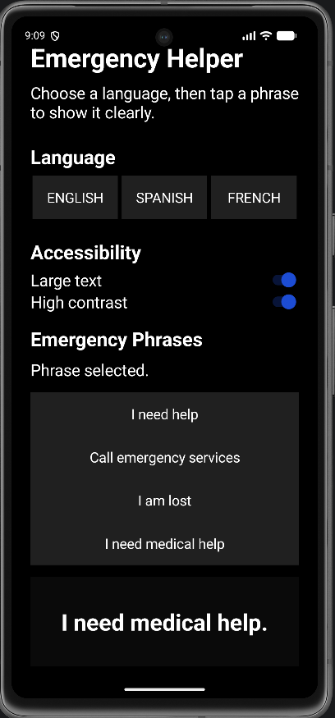
Emergency Phrase Buttons
Displays the selected emergency phrase clearly on the screen for quick communication.
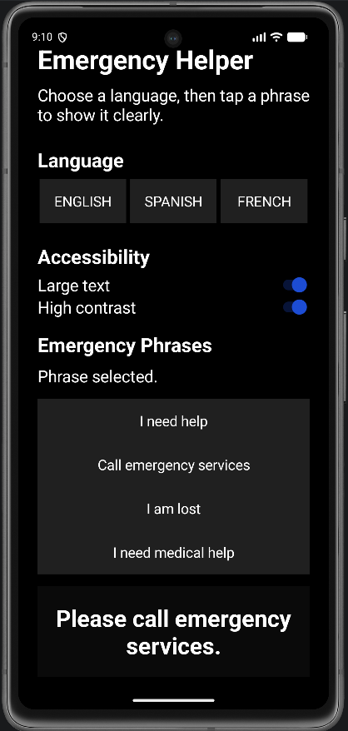
Skill Demonstrated:
Debug Code Generated by AI
This project demonstrates the skill of debugging AI-generated code because the first version of the app launched to a black screen even though the app was installed and running. To fix the issue, I checked the app behavior, rebuilt the project, and corrected the theme/manifest settings so the actual activity screen displayed properly instead of being hidden by a black splash screen.

