Answers:

Task 1:

* 1. Remove Noise = Image Restoration
  2. Compress Frame = Image Compression
  3. Image Restoration is used to remove to improve the quality of an image by removing flaws. Two examples for flaws are: blur and noise, the following image highlights an example of Image restoration. [1]  
     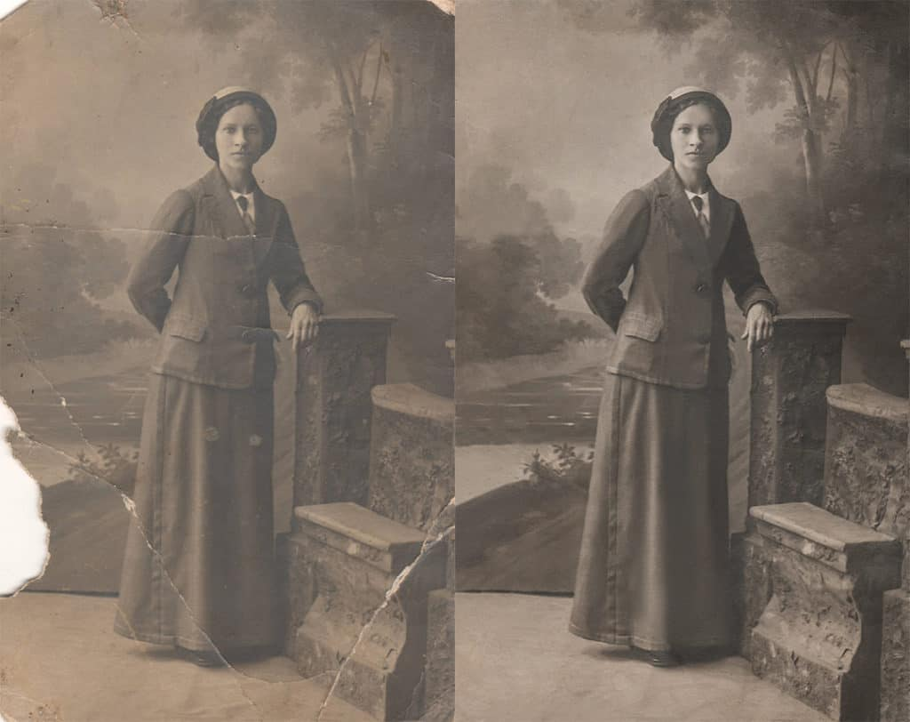
  4. Image Compression is used to lower the amount of space an image or video requires. It is further split into two sections, lossy and lossless. Lossy compression removes non-important information from the image to reduce file size. Lossless produces a compressed image that can later be restored to its primary form. [2]

1. In a supervised learning model, learning is done through processing labelled input and output data to learn the connection between them and is developed by processing the data given to it to guess unseen data. An unsupervised learning model is fed raw data and allowed to draw conclusions and relationships between the data, hence, this is often used to discover trends in data. [3]
2. Data augmentation is used to further enhance an existing dataset. Through augmentation, new data is generated from existing data by introducing small changes, [4] such small changes can include cropping or rotating an image.
3. Image classification aids in displaying what the image holds, through object detection, multiple objects and their respective location are predicted. [5] The example given is an Object Detector as it is also predicting the objects position in relation to the camera position.
4. Image segmentation will develop a mask over the object and provide further detail on the object such as its shape. [5] A technique implemented in segmentation is Edge-Based Segmentation, through differing grey levels, textures, colours, etc… the object can be segmented from the background. A practical example would include extracting the outlines of buildings by removing un-needed data to reveal distinct features. [6]
5. To classify room type, I would gather specific objects that are to be included in a specific room in the dataset, for example: to develop a bedroom classification, these items will help the program to identify it as a bedroom: a bed, nightlight, and a bedside table.

Task 2:

1. The process of sampling includes the transformation of a digital image, where an analog signal is extracted from an image and is then used to get the value of each pixel. [7]
2. Samsung A53 vs Samsung S22 Ultra
   1. Both phones have a quad camera system. The A53 has wide, ultrawide, macro and depth for lenses. The S22 Ultra has wide, periscope telephoto, telephoto and ultrawide.
   2. The S22 also boasts higher megapixels in every single camera by having a 108mp wide, 10mp periscope telephoto, 10mp telephoto, and a 12mp ultrawide.
   3. As for aperture, only the wide and ultrawide are comparable as they are the same type of lens with both phones having the same apertures of 1.8 on the wide camera and 2.2 on the ultrawide camera.
   4. As for zooming, the S22 gets access to optical zoom on its telephoto cameras, while the A53 has only digital zoom.

Task 3:

The HSV colour space is divided into hue, saturation, and value. This colour space is often used in image processing as it correlates closer to how humans perceive colours when compared to RGB. [8]

# Works Cited

|  |  |
| --- | --- |
| [1] | "Image Restoration," [Online]. Available: https://www.owlnet.rice.edu/~elec539/Projects99/BACH/proj2/intro.html. [Accessed 1 12 2022]. |
| [2] | R. Sheldon, "What is image compression and how does it work?," 07 2022. [Online]. Available: https://www.techtarget.com/whatis/definition/image-compression. [Accessed 1 12 2022]. |
| [3] | Seldon, "Supervised vs Unsupervised Learning Explained," 16 09 2022. [Online]. Available: https://www.seldon.io/supervised-vs-unsupervised-learning-explained#:~:text=The%20main%20difference%20between%20supervised,processes%20unlabelled%20or%20raw%20data.. [Accessed 1 12 2022]. |
| [4] | C. Dilmegani, "What is Data Augmentation? Techniques, Examples & Benefits," 30 04 2021. [Online]. Available: https://research.aimultiple.com/data-augmentation/. [Accessed 1 12 2022]. |
| [5] | P. Sharma, "Image Classification vs. Object Detection vs. Image Segmentation," 21 08 2019. [Online]. Available: https://medium.com/analytics-vidhya/image-classification-vs-object-detection-vs-image-segmentation-f36db85fe81. [Accessed 1 12 2022]. |
| [6] | M. Tyagi, "Image Segmentation: Part 1," 18 07 2021. [Online]. Available: https://towardsdatascience.com/image-segmentation-part-1-9f3db1ac1c50. [Accessed 1 12 2022]. |
| [7] | M. Yawar, "Image sampling and quantization," 18 11 2022. [Online]. Available: https://www.codingninjas.com/codestudio/library/image-sampling-and-quantization. [Accessed 1 12 2022]. |
| [8] | J. H. Bear, "What Is the HSV (Hue, Saturation, Value) Color Model?," 29 07 2020. [Online]. Available: https://www.lifewire.com/what-is-hsv-in-design-1078068. [Accessed 1 12 2022]. |