ComStock Change
  - v48 – Hospitals from the corrected AHA 2022 survey
Implementer: Jessica Leffel (AHA data and stock estimate); Chris CaraDonna (sampling, runs and postprocessing)
Change Document Author: Jessica Leffel; Chris CaraDonna
Reviewer: TBD

Description of Change

Summary
We are updating the hospital building type in ComStock to draw on a corrected version of the American Hospital Association (AHA) 2022 Annual Survey instead of the HSIP Gold 2012 hospital file, so that hospital floor area and size characteristics are informed by the floor area each hospital reports. The goal is to improve how well ComStock represents the diversity of hospitals in the U.S. building stock, which in turn improves the accuracy of its hospital energy use estimates, especially geospatially.
The survey reaches ComStock through a new stock estimate, 2026R1, the TSV set and bucket definition files sampled from it (tsvs-v34.zip and sample_input_20260919-1409_*), and apportionment to 2026R1 in postprocessing. In the stock estimate, hospitals go from 3,224 to 5,952 buildings and from 0.838 to 2.100 billion ft², and they now cover all 50 states and the District of Columbia (48 before). The CBECS scaling factor for hospitals falls from 4.31 to 1.51, so most of the hospital floor area ComStock models now comes from hospitals in the estimate rather than from scaling.
Floor area by building type is set by CBECS 2018 in the before and after runs (str_100k_fixes_ts and str_100k_fixes_ts_new_sample), so this change moves where hospital floor area is and what kind of hospitals hold it: hospitals of 1 million ft² or more hold 10.7% of it instead of 4.2%, the East North Central division 17.3% instead of 7.4%, and California, New York, Texas and Pennsylvania less. Hospital site EUI rises 2.1%, from 210.7 to 215.3 kBtu/ft², almost all of it natural gas (+9.5%; electricity −0.5%), and national site energy does not change (6,399.0 → 6,400.0 TBtu). The change in hospital site EUI is within the range that resampling alone produces in the other building types (up to 2.2%); the change in hospital natural gas is larger than in any of them but LargeOffice. Both runs use the same ComStock commit of 2026-09-19 (baf2895e), so this document reads the change from Before to After, not from the gap to CBECS 2018, which later code changes have moved: on that commit hospital natural gas was above CBECS, while on current code (str_100k_new_sample_fix5, the v42 change document's run) it is 42.8% below.
The new estimate also changes the other building types a little. Schools lose about 5% of their buildings, in 47 states and in none the other way, while their distributions of year built, floor area and location are unchanged; the loss is in both 2026-09-16 deliverables, the estimate file (2026R1_building_estimate.parquet) and the v34 sampling TSVs, and it reaches results as a 5% rise in the school CBECS scaling factors. The other types lose under 1%. In the samples, the shares of every drawn characteristic of the non-hospital types move by at most 2.7 percentage points for any single type and 0.3 pooled, which is the sampler's own run-to-run noise. The school loss is listed as a confound and an open question for the estimate's authors; its effect on energy is small (Figure 5).

Existing Methodology
Hospitals entered ComStock's stock estimate from the Homeland Security Infrastructure Program (HSIP) Gold 2012 hospital file (Figure 1). Its hospital table does not report the number of beds in about half of the states, so floor area there was inferred from the states that do. Two limits of the 2025R3 estimate matter for this change:
- Coverage. It holds 3,224 hospitals in 48 states: none in Delaware, Rhode Island or Vermont, one in each of Illinois, South Dakota, Idaho, Connecticut and New Hampshire, and fewer than 10 in 17 states (Table 2). Only 1,048 of its hospitals carry their own census tract; 1,827 are placed in a tract weighted within their county and 349 by county and building type.
- Floor area. Its hospitals hold 0.838 billion ft², against 2.29 billion ft² in CBECS 2018. The CBECS scaling therefore multiplies the hospital weights by 4.31 in the Before run (Table 8): most of ComStock's hospital floor area came from scaling up the hospitals the estimate had, in the states where it had them.
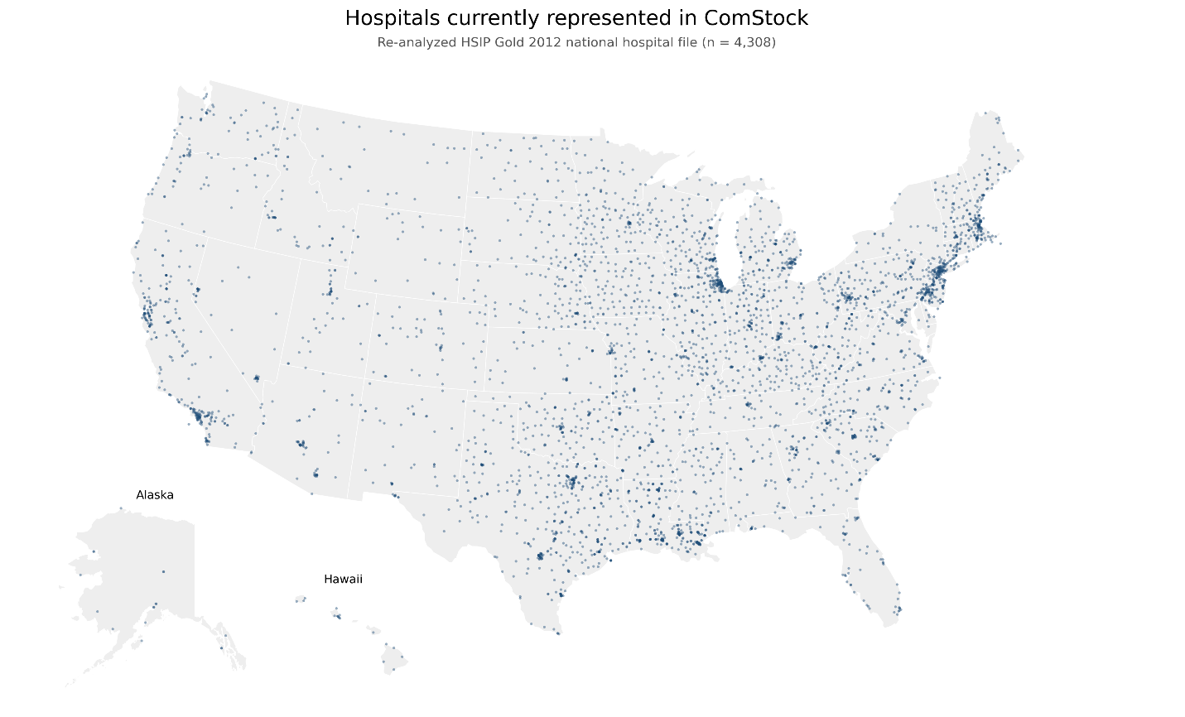
Figure 1. Hospitals in the re-analyzed HSIP Gold 2012 hospital file (n = 4,308)
Source: HSIP Gold 2012 national hospital file, re-analyzed. The map's title says these are the hospitals represented in ComStock; the 2025R3 stock estimate holds 3,224 hospitals (see Open Items).
Not changing: the hospital prototype model (geometry, space types, schedules and loads); how HVAC system type and heating fuel are assigned (hvac_system_type_v4.tsv and heating_fuel_v2.tsv, in sampling and in apportionment); the Outpatient building type; the scaling of floor area by building type to CBECS 2018; and every other modeling assumption. ComStock has one hospital building type. Nothing in ComStock reads the hospital categories below (hospital_subtype).

New Methodology

The corrected AHA 2022 survey
The hospitals used previously came from the Homeland Security Infrastructure Program (HSIP) Gold 2012 hospital dataset, which had uneven coverage across the country. To give a more consistent and current representation of US hospitals, we processed the American Hospital Association (AHA) 2022 annual survey so that it could serve as a reliable input to ComStock (American Hospital Association, 2022). Beyond broader coverage (Figure 2), the AHA data report each hospital's gross square footage, which is needed to size hospital floor area in ComStock. We sorted hospitals into six categories, using bed count as the primary indicator and square footage as a secondary indicator (Centers for Medicare & Medicaid Services, 2026; Definitive Healthcare, 2025):
- Critical Access Hospital (CAH): 1 to 25 beds
- Small Community Hospital (SCH): 26 to 100 beds
- Community General Acute Hospital (CGAH): 101 to 250 beds
- Regional Referral Hospital (RRH): 251 to 500 beds
- Academic Medical Center (AMC): 501 to 1,000 beds
- Quaternary Academic Medical Center (QAMC): 1,001 or more beds
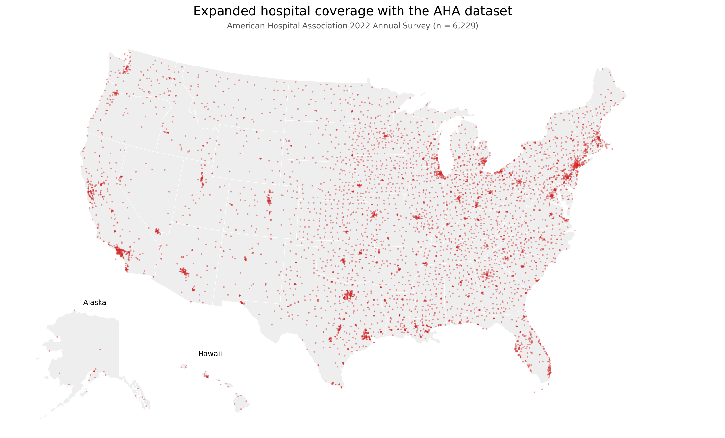
Figure 2. Hospitals in the American Hospital Association 2022 Annual Survey (n = 6,229)
Source: AHA Annual Survey, 2022 (Health Forum LLC).
We found that the raw AHA square footages often included space that does not belong to the acute-care hospital itself, most notably freestanding outpatient centers, offices, and similar buildings. To confirm this, we ran two-sample Kolmogorov-Smirnov tests for each category comparing hospitals that indicated having a freestanding outpatient center against those without. In every category the two populations came from different distributions, with the outpatient center hospitals carrying more square feet per bed. We removed that excess by rescaling each outpatient center hospital's ratio to match the distribution of hospitals without outpatient centers, then reassigned the removed area to a separate outpatient building group.
After that correction, some hospitals still reported ratios that were not realistic for their size. We screened these using an adjusted boxplot, which uses the medcouple (MC), a robust measure of skewness, to build a pair of outlier thresholds for each category (Hubert & Vandervieren, 2008). With Q1 and Q3 the first and third quartiles of square feet per bed in the category and IQR = Q3 − Q1, the thresholds are:
- MC ≥ 0: [Q1 − 1.5 · e^(−4 · MC) · IQR, Q3 + 1.5 · e^(3 · MC) · IQR]
- MC < 0: [Q1 − 1.5 · e^(−3 · MC) · IQR, Q3 + 1.5 · e^(4 · MC) · IQR]
The resulting per-category thresholds give us realistic square feet per bed ratios that describe actual hospital floor area rather than other space types. These thresholds and the hospitals they retain are summarized in Figure 3.
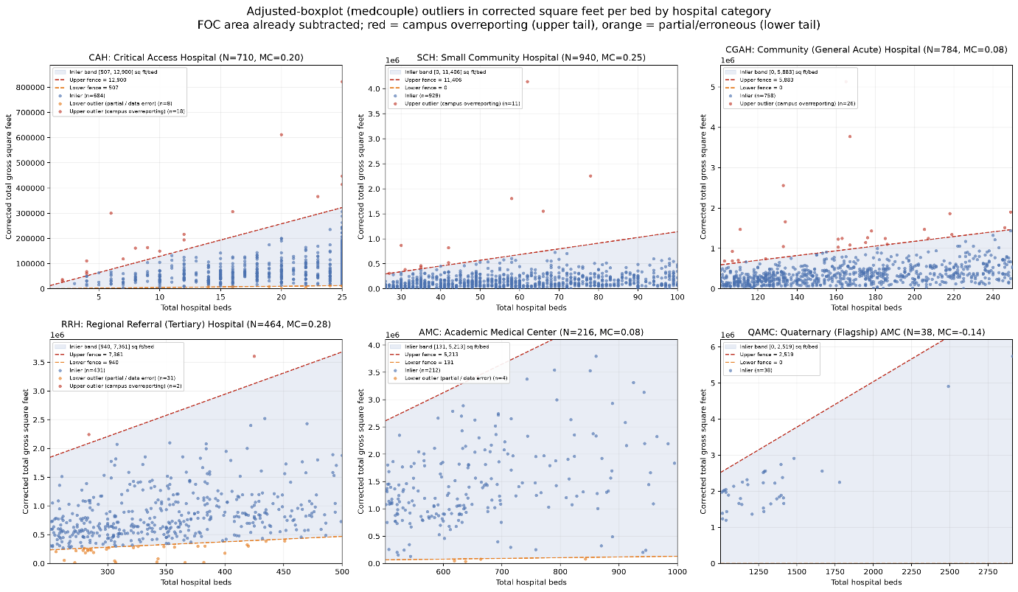
Figure 3. Corrected gross floor area against beds by hospital category, with the adjusted-boxplot fences
Source: AHA Annual Survey, 2022, with freestanding outpatient center area removed; adjusted boxplot after Hubert & Vandervieren (2008). Red points are upper outliers (campus overreporting) and orange points lower outliers (partial or erroneous reports).

From the survey to ComStock
The corrected survey reaches ComStock in five steps. All but the first are on the ComStock branch hospital_resampling.
- Stock estimate 2026R1. The corrected hospitals replace the HSIP hospitals in a new stock estimate, delivered on 2026-09-16 and published as 2026R1_building_estimate.parquet in s3://eulp/truth_data/v01/StockE/. Every hospital in it carries its own census tract. Table 1 compares it with 2025R3 by building type, and Figure 4 shows the hospitals by state. The published file leaves out the estimate's hospital-category column (hospital_subtype): nothing in ComStock reads it, and apportionment rejects a column with missing values. The code that built the estimate is not yet in a repository (see Open Items).
- TSV set v34. sampling/tsvs/tsvs-v34.zip is the same as v33 with the ten files that the new estimate defines rebuilt from it (Table 4).
- Bucket definition files. sample_input_20260919-1409_8634.csv and sample_input_20260919-1409_103608.csv are generated from 2026R1 with the same HVAC and fuel distributions as before. They hold 8,634 buckets, against 8,602 (Table 5).
- Geospatial join. sampling/join_geospatial.py now translates retired county FIPS codes only in its join key, so county_id keeps a value that options_lookup.tsv accepts and that has a weather file. The new county_id.tsv adds counties whose only tract is missing from the spatial lookup, which crashed the join before this fix.
- Postprocessing. A run sampled from the new bucket files must be apportioned to 2026R1, the estimate those bucket files were generated from. Apportionment matches the estimate's buildings to the sample's models bucket by bucket; apportioned to another estimate, a sample silently loses the models in buckets that estimate lacks, and its weights follow that estimate's buildings (Table 17). The four postprocessing templates now default to stock_estimation_version='2026R1', and sampling/README.md lists which estimate goes with which bucket files. Every apportionment input downloads from S3 unchanged, and a fresh download reproduces the apportionment exactly; the allocation of models drawn from it is random unless reloaded from cache (Data and Methods).
Table 1. The stock estimate by building type, 2025R3 (Before) → 2026R1 (After), as delivered and before any scaling to CBECS
Building type | Buildings | Change (%) | Floor area (billion ft²) | Change (%)
FullServiceRestaurant | 303,627 → 303,453 | −0.1 | 1.518 → 1.515 | −0.2
QuickServiceRestaurant | 152,433 → 152,398 | 0.0 | 0.435 → 0.434 | −0.1
RetailStripmall | 1,013,873 → 1,006,338 | −0.7 | 13.861 → 13.711 | −1.1
RetailStandalone | 749,952 → 749,824 | 0.0 | 12.559 → 12.547 | −0.1
SmallOffice | 1,069,540 → 1,067,557 | −0.2 | 6.410 → 6.398 | −0.2
MediumOffice | 149,525 → 149,114 | −0.3 | 7.702 → 7.680 | −0.3
LargeOffice | 41,696 → 41,674 | −0.1 | 10.309 → 10.276 | −0.3
PrimarySchool | 55,150 → 52,361 | −5.1 | 1.940 → 1.850 | −4.7
SecondarySchool | 60,277 → 56,809 | −5.8 | 3.529 → 3.354 | −5.0
Outpatient | 24,838 → 24,827 | 0.0 | 0.658 → 0.657 | −0.1
Hospital | 3,224 → 5,952 | +84.6 | 0.838 → 2.100 | +150.5
SmallHotel | 55,176 → 55,176 | 0.0 | 1.193 → 1.193 | 0.0
LargeHotel | 67,664 → 67,624 | −0.1 | 4.874 → 4.867 | −0.1
Warehouse | 924,122 → 923,570 | −0.1 | 33.210 → 33.079 | −0.4
Grocery | 28,882 → 28,873 | 0.0 | 1.133 → 1.132 | −0.1
All | 4,699,979 → 4,685,550 | −0.3 | 100.169 → 100.795 | +0.6
Source: ComStock stock estimates 2025R3 and 2026R1 (one row per building).
The new estimate holds more large hospitals: the median hospital is the same size in both estimates (174,000 and 173,638 ft²), but the 75th percentile rises from 333,122 to 447,406 ft², and hospitals over 1 million ft² go from 75 to 486. They are in 2,413 counties instead of 1,351. Where the estimate had few hospitals, it now has many (Table 2).
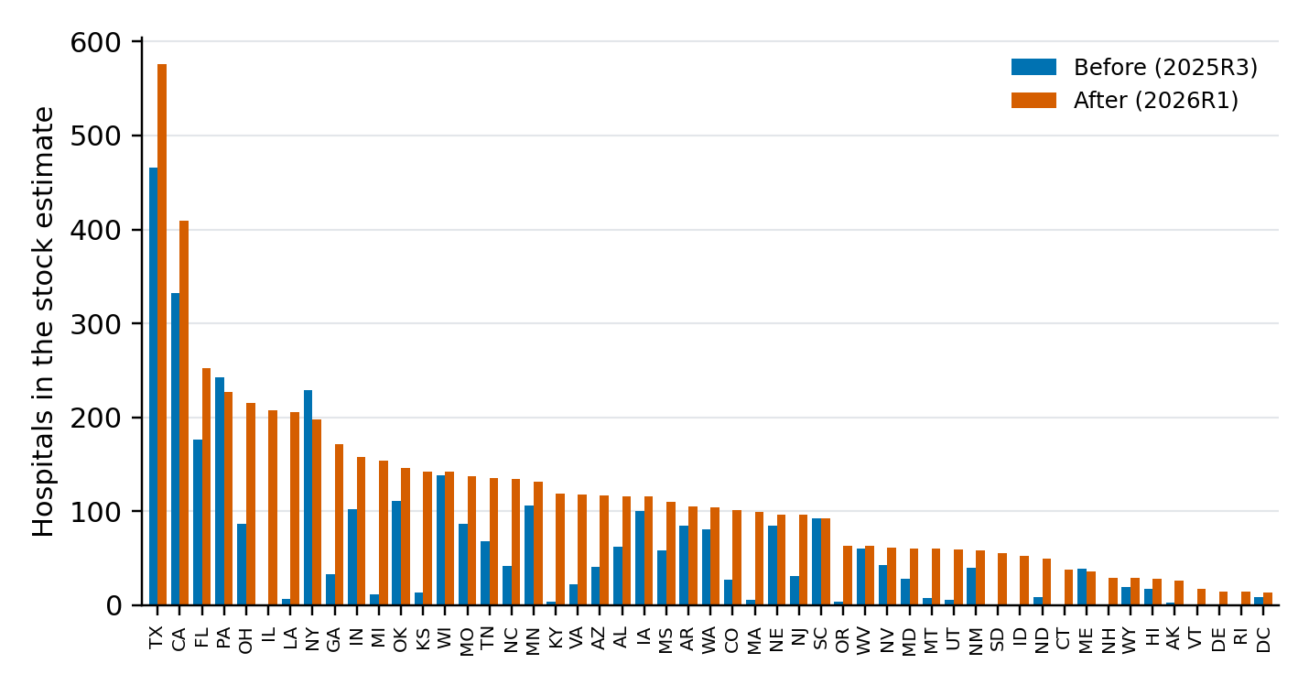
Figure 4. Hospitals in the stock estimate by state, Before (2025R3) and After (2026R1)
Source: ComStock stock estimates 2025R3 and 2026R1; hospital rows by state.
Table 2. The states where the number of hospitals in the estimate grows most, 2025R3 → 2026R1
State | Hospitals | Floor area (million ft²)
IL | 1 → 207 | 0.9 → 91.5
SD | 1 → 55 | 0.2 → 11.4
ID | 1 → 52 | 0.1 → 11.2
CT | 1 → 38 | 0.1 → 17.9
LA | 6 → 205 | 1.9 → 42.6
KY | 4 → 119 | 1.3 → 38.2
NH | 1 → 29 | 0.1 → 9.3
MA | 5 → 99 | 1.6 → 45.8
VT | 0 → 17 | 0.0 → 5.5
OR | 4 → 63 | 0.7 → 21.5
DE | 0 → 14 | 0.0 → 5.3
MI | 11 → 154 | 3.7 → 61.1
Source: as Table 1; the 12 states with the largest ratio of hospitals After to Before. Rhode Island, also without hospitals Before, has 14 After.
The new estimate also changes the other building types a little. Schools lose about 5% of their buildings (Table 1): 47 states lose primary and secondary schools and none gains any, with the largest losses in Texas (4,932 → 4,206 primary; 4,350 → 3,617 secondary) and Michigan (1,944 → 1,604; 2,411 → 2,051). The schools that remain are the same kind of schools: their distributions of year built, floor area and location are within half a percentage point of 2025R3 in every bin (Table 3 shows year built). The other 12 types lose under 1% of their buildings, with the same distributions.
The loss is in both files the stock-estimation work delivered on 2026-09-16, before any ComStock code runs. The stock estimate, 2026R1_building_estimate.parquet as published to S3, holds 55,150 → 52,361 primary and 60,277 → 56,809 secondary school rows (5.1% and 5.8% fewer), and the apportioned estimate carries the same drop (5.1% and 5.9%). The ten sampling TSVs delivered with it, now in tsvs-v34.zip, show it too: building_type.tsv gives a school a 4.1% and 5.0% lower probability in 55 and 57 of the 61 sampling regions, beyond the small fall every type takes when the hospital share rises. ComStock does not build either file from the other; tsv_sampling.py only reads the TSVs, and apportionment only reads the parquet. The same drop in both is consistent with a change upstream of both, in the stock-estimation run that produced them. In the sample, where each type's model count is fixed by the bucket file, the drop appears as fewer schools per model: the school CBECS scaling factors rise from 3.04 to 3.19 and 1.72 to 1.82 (Table 8), so each school model represents more floor area. Whether the school change was intended is a question for the estimate's authors (Open Item 4); ComStock's files cannot say. Four states keep every school (Connecticut, Delaware, the District of Columbia and Utah), which should identify the source file or filter that changed; that is Open Item 4. The row-level differences between the two estimates (most 2025R3 buildings are not found as an identical row in 2026R1) come from the build re-drawing year built and stories per building, and do not reach the samples: the non-hospital types' drawn characteristics move by at most 2.7 percentage points for any single type and 0.3 pooled, the sampler's own noise (Table 7).
Table 3. Year built of the schools in the stock estimate, 2025R3 → 2026R1 (share of buildings, %)
Year built | Primary, 2025R3 | Primary, 2026R1 | Change (pp) | Secondary, 2025R3 | Secondary, 2026R1 | Change (pp)
before 1946 | 16.8 | 16.8 | −0.1 | 17.9 | 17.9 | 0.0
1946–1959 | 18.5 | 18.7 | +0.2 | 16.9 | 17.2 | +0.3
1960–1969 | 17.3 | 17.1 | −0.2 | 19.1 | 19.3 | +0.2
1970–1979 | 10.4 | 10.3 | −0.1 | 12.5 | 12.6 | +0.1
1980–1989 | 10.2 | 10.1 | −0.1 | 10.5 | 10.1 | −0.5
1990–1999 | 11.1 | 11.1 | 0.0 | 9.7 | 9.7 | 0.0
2000–2009 | 12.9 | 13.1 | +0.2 | 10.9 | 10.9 | 0.0
2010 or later | 2.8 | 2.8 | 0.0 | 2.5 | 2.4 | −0.1
Source: as Table 1; the yb column of each school row, binned. The total change (half the sum of absolute differences) is 0.4 percentage points for primary and 0.6 for secondary schools.
The rebuilt TSVs carry both changes (Table 4). Hospital entries change completely. Other types' entries change a little for floor area, size bin, tract and stories, and more for year built: the median changed year_built.json entry moves by 10.5 percentage points. That number is per entry, and an entry is one sampling region, building type and size bin, often a few dozen buildings, so re-drawing each building's year built in the estimate build moves it a lot. Across the whole stock the distributions are the same (Table 3), and in the samples the other types' year-built shares move by at most 1.8 percentage points in any bin, with every other drawn characteristic within 0.3 (Table 7).
Table 4. The ten files of TSV set v34 that differ from v33
File | Keyed by | Entries | Changed: hospital | Changed: other types | Median change of a changed other-type entry (pp)
building_area.tsv | region, type, size bin | 1,818 | 117 | 919 | 0.19
size_bin.tsv | region, type | 914 | 58 | 494 | 0.05
number_stories.json | region, type, size bin | 1,818 | 119 | 1,519 | 1.31
year_built.json | region, type, size bin | 1,818 | 119 | 1,677 | 10.53
tract.json | region, type, size bin | 1,818 | 119 | 1,269 | 1.00
building_type.tsv | region | 61 | all 61 rows
sampling_region.tsv | (none) | 1 | the one row
county_id.tsv, state_id.tsv, climate_zone.tsv | tract | 91,264 | 170 tracts added, 36 removed
Source: ComStock sampling/tsvs/tsvs-v33.zip and tsvs-v34.zip. Region is the sampling region and type the building type. The size of a change is the total variation distance between an entry's two distributions: half the sum of the absolute differences in probability, in percentage points. In building_type.tsv the median hospital probability of a sampling region rises from 0.065% to 0.142%; within a region, the mix of the other 14 types moves by no more than 1.875 percentage points.
Table 5. Production bucket definition files: buckets and models, Before → After
Building type | Buckets Before | Buckets After | Added | Removed | Models Before | Models After
Hospital | 181 | 209 | 57 | 29 | 2,172 | 2,508
Other 14 types | 8,421 | 8,425 | 564 | 560 | 101,052 | 101,100
All | 8,602 | 8,634 | 621 | 589 | 103,224 | 103,608
Source: ComStock sampling/sample_input_20250916-1309_103224.csv (Before) and sample_input_20260919-1409_103608.csv (After); 12 models per bucket in both. A bucket is a combination of sampling region, building type, size bin, heating fuel and HVAC system type.
Hospital buckets go from 181 to 209, and hospitals now have buckets in sampling region 46 and none in region 110. The churn in the other types' buckets (564 added and 560 removed, of 8,421) is likely a by-product of regenerating the file rather than a change in those types: apportionment draws each building's heating fuel and HVAC system with a fixed random seed, so adding buildings to the estimate changes the draws of the rest, and the buckets near the cut that keeps the combinations covering 99% of buildings change. Re-generating the 2025R3 bucket files with one more building would confirm it.

Impact of Change
The comparison is of two runs that differ only in the sample file (Table 6). They ran the same ComStock commit, container image, weather and workflow.
Table 6. Runs compared
 | Before | After
Run | str_100k_fixes_ts | str_100k_fixes_ts_new_sample
Sample (models) | v33 sample of 2026-04-05 (103,224) | v34 sample of 2026-09-19 (103,608)
TSV set, bucket file | v33, …20250916-1309_103224 | v34, …20260919-1409_103608
Stock estimate | 2025R3 | 2026R1
ComStock | spacetype_refactor_timeseries @ baf2895e | same
ComStock-Typical | 6b5f913d (from the image) | same
OpenStudio | 3.10.0+86d7e215a1 | same
Task starts | 2026-09-19, 18:58–19:13 | 2026-09-19, 19:14–19:21
Completed | 103,198 (26 failed) | 103,582 (26 failed)
Source: the runs' ymls in /kfs2/projects/cscore/ymls/hospital_resampling/, their Slurm records, the reflog of the ComStock checkout they name, the image's Gemfile.lock and the runs' buildstockbatch results. Samples: buildstock_20260405-1804_v33_2018_mprapros_103224_hardsize.csv and buildstock_20260919-1409_v34_2018_ccaradon_103608_hardsize.csv; bucket files sampling/sample_input_*.csv; image OpenStudio-os_310_typ_010.6b5f913deec2-Apptainer.sif. The stock estimate is the one each run is apportioned to in postprocessing.
- The two ymls differ only in the sample file, the output directory and the S3 prefix.
- The ComStock checkout's reflog has one entry, at 10:28 on 2026-09-19, before the first task of either run started. Its HEAD is origin/spacetype_refactor_timeseries, with no local changes, so every task ran baf2895e.
- Each run's buildstock.csv is its sample file (md5 a50fc2a9… Before, dba04cb6… After), and each sample holds exactly its bucket file's buckets, 12 models each.
- The Before run's allocation has hospital weight in 48 states and the After run's in 51, as its estimate does.
Because this is a sampling-only change, nothing but the sample differs, and the other building types serve as the control: their estimate barely changed, so their differences between the runs measure resampling noise.
Both runs use the ComStock code of 2026-09-19, before the later changes on spacetype_refactor (the runs named plugfix, fanfix and fix3 to fix5 followed). Those changes move every building type's energy, hospitals included, so the gaps to CBECS in this document are not those of the release; the change is read from Before → After. Every later run in hospital_resampling is on the new sample (three on variants of it), so none can serve as a Before.
All numbers here come from each run's own allocation (Data and Methods).

Individual Model Input Change
N/A as a model-by-model comparison: the two samples hold different buildings, so no model has a Before and an After, and every hospital model in both runs is built from the same hospital prototype with its floor area, stories, vintage, location, HVAC system and fuel drawn by the sampler. The model inputs that change are the stock-level ones in the next section. One count from the models themselves is worth stating: 142 hospital models of 1 million ft² or more carry weight After, against 39 Before.

Stock-Level Input Change
The sample. Hospitals are 2,172 of the 103,224 models Before (2.10%) and 2,508 of the 103,608 After (2.42%). The Before sample has hospital models in 47 states and none in Delaware, Illinois, Rhode Island or Vermont; the After sample has them in all 51. The largest gains are in Louisiana (1 → 43 models), Colorado (48 → 85), Delaware (0 → 36), Kansas (10 → 40) and Illinois (0 → 30), and the largest losses in Washington (110 → 48) and Arkansas (56 → 29). These are models the sampler placed in each state, not hospitals: Delaware's 14 hospitals in the estimate (Table 2) are represented, after allocation, by 14 of the 36 models the sampler placed there, since allocation matches within a sampling region and the other 22 serve buildings in the neighbouring states of region 46. The sampler draws hospitals' floor area, stories, vintage and location from the new distributions; Table 7 compares how much these moved for hospitals and for the other types.
Table 7. Change in the shares of the sampled characteristics, hospitals and the other 14 types (percentage points)
Characteristic | Hospitals: largest change of one category | Hospitals: sum of changes | Other types: largest | Other types: sum | One other type: largest
Floor area bin | 6.4 | 33.6 | 0.2 | 1.4 | SmallHotel 2.7
Number of stories | 7.3 | 29.0 | 0.3 | 1.0 | LargeOffice 1.6
Vintage | 4.7 | 15.9 | 0.3 | 1.0 | Grocery 1.8
ASHRAE climate zone | 2.9 | 11.7 | 0.1 | 0.7 | Grocery 1.0
State | 3.2 | 34.6 | 0.1 | 1.5 | PrimarySchool 1.1
Census division | 4.7 | 13.9 | 0.1 | 0.3 | PrimarySchool 1.1
Source: the two samples (buildstock.csv), model counts. For each characteristic: the largest change in one category's share of models, After − Before, and the sum of the absolute changes over its categories.
What apportionment keeps. Apportionment drops the buildings of the estimate whose county has no heating-fuel distribution for their type, or whose combination of type, size bin, fuel and census division has no HVAC distribution. It keeps 81.4% of the 2025R3 hospitals and 84.8% of the 2026R1 hospitals, against 91.8% to 105.3% of the other types (above 100% where the HVAC distribution repeats a key, an existing defect that counts some buildings twice). This is existing behavior, not part of this change; the CBECS scaling then restores the national hospital floor area.
The weighted stock. Of the hospital models, 1,393 of 2,172 (64%) carry weight Before and 1,844 of 2,506 completed (74%) After. With CBECS 2018 floor area by building type in both runs, the hospital scaling factor falls from 4.31 to 1.51 (Table 8). The school factors rise, because the estimate holds fewer schools; the others change by 0.01 at most.
Table 8. Models with weight and the CBECS scaling factor by building type, Before → After
Building type | Models with weight | CBECS scaling factor
FullServiceRestaurant | 6,308 → 6,352 | 0.59 → 0.59
QuickServiceRestaurant | 3,712 → 3,757 | 0.66 → 0.66
RetailStripmall | 7,178 → 7,164 | 0.36 → 0.37
RetailStandalone | 7,581 → 7,569 | 0.41 → 0.41
SmallOffice | 11,267 → 11,258 | 0.64 → 0.65
MediumOffice | 10,137 → 10,093 | 0.53 → 0.53
LargeOffice | 5,561 → 5,587 | 0.53 → 0.53
PrimarySchool | 6,323 → 6,337 | 3.04 → 3.19
SecondarySchool | 6,742 → 6,623 | 1.72 → 1.82
Outpatient | 5,500 → 5,469 | 3.62 → 3.62
Hospital | 1,393 → 1,844 | 4.31 → 1.51
SmallHotel | 3,403 → 3,458 | 0.48 → 0.48
LargeHotel | 5,851 → 5,918 | 0.81 → 0.81
Warehouse | 9,010 → 9,080 | 0.53 → 0.53
Grocery | 3,463 → 3,463 | 0.59 → 0.59
Source: each run's allocation before and after CBECS scaling, with the models' floor area. The scaling factor of a building type is its weighted floor area after scaling over its weighted floor area before.
The weighted hospital stock shifts toward the largest hospitals, toward taller buildings (single-story models hold 10.4% of hospital floor area After, against 30.3%), toward the north-central and northeastern states, and toward air-cooled chillers (Table 9). By state, hospital floor area grows most in Illinois (1.3 → 112.2 million ft²), Michigan (11.1 → 78.1) and New Jersey (17.3 → 77.0), and falls most in California (356.5 → 187.0), New York (276.5 → 113.7), Texas (275.4 → 169.2) and Pennsylvania (236.6 → 132.8).
Table 9. The weighted hospital stock: share of hospital floor area (%), Before → After
Group | Category | Before | After | Change (pp)
Floor area of the model (ft²) | under 50,000 | 1.0 | 0.4 | −0.6
 | 50,000–99,999 | 10.5 | 17.7 | +7.2
 | 100,000–199,999 | 32.6 | 25.7 | −7.0
 | 200,000–499,999 | 30.1 | 21.7 | −8.4
 | 500,000–999,999 | 21.5 | 23.8 | +2.3
 | 1 million or more | 4.2 | 10.7 | +6.5
Census division | East North Central | 7.4 | 17.3 | +10.0
 | South Atlantic | 13.6 | 15.5 | +1.9
 | Middle Atlantic | 23.1 | 14.1 | −9.0
 | West South Central | 16.1 | 12.3 | −3.8
 | Pacific | 18.7 | 11.5 | −7.3
 | West North Central | 8.7 | 10.0 | +1.3
 | Mountain | 6.0 | 7.5 | +1.5
 | East South Central | 5.4 | 7.5 | +2.1
 | New England | 0.9 | 4.4 | +3.5
HVAC system type | VAV chiller with gas boiler reheat | 74.3 | 66.6 | −7.7
 | VAV district chilled water with district hot water reheat | 22.8 | 20.6 | −2.3
 | VAV air-cooled chiller with gas boiler reheat | 2.2 | 11.5 | +9.3
 | VAV air-cooled chiller with district hot water reheat | 0.1 | 1.0 | +1.0
 | PSZ-AC with electric coil | 0.3 | 0.1 | −0.1
 | PVAV with gas boiler reheat | 0.2 | 0.1 | 0.0
 | PSZ-AC with gas coil | 0.1 | 0.0 | 0.0
Source: each run's allocation after CBECS scaling, hospital models only; floor area is weight × model floor area, located at the allocated building (census division).

Stock-Level Output Change
All results here weight each run with its own allocation, scaled to CBECS 2018 floor area by building type. The runs hold different samples, so every comparison is of weighted totals, not of models. Both runs completed all but 26 models (Table 10).
Table 10. Simulation completion
Run | Models | Succeeded | Failed
Before | 103,224 | 103,198 | 26
After | 103,608 | 103,582 | 26
Source: each run's buildstockbatch results, as summarized by comstockpostproc.
Nationally, site energy does not change (Table 11). Natural gas rises 35.8 TBtu (+1.5%), mostly in water heating (+23.6) and space heating (+13.4), and electricity falls 23.6 TBtu (−0.6%). District cooling falls 9.4 TBtu (−9.0%), 6.5 TBtu of it in hospitals (Table 12).
Table 11. National annual energy by fuel and end use (TBtu)
Fuel | End use | Before | After | Change | Change (%)
Electricity | Water systems | 320.8 | 312.4 | −8.47 | −2.6
Electricity | Fans | 761.7 | 756.6 | −5.03 | −0.7
Electricity | Heating | 302.7 | 300.0 | −2.71 | −0.9
Electricity | Cooling | 830.4 | 827.8 | −2.59 | −0.3
Electricity | Interior equipment | 839.6 | 837.8 | −1.80 | −0.2
Electricity | Refrigeration | 81.7 | 80.7 | −1.05 | −1.3
Electricity | Exterior lighting | 100.5 | 99.5 | −1.01 | −1.0
Electricity | All other end uses | 539.6 | 538.6 | −0.97 | −0.2
Electricity | Total | 3,777.2 | 3,753.5 | −23.62 | −0.6
Natural gas | Interior equipment | 736.7 | 735.5 | −1.22 | −0.2
Natural gas | Heating | 1,082.7 | 1,096.0 | +13.38 | +1.2
Natural gas | Water systems | 508.8 | 532.5 | +23.64 | +4.6
Natural gas | Total | 2,328.2 | 2,364.0 | +35.79 | +1.5
Propane | Water systems | 17.5 | 14.6 | −2.90 | −16.6
Propane | Heating | 37.0 | 38.1 | +1.10 | +3.0
Propane | Total | 54.5 | 52.7 | −1.80 | −3.3
Fuel oil | Total | 72.4 | 72.5 | +0.17 | +0.2
District heating | Total | 62.0 | 61.9 | −0.17 | −0.3
District cooling | Cooling | 104.8 | 95.4 | −9.38 | −9.0
All fuels | Site energy | 6,399.0 | 6,400.0 | +0.98 | 0.0
Source: each run's annual results, weighted. End uses that change by less than 1 TBtu are grouped by fuel.
By building type, hospital site EUI rises 2.1% (Figure 5). The 12 types whose floor area in the estimate changed by less than 1.1% move by a median of 0.7% and by up to 2.2% (RetailStandalone); this is the noise floor of resampling, and the hospital change is inside it. The fuel split is noisier: LargeOffice natural gas rises 10.1%, more than hospital natural gas (+9.5%).
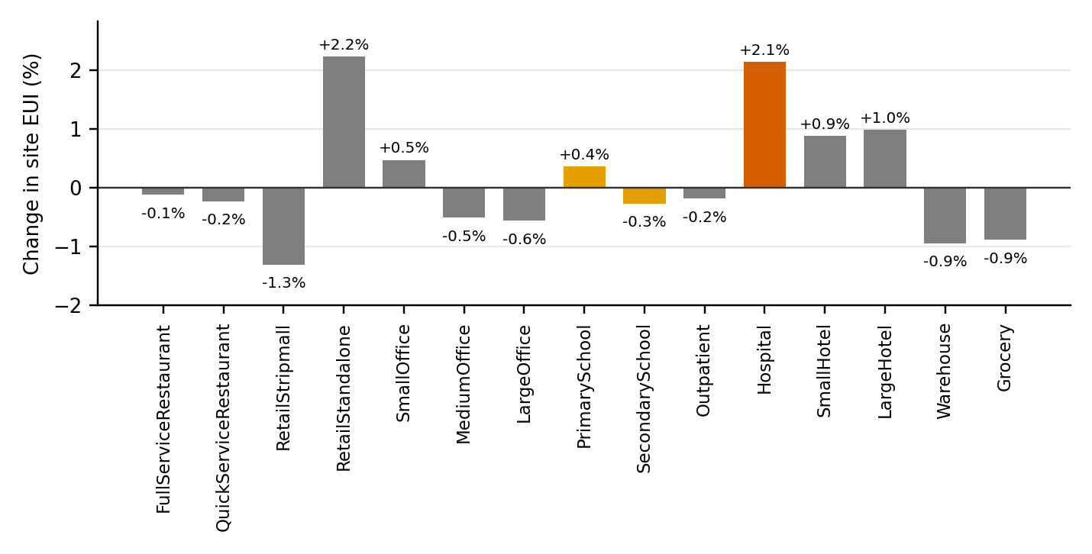
Figure 5. Change in site EUI by building type, After − Before
Source: as Table 11. Hospital in dark orange; schools, whose estimate changed by about 5%, in light orange; the other 12 types, the control, in gray.
Hospital site energy follows the floor area: California, Texas, Pennsylvania and New York hold 48.1% of it Before and 26.0% After, a third of hospital site energy (159.7 TBtu) changes state, and Delaware, Rhode Island and Vermont go from none to 1.2 to 1.7 TBtu each (Figure 6).
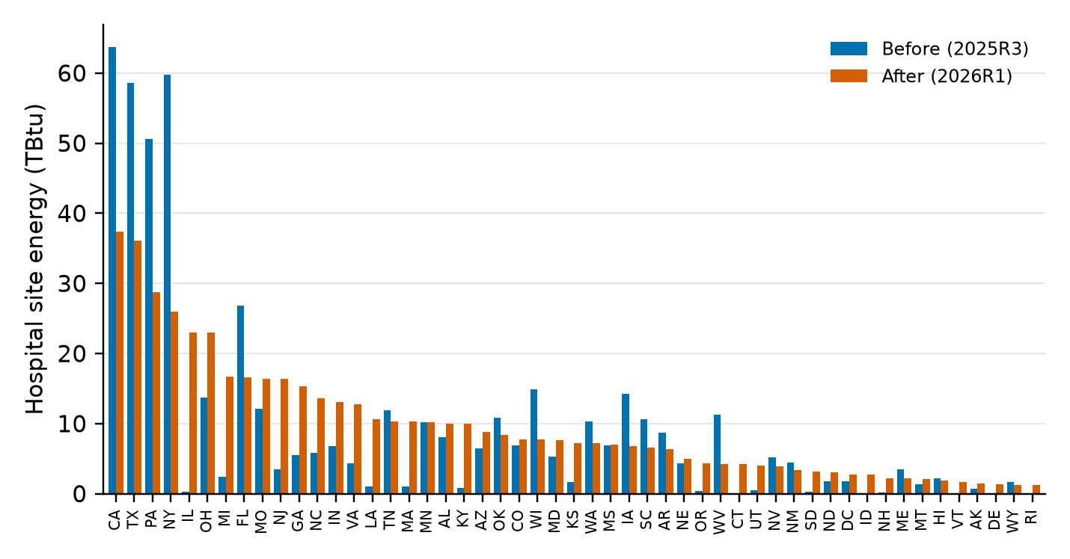
Figure 6. Hospital annual site energy by state (TBtu), Before (2025R3) and After (2026R1)
Source: each run’s annual results, weighted, by the state of the allocated building. Floor area by state is not fixed between the runs, so the figure shows where hospital energy moved, not a change in intensity.

Within hospitals, space heating (+11.8% per ft²) and water heating (+24.7%) rise and fans (−9.2%), cooling (−6.0%) and heat rejection fall (Table 12, Table 13). These likely follow the shift of hospital floor area toward colder climates (zone 5A holds 26.6% of it After, against 18.3%) and away from district chilled water (22.8% → 20.6%). The rise in water heating is likely the new mix of hospital sizes and locations as well, since the water heating model did not change; comparing water heating per bed or per floor area by size band would confirm it.
Table 12. Hospital annual energy by fuel and end use (TBtu)
Fuel | End use | Before | After | Change | Change (%)
Electricity | Fans | 31.9 | 29.0 | −2.93 | −9.2
Electricity | Interior lighting | 26.4 | 25.9 | −0.52 | −2.0
Electricity | Cooling | 42.7 | 43.3 | +0.64 | +1.5
Electricity | Water systems | 6.7 | 9.2 | +2.55 | +38.3
Electricity | All other end uses | 113.5 | 112.7 | −0.78 | −0.7
Electricity | Total | 221.2 | 220.2 | −1.05 | −0.5
Natural gas | Water systems | 30.1 | 37.8 | +7.73 | +25.7
Natural gas | Heating | 67.1 | 76.5 | +9.39 | +14.0
Natural gas | All other end uses | 84.8 | 84.9 | +0.09 | +0.1
Natural gas | Total | 182.0 | 199.2 | +17.21 | +9.5
Fuel oil | Total | 4.0 | 5.2 | +1.22 | +30.7
District heating | Total | 20.1 | 19.6 | −0.47 | −2.3
District cooling | Cooling | 56.0 | 49.5 | −6.54 | −11.7
All fuels | Site energy | 483.3 | 493.6 | +10.37 | +2.1
Source: as Table 11, hospital models only; hospital floor area 2.293 billion ft² in both runs. End uses that change by less than 0.5 TBtu are grouped by fuel; propane is below 0.05 TBtu in both runs.
Table 13. Hospital site EUI by end use, every fuel (kBtu/ft²)
End use | Before | After | Change (%)
Interior equipment | 79.8 | 80.0 | +0.3
Cooling | 43.0 | 40.5 | −6.0
Heating | 37.8 | 42.2 | +11.8
Water systems | 18.0 | 22.5 | +24.7
Fans | 13.9 | 12.6 | −9.2
Interior lighting | 11.5 | 11.3 | −2.0
Pumps | 4.5 | 4.3 | −3.8
Heat rejection | 1.0 | 0.8 | −15.3
Exterior lighting | 0.6 | 0.4 | −30.9
Refrigeration | 0.4 | 0.4 | −5.6
Heat recovery | 0.2 | 0.2 | +11.4
Site energy | 210.7 | 215.3 | +2.1
Source: as Table 12.
The EUI of each size band rises, except the largest (Table 14), so the hospital change is not only a shift in the mix of sizes. By census division, the hospital EUI rises most in the Pacific division (179.9 → 198.1 kBtu/ft²) and falls most in East North Central (224.9 → 210.2), the division that gains most floor area.
Table 14. Hospital site EUI by model floor area
Floor area (ft²) | Share of hospital floor area (%), Before → After | Site EUI (kBtu/ft²), Before → After
under 100,000 | 11.5 → 18.1 | 215.0 → 224.0
100,000–199,999 | 32.6 → 25.7 | 213.8 → 223.3
200,000–499,999 | 30.1 → 21.7 | 208.2 → 214.3
500,000–999,999 | 21.5 → 23.8 | 205.5 → 206.7
1 million or more | 4.2 → 10.7 | 220.7 → 202.3
Source: as Table 12.

Comparison with CBECS 2018
Floor area matches CBECS 2018 by building type in both runs, by construction. For energy, Figure 7 and Figure 8 compare each building type with CBECS 2018 and its 95% confidence interval, and Table 16 gives each type's gap, Before → After. Read them for the change between the runs; the gaps themselves belong to the ComStock commit both runs used (baf2895e, 2026-09-19), which later work on spacetype_refactor has moved. Between the runs, hospital electricity stays within 1% of CBECS (−0.4% → −0.9%; 96.5 → 96.0 kBtu/ft², against 96.8), and hospital natural gas rises from 7.0% to 17.1% above it (79.4 → 86.9 kBtu/ft², against 74.2). Six types are inside the interval for electricity in both runs, and six for natural gas: MediumOffice moves inside and Hospital outside. The additional gas usage is attributable in part to the shift of hospital floor area toward colder climates (zone 5A holds 26.6% of it After, against 18.3%).
Later code changes moved the hospital gap to the other side of CBECS. The v42 change document's run (str_100k_new_sample_fix5, on the new sample, with the bills-join fix) puts hospital natural gas 42.8% below CBECS 2018 and hospital electricity 19.1% below. There, a rise in hospital natural gas of the size measured here would likely move hospitals toward CBECS; a run of the old sample on current code would measure it. Nationally, both runs here are far above CBECS (Table 15), electricity by 43.4% and 42.5% and natural gas by 56.1% and 58.5%, which is also the 2026-09-19 code; the v42 run is 12.5% above CBECS for electricity and 7.3% below for natural gas.
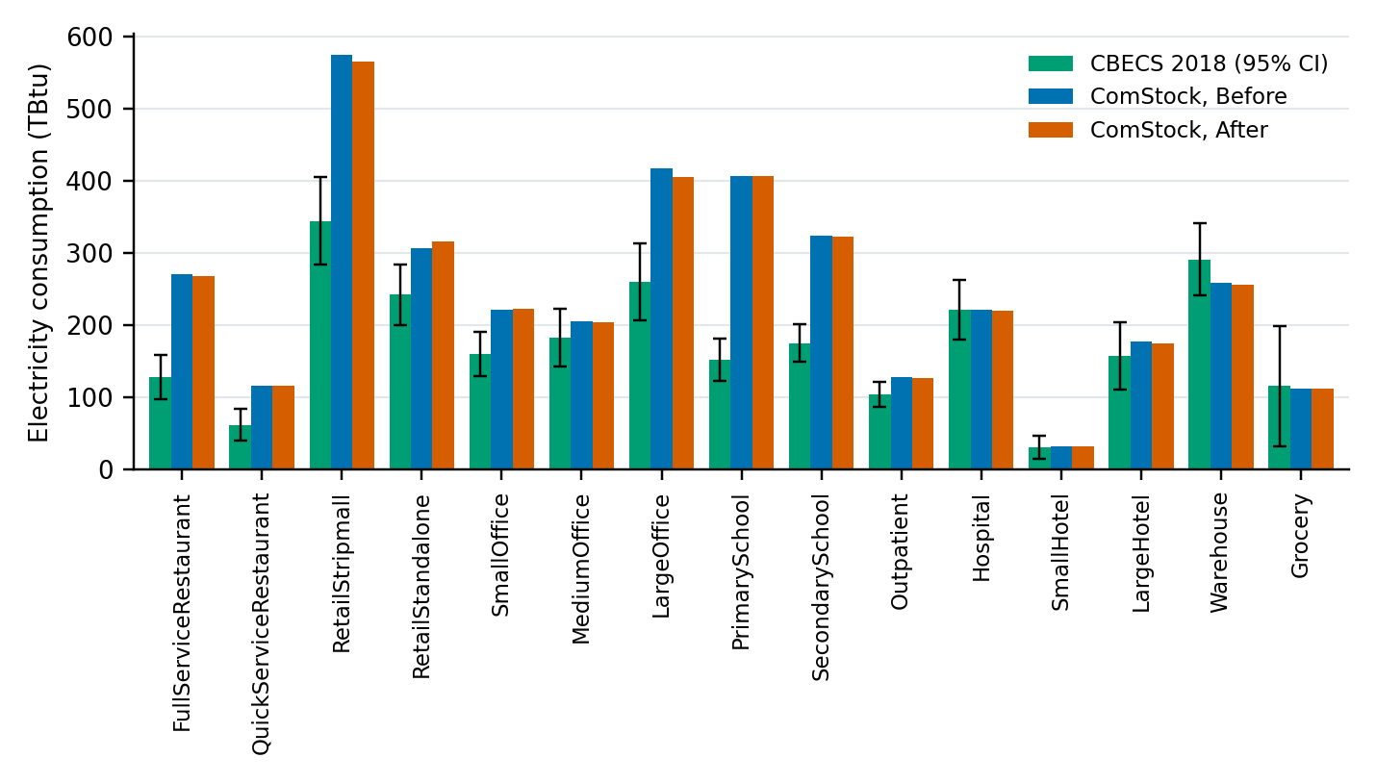
Figure 7. Annual electricity consumption by building type: CBECS 2018 with its 95% confidence interval, Before and After
Source: CBECS 2018 microdata with its replicate weights (comstockpostproc); each run's annual results, weighted.
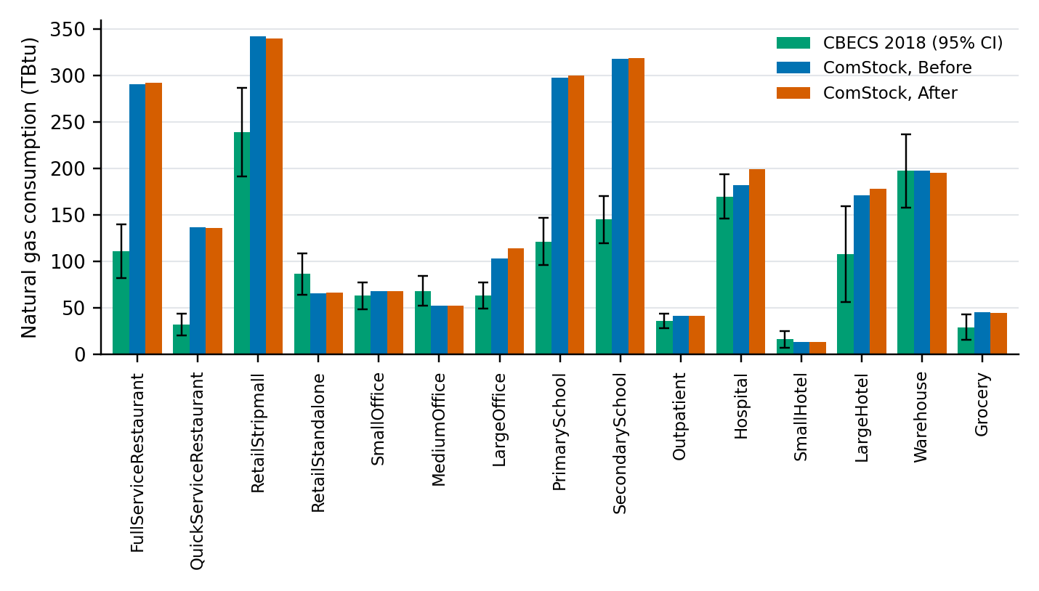
Figure 8. Annual natural gas consumption by building type: CBECS 2018 with its 95% confidence interval, Before and After
Source: as Figure 7.
Table 15. National totals against CBECS 2018
Quantity | CBECS 2018 (95% CI) | Before | After | Before vs CBECS (%) | After vs CBECS (%)
Floor area (million ft²) | 61,162.4 (56,984.7–65,340.1) | 61,162.4 | 61,162.4 | 0.0 | 0.0
Electricity (TBtu) | 2,633.2 (2,443.4–2,822.9) | 3,777.2 | 3,753.5 | +43.4 | +42.5
Natural gas (TBtu) | 1,491.2 (1,372.1–1,610.3) | 2,328.2 | 2,364.0 | +56.1 | +58.5
Source: as Figure 7; the 15 ComStock building types.
Table 16. Gap to CBECS 2018 by building type, Before → After (%)
Building type | Floor area | Electricity | Natural gas
FullServiceRestaurant | 0.0 → 0.0 | +111.0 → +109.6 | +161.9 → +163.5
QuickServiceRestaurant | 0.0 → 0.0 | +86.4 → +86.4 | +321.9 → +320.3
RetailStripmall | 0.0 → 0.0 | +66.6 → +63.9 | +43.0 → +41.9
RetailStandalone | 0.0 → 0.0 | +26.8 → +30.2 | −24.0 → −23.1
SmallOffice | 0.0 → 0.0 | +38.6 → +39.2 | +7.5 → +8.0
MediumOffice | 0.0 → 0.0 | +12.3 → +11.3 | −23.4 → −22.8
LargeOffice | 0.0 → 0.0 | +60.5 → +56.1 | +62.5 → +79.0
PrimarySchool | 0.0 → 0.0 | +165.7 → +166.5 | +144.8 → +146.5
SecondarySchool | 0.0 → 0.0 | +85.1 → +83.9 | +118.7 → +119.5
Outpatient | 0.0 → 0.0 | +23.1 → +22.0 | +13.8 → +14.7
Hospital | 0.0 → 0.0 | −0.4 → −0.9 | +7.0 → +17.1
SmallHotel | 0.0 → 0.0 | +3.2 → +3.6 | −16.1 → −14.7
LargeHotel | 0.0 → 0.0 | +12.5 → +11.0 | +58.1 → +64.8
Warehouse | 0.0 → 0.0 | −11.2 → −11.9 | +0.2 → −1.1
Grocery | 0.0 → 0.0 | −2.8 → −3.3 | +53.7 → +51.4
All building types | 0.0 → 0.0 | +43.4 → +42.5 | +56.1 → +58.5
Source: as Figure 7. Gap = ComStock / CBECS 2018 − 1.

EUSS Upgrade Measure Impacts
N/A for measure code: no upgrade measure reads the sample, the stock estimate or the hospital categories, so none changes. The runs compared are baseline only, so no change in upgrade savings is measured here. Hospital savings will move with the hospital stock's HVAC systems (Table 9): more hospital floor area has air-cooled chillers (2.2% → 11.5%) and less has water-cooled chillers with boilers or district systems. Measure applicability by hospital was reviewed and found unremarkable; it is left out of this document. Most measure savings differences as a result of this sampling change are expected to be attributable to differences in the prevalence of climate zones.

Open Items
- Names. Confirm the implementer and author lines, and assign a reviewer.
- Hospital counts. Reconcile the AHA survey's 6,229 hospitals (Figure 2), the 3,152 in the six panels of Figure 3 and the 5,952 in 2026R1: how many hospitals report beds and floor area, how the others get a floor area, and which are excluded.
- The removed outpatient area. The text says it went to a separate outpatient building group, but the estimate's Outpatient type is unchanged (24,838 → 24,827 buildings, 0.658 → 0.657 billion ft²). Say whether that area entered ComStock.
- Schools in 2026R1: is the drop expected? Both 2026-09-16 deliverables hold about 5% fewer primary and secondary schools than 2025R3: 2026R1_building_estimate.parquet (as published to S3) has 5.1% and 5.8% fewer school rows, and building_type.tsv in the delivered TSVs gives schools a 4% to 5% lower probability. The loss is in 47 states, with no state gaining and four unchanged (CT, DE, DC, UT), and the schools that remain have the same distributions as before (Table 3). ComStock reads each file as delivered, so the question is for the estimate's authors: was the school change intended? If it was, this document notes it; if not, both files need a rebuild. The effect reaches results as a 5% rise in the school CBECS scaling factors, not as different schools.
- Hospital year built and stories. Say how 2026R1 assigns them; the AHA survey reports neither. The reference documentation keeps its general wording until then.
- The code behind 2026R1. Name the repository and commit that produced the corrected survey, the 2026-09-16 estimate and the hospital TSVs; none of the stock-estimation branches on GitHub holds it.
- The HSIP map. Its title says "currently represented in ComStock" and counts 4,308 hospitals; the 2025R3 estimate holds 3,224. Correct the title or explain the difference.
- Hospitals dropped by apportionment and allocation. Apportionment keeps 84.8% of the 2026R1 hospitals, and allocation finds no model for 19.5% of the hospital floor area kept; the HVAC fallback the reference documentation describes is not in the code (existing behavior). Worth an issue.
- The release code. The comparison runs on the code of 2026-09-19; check hospital energy against CBECS again on the release run (str_100k_new_sample_fix_final), which uses the new sample, apportioned to 2026R1.

Data and Methods
Runs and access. Kestrel ymls in /kfs2/projects/cscore/ymls/hospital_resampling/; results in s3://eulp/euss_com/hospital_resampling/<run>, Athena database enduse. Postprocessed with comstockpostproc, apportioning Before to 2025R3 and After to 2026R1.
Weights. Each run's allocation, scaled to CBECS 2018 floor area by building type. A model's weight is the sum of its rows' weights. National values are Σ weight × annual kWh × 3,412.14 Btu/kWh. The runs hold different samples, so there is no shared allocation draw and no model-by-model comparison; every comparison is of weighted totals. Both runs' ymls say n_buildings_represented: 103224; apportionment replaces those weights.
Allocation is a random draw. Each building of the apportioned estimate gets a model drawn at random from its bucket, with no fixed seed, so postprocessing a run again without reload_from_cache=True gives different weights. The Before and After weights are one draw each, and the control types' differences include this noise as well as the samples'.
The stock estimate on S3. All eight files Apportion('2026R1', 'v01') needs are in s3://eulp/truth_data/v01/StockE/ and identical to the files used here (hvac_system_size_bin_v1.tsv differs only in line endings). The apportionment itself (the estimate with heating fuel and HVAC system drawn onto it) uses fixed seeds, and one rebuilt from a fresh download is identical, row for row, to the one the After run used. A fresh postprocessing run therefore starts from the same inputs; only the allocation drawn from them differs. 2026R1_tract_list.csv is a copy of the 2025R3 tract list; apportionment loads it but does not use it, because no hospital or other building in 2026R1 lacks a tract.
Why the estimate must match the sample. A sample is drawn from bucket files generated from one estimate, and allocation matches the estimate's buildings to the sample's models bucket by bucket (Table 17). Matched, as both runs here are, no model is left without buildings. Apportioned to 2025R3, the new sample would lose 2.09% of its models (11.4% of its hospital models) without a message, and its weights would follow the 2025R3 hospitals: New England would hold 0.8% of hospital floor area instead of 4.1%, and East North Central 9.2% instead of 17.5%. The one number allocation logs, the share of the estimate's buildings without a model, barely moves (0.70% → 0.71%).
Table 17. Each sample apportioned to each stock estimate
Sample | Estimate | Estimate's buildings without a model (%) | Hospital floor area without a model (%) | Models without a building (%) | Hospital models without a building (%)
old (v33), as run | 2025R3 | 0.69 | 28.8 | 0.00 | 0.0
old (v33) | 2026R1 | 0.73 | 29.2 | 2.00 | 4.4
new (v34) | 2025R3 | 0.71 | 21.8 | 2.09 | 11.4
new (v34), as run | 2026R1 | 0.70 | 19.5 | 0.00 | 0.0
Source: the apportioned stock estimates 2025R3 and 2026R1, and each sample's models; a bucket is a combination of sampling region, building type, size bin, HVAC system and heating fuel. Percentages of the apportioned estimate's buildings and hospital floor area, and of the sample's models.
The three-run results dashboard. The dashboard three runs - new sample vs original vs baseline_10k (2026-09-21) reads Athena tables whose new-sample weights come from a bills cache built on 2025R3, so its hospital floor area by census division is the old one (New England 0.8%, against 4.1% here). Its hospital totals change by about as much as this document's: natural gas 194.2 → 214.0 TBtu and site EUI 211.1 → 216.3 kBtu/ft², on exported weights that carry the bills-join inflation in both runs.
Existing behavior that affects hospitals. Apportionment drops buildings whose heating-fuel or HVAC keys have no distribution; it keeps 84.8% of the 2026R1 hospitals. Allocation then finds no model for 19.5% of the hospital floor area it keeps (28.8% for 2025R3 and the old sample), because the bucket files hold the combinations that cover 99% of the estimate's buildings plus one HVAC system for each remaining combination of region, type, size bin and fuel; the reference documentation describes a fallback that relaxes the HVAC system for such buildings, but the allocation code drops them. CBECS scaling restores the national hospital floor area either way. generate_sampling_input removes two California hospital buckets (sampling regions 103 and 109, size bin 0) when it writes bucket files.
Sign convention. Change = After − Before. A gap to CBECS is ComStock / CBECS − 1. CBECS confidence intervals use comstockpostproc's replicate-weight method, which matches the results dashboard.

References
- American Hospital Association. (2022). AHA Annual Survey [Data set]. Health Forum LLC.
- Centers for Medicare & Medicaid Services. (2026, August 17). Critical Access Hospitals. https://www.cms.gov/medicare/health-safety-standards/certification-compliance/critical-access-hospitals
- Definitive Healthcare. (2025, December 31). Average U.S. Hospital Square Footage. https://www.definitivehc.com/resources/healthcare-insights/average-us-hospital-square-footage
- Hubert, M., & Vandervieren, E. (2008). An adjusted boxplot for skewed distributions. Computational Statistics & Data Analysis, 52(12), 5186–5201. https://doi.org/10.1016/j.csda.2007.11.008

