Note: This program is OS agnostic. For larger runs (e.g. full national runs), the user should pursue access to the High Performance Computing (HPC) environment. Use of the HPC is optional, but directions for its use are integrated into the following instructions.

Quickstart: Accesses
- AWS Account and Allocation – Please reach out to the Stratus Cloud team (Stratus Cloud: Home) to acquire them.
- AWS ResStock/ComStock Sandbox Access (likely resbldg) – Please contact Anthony Fontanini for access
- HPC (optional) – Please reach out to the HPC team for an account and allocation (High-Performance Computing | NREL)

Quickstart: Environment Setup
- Install AWS CLI – Installation instructions here
  - On Linux (e.g. Yampa/HPC), you will need to install a non-sudo version of AWS CLI. Get the system architecture by using the command uname -m
    - See the section that starts with the text “You can install without sudo if you specify directories that you already have write permissions to….”
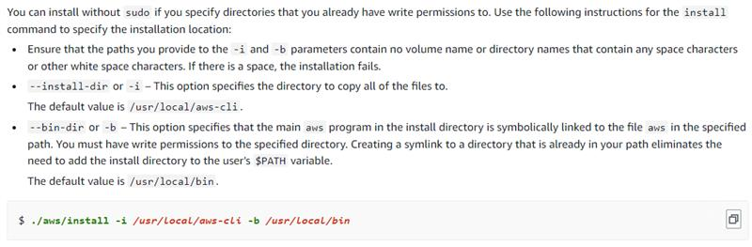
    - If the default command (at the bottom of the image) produces a “Permission denied”, the following command ./aws/install -i ./local/aws-cli -b ./local/bin works
  - Also on Linux, you will need to update your ~/.bashrc to reflect the PATH of the AWS CLI (Line 25); (Note: Line 24 may not be necessary); you will need to customize the path based on your installed version (here 2.17.5)
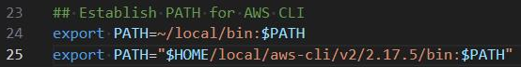
- AWS SSO Login setup – Instructions here
- Clone repo
  - (via HTTPS): git clone https://github.nrel.gov/ReEDS/ReEDS-2.0.git
  - (via SSH – additional prior setup necessary): git clone git@github.nrel.gov:ReEDS/ReEDS-2.0.git
- Install the geothermal environment – this assumes you have conda and git installed
  - Open Git Bash or similar Command Line Interface
  - Navigate to the root directory of your repository
  - conda env create -f geothermal_env.yml
  - conda activate geothermal
  - conda install git-lfs
  - pip install tensorflow
  - pip install --upgrade "numpy<2.0"
  - Buildstock query
    - pip install git+https://github.com/NREL/buildstock-query#egg=buildstock-query[full]
    - The Comstock db_schema must be manually placed in the buildstock-query site packages
      - python -c "import site; print(site.getsitepackages())
      - Copy comstock_oedi.toml (in the current directory) to directory-path-from-previous-step/buildstock_query/db_schema/

Quickstart: Running the Program
- Navigate to the root directory of your repository
- conda activate geothermal
- aws sso login
  - (Yampa) For Yampa setup, the AWS SSO needs to be performed on a different machine (e.g. local). Directions:
    - Sign into AWS using SSO on your local computer (aws sso login)
    - Using WinSCP, remove the cache directory on Yampa and copy over the cache directory (which contains credentials in the SSO token file) from the local computer (see image).
- Adjust your switches_agg.json to match desired settings
  - “workgroup” must match your Stratus Cloud “Handle”/AWS Sandbox “Workgroup”
- python B_building_stock_parallel_agg.py

