**Lab 10: Conducting an Incident Response Investigation for a Suspicious Login (E3)**

**By**

**Natnael Kebede**



**University of Dallas**

**2020**

This Paper Submitted in Partial Fulfillment of the Requirements for

CYBS 7359 – Digital Forensics

Spring 2020

Presented to Dr. Renita Murimi

**Section 2**

**Part 1**

1. Make a screen capture showing the image files in the NetWitness Investigator Evidence folder and paste it into your Lab Report file.

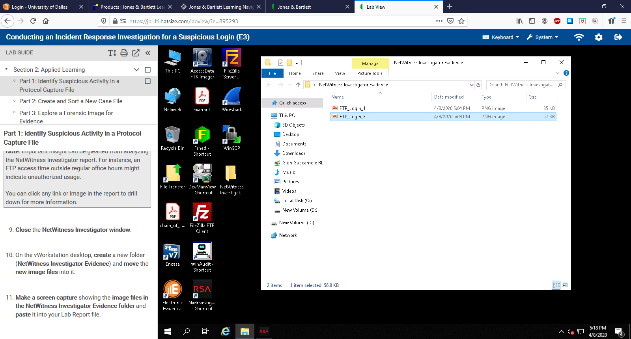

**Part 2**

1. Make a screen capture showing the total number of sorted files in the case file and paste it into the Lab Report file.

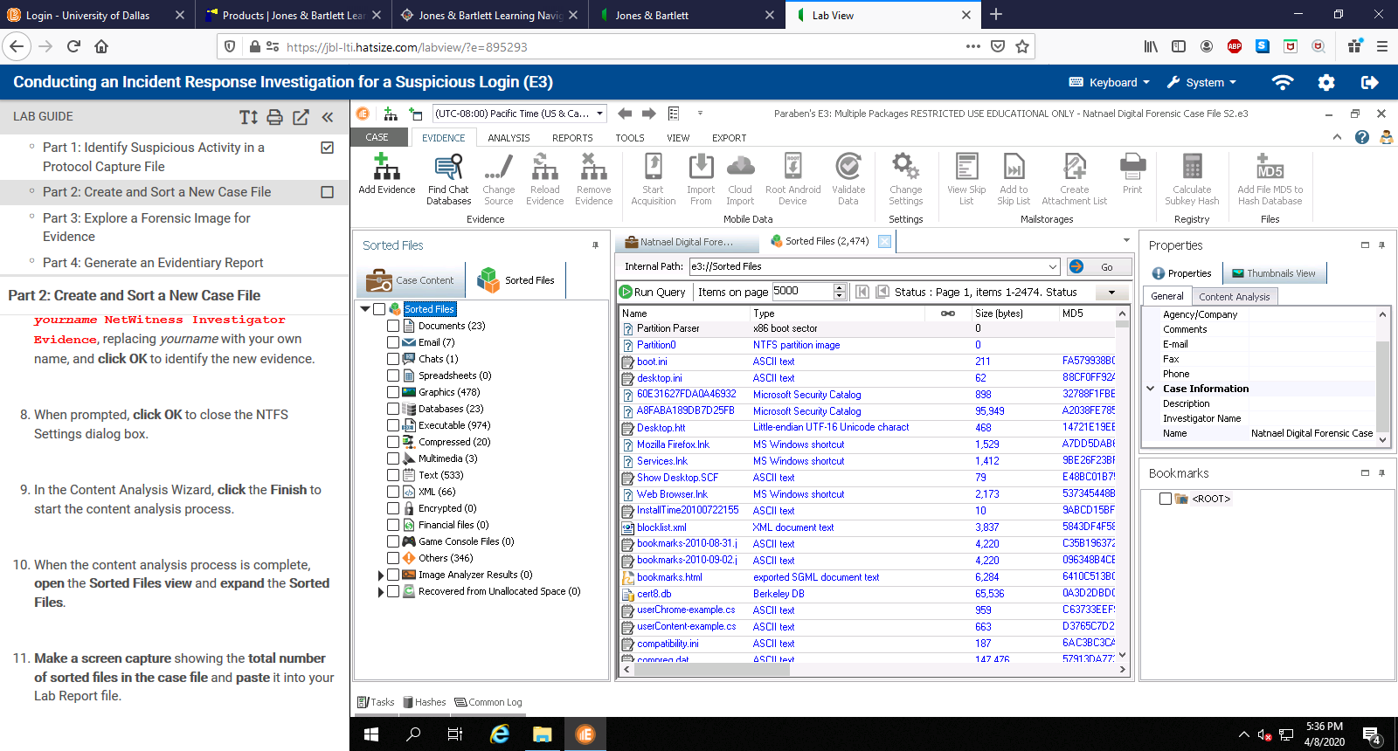

**Part 3**

1. Make a screen capture showing the MD5 hash values for the FTP_Login

evidence files and paste it into your Lab Report file.

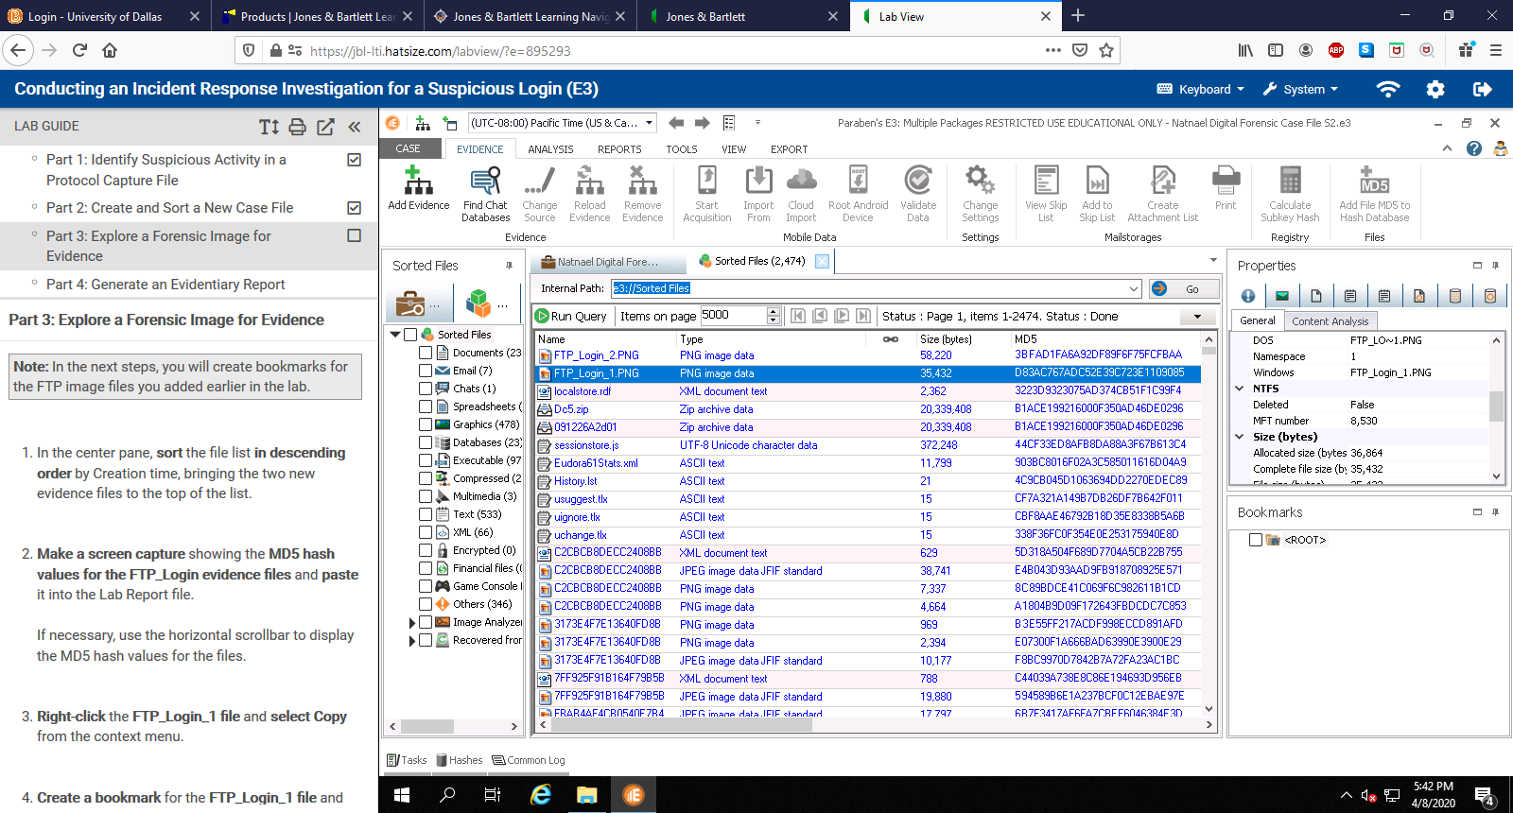

1. Make a screen capture showing the bookmarked screen captures and paste it into the Lab Report file.

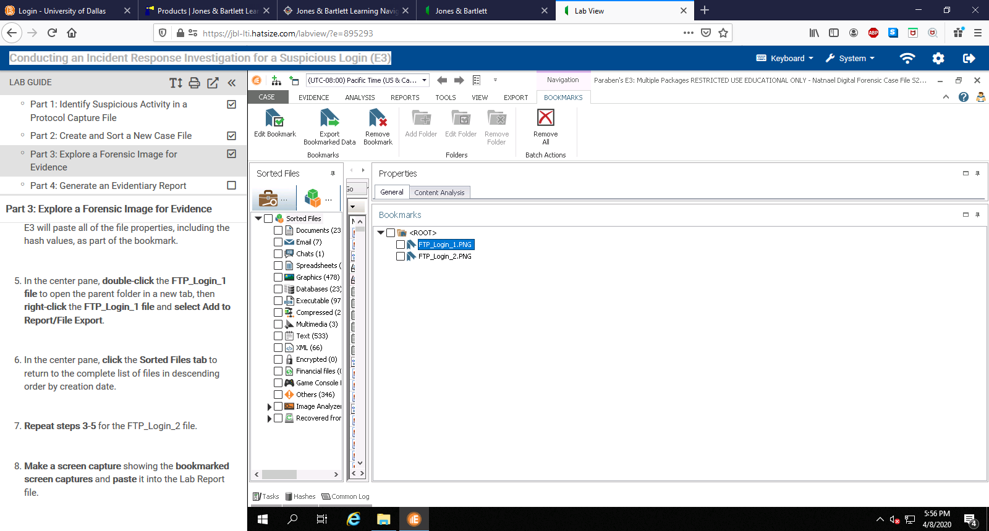

**Part 4**

1. Make a screen capture showing the bookmark associated with FTP_Login_1 file and paste it into the Lab Report file.

