**Lab 4: Creating a Forensic System Case File for Analyzing Forensic Evidence (E3)**

**By**

**Natnael Kebede**



**University of Dallas**

**2020**

This Paper Submitted in Partial Fulfillment of the Requirements for

CYBS 7359 – Penetration Testing and Vulnerability Assessment

Spring 2020

Presented to Dr. Renita Murimi

**Section 1**

1. In the Lab Report file, briefly describe the contents of the Root folder.

The Root folder contains contents several directory folders, log and boot files, and configuration files. It contains data that are at the most top-level contents of a Windows system including the documents and settings folder, bootloader files, the WINDOWS system folder, RECYCLER, program files, and various Windows system attributes.

Furthermore, for each folder and file, the E3 window also displays information about the digital file, its file path, the date and time it was created, its allocated size and file size in bytes, and the MFT number associated with it.

1. Make a screen capture showing the contents of the Root folder and paste it into your Lab Report file.

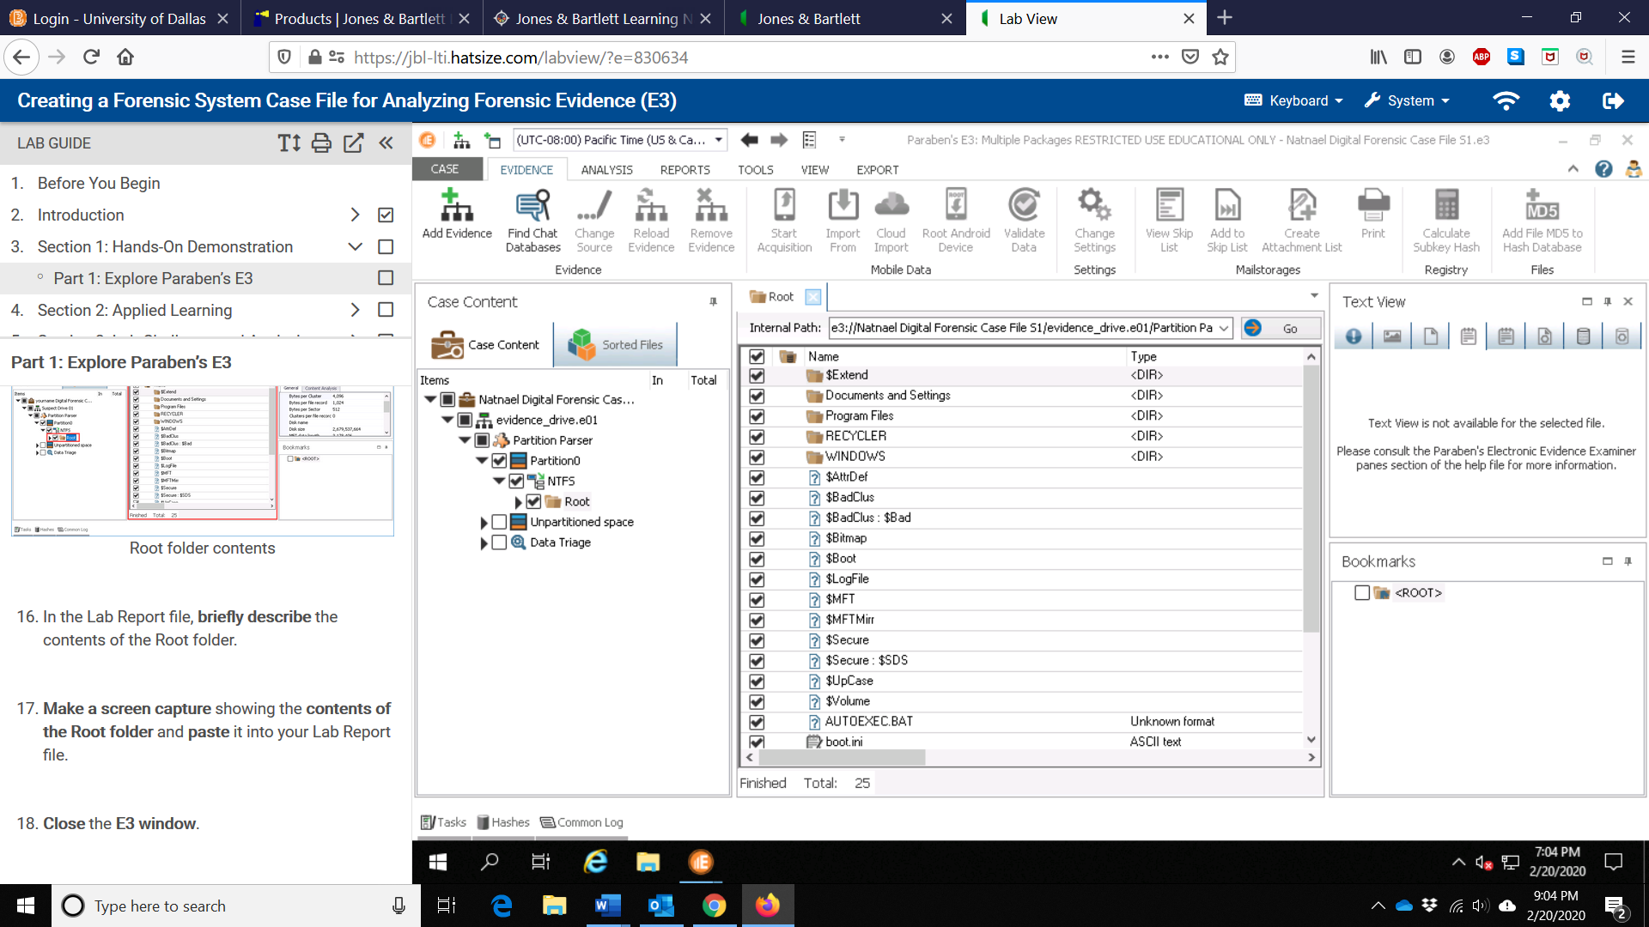

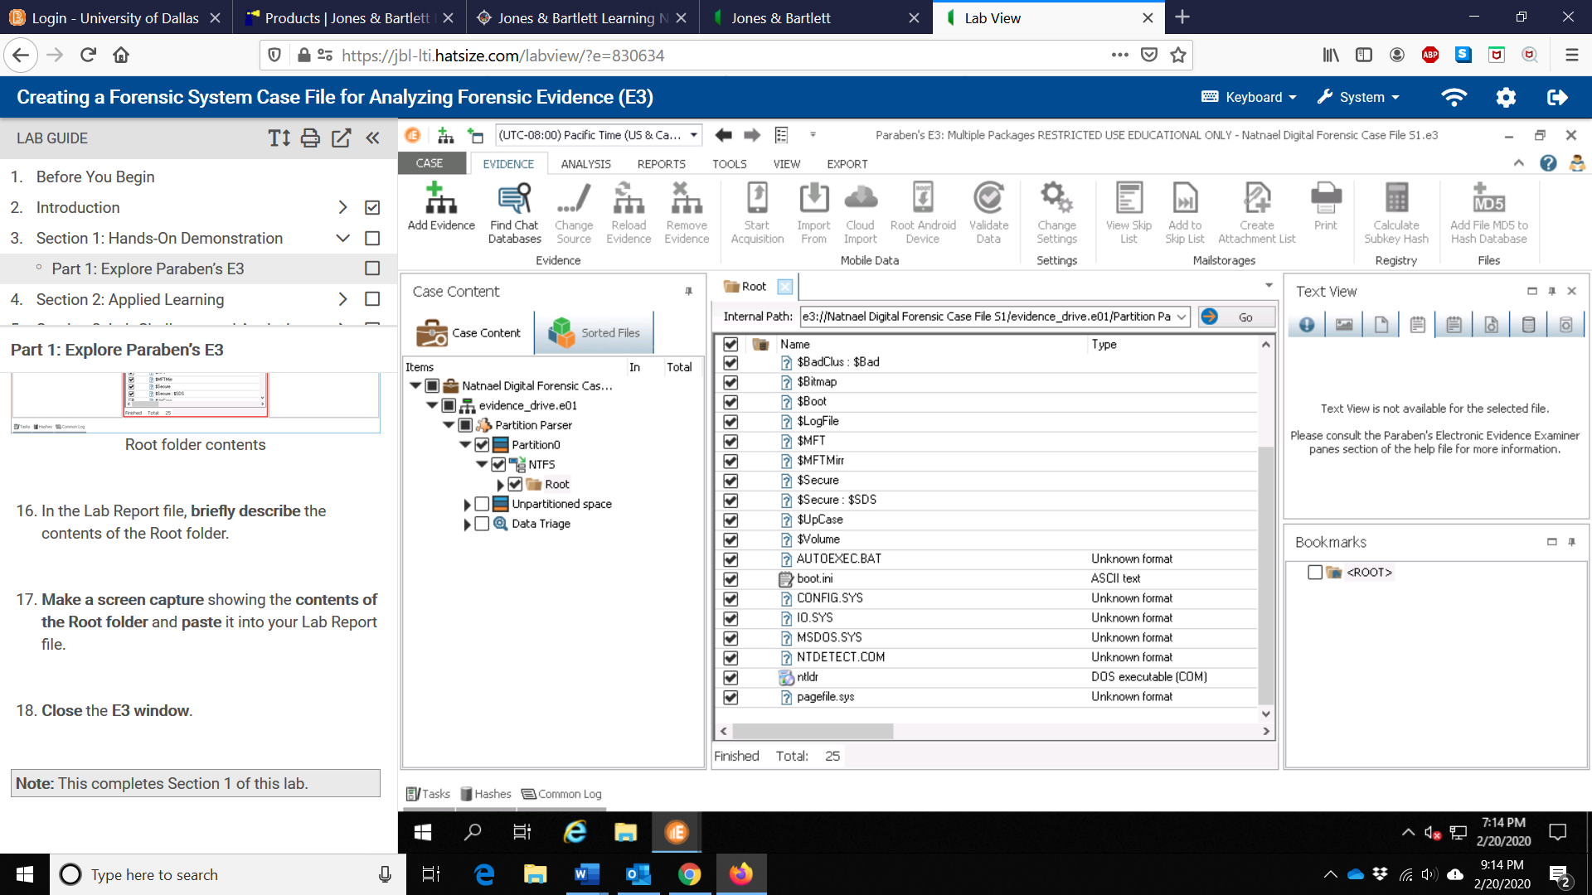

1. Files downloaded from the virtual environment:

Natnael Digital Forensic Case File S1.e3