**Lab 9: Identifying and Documenting Evidence from a Forensic Investigation (E3)**

**By**

**Natnael Kebede**



**University of Dallas**

**2020**

This Paper Submitted in Partial Fulfillment of the Requirements for

CYBS 7359 – Digital Forensics

Spring 2020

Presented to Dr. Renita Murimi

**Section 2**

**Part 1**

1. Make a screen capture showing the sorted evidence and paste it into your Lab Report file.

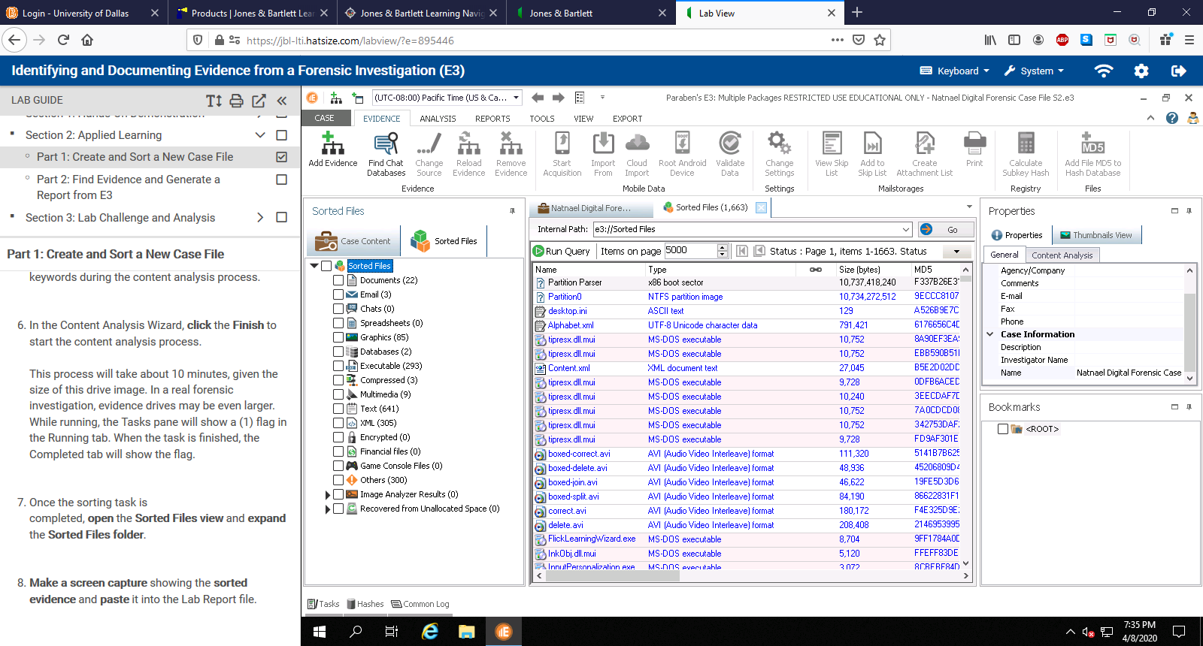

**Part 2**

1. Make a screen capture showing the results of the .crt search and paste it into the Lab Report file.

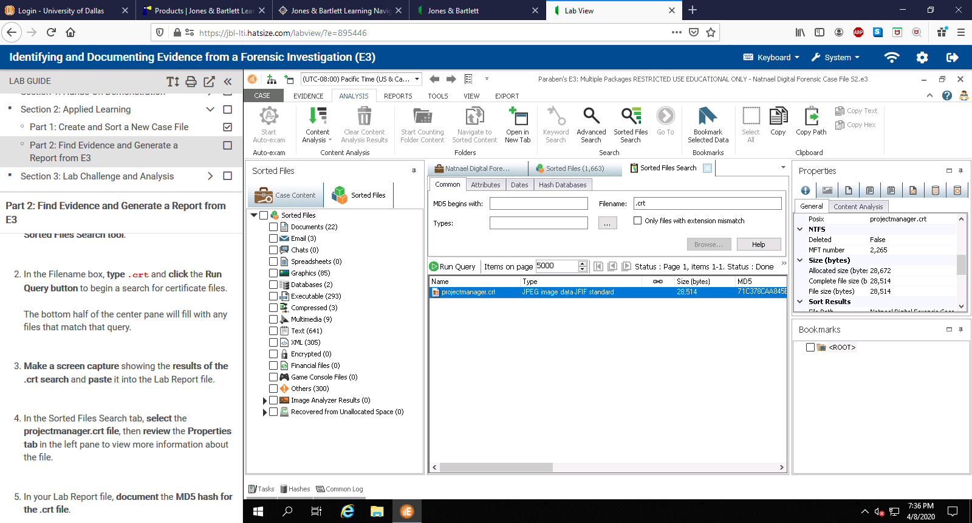

1. In your Lab Report file, document the MD5 hash for the .crt file



1. Make a screen capture showing the File View tab and paste it into the Lab Report file.

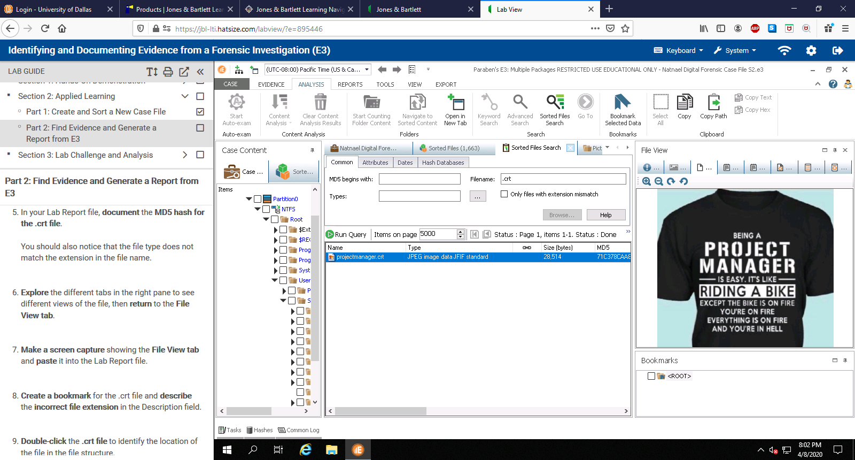

1. In the Lab Report file, document the file location



1. In your Lab Report file, document the type of car that appears in the image file.

The camaro2011.jpg image is a photo of a silver Chevrolet Camaro with a plate of USA1.

1. Make a screen capture showing the MD5 hash for the image file and paste it into the Lab Report file.

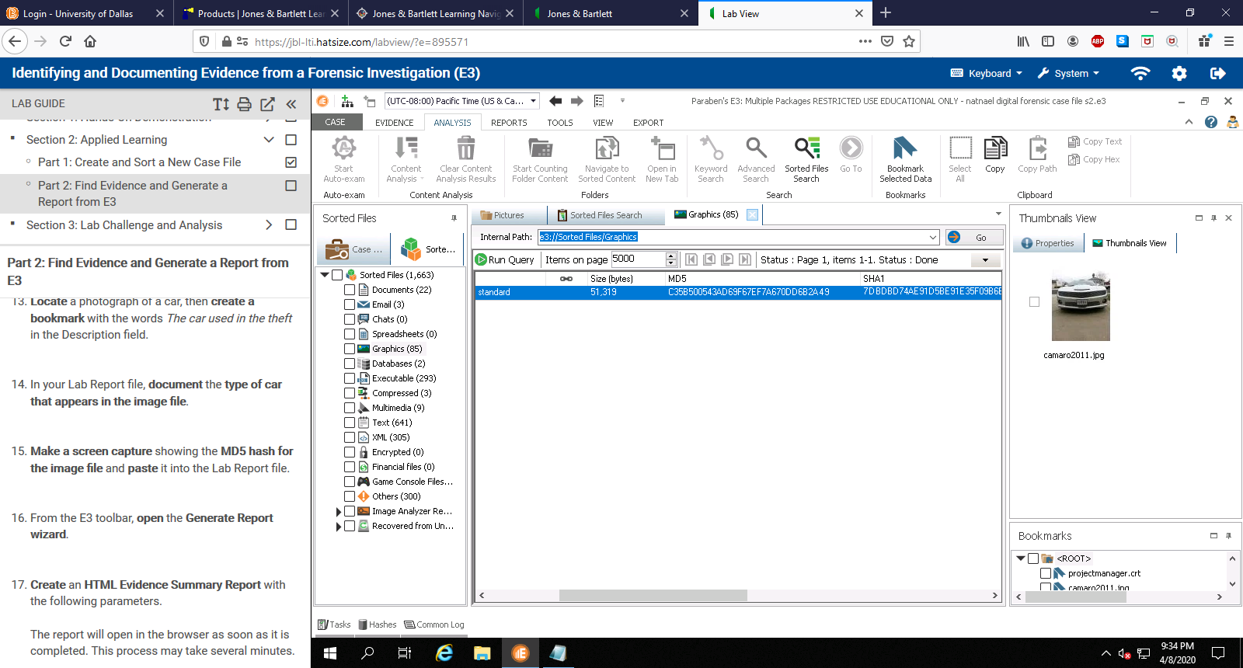

1. Make a screen capture showing the bookmarks in the Evidence Summary Report and paste it into the Lab Report file.

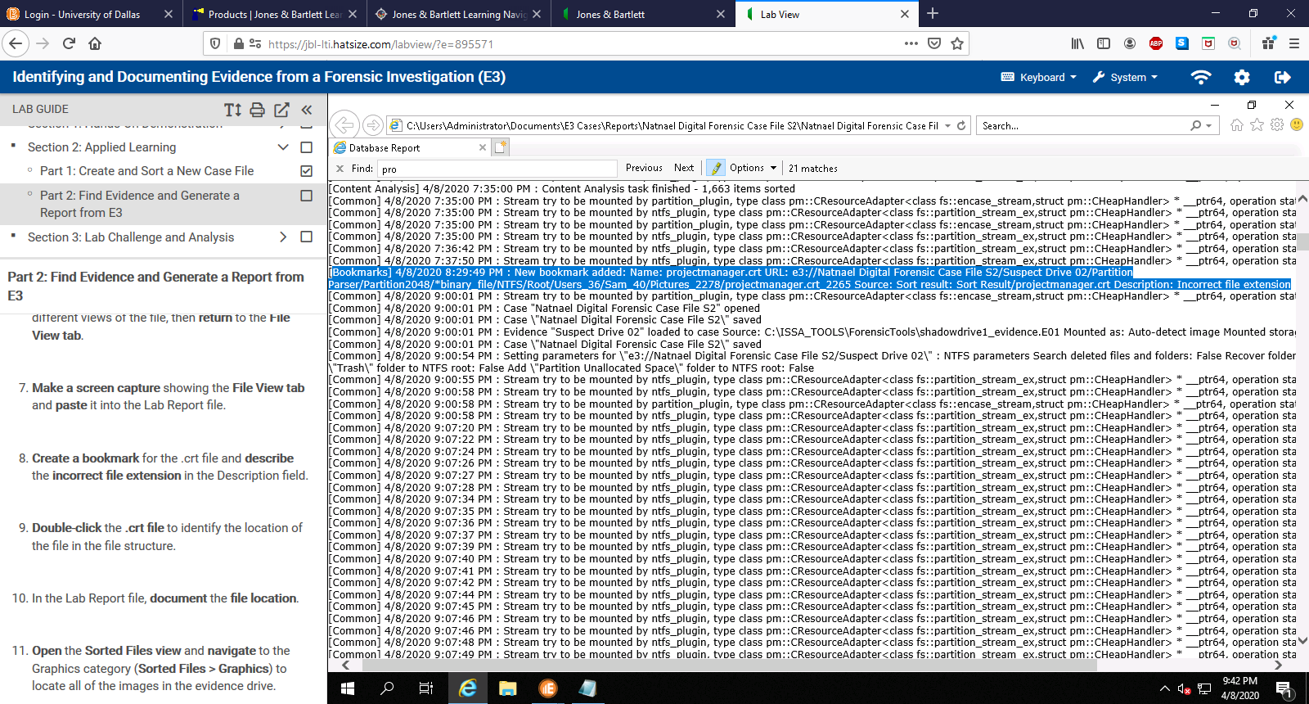

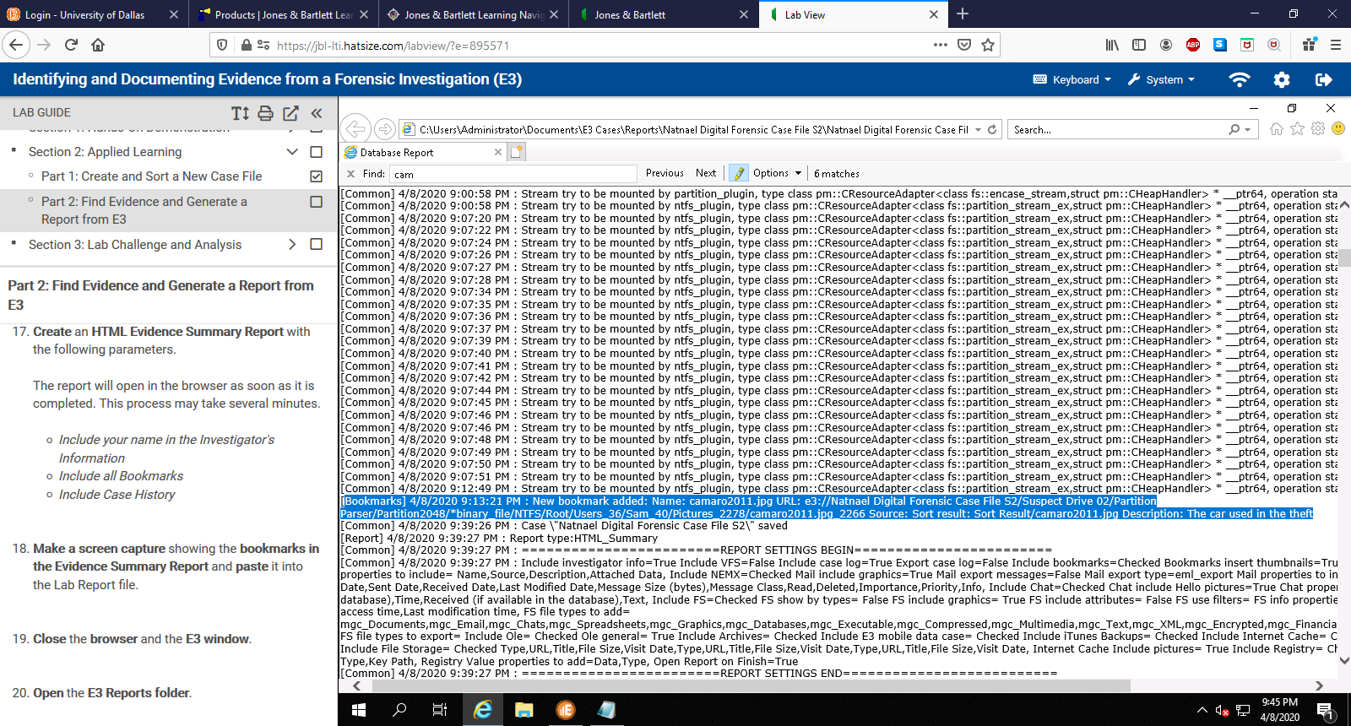

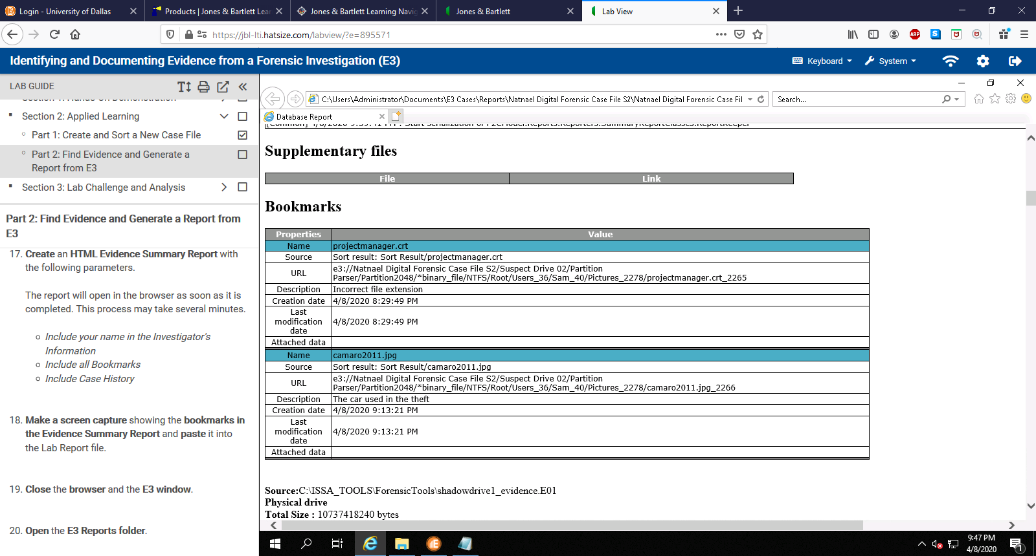

1. Make a screen capture showing the MD5 hash and paste it into your Lab Report file.

