Clear-Text Data in Packet Trace

By

Natnael Kebede

University of Dallas

2019

This Paper Submitted in Partial Fulfillment of the Requirements for

CYBS 7357 – Network Security

Fall 2019

Presented to Professor Brian Wrozek

Table of Contents

Introduction………………………………………………………………………………………iii
Finding and recording the clear text password………………………………………………1
Finding the text file containing credit card information………………………………………1
Conclusions……………………………………………………………………………………...3
References…………………………………………………………………...……………………...4

ii
Introduction

NetWitness Investigator is a free tool provided by RSA. It captures live traffic and process packet files from virtually any existing device. It also provides forensic and analytical tools for analyzing data packets and investigating incidents that occurred (“RSA NetWitness Investigator”, n.d.). NetWitness is also known for its ability to obtain threat intelligence from SANS Internet Storm Center. This property allows users to analyze advanced threats, malware, and other harmful behaviors on the network (Girardi, n.d.).
This paper provides the necessary actions/steps needed to accurately identify clear-text data and find information in a packet trace once an individual has access to the activated and installed software.

iii
- Finding and recording the clear text password
Once the NetWitness Investigator tool is launched, one can see a Demo Collection file located on the left side of the window. Next, open this directory. NetWitness will then show information about Service Type, Top Level Domains, Hostname Aliases, IP addresses, and so on. Scroll down and navigate to “Password”. Once located, click on the [open] option. NetWitness will then display the actual password in clear text format as “mypassword1”. Another information that is possibly associated with the password can be the “Full Name” and “Subject”. Clicking on the [open] option in both cases shows that the user is bob smith and the subject is welcome to netwitness investigator. This information is shown in the screenshot below.
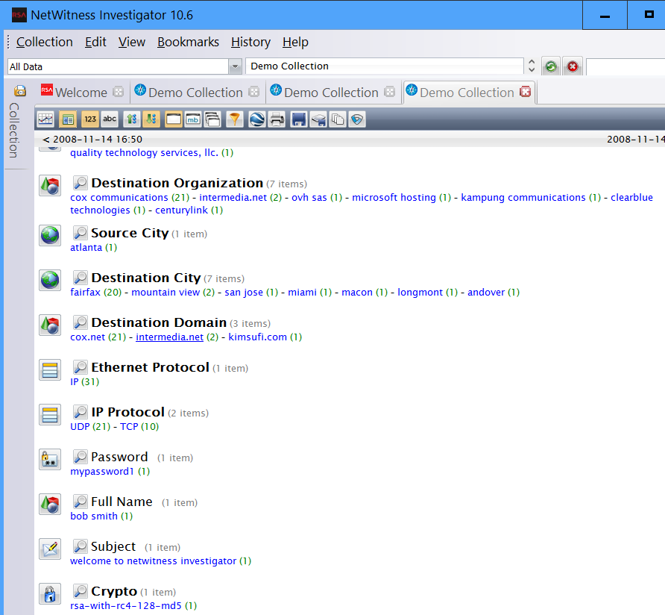
- Finding the text file containing credit card information
In the opened Demo Collection directory, scroll down and navigate to “Attachment”.

1
Click on the (1) option to view the details of this specific file. A new window opens with the title "Demo Collection > Sessions" for ‘creditcards.txt” at the top. On the left side of the window, click on the view button. Another window will then open at the bottom with the title "Demo Collection Content – Session 8". Careful examination of this window shows an email from "Joann" jo@investigator.demo to jo@investigator.demo with the subject Welcome to NetWitness Investigator, the date and two attachments namely, Creditcards.txt and moon.jpg. Click on the Creditcards.txt attachment. When prompted for the way to view the content, choose the open in Investigator option from the drop-down menu and click on ok. The list of credit card information contained in the file will then get displayed in the top window. The records held in the file will look like the following screenshot.
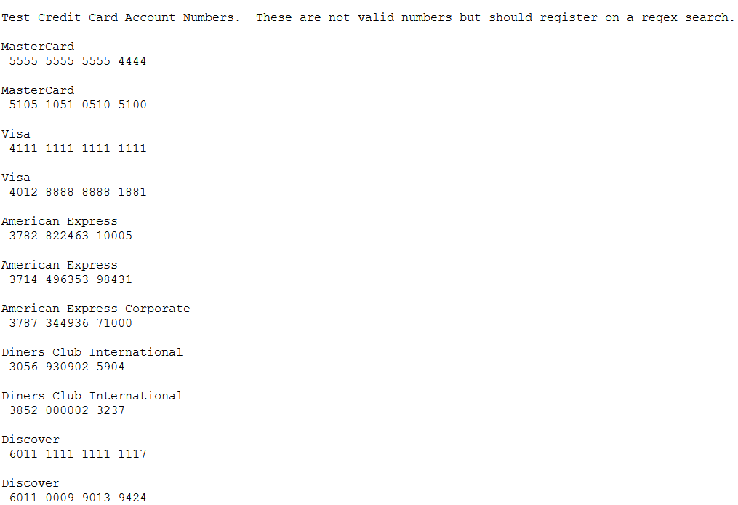
2
Conclusion
NetWitness Investigator is a valuable tool for analyzing data packets and identify various activities on a network. Specifically, this paper demonstrated how to identify the clear-text password and find the text file containing credit card information by accessing the Demo Collection file that comes with the installed tool. Furthermore, the information associated with both instances was recorded to provide a clear understanding of what the output data looks like in NetWitness.

3
References

Girardi, B. (n.d.). NetWitness Investigator Freeware: Network Intelligence, Threat Indicators and Session Exploitation. Retrieved from https://www.sans.org/cyber-security-summit/archives/file/summit-archive-1493922492.pdf

RSA NetWitness Investigator. (n.d.). Retrieved from https://www.emc.com/collateral/data-sheet/rsa-netwitness-investigator.pdf

4

