Selecting Security Countermeasures

By

Natnael Kebede

University of Dallas

2019

This Paper Submitted in Partial Fulfillment of the Requirements for

CYBS 7357 – Network Security

Fall 2019

Presented to Professor Brian Wrozek

Table of Contents

Introduction………………………………………………………………………………………iii
Description of the security threats posed by the network expansion.………………...…...1
Description of countermeasures for the identified threats ….……………………………...1
Reasons for the chosen countermeasures…………………………………………………...2
Benefits and limitations of each countermeasure……………………………………………3
Conclusions……………………………………………………………………………………...4
References…………………………………………………………………...……………………...5

ii
Introduction

Network integrity is essential to protect the critical infrastructure of business and resist attacks that could damage assets and expose data to unauthorized individuals. To make this possible various security countermeasures need to be considered in the different domains of an IT infrastructure as it pertains to an organization.
This paper examines Corporation Techs, a company with new proposed network design, and provides the security threat posed by the network expansion. It also provides the necessary countermeasures and controls that need to be implemented for the identified threats. Additionally, it explains the reasons behind the chosen countermeasures and the benefits and limitations of each of them.

iii
Description of the security threats posed by the network expansion
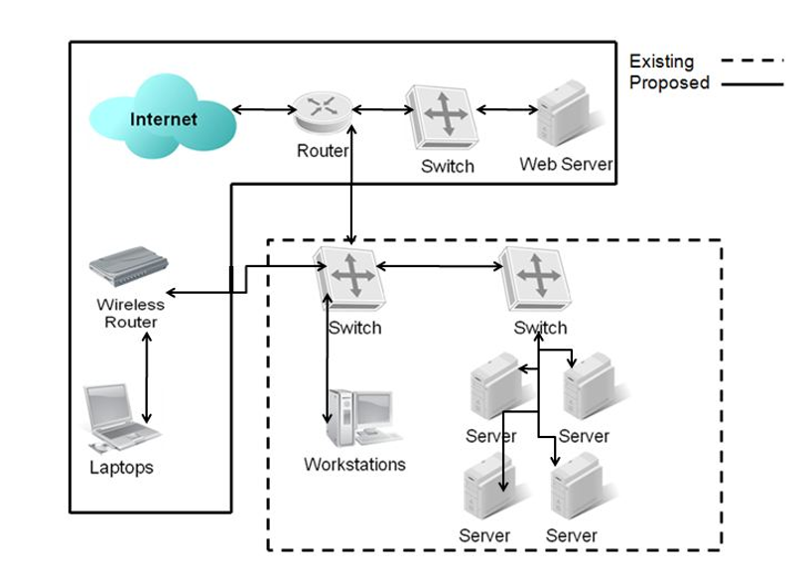
Serious security threats can be identified by looking at the proposed network architecture shown above. This scenario suggests that improvements in the design and enforcement measures are very crucial. Such security threats include stolen data due to theft of mobile devices; breaches due to unintended employee behaviors, and intruders’ access to unauthorized information via an installed malware. There are also new attack surfaces due to the introduction of the wireless network and external attacks due to the absence of technical access controls such as firewalls.
Description of countermeasures for the identified threats
To address the security threats that are identified above, proper controls need to be deployed for each of the security countermeasures. Some of these include securing the facility with physical intrusion detection systems, alarm systems, and man traps (Hutter, 2019), enforcing users to review and sign an Acceptable Use Policy (AUP); installing antivirus and antispyware software and patching all the software on laptops, implementing segmented wireless networks and using encryption, placing a firewall

1
between the switch and the webserver and isolating the whole network from the internet via another firewall.

Reasons for the chosen countermeasures

There are various reasons to consider the countermeasures and controls described above. First, physical preventive controls can protect the company’s devices and the sensitive data stored on them. Second, Acceptable Use Policy (AUP) shows due diligence with regards to the security of the network and the protection of confidential information in the event of a breach or regulatory audit (Stewart, 2017). Additionally, installing antivirus, antispyware or other software products at information system entry and exit points (e.g., electronic mail servers, web servers, remote-access servers) and workstations can help detect malicious code and prevent its execution (“NIST Special Publication 800-53 Revision 5, Security and Privacy Controls…”, 2017). At the same time, patching is critical to fill vulnerability holes and prevent malware attacks that take advantage of software weaknesses (Davis, 2017).
Moreover, addressing the wireless network concerns via segmenting the network and encryption prevents anyone from accessing the data that is transmitted over that air. Encryption technologies such us requiring VPN authentication for wireless access make this safeguarding technique possible. Through shielding, Corporation Techs can also prevent the network from being directly accessed over a distance (Ballad, Banks & Chapple, 2017). Lastly, technical control such as firewall placed between the switch and the webserver can reduce significant risk and exposure for the network infrastructure. Furthermore, a firewall placed behind the untrusted internet network acts like a shield preventing unauthorized access to and from Corporation Techs’ Local-Area Network enhancing the security of the devices connected to the network.

2
Benefits and limitations of each countermeasure

In addition to the benefits described above, each of the above countermeasures and controls have their limitations too. For example, physical security controls can protect Corporation Techs’ devices and the sensitive data stored on them. However, it can be compromised due to human error or failure to comply with it. In the same manner, policies such as Acceptable Use Policy (AUP) have limitations in securing the network if they aren’t strictly enforced by leadership. Additionally, security countermeasures such as antivirus and antispyware rely on signatures while patching relies on security professionals to perform. Furthermore, firewalls act as perimeter defenses and can be limited in their ability to secure the network entirely since they only approve and deny network traffic. Hence, a layered defense mechanism with all the security countermeasures and controls is the only viable defense mechanism to maintain network integrity.

3
Conclusion
Maintaining Network integrity is essential to protect the critical infrastructure of business and resist attacks that could damage assets and expose data to unauthorized individuals. Specifically, this paper analyzed a given proposed network design for the company, Corporation Techs, and identified possible security threats and appropriate countermeasures that need to be employed. Additionally, it discussed the reasons, benefits, and limitations of each countermeasure and controls. Furthermore, it suggests a layered defense mechanism as a viable defense mechanism to maintain network security.

4
References

Ballad, B., Banks, E, K., Chapple, M., Ballad, B. (2017). Access Control, Authentication, and Public Key Infrastructure, Second Edition. Burlington, MA. Jones & Bartlett Learning.

Davis, G. (2017). Why software updates are so important. McAfee Consumer Threat Notices. Retrieved from https://securingtomorrow.mcafee.com/consumer/consumer-threat-notices/software-updates-important/

Hutter, D (2019). Physical Security and why is important. SANS Institute Information Security Reading Room. Retrieved from https://www.sans.org/reading-room/whitepapers/physical/physical-security-important-37120

NIST Special Publication 800-53 Revision 5. Security and Privacy Control for Federal Information Systems and Organizations. (2017). Retrieved from https://csrc.nist.gov/csrc/media/publications/sp/800-53/rev-5/draft/documents/sp800-53r5-draft.pdf

Stewart, B. (2017). The importance of an acceptable use policy: An acceptable use policy (AUP) is an integral part of your information security policy. Retrieved from https://www.itispivotal.com/post/the-importance-of-an-acceptable-use-policy

5

