Social Engineering Defense Issues

By

Natnael Kebede

University of Dallas

2019

This Paper Submitted in Partial Fulfillment of the Requirements for

CYBS 7357 – Network Security

Fall 2019

Presented to Professor Brian Wrozek

Table of Contents

Introduction………………………………………………………………………………………iii
Social engineering and prevention difficulty………………………….………………...…....1
Types of social engineering attacks...……...………………….……………………………..2
Phishing...……………………….…………………………….....................................2
Tailgating……………….………………………….…………………………………….2
Security awareness training solutions to offset the social engineering attacks………………………………………………………………………...………………….3
Conclusions……………………………………………………………………………………...4
References…………………………………………………………………...……………………...5

ii
Introduction

Social engineering attacks are the most common threats in the user domain of a typical IT infrastructure. These attacks typically involve some form of psychological manipulation to trick users into providing access or handle over confidential or sensitive data. Such attacks are not only becoming more common against enterprises, but they are also increasingly sophisticated.
This paper provides a clear explanation of what social engineering is and why social engineering attacks are difficult to prevent. It also examines two common types of such attacks, and whom they target, how they work, and the attacker’s motivations. Lastly, the paper provides some appropriate security awareness training concepts that will offset the identified attacks.

iii
Social engineering and prevention difficulty
Social engineering can be defined as the act of hacking humans instead of systems (Ballad, Banks, Chapple & Ballad, 2017). The term encompasses a broad range of malicious activities that are accomplished via human interactions. The attacks that utilize social engineering typically involve some form of psychological manipulation to trick users into providing access or handle over confidential or sensitive data. Such attacks are difficult to prevent due to increased personnel and corporate information being shared on the web. This scenario gives the attacker an advantage to launch more sophisticated attacks. Additionally, prevention relies on the knowledge of what the attacks look like. However, social engineering attacks occur in one or more steps that can be difficult for victims to track and document (“Social Engineering”, n.d.).
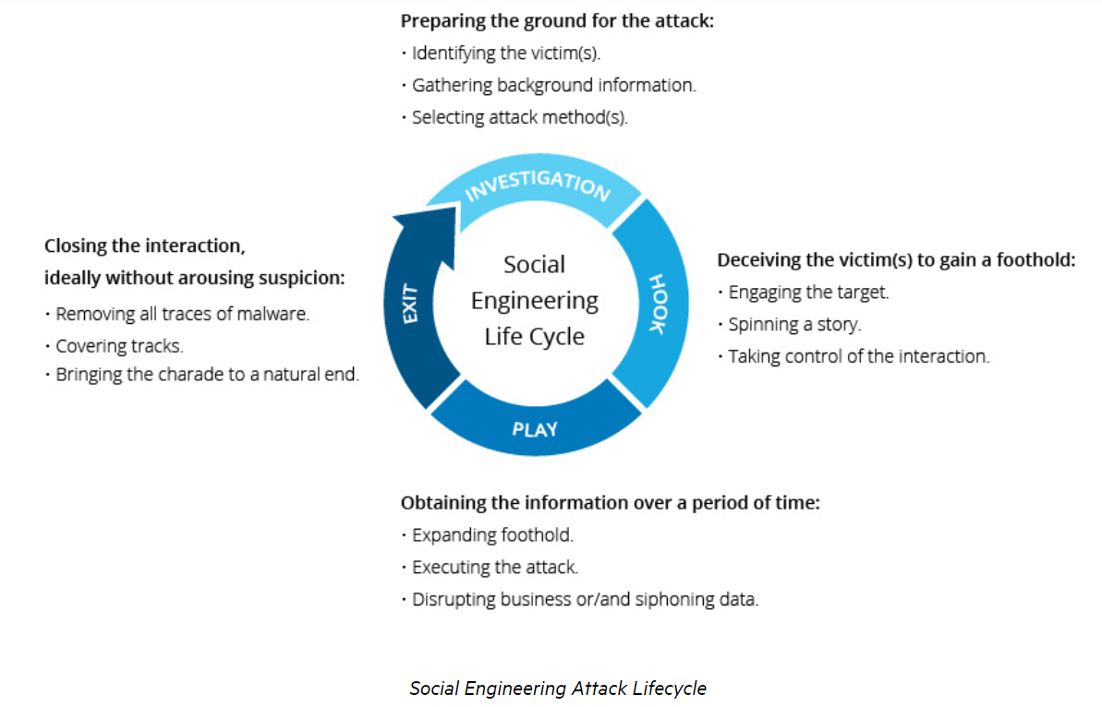
As shown in the figure above, these steps each involve various actions too. The attacker must first investigate the targeted victim to gather necessary background information such as potential points of entry and weak security controls. Then, the attacker attempts to gain the victim’s trust to effectively deliver mechanisms that break security practices and reveal sensitive information or grant access to critical resources.

1
After obtaining all the information it needs over a period and probably causing damage, the attacker leaves without providing any viable evidence of intruder existence (“Social Engineering”, n.d.).
Types of social engineering attacks
Social engineering attacks come in many different forms and can be launch anywhere where human interaction is involved. In an enterprise, such attacks are mostly seen in the user domain of a typical IT infrastructure. Two common forms of social engineering attacks are phishing and tailgating.
Phishing
Phishing is a form of a fraudulent email where users are tricked into giving away their login credentials. Such emails contain links to malicious websites or attachments that contain malware. Phishing emails can target anyone in the organization. The attacker’s incentive is to gain access to critical information by establishing trust and impersonating someone else, such as the help desk staff, clients, or executives. This technique becomes successful when users are effectively tricked into providing their information or install malware on their systems.
Tailgating
Tailgating, also known as piggybacking, is another form of social engineering attack in which an unauthorized person physically follows an authorized person into a restricted corporate area or system. Such attacks can target anyone in the organization. All the attacker must do is pretend that he or she has something legitimate to do like anyone else who has access to the environment. In a typical attack scenario, the intruder impersonates a delivery driver, technician, or caretaker with their hands full and requests an employee or the receptionist to hold or open the door for them.
Once the attacker gains access, they can look around for open offices,

2
unsecured workstations, plug-in keyloggers that will send live captured keystroke data back to them and take photos of sensitive information left on desks. With all the information they gathered, they will then analyze the data, to access confidential information (Ballad, Banks, Chapple & Ballad, 2017).

Security awareness training solutions to offset the social engineering attacks

There are various ways to raise awareness and countermeasures against the attacks described above. First, an organization should require regular mandatory social engineering training for all employees. Workers should be familiar with what a social engineering attack looks like, the most commonly used attack mechanisms, and get tested regularly by the IT staff to ensure their understanding (Hulme & Goodchild, 2017). They should also report attacks such as phishing so that the staff documents it and takes appropriate measures. Additionally, they should always verify that people are who they say they are and avoid giving them easy access to corporate infrastructure.
Moreover, enterprises should provide detail briefing on the latest social engineering attack. They should also review the existing process and procedures for security controls. Leadership must also ensure that employees understand the reasons for controls such as multifactor authentication and up to date antivirus/antimalware software.

3
Conclusion
Understanding social engineering and attack tactics is essential to protect the critical infrastructure of business and resist attacks that could damage assets and expose data to unauthorized individuals. Specifically, this paper described social engineering is, the attack lifecycle and two common social engineering attacks, namely, phishing and tailgating. Additionally, it discussed countermeasure and awareness training solutions to offset the identified social engineering attacks. Furthermore, the paper suggested a viable defense mechanism that involves both employees and leadership to resist such attacks.

4
References

Ballad, B., Banks, E, K., Chapple, M., Ballad, B. (2017). Access Control, Authentication, and Public Key Infrastructure, Second Edition. Burlington, MA. Jones & Bartlett Learning.

Hulme, G. & Goodchild, J. (2017). What is social engineering? 3 ways criminal exploit human behavior.CSO. Retrieved from https://www.csoonline.com/article/2124681/what-is-social-engineeing.html

Social Engineering. (n.d.). Imperva Learning Center Retrieved from https://www.imperva.com/learn/application-security/social-engineering-attack/

5

