Threat Intel Alert Bulletin

By

Natnael Kebede

University of Dallas

2019

This Paper Submitted in Partial Fulfillment of the Requirements for

CYBS 7357 – Network Security

Fall 2019

Presented to Professor Brian Wrozek

Table of Contents

Introduction………………………………………………………………………………………iii
Executive Summary………………………….…………………………………….……...……1
Technical Information Overview ……….………………...…………………………….….….1
Mitigation Recommendations ……………………………………………...………………….3
Detection…………………………………...………………….………………………...3
Prevention…….……………………………….…...………………….………………...3
Responding….…………………………………………...………………….……….….3
Paying or Not Paying the Ransom ………....………………….……………....….….4
Conclusions……………………………………………………………………………………...5
References…………………………………………………………………...……………………...6

ii
Introduction

Ransomware is a type of malicious software that prevents users from accessing their computer system or data, usually by encryption, until the victim pays a certain fee to the hacker. In many cases, the ransom demand has a deadline by which the victim needs to pay to regain access to the resources. Such attacks come in many shapes and sizes. One of the well-known types of ransomware is crypto malware.
This paper provides a clear explanation of the WannaCry ransomware, a crypto malware that targeted thousands of computers around the world and spread itself within corporate networks globally. It also examines how the ransomware works and provides mitigation recommendations, including ways to prevent, detect, and react. Lastly, the paper offers options regarding paying or not paying the ransom.
The goal of this threat intelligence alert bulletin is to ensure that all BeHealthy HealthCare’s state affiliations are aware of the threat. Moreover, it suggests that they take appropriate actions to protect themselves.

iii
Executive Summary
WannaCry is a type of crypto-malware ransomware that encrypts files stored on a computer or mobile device to extort money. The ransomware leverages vulnerabilities in the Windows operating system and exploits them to spread rapidly across several computer networks. After infecting Windows computers, WannaCry encrypts files on the PC’s hard drive, making it impossible for users to access them. After encryption, it demands a ransom payment in bitcoin to decrypt the files (Fruhlinger, 2018).
It is believed that the NSA discovered the vulnerability in the Windows operating system. However, instead of reporting it, the agency developed a code to exploit it, called Eternal Blue. Microsoft had also discovered the vulnerability a month before and released a patch. Unfortunately, the exploit was stolen by the Shadow Brokers hacking group on April 8, 2017, when many systems were still vulnerable. WannaCry used Eternal Blue and began spreading across computer networks on May 12, 2017 (Fruhlinger, 2018). Since then, the ransomware worm had infected over 250,000 systems before a kill switch was tripped to stop its spread. Computers in as many as 150 countries, including systems in the National Health Service of England and Scotland, were affected. In those counties, WannaCry prevented doctors from accessing patient records and forced emergency rooms to turn away ambulances (Rouse, 2018). WannaCry infections were also seen in other enterprises such as manufacturing, energy (oil and gas), technology, food and beverage, education, media, communications, and government (“WannaCry/Wcry Ransomware”, 2017).

Technical Information Overview

WannaCry ransomware targets and encrypts 176 file types, including database, multimedia, archive files, and Office documents. To accomplish the attack, the ransomware leverages a vulnerability in Server Message Block, CVE-2017-0144.

1
Once the vulnerability is identified, it propagates without any user interaction. That is, it only takes one user on a network to be infected for the entire network to be at risk (“WannaCry/Wcry Ransomware”, 2017). The infection stages of how WannaCry works is shown below.
Figure 1: Screenshot of Trend Micro XGen Security detect and block of WannaCry by Trend Micro
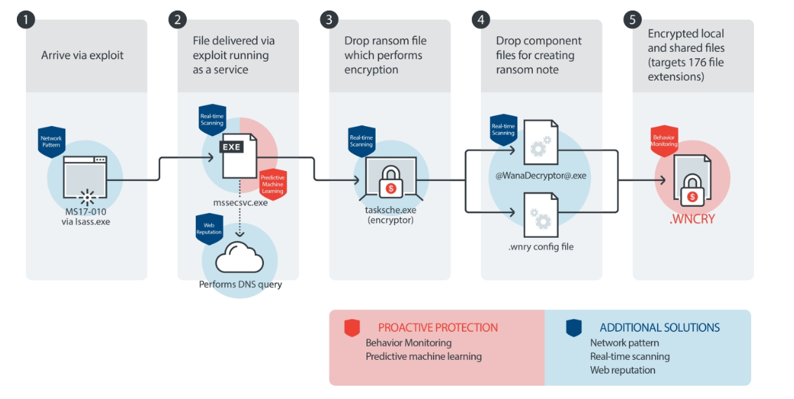
First, WannaCry identifies the Windows operating system Server Message Block (SMB) protocol vulnerability (now addressed by Microsoft’s MS17-010 patch) and delivers a dropper that allows malicious software to be executed. Once the dropper is executed, it attempts to make a connection to the domain http://www[.]iuqerfsodp9if aposdfjhgosurijfaewrwergwea[.]com and exits if the connection is successful. At this stage, the dropper also creates a service called “mssecsvc” with the display name “Microsoft Security Service Center Service”. The dropper then extracts the encryptor binary file and executes it. During the extraction process, the dropper also delivers a directory named “msg” that contains files in various languages that will be used by the @WanaDecryptor@.exe program to address the ransom note. The malware then attempts to change the attributes of all the user’s files to hidden and grants itself full access to the current directory and any directories below (“ A Technical Analysis…”, n.d.).
2
WannaCry then proceeds to encrypt files on the user’s system, searching for file extensions 176 file extensions are targets during this process. Lastly, the WannaCry encryptor launches the @WanaDecryptor@.exe program, which displays instructions for sending the ransom in the configured language of the infected system (“ A Technical Analysis…”, n.d.).
Mitigation Recommendations
Mitigation strategies against WannaCry involve a serious of detection, prevention, and responding techniques that are worthwhile based on a company’s needs, resources, and budget.
Detection
Security tools such as endpoints protection, real-time scanning, and web reputation shown above are the first line of defense. Intrusion Detection Systems (IDS) can also be used to detect ransomware command-and-control and alert against ransomware attacks.
Prevention
Prevention techniques include patching operating systems, installing antivirus software that detects malicious programs such as ransomware as they arrive, and backing up files frequently. Security tools such as firewalls, application control, and behavioral monitoring shown above, can prevent unwanted and unknown applications from executing and block unusual modifications to the system. Additionally, network segregation can prevent the spread of the attack. Furthermore, increasing employee’s social engineering awareness is essential for prevention.
Responding
In the event of an attack, one should locate the system that was infected, disconnect it from the network, and notify the company’s security team and law enforcement.
3
Paying or Not Paying the Ransom
No guarantee that paying a ransom will allow companies to get back their files. Cybercriminals don’t have scruples and could ask for more money, again and again, exporting the organization’s capital but never releasing the data. Additionally, paying ransom encourages cybercriminals to launch further attacks. Instead, organizations must follow best practices and keep system backups that allow them to restore data and resume normal business operations.

4
Conclusion
A ransomware attack is increasingly sophisticated and comes in many shapes and sizes. Specifically, this paper described one of the well-known types of ransomware, WannaCry. WannaCry belongs to the crypto malware ransomware group and encrypts files stored on a computer or mobile device to extort money.
Additionally, the paper examined how the ransomware works and provided mitigation recommendations, including ways to prevent, detect, and react. Furthermore, the bulletin suggested a viable mechanism that addressed the options regarding paying or not paying the ransom in the event of such an attack.

5
References

A Technical Analysis of WannaCry Ransomware. (n.d.). LogRhythm Labs. Retrieved from https://logrhythm.com/blog/a-technical-analysis-of-wannacry-ransomware/

Fruhlinger, J. (2018). What is WannaCry ransomware, how does it infect, and who was responsible? CSO. Retrieved from https://www.csoonline.com/article/3227906/what-is-wannacry-ransomware-how-does-it-infect-and-who-was-responsible.html

Rouse, M. (2018). WannaCry ransomware. TechTarget. Retrieved from https://searchsecurity.techtarget.com/definition/WannaCry-ransomware

WannaCry/Wcry Ransomware: How to Defend against It. (2017). Trend Micro Inc. Retrieved from https://www.trendmicro.com/vinfo/us/security/news/cybercrime-and-digital-threats/wannacry-wcry-ransomware-how-to-defend-against-it

6

