Lab 1
Natnael Kebede
Section 1
- Screen capture showing the active database name
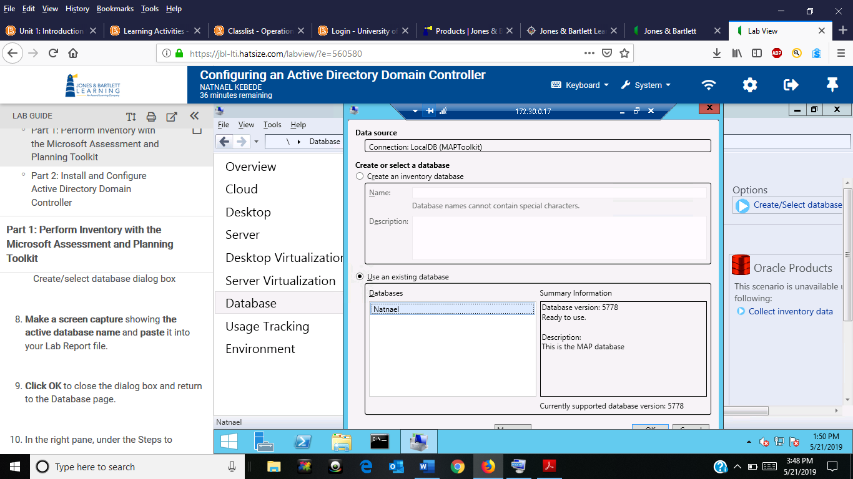
- Screen capture showing the server inventory results
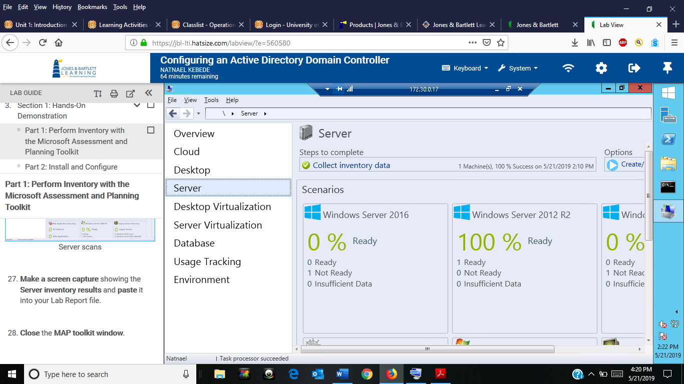
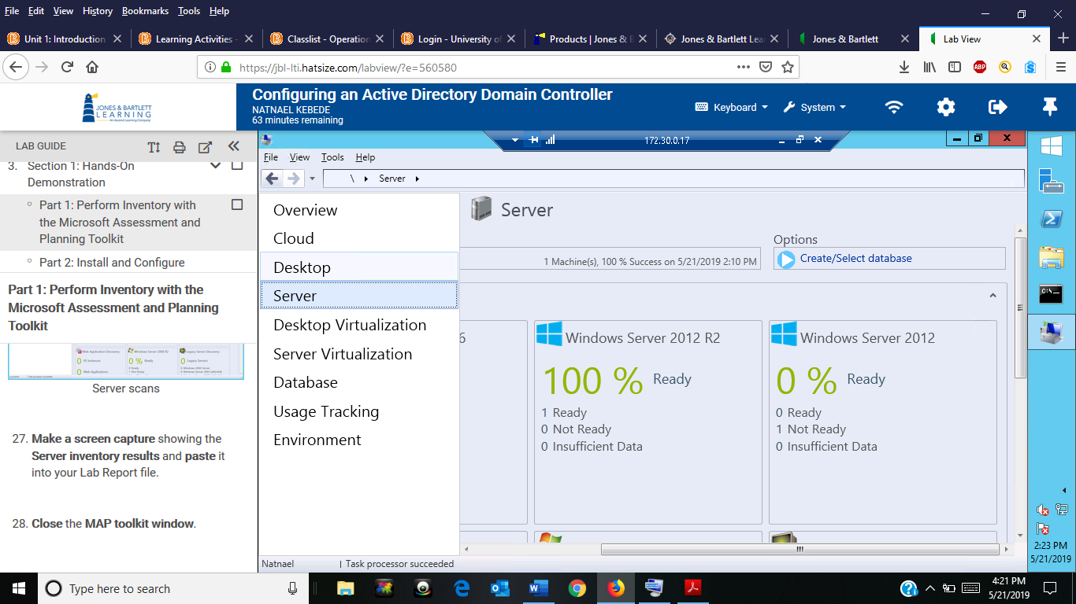

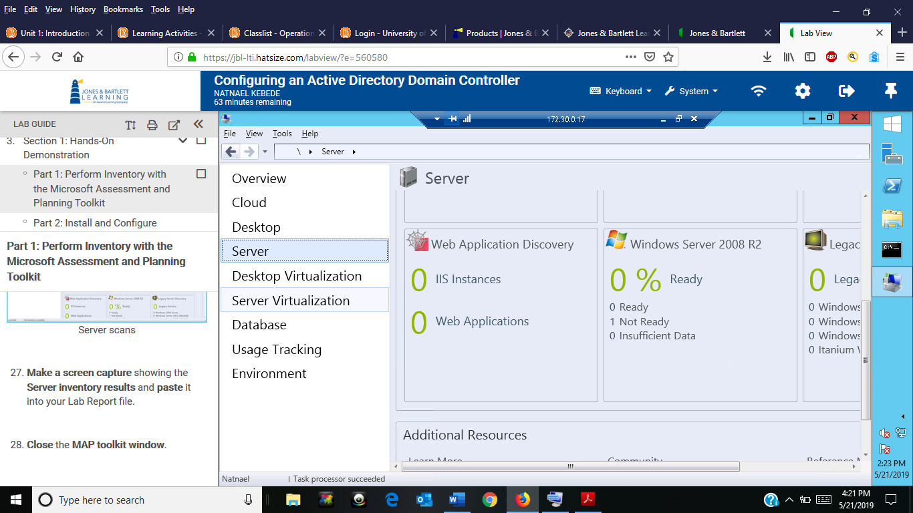
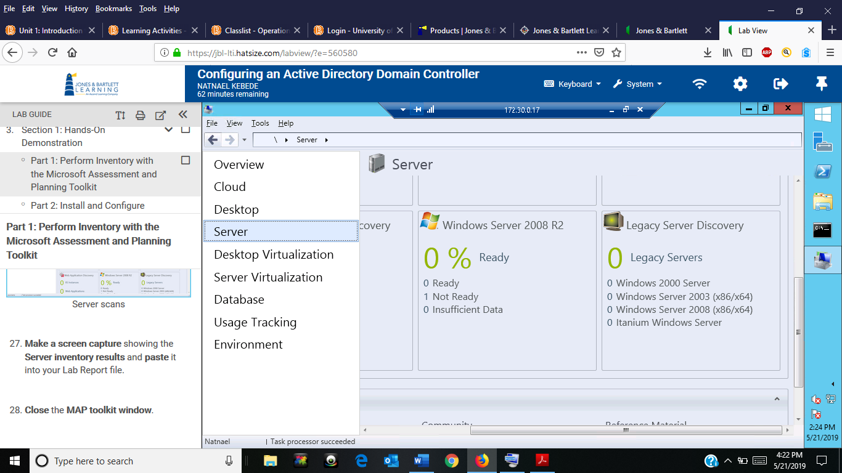
- Screen capture showing the new domain name in the Active Directory Users and Computers window
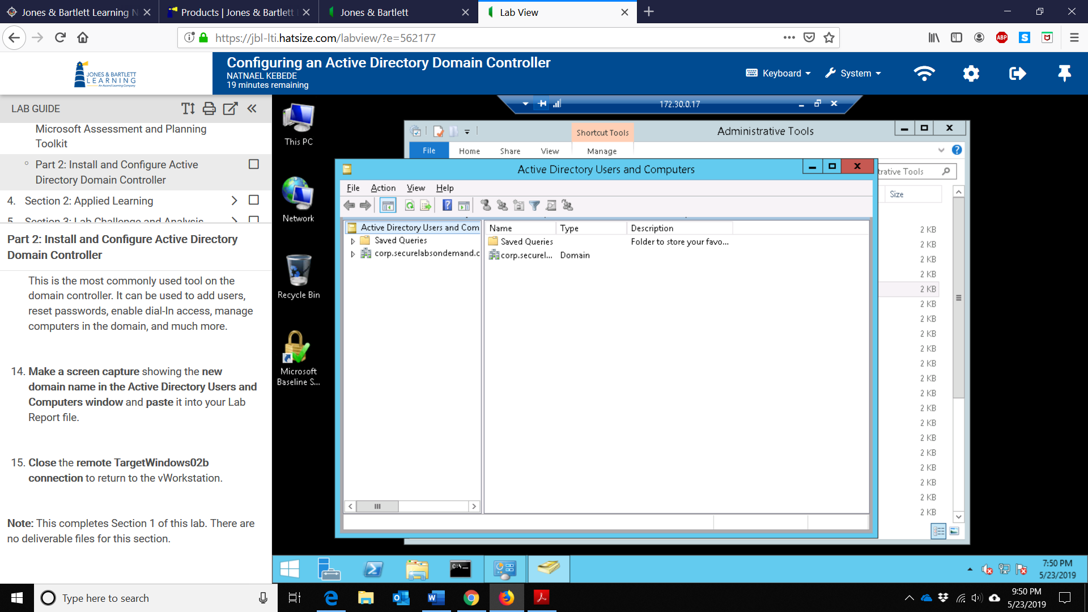

Section 2
- Screen capture showing the summary page of the Inventory and Assessment Wizard
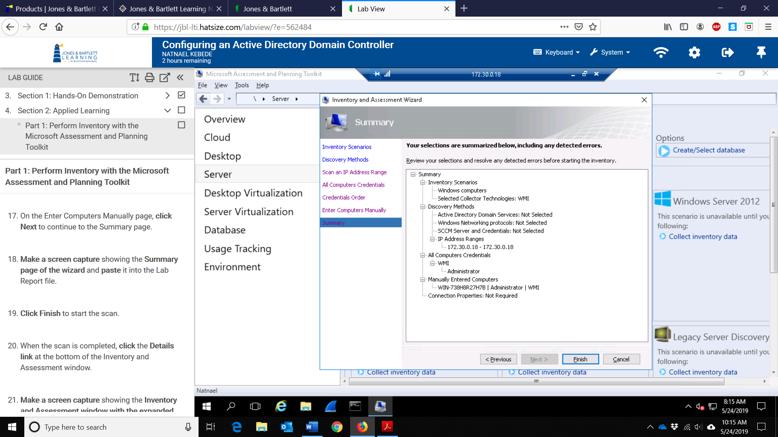
- Screen capture showing the Inventory and Assessment window with the expanded details pane
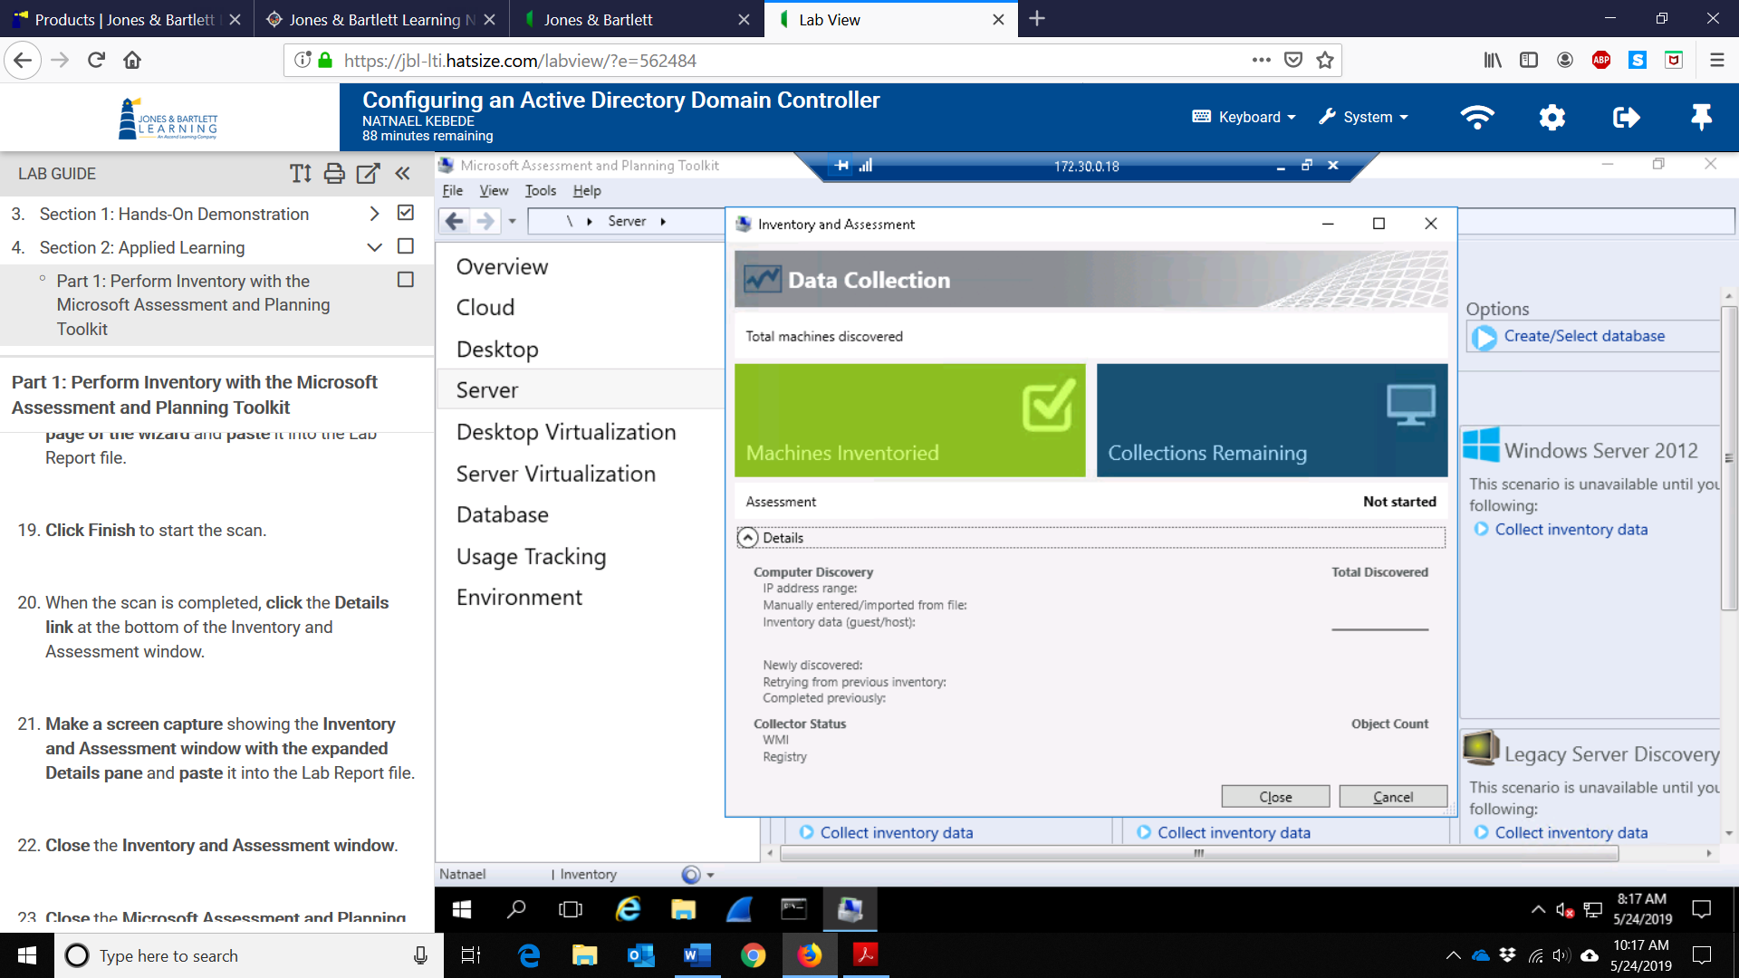

- Screen capture showing the updated Inventory and Assessment window with the expanded details pane
