Lab 10
Natnael Kebede
Section 1
1) Screen capture showing the certificate created in my name
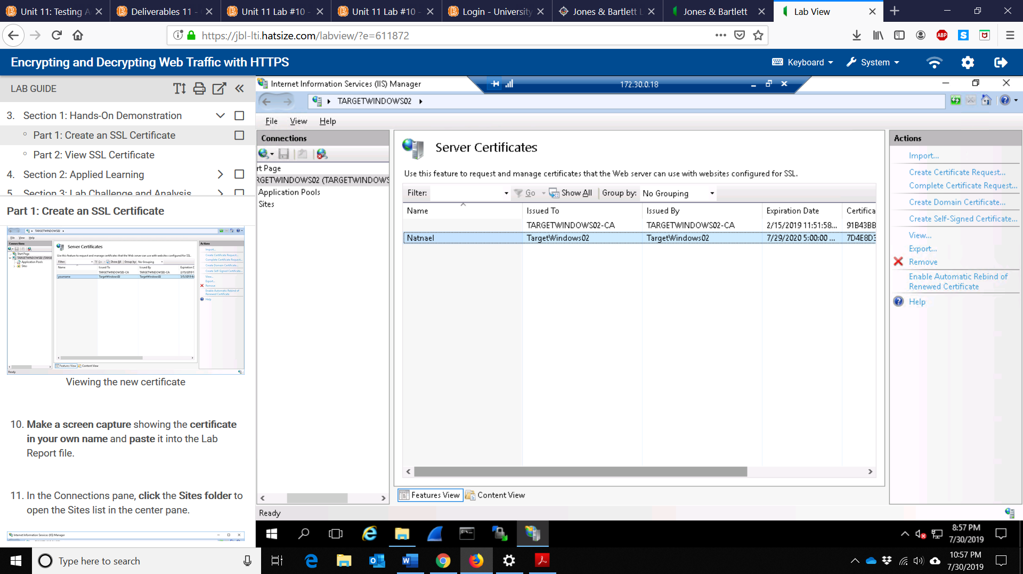

2) Screen capture showing my site binding cofiguration
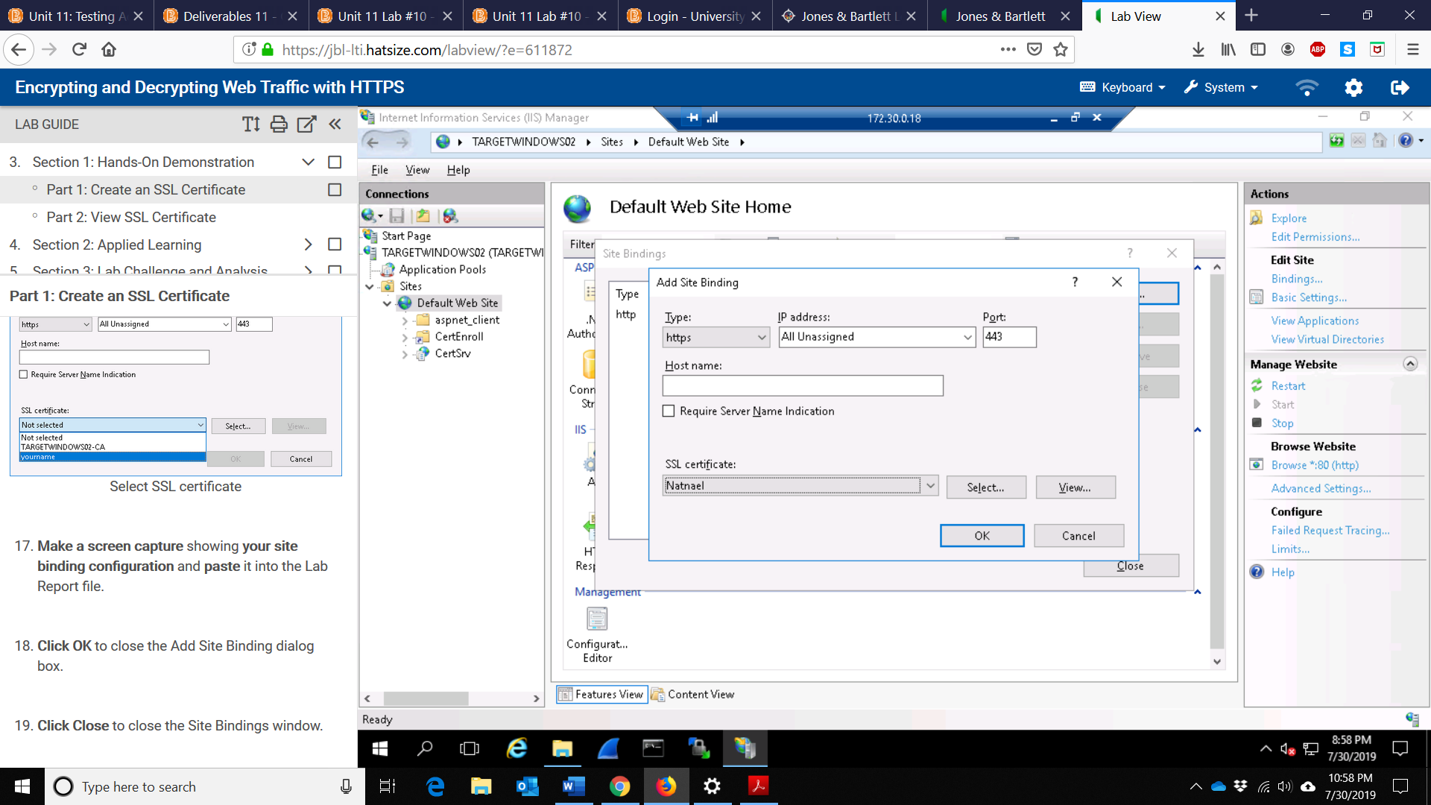

3) Screen capture showing the certificates dialog box
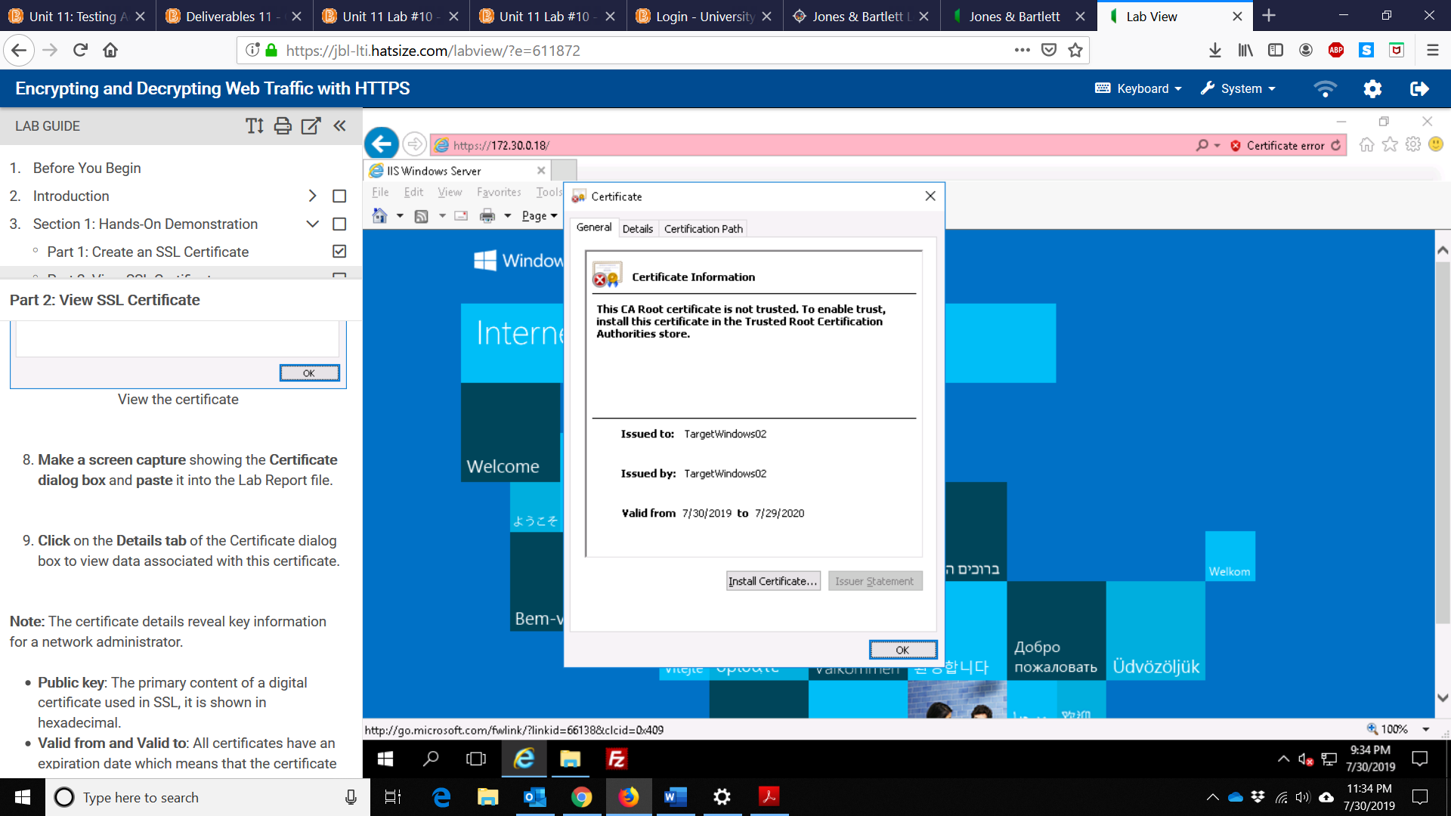

4) Screen capture showing the expiration date for the certificate
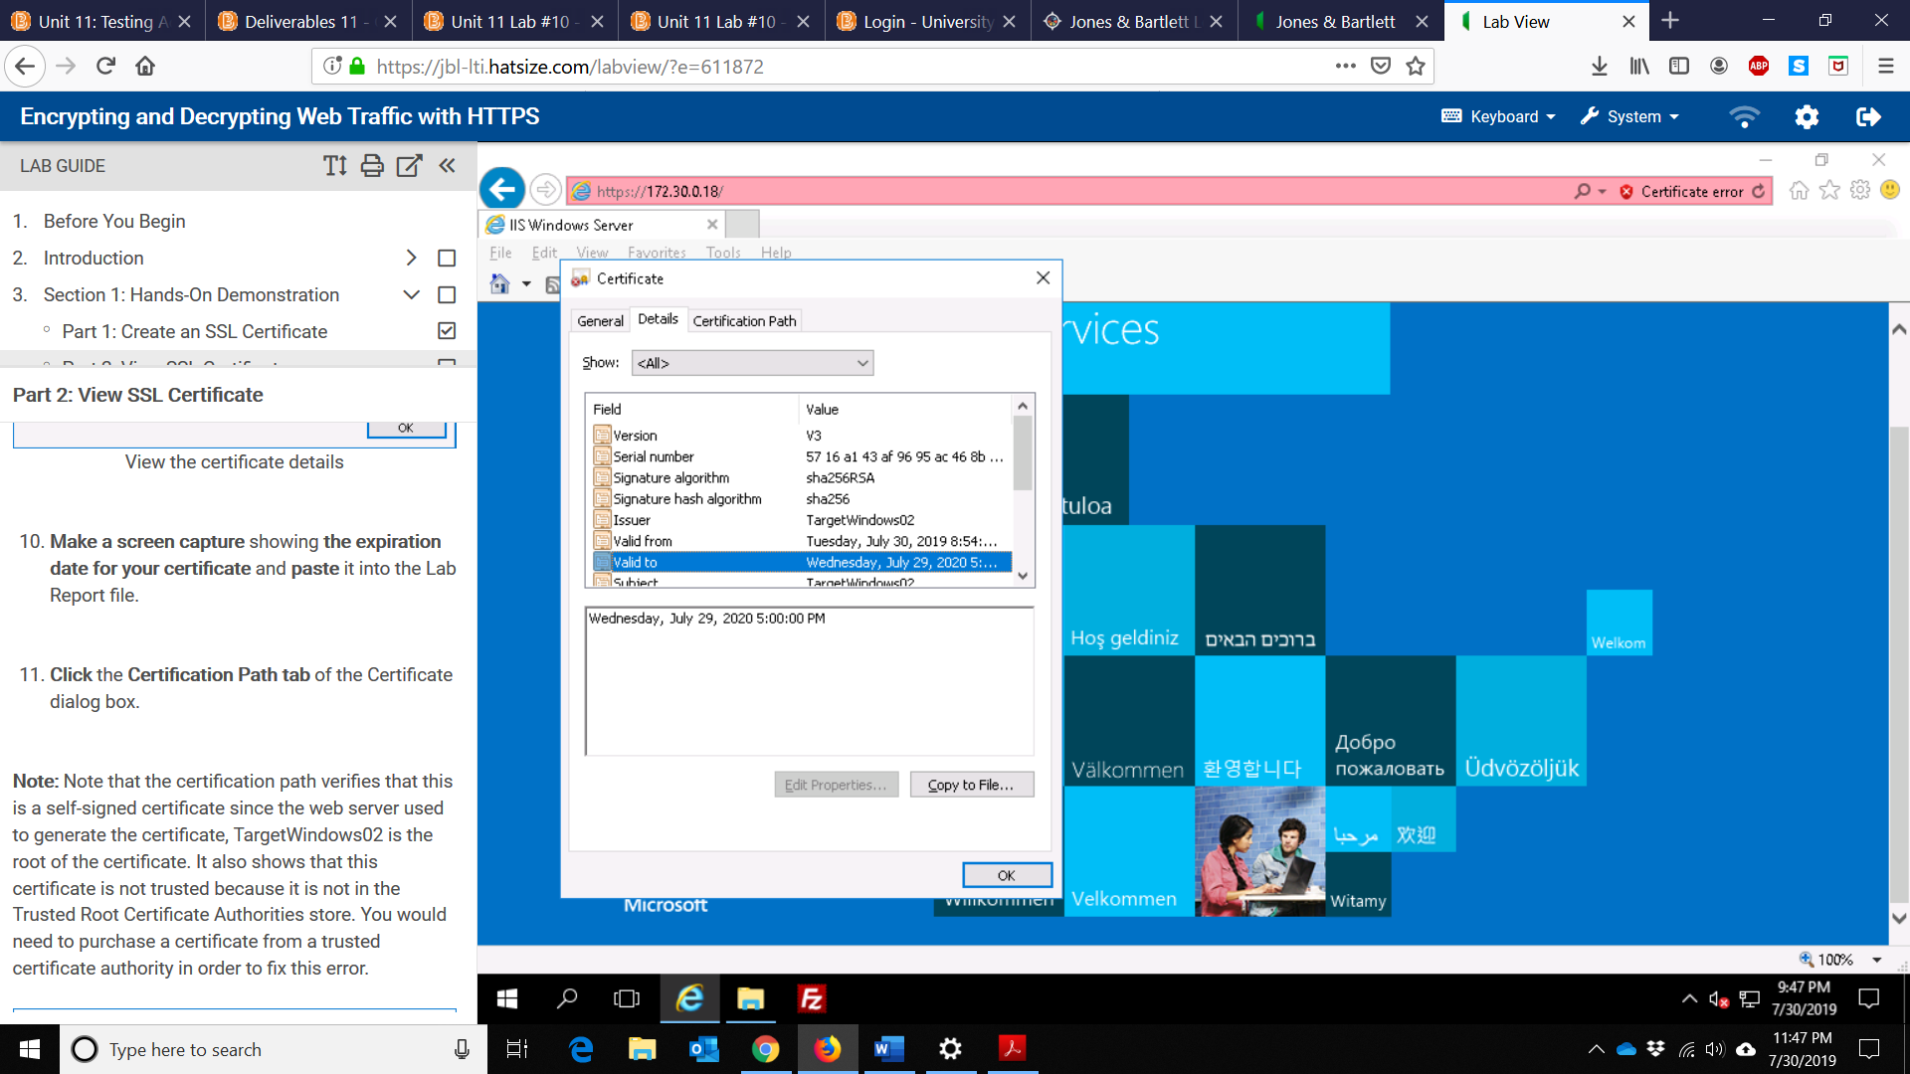

Section 2
1) Screen capture showing the contents of the /etc/apache2/ssl directory
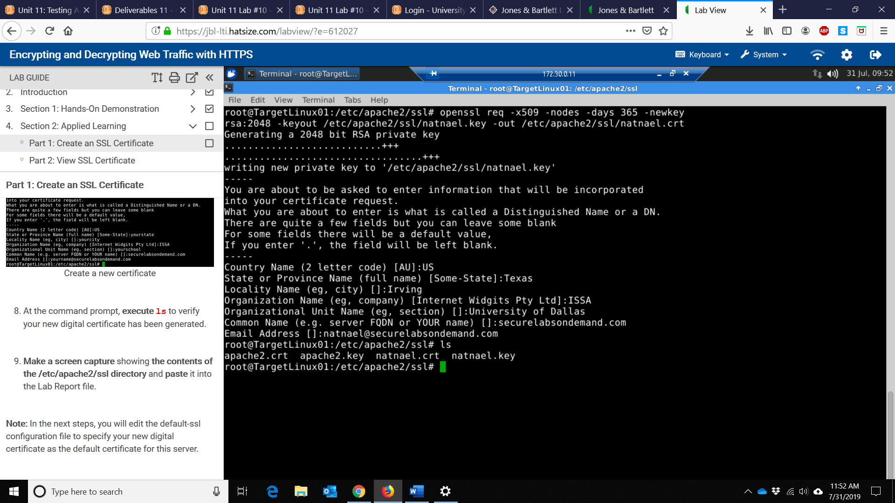
2) Screen capture showing the output of all three echo | openssl commands
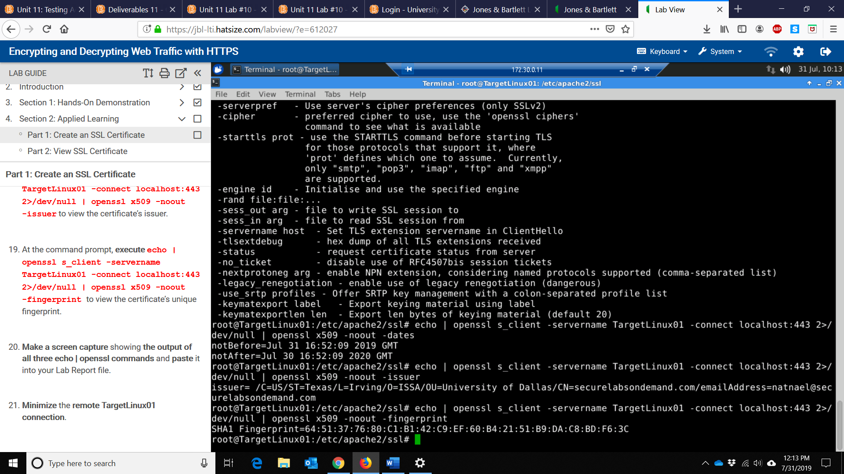

3) Screen capture showing the complete certificate fingerprint
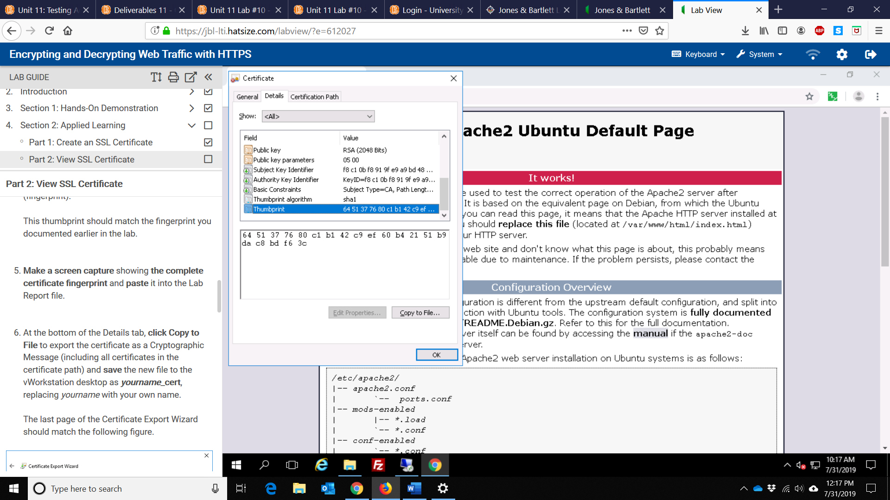
4) Screen capture showing the fingerprint in the certificate viewer
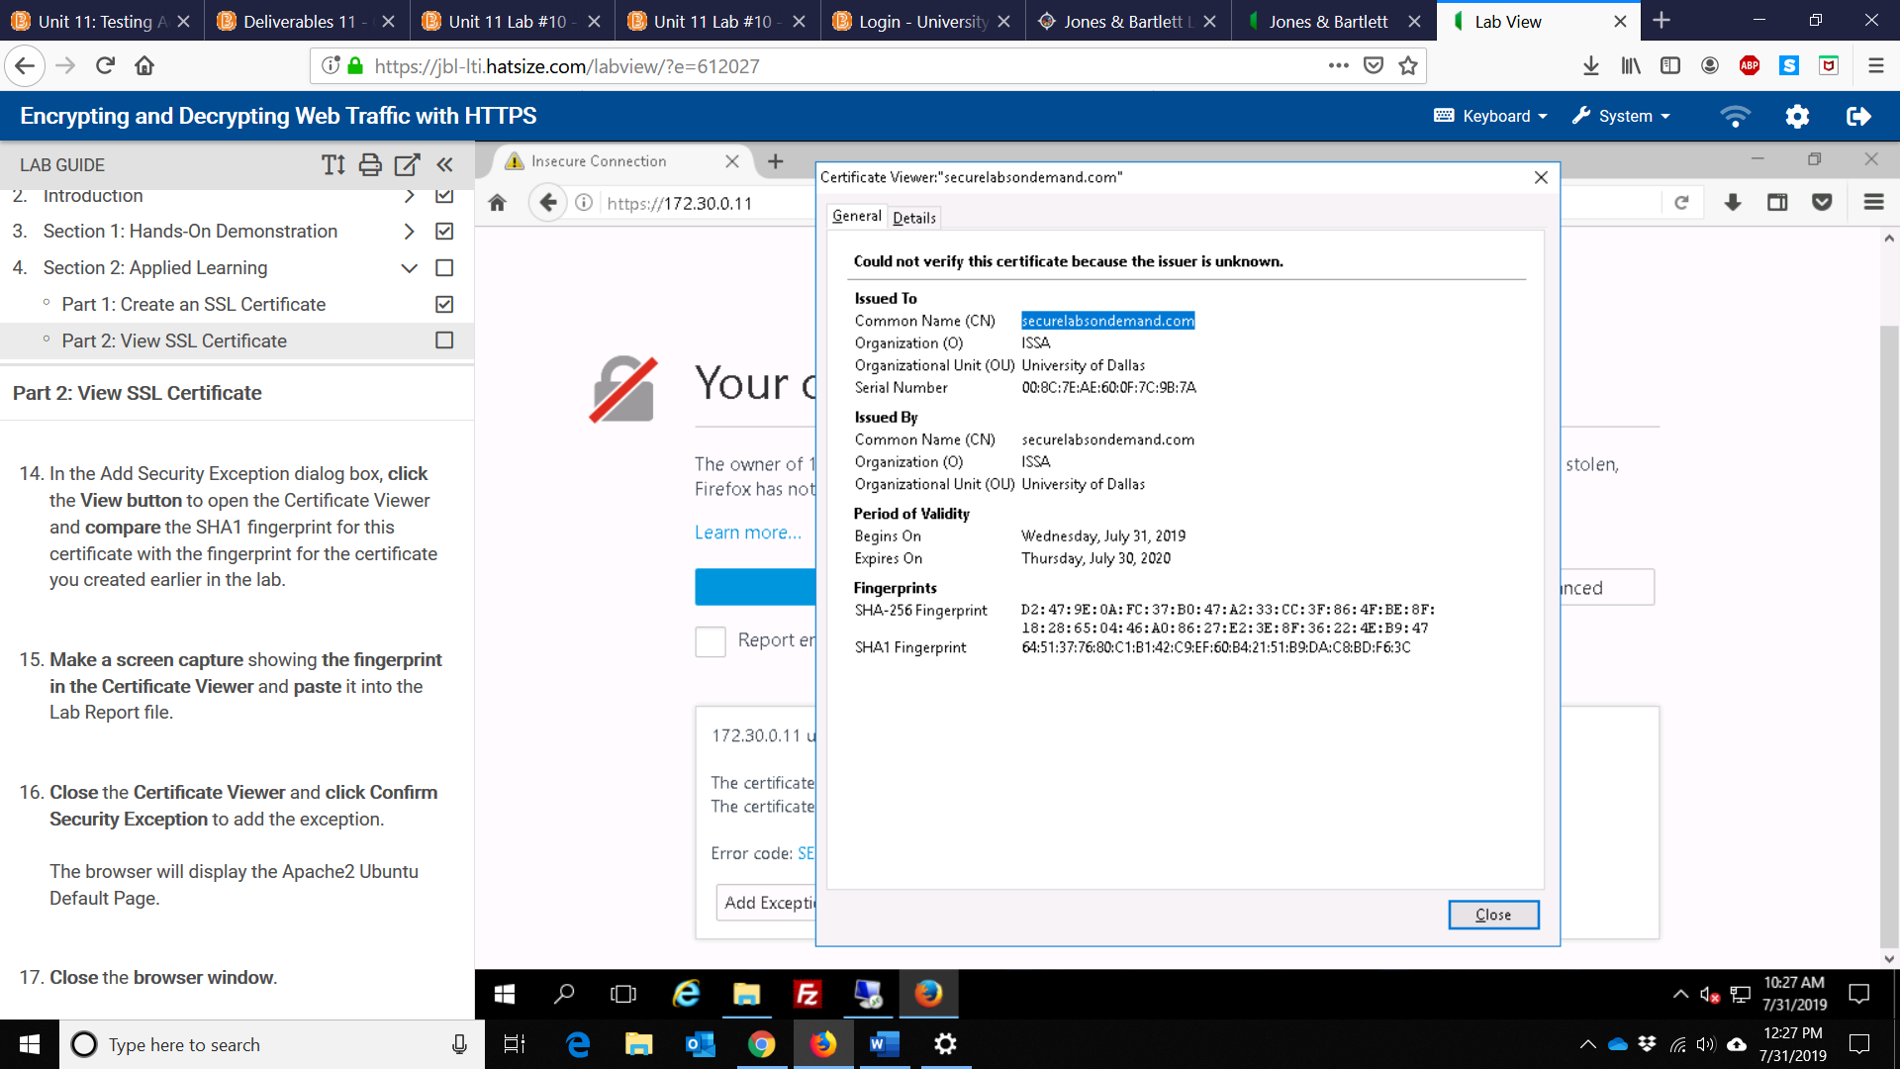

5) Screen capture showing the file permissions in the /etc/apache2/ssl directory
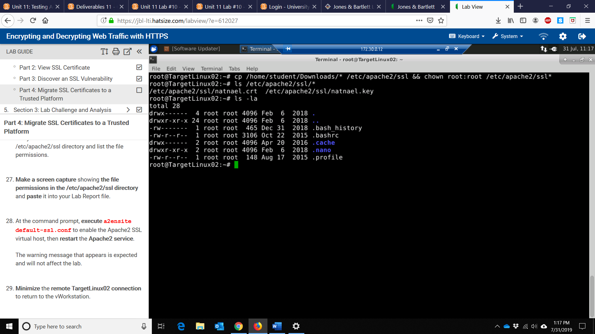
6) Screen capture showing the thumbprint for the certificate on TargetLinux02
