Lab 2
Natnael Kebede

Note: The bullet points show the screen captures instructed for Delivery 2 from bright space
The numbers show the screen capture instructions instructed by Lab 2
Section 1
- Screen capture showing the active directory users and computers showing my personal account
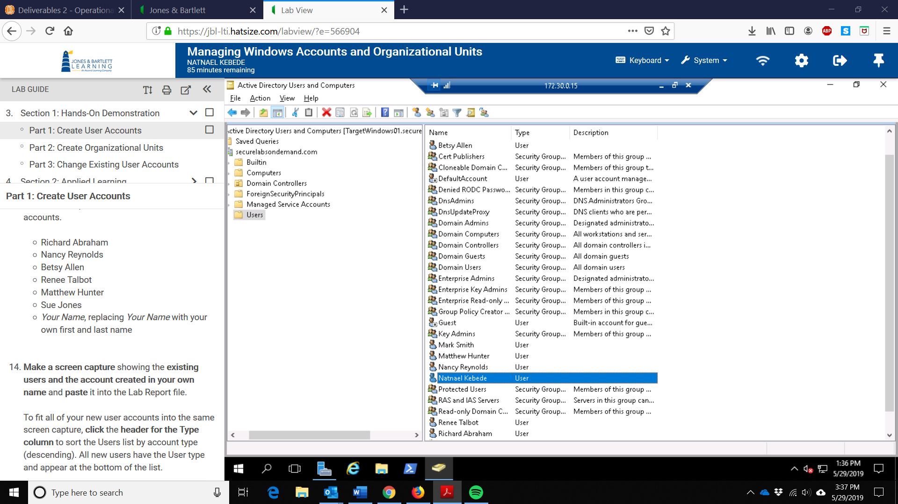
- Screen capture showing the existing users and the account created in my Name
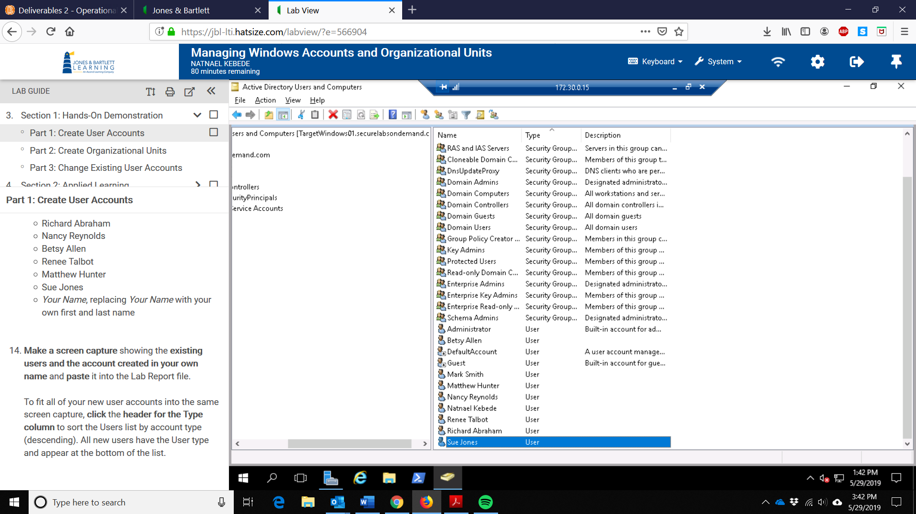

- Screen capture showing the two new organizational units (Students and Facuity)
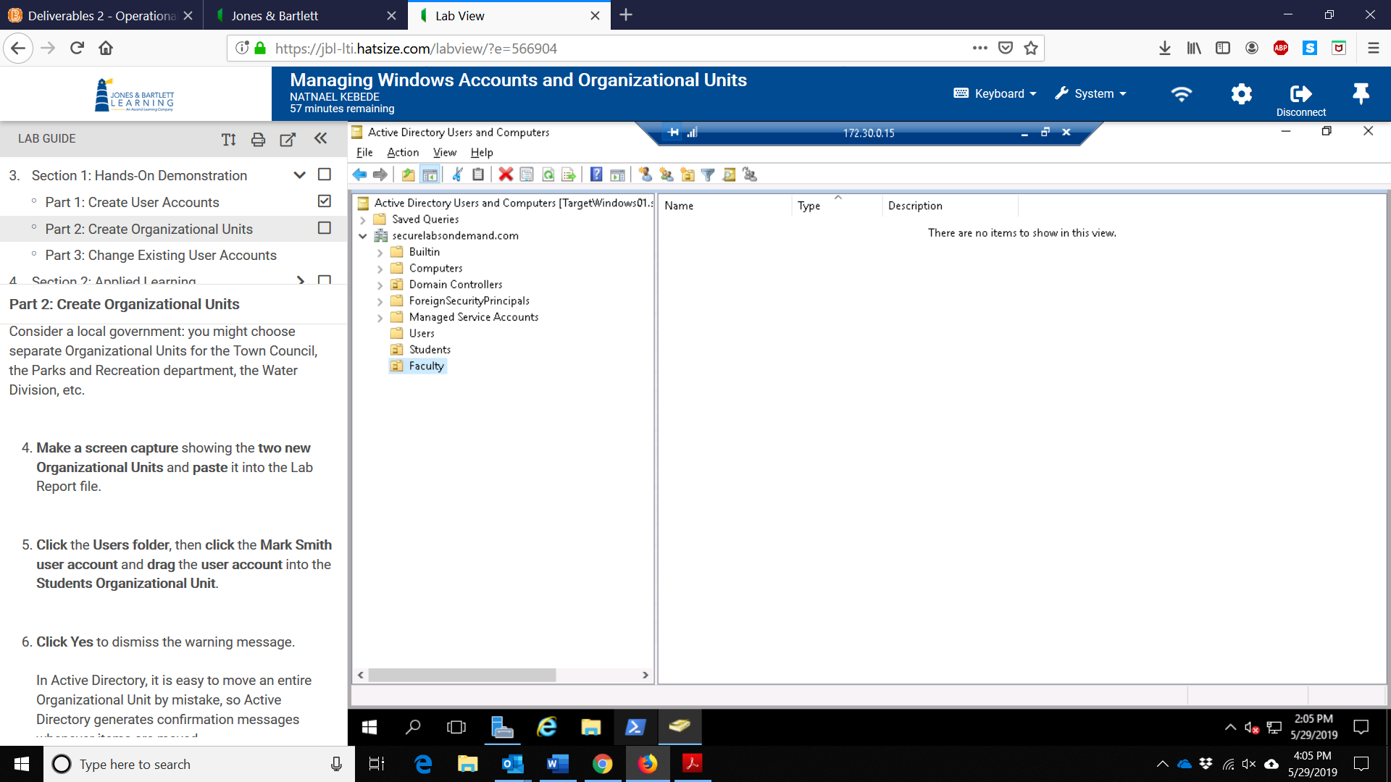
- Screen capture showing the accounts in the faculty organizational unit
- Screen capture showing the active directory users and computers of the faculty organizational unit containing personal accounts
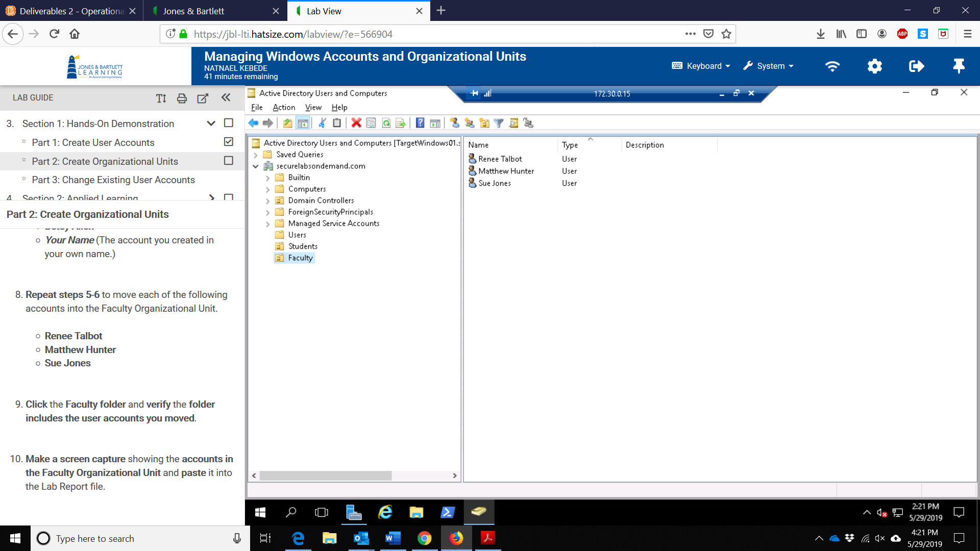

- Screen capture showing the edited contents of the students’ organizational unit
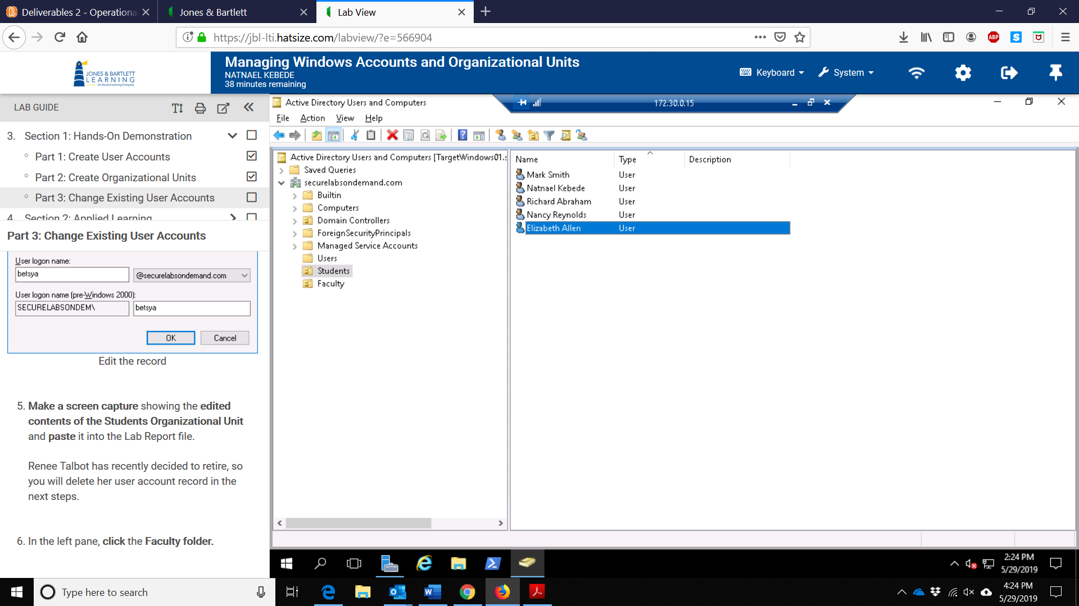
- Screen capture showing the edited contents of the faculty organizational unit
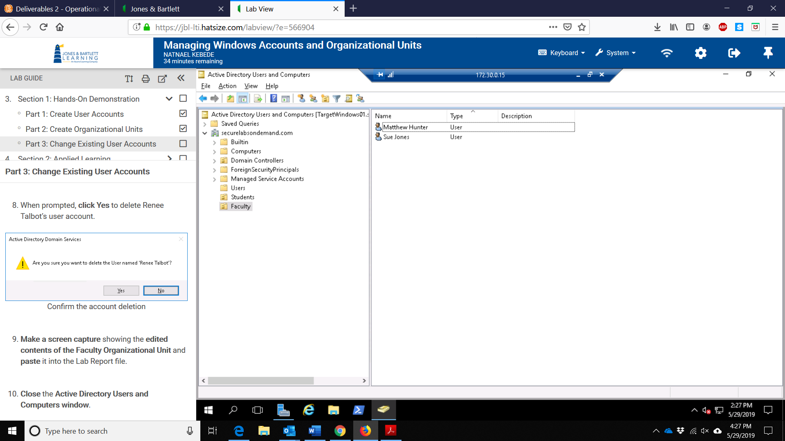

- Screen capture showing the account deletion confirmation pop-up showing my name
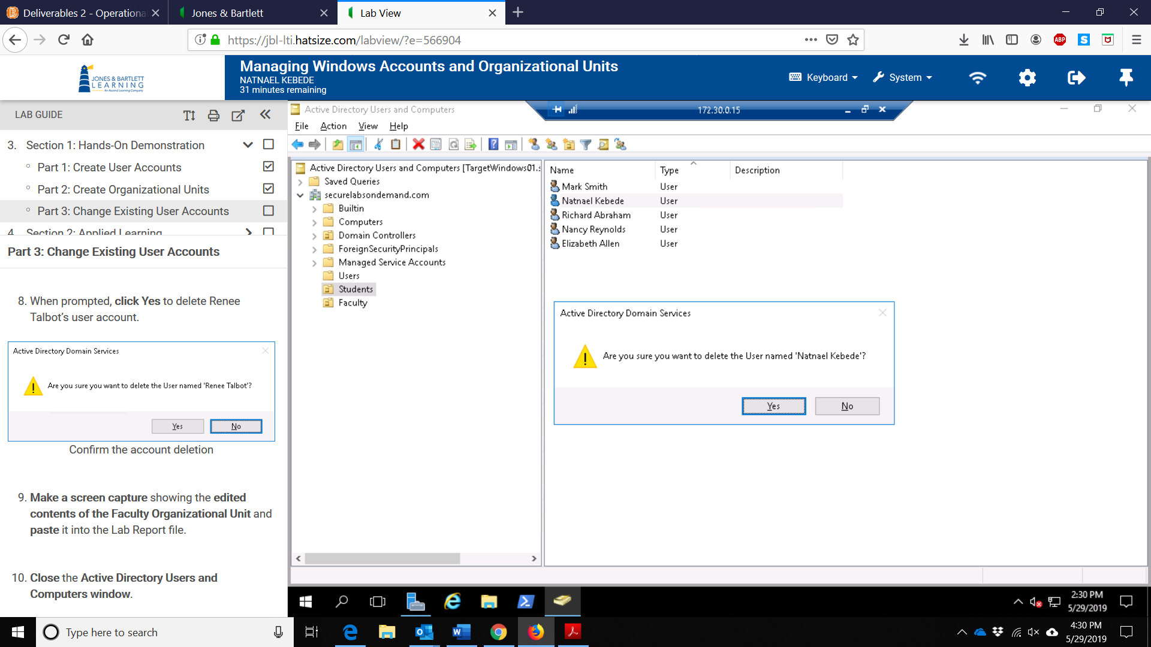
Section 2
- Screen capture showing the user account details for my own user account
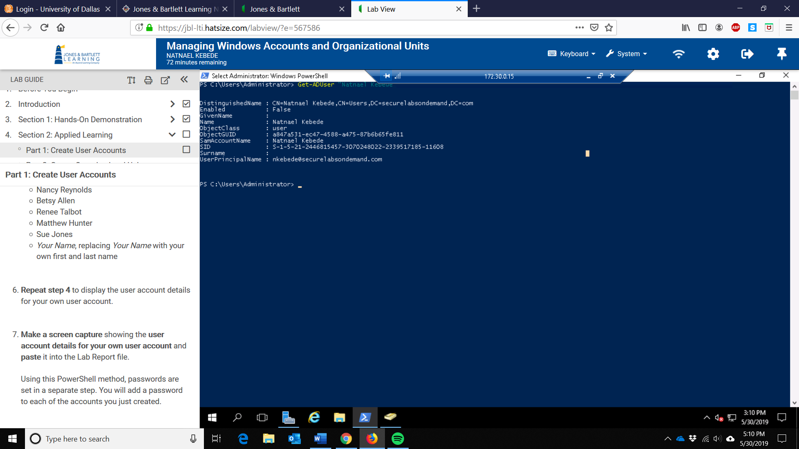
- Screen capture showing the PowerShell commands that enabled all of the user accounts
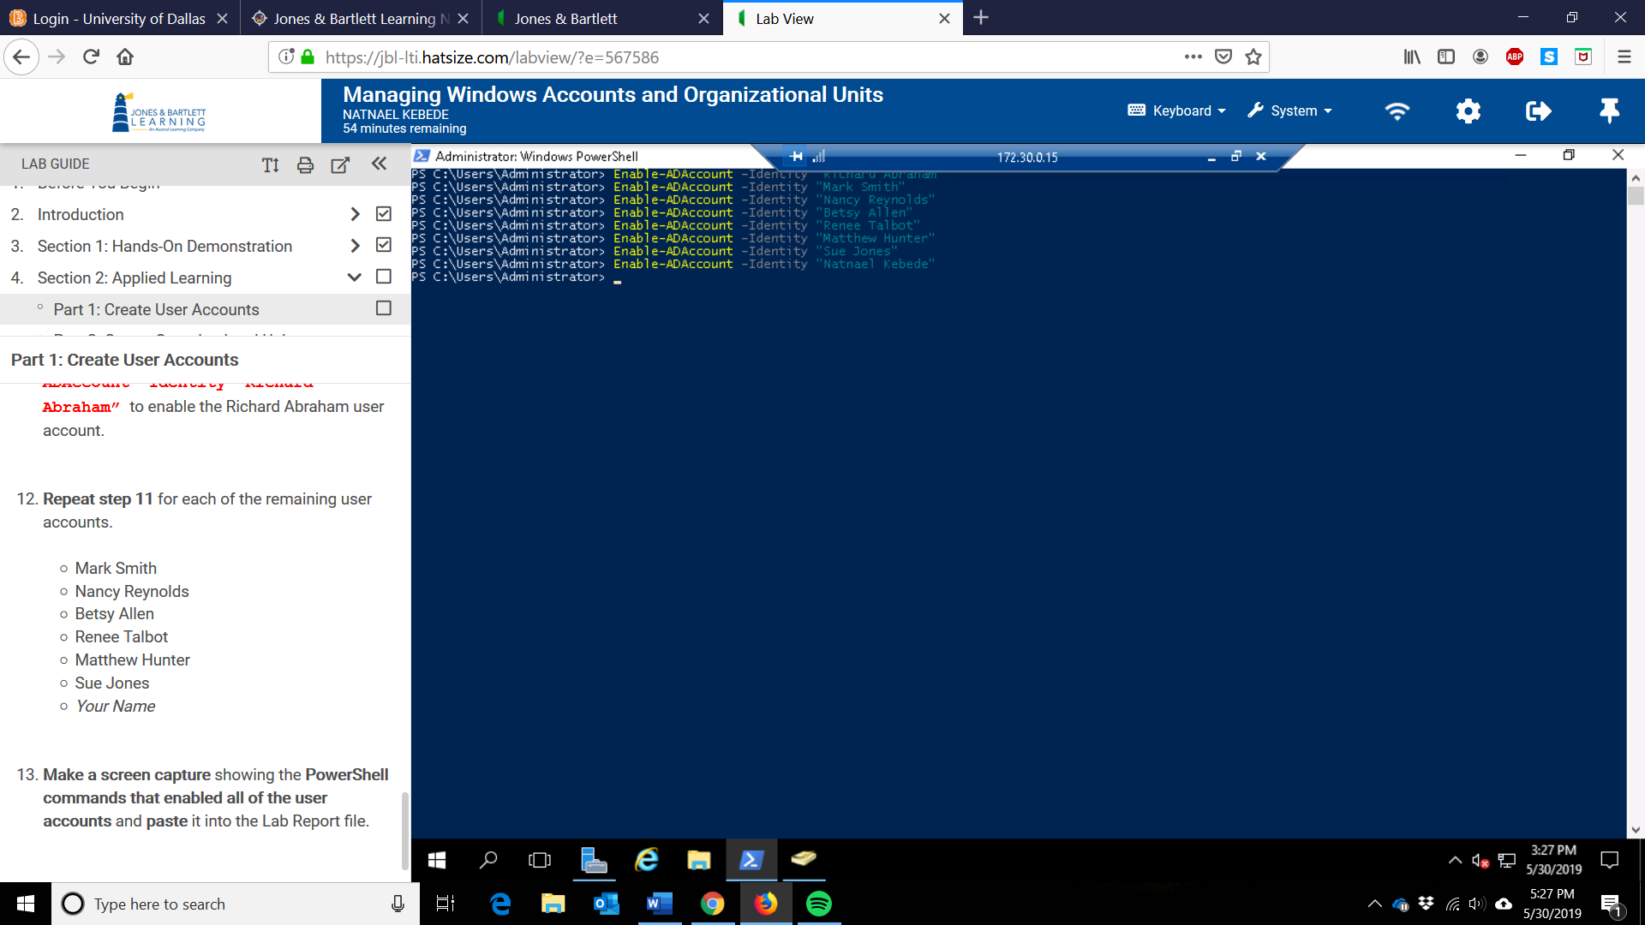
- Screen capture showing the users in the Faculty Organizational Unit
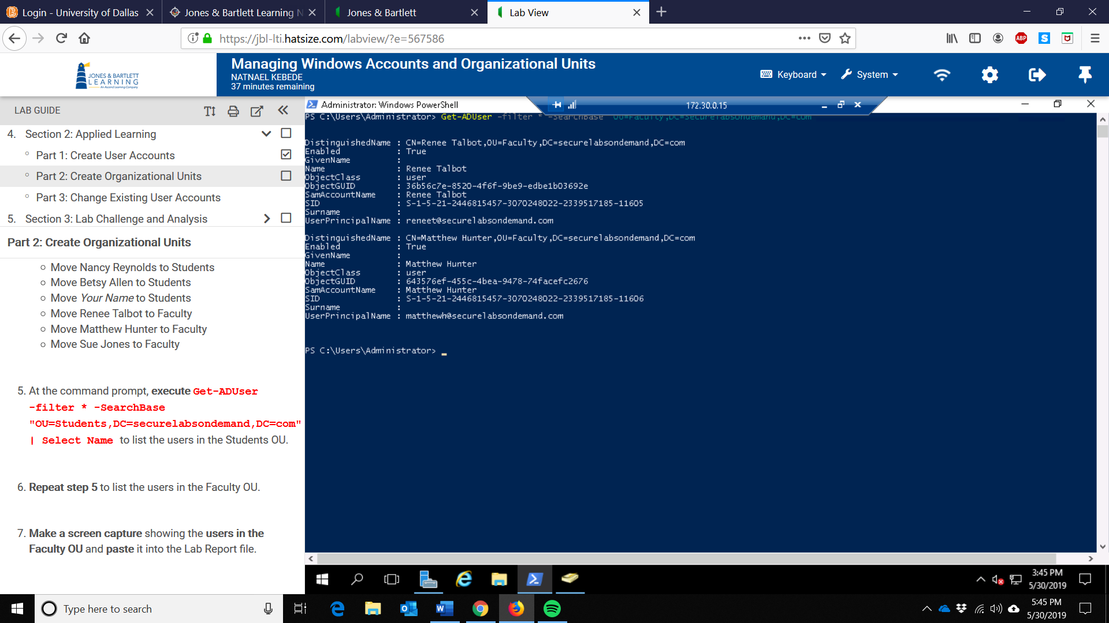

- Screen capture showing the details for the disabled user account created in my name.
