Lab 4
Natnael Kebede

Note: The letters show the screen captures instructed for Delivery 4 from bright space
The numbers show the screen capture instructions instructed by Lab 4
Section 1
- Screen capture showing the minimum password length setting changed to 10 characters 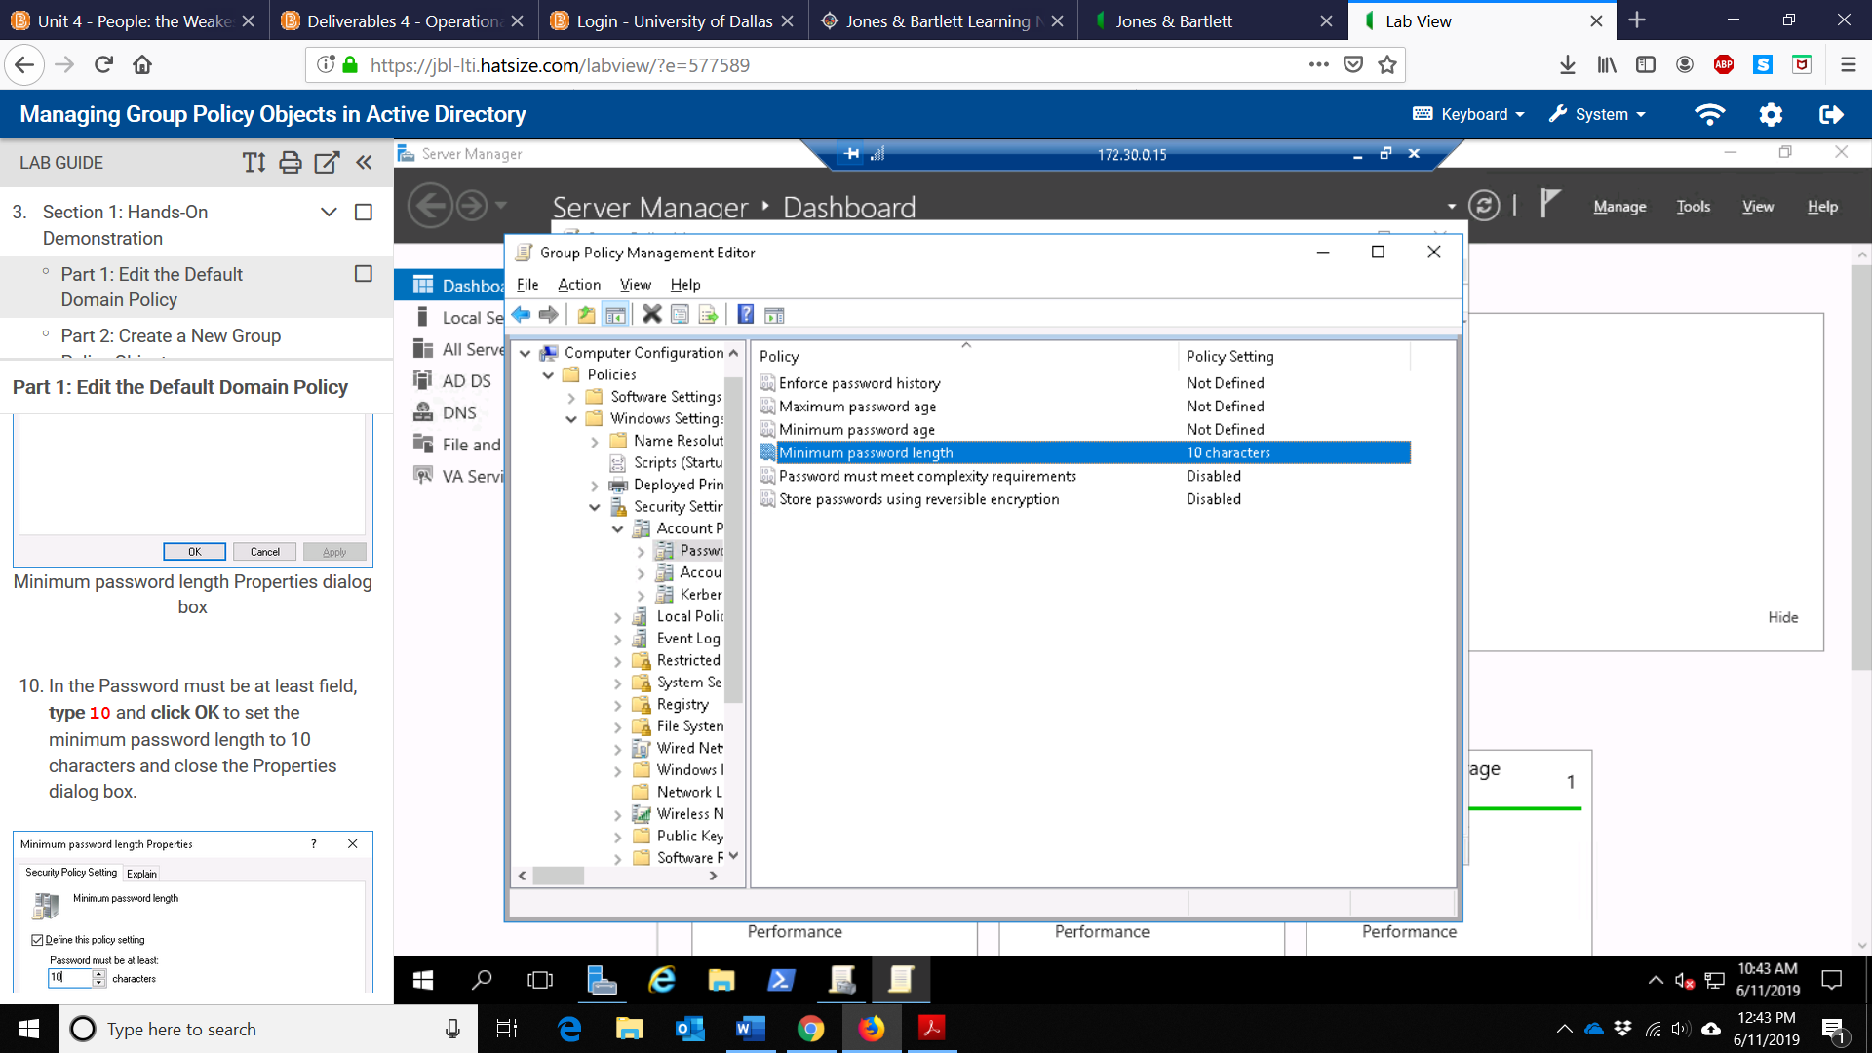
- Screen capture showing the updated password policies
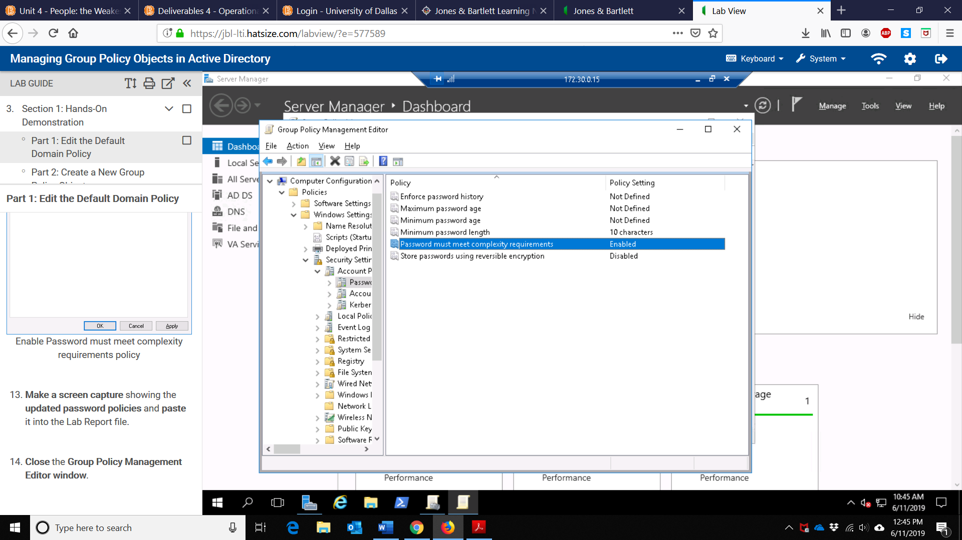
- Screen capture of the logon hours properties windows showing that the policy setting is defined and enabled
- Screen capture showing the updated security settings in the group policy management editor
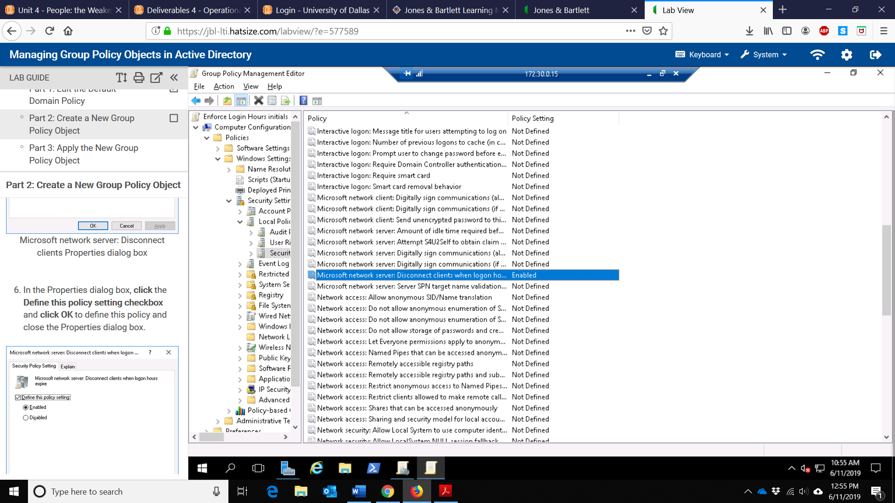
- Screen capture of the Students OU with the Enforce Login Hours GPO applied
- Screen capture showing the linked GPO in the group policy management window
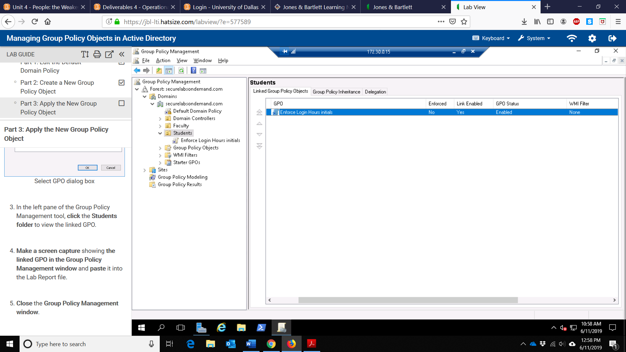
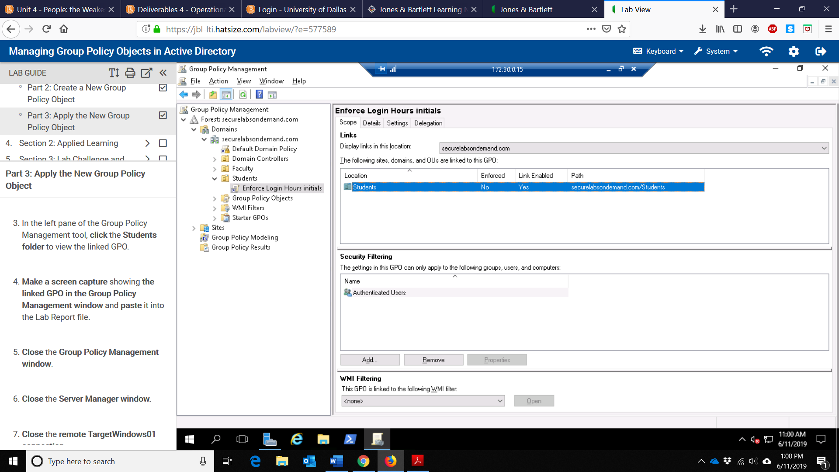
Section 2
- Screen capture showing the newly configured password policy in the GPO
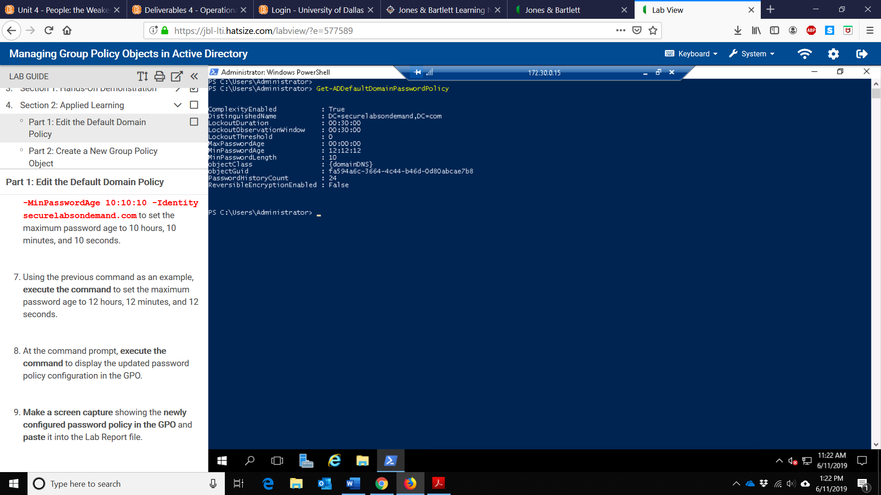

- Screen capture showing the results of the GPLink command
