Lab 5
Natnael Kebede

Note: The letters show the screen captures instructed for Delivery 5 from bright space
The numbers show the screen capture instructions instructed by Lab 5
Section 1
- Screen capture showing the failed HTTP connection attempt
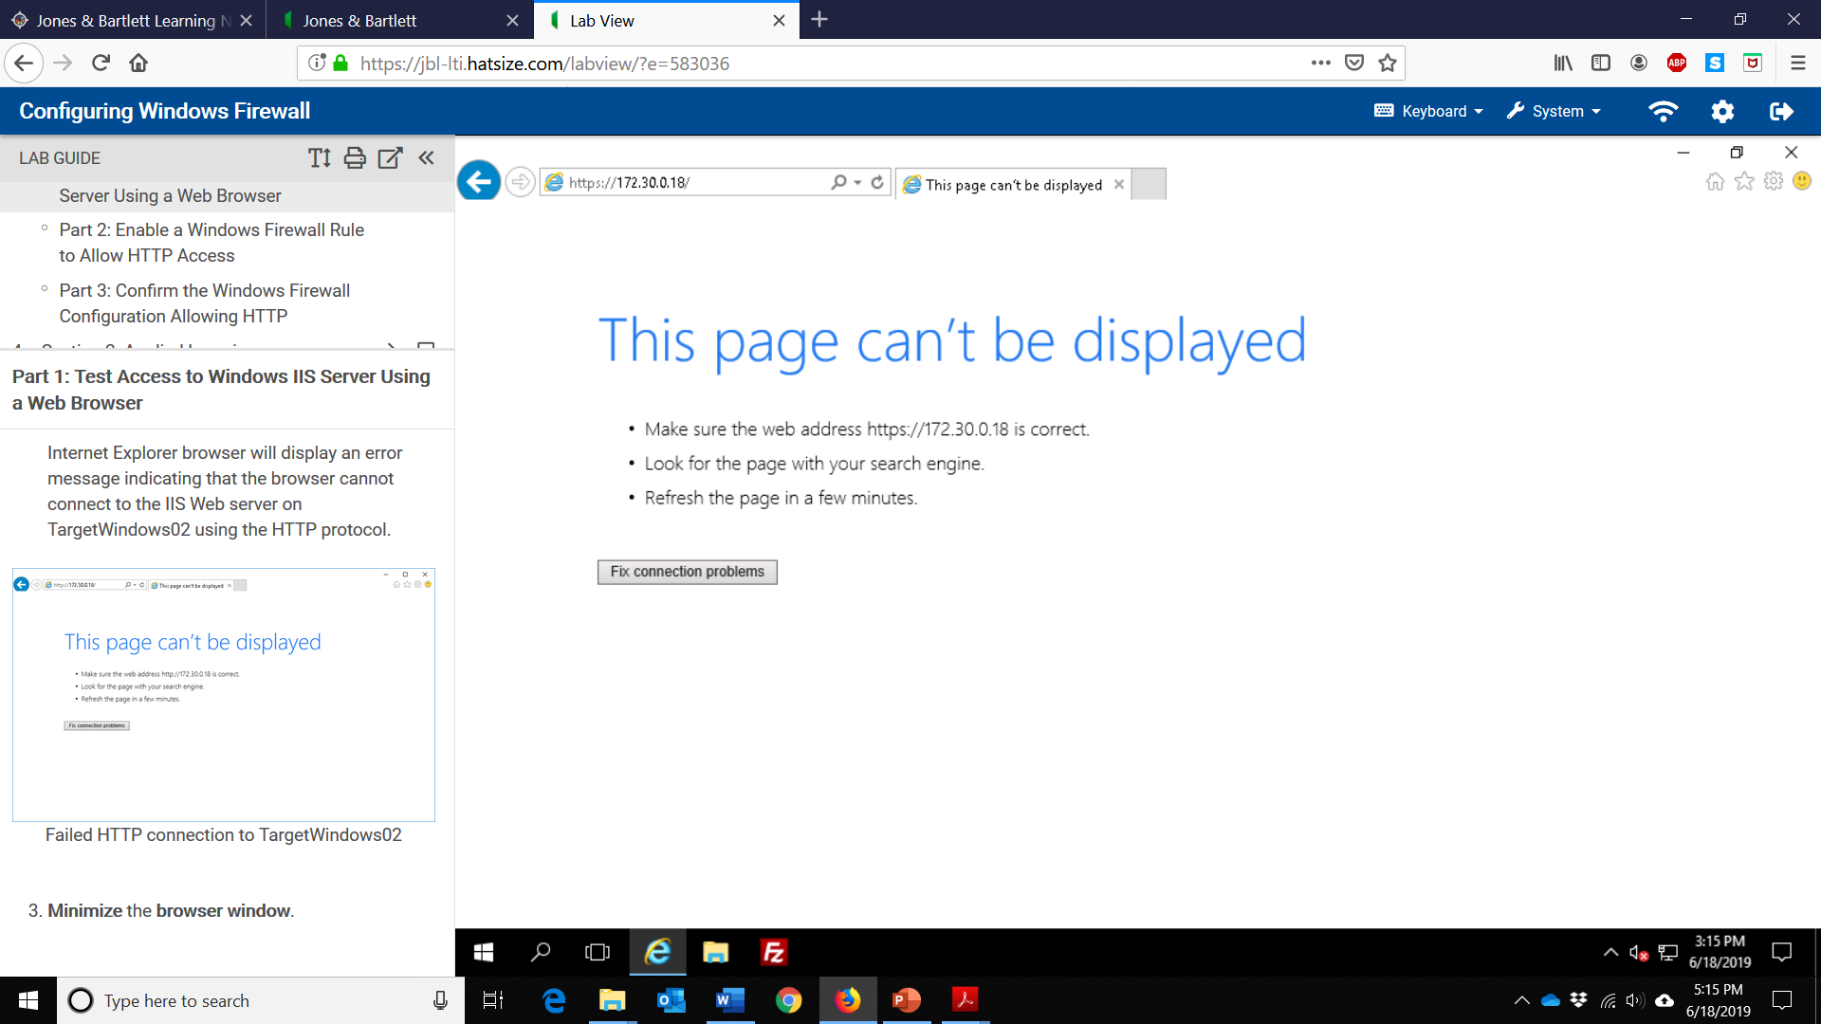
- Screen capture showing windows firewall showing the new rule created in this lab
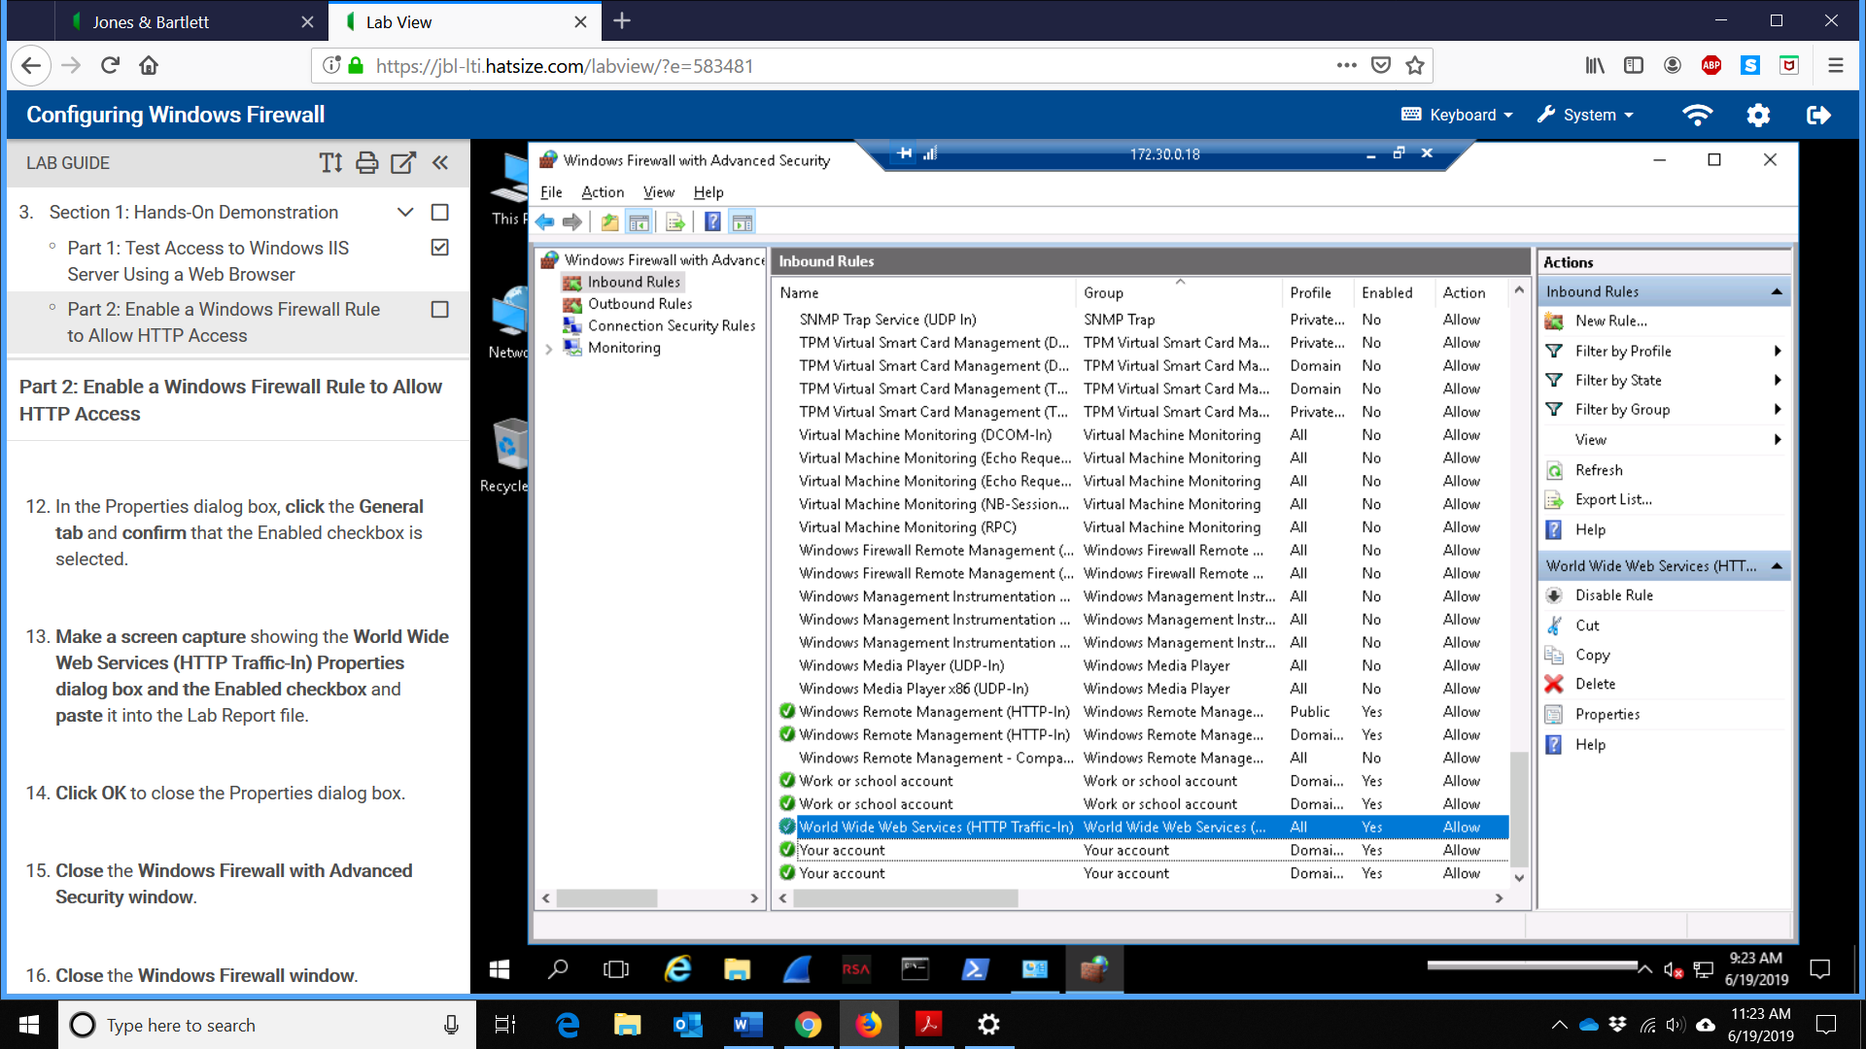
- Screen capture showing the World Wide Web Services (HTTP Traffic-In) Properties dialog box and the enabled checkbox
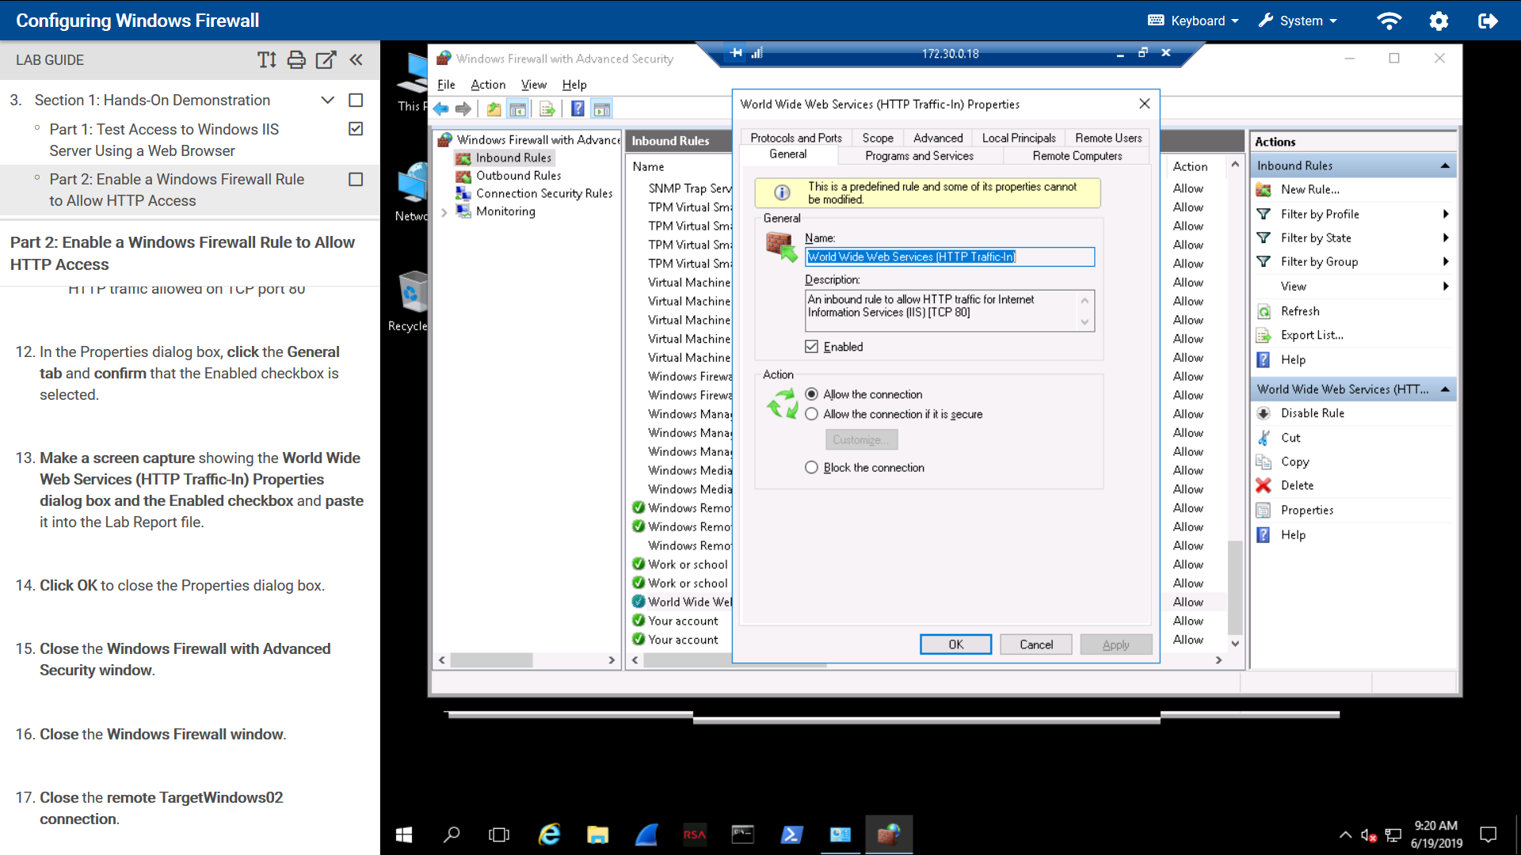
- Screen capture showing the IIS server homepage in the internet explorer window
- Screen capture showing the successful HTTP connection attempt
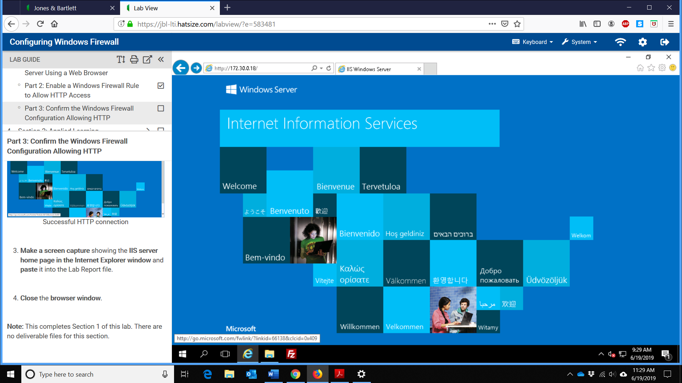

Section 2
- Screen capture showing the updated status of the world wide web service
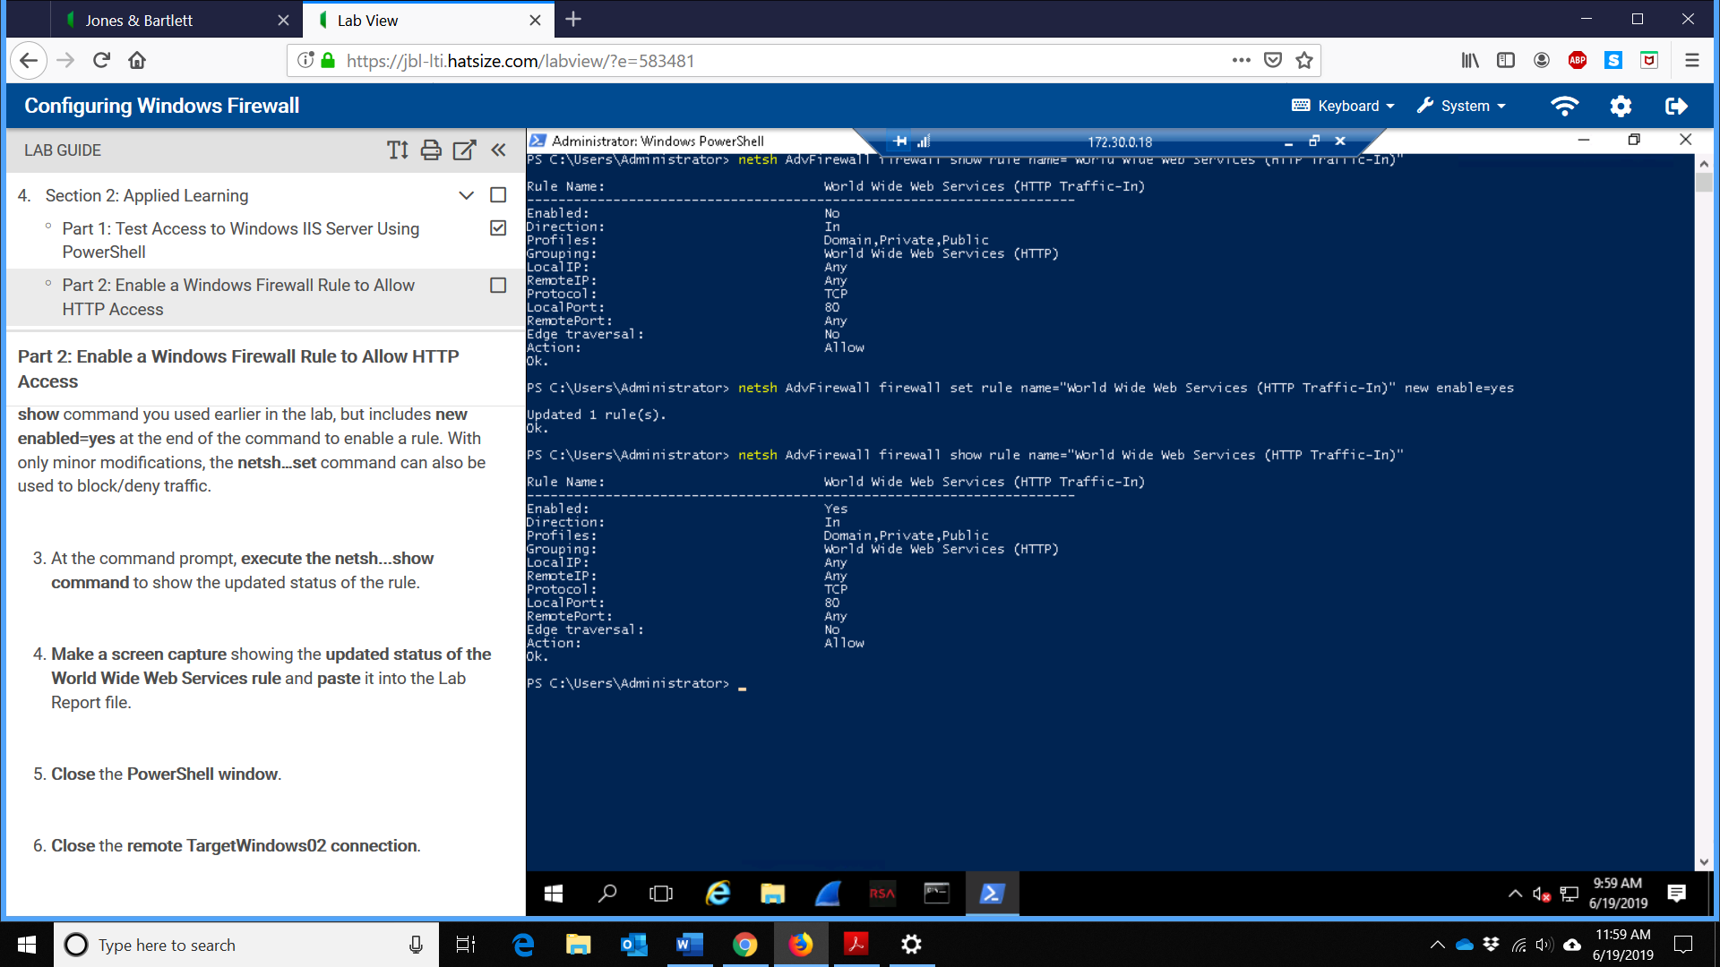
- Screen capture showing the IIS server homepage in the Internet Explorer Window
