Lab 6
Natnael Kebede
Section 1
1) Screen capture showing my name in the list of existing users
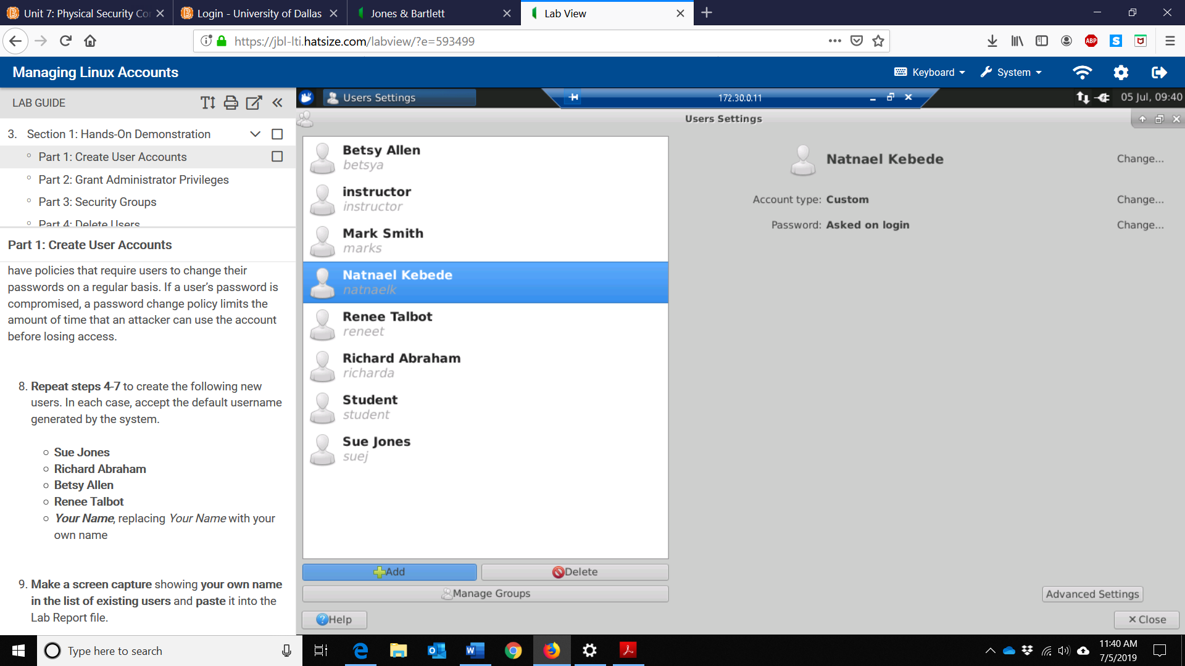

2) Screen capture showing the updated Users Settings data for the account in my name
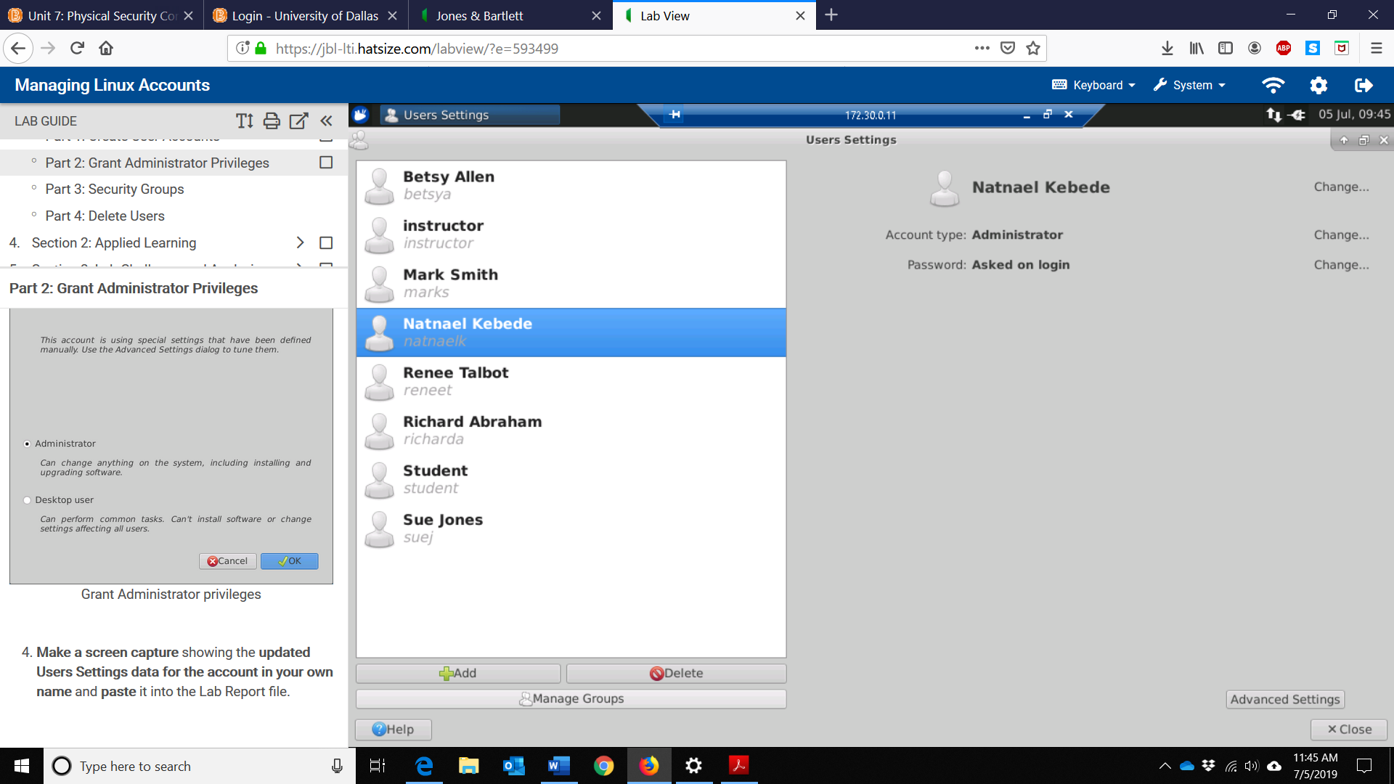
3) Screen capture showing the members of the faculty group
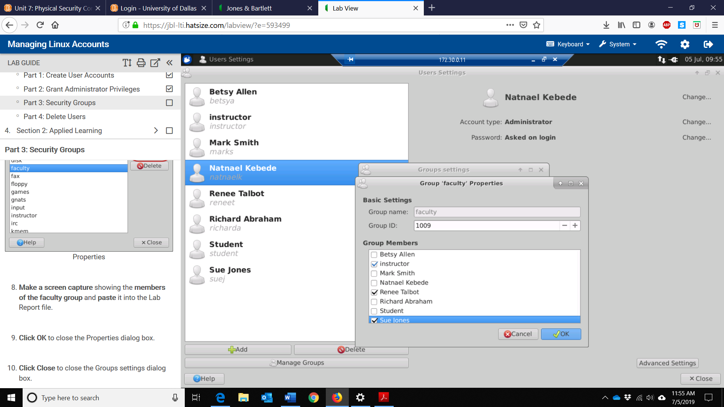

4) Screen capture showing the missing user account in the Users Settings dialog box
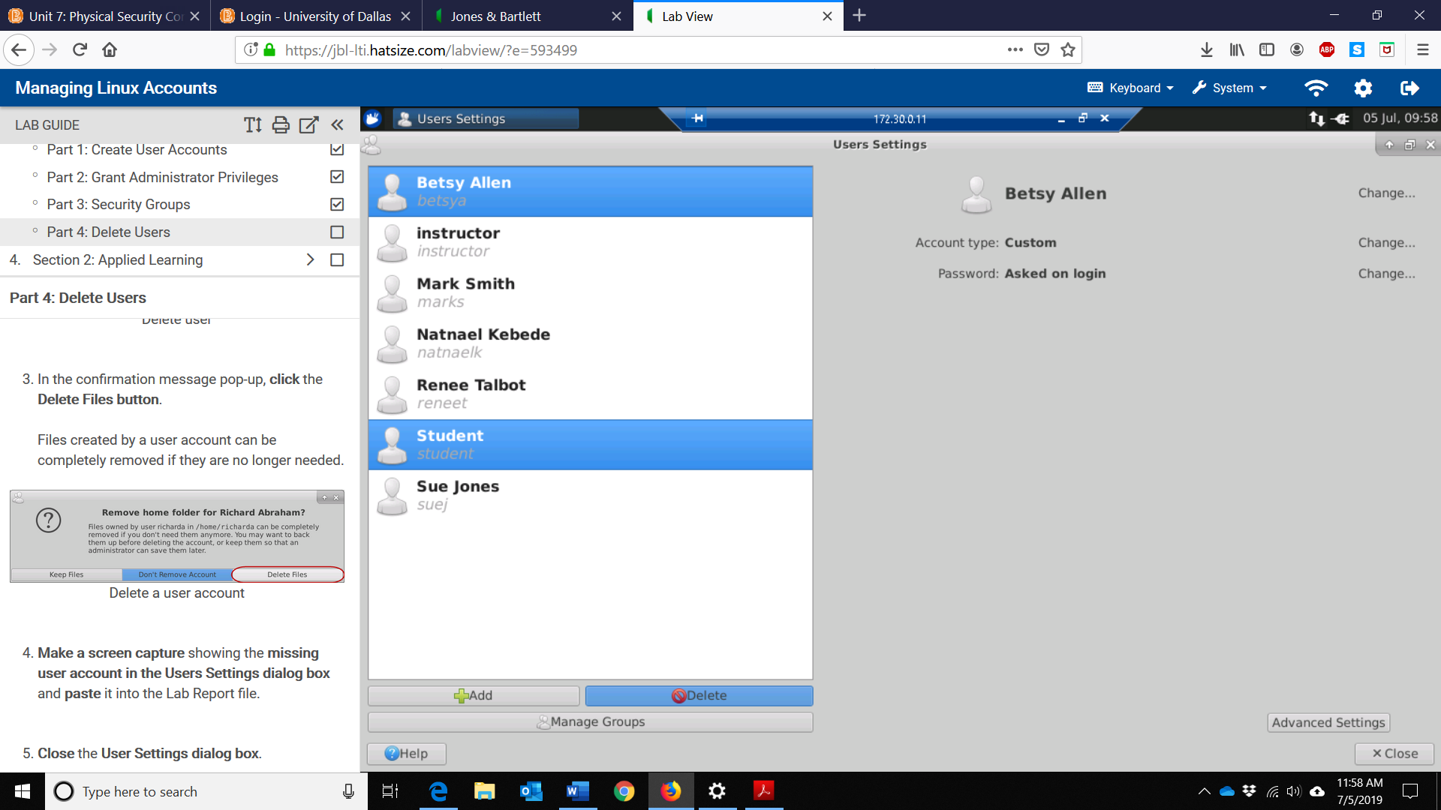

Section 2
1) Screen capture showing the new users that have been added to the /etc/passwd file
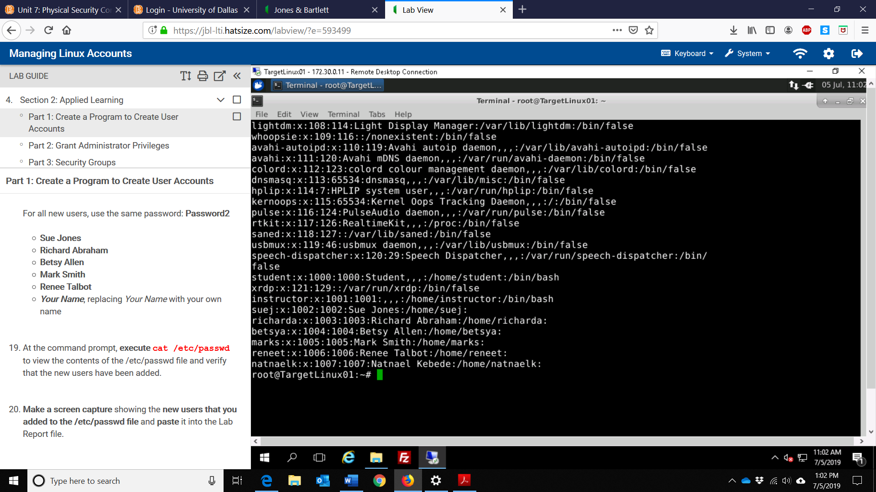
2) Screen capture showing my account as a member of the root group
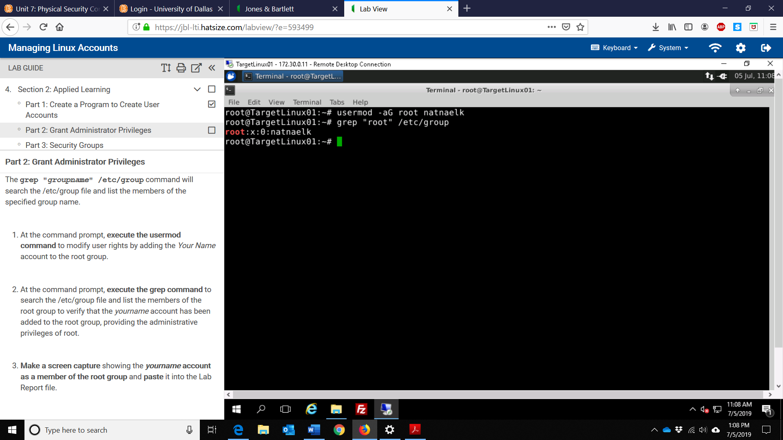

3) Screen capture showing the members of the students group
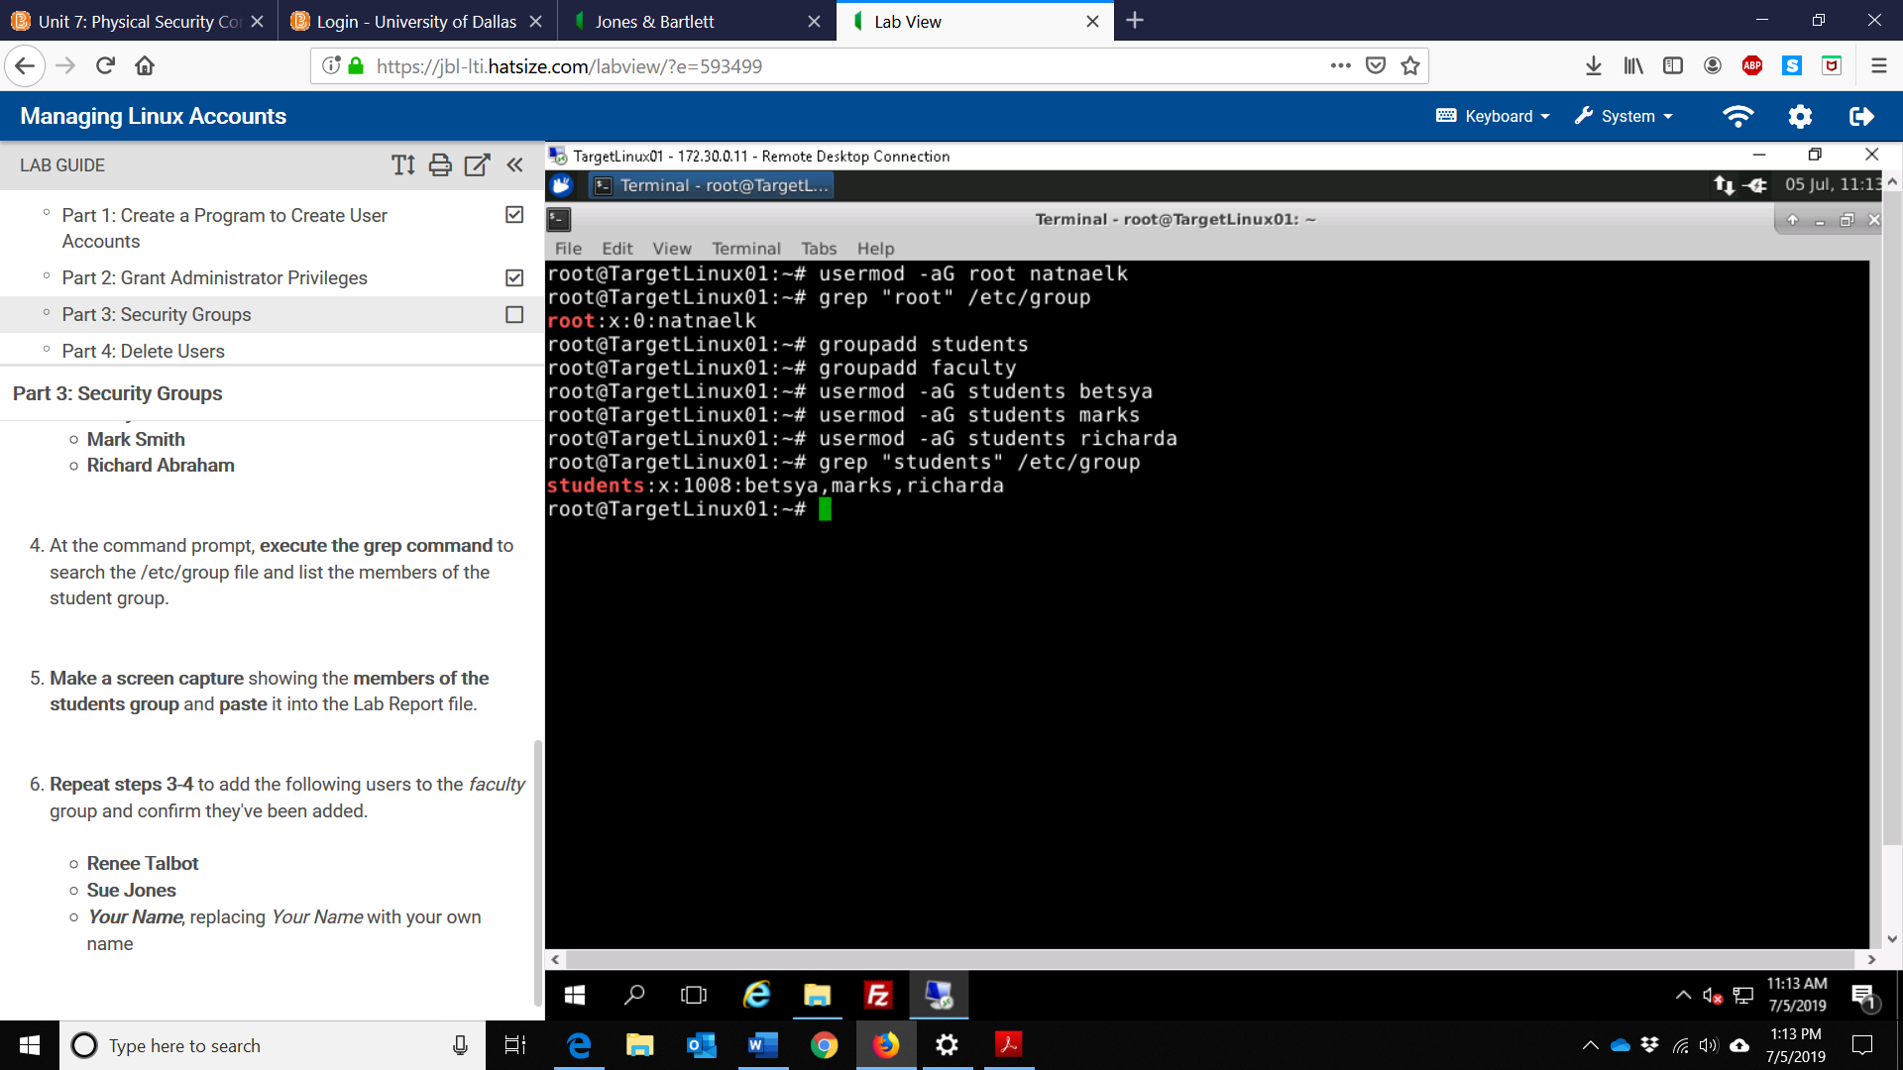
4) Screen capture showing the updated members of the faculty group
