Lab 9
Natnael Kebede
Section 1
1) Screen capture showing Roger’s public and private keyrings
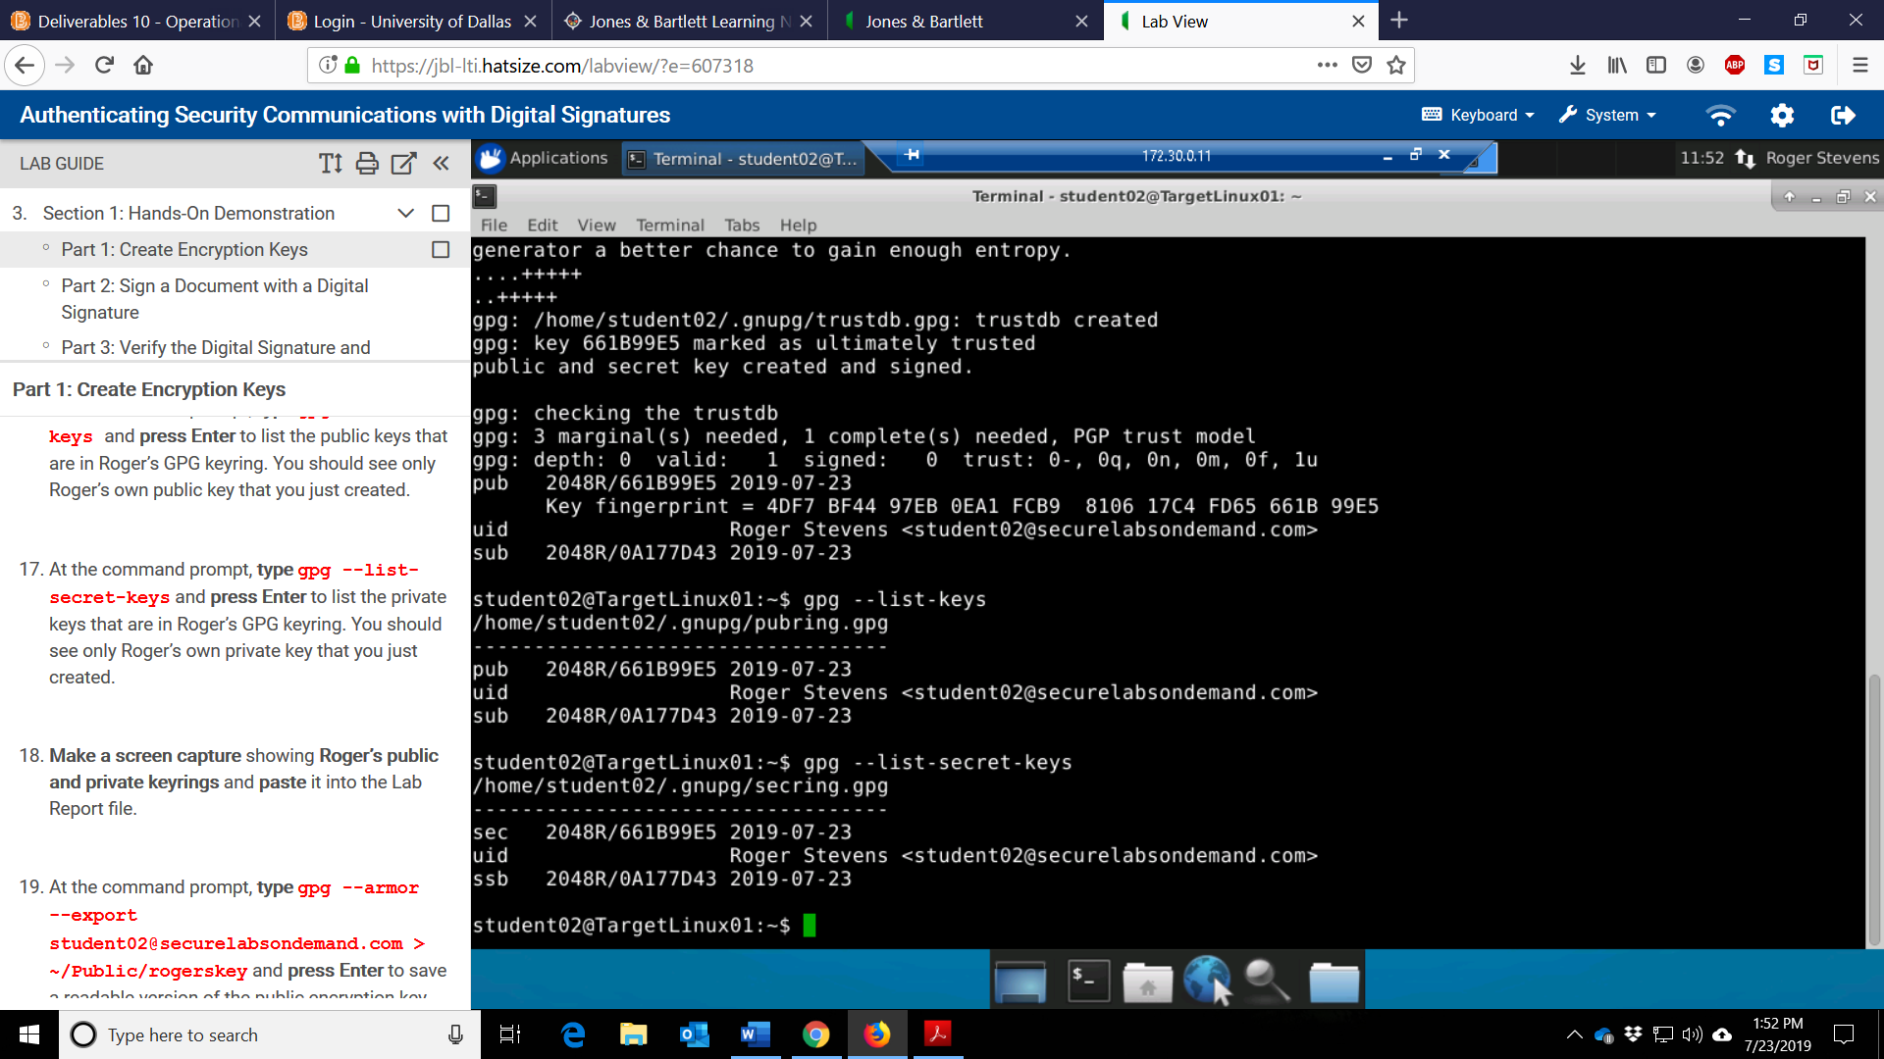

2) Screen capture showing the contents of the signed message
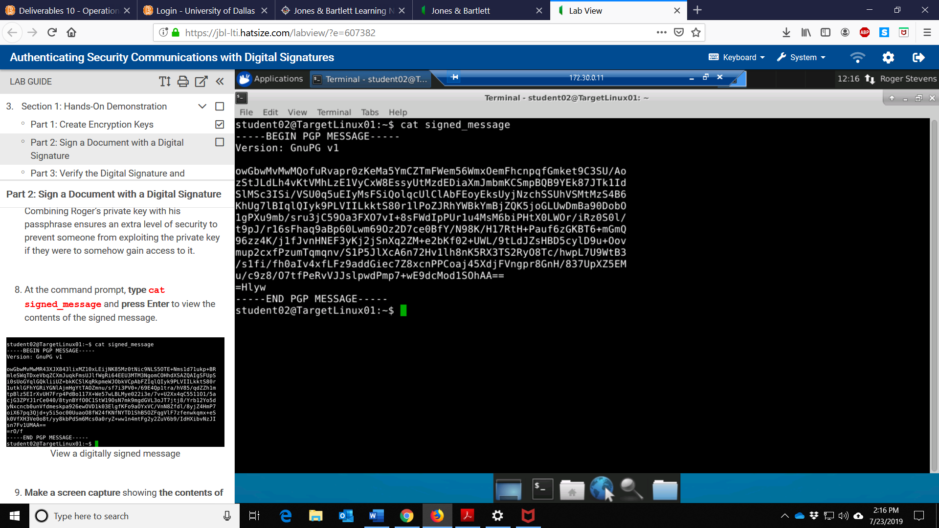
3) Screen capture showing the contents of the digitally signed message
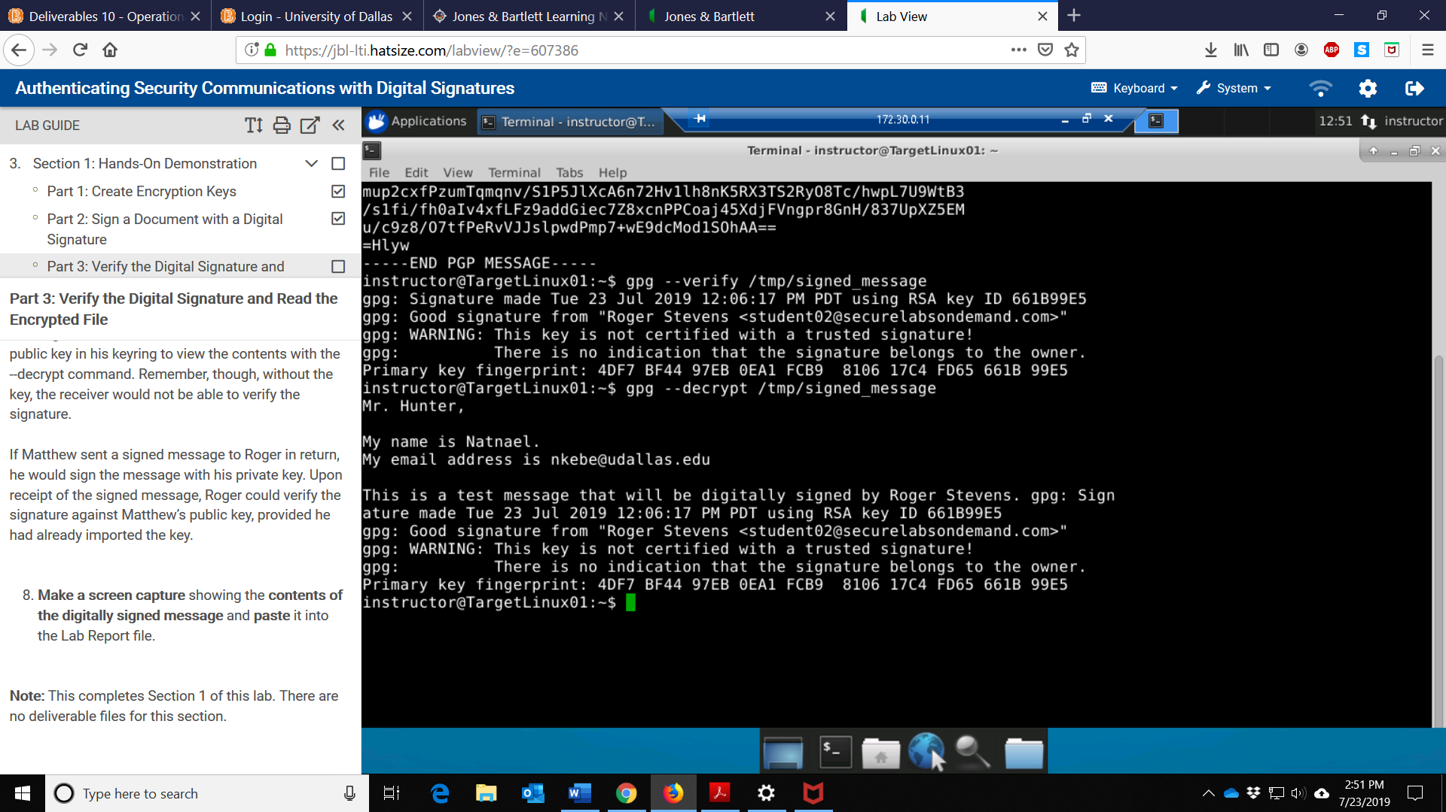
Section 2
1) Screen capture showing the contents of the natnael_unsignedmessage.txt file
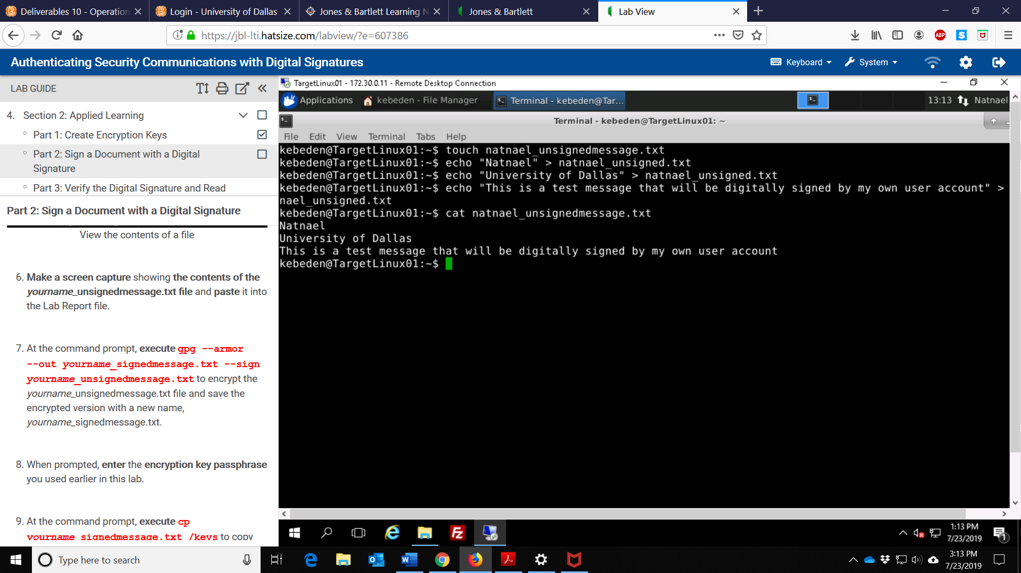

2) Screen capture showing the Kleopatra key pair fingerprint
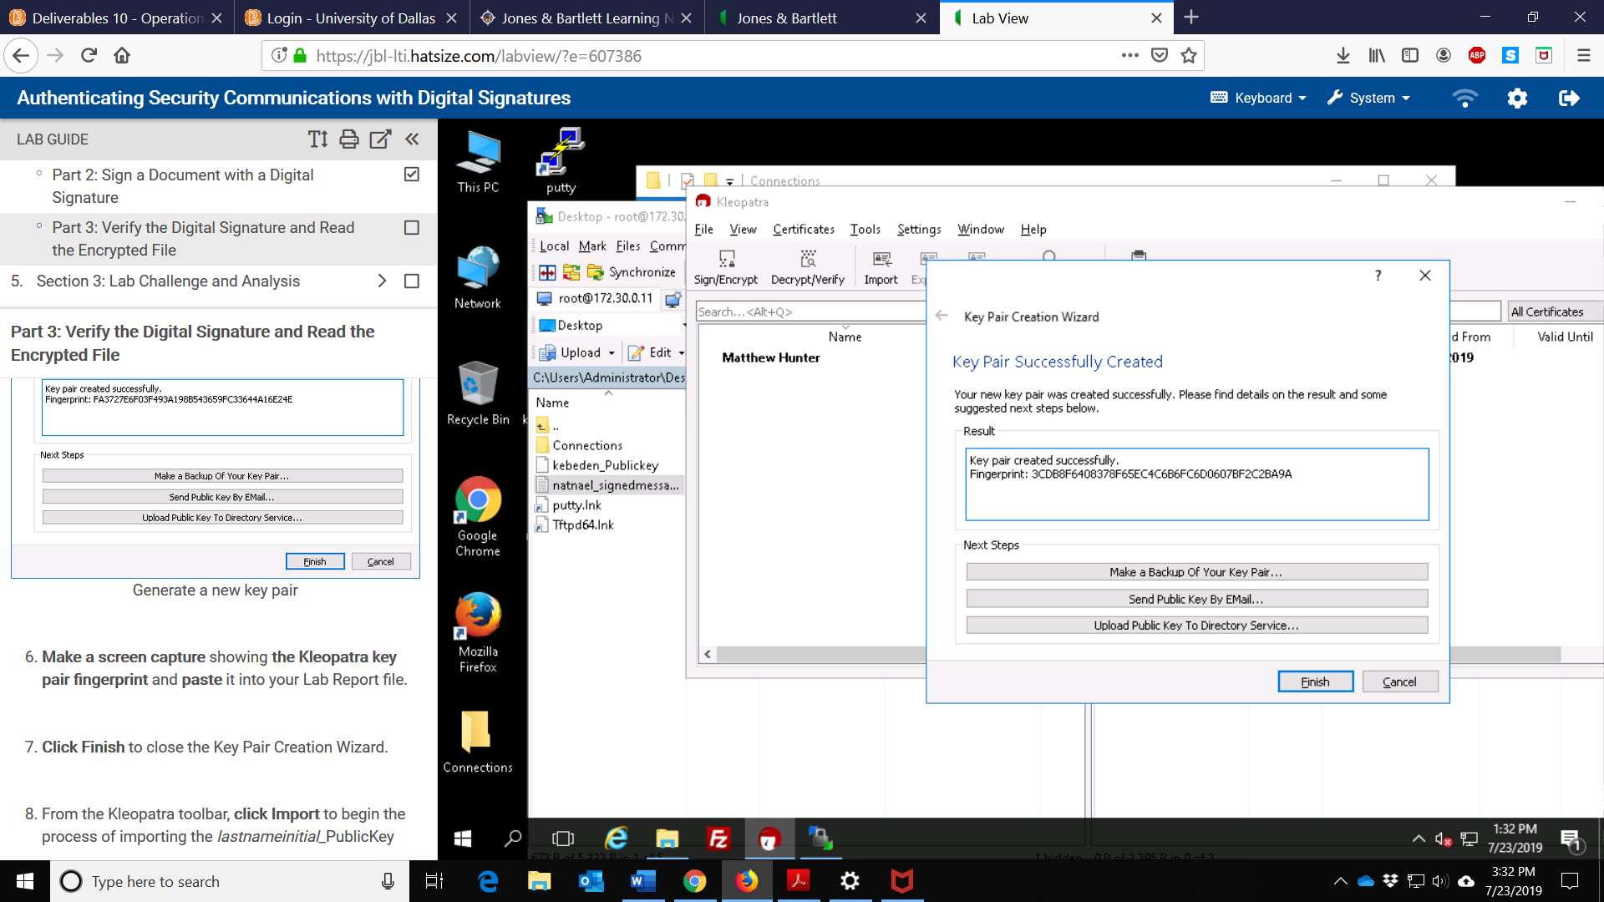
3) Screen capture showing the successful certification message
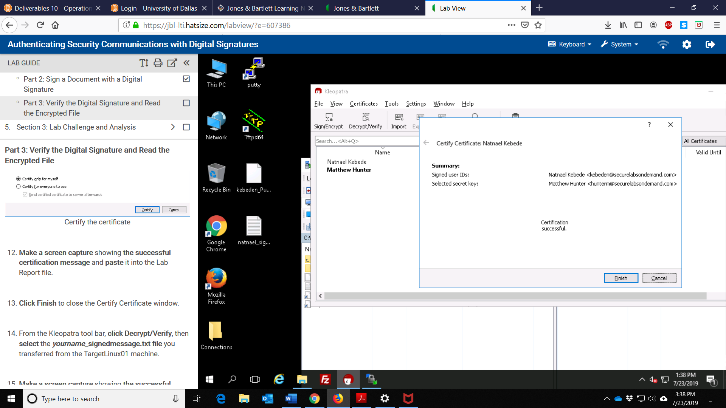

4) Screen capture showing the successful decryption message
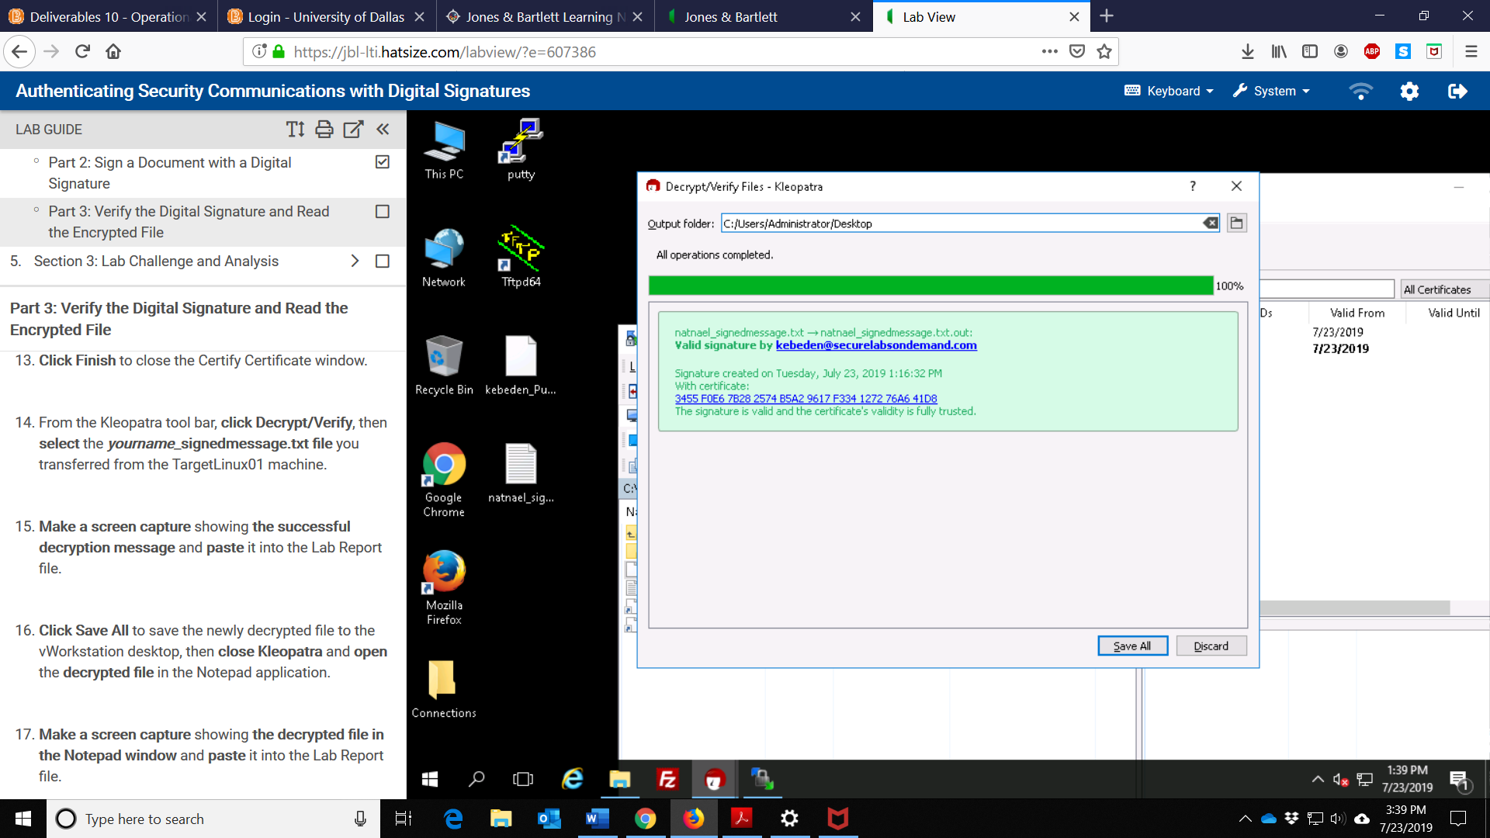
5) Screen capture showing the decrypted file in Notepad window
