Natnael Kebede

1001149004

Section 5.2: Problems 1, and 2 (only for method sum()).

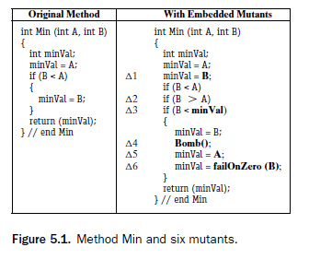

1. ∆2

Reachability: True, the statement will always be reached.

Infection: (B < A) ≠ (B > A) additionally, A ≠ B

Propagation: True, the infection will lead to a different path and will always propagate.

∆4

Reachability: the statement is only reached when the predicate B < A is true.

Infection: True because Bomb() is a mutant that will result in runtime exception.

Propagation: True, because Bomb() is a mutants that will always propagate.

∆5

Reachability: the statement is only reached when the predicate B < A is true.

Infection: A ≠ B

Propagation: True, because minVal has been given a different value and the infection will always propagate.

∆6

Reachability: the statement is only reached when the predicate B < A is true.

Infection: failOnZero() results in a runtime exception when B = 0

Propagation: True, because failOnZero() is a mutants that will always propagate.

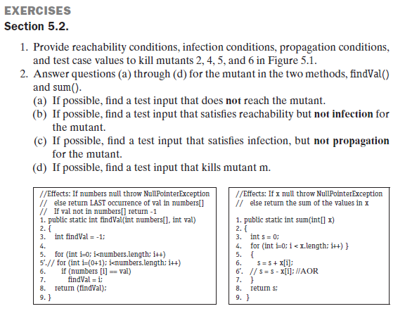

2 a) If the test input for x = NULL or [] the mutant will not be reached

b) If we consider a test input where x = [0, 0] then it satisfies reachability but not infection for

the mutant.

c) If we consider a test input where x = [1, 3, -4] and other test inputs where each element is

non-zero and the sum of the elements is a zero, it satisfies infection but not propagation for

the mutant.

d) If we consider a test input where x = [1, 3, 4] and other test inputs where the sum of the

elements isn’t zero, it will strongly kill the mutant.