Intelle-T

All About Circuits

Brits are one of the world’s biggest tea drinkers which is why having a cupboard stocked full of tea bags is a must for most homeowners. However, it is not unheard of to open the tea bag container and find it empty so in this episode we will create the Intelle-T; an intelligent tea bag container that estimates the number of tea bags left and will inform us as we start to run out!

# BOM

* Raspberry Pi 3 Model B - 1690-1000-ND
* Arduino Uno - 1050-1024-ND
* HX711 ADC for load sensors - 1568-1436-ND
* Weight sensor (between 3KG and 15KG) - 1597-1575-ND
* Reed switch - 374-1092-ND
* Magnet - 469-1005-ND
* 10KΩ resistor - CF14JT10K0TR-ND
* Speaker
* 3.5mm cable (for speaker)
* USB B Cable (for Arduino Uno to Raspberry Pi connection)

# SchemeIT

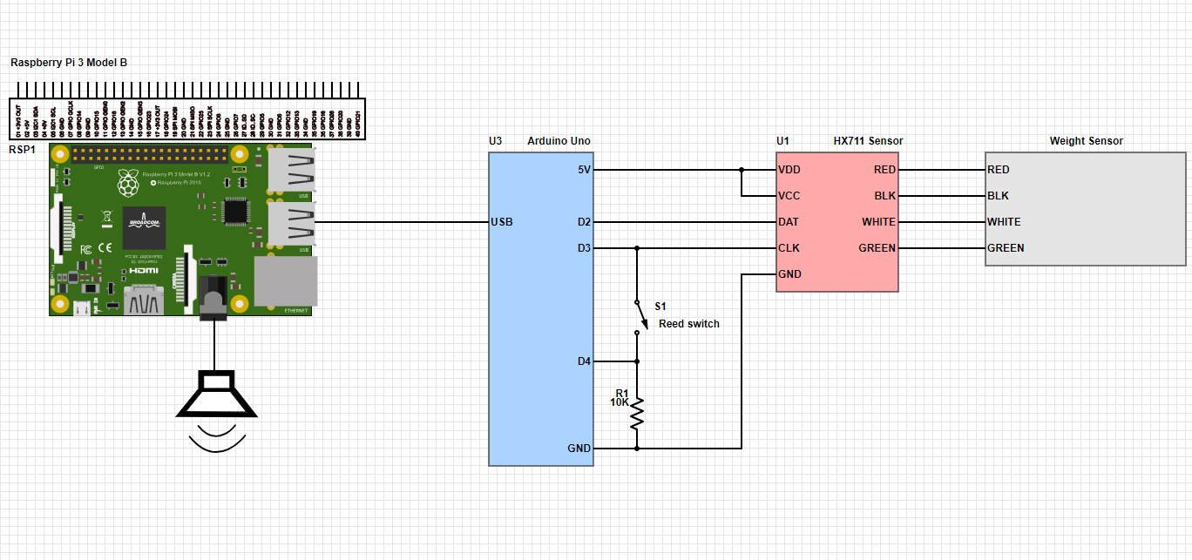

<https://www.digikey.com/schemeit/project/intellet-140KBLO402HG/>

# Theory of operation

The Intelle-T is a tea bag box that sits on an electronic scale that estimates the number of tea bags by weight. The user first turns on the Photon and then places a single tea bag into the pot. From there, the user can fill the container and the system can make an estimate on how many bags remain. When the user opens the lid a small contact / reed switch is broken which informs the Arduino Uno that the container has been opened. This triggers the Raspberry Pi to play a witty message about how great the UK is, a fun fact about tea, or how coffee is an inferior beverage. When the number of teabags begins to fall below a threshold the Raspberry Pi will inform the user that the number of teabags is becoming dangerously low.

# Load Sensor

The load sensor has two sets of two screw mountings which are used to hold the sensor down to a platform and the tea bag container that will hold the tea bags. The sensor has a resistor bridge configuration which results in four outputs that are connected to the HX711 serially accessed ADC. The ADC is a read only device but is specifically designed for load sensors and is very easy to interface with thanks to the HX711 library available for the Arduino Uno. Using the sensor requires zeroing and then measuring the weight of a tea bag so that the initial weight applied to the sensor can be ignored and that additional bags can be accurately counted (having said that, tea bag weights will vary so the final number will be an accurate estimate). While a reset button could be used externally it is simpler to have the Arduino run a simple procedure on start-up that zeros the sensor, waits for a weight increase, then uses that increase as a divider for future recorded weights.

# Lid detection

When the lid is opened the Arduino Uno sends a message to the Raspberry Pi indicating the quantity of tea bags as well as the fact that the lid has been opened. The lid detection is done with the use of a simple reed switch which is mounted on the inside of the tin while a small yet powerful magnet is mounted on the lid such that during normal conditions the magnet causes the reed switch to close. This means that the Arduino Uno will read a digital “1” when the lid is closed and “0” when the lid is opened.

# The Raspberry Pi

The Raspberry Pi is used to play audio files using the PyGame library as well as interact with tea bag quantity data. For example, as the number of tea bags begins to fall below a pre-defined threshold the Pi will announce to the user that the number of bags is low. During typical lid opens the Pi will also play an interesting fact about tea and how amazing Britain is as a nation.