Introduction

## The Brief

The brief in place is as follows: “The Department of Computer Science and Technology has in place a personal supervisor (PS) for each student. Supporting our students has always been a key part of their journey. The operation of the personal supervisor system is a key area of the department we are wishing to improve.  The department is looking for a digital solution to help both students and staff monitor engagement and be able to action support at vital points in time where needed. There are number of engagement metrics available but sometimes these do not present a true picture. You need to design, develop and test a program that will allow users/stakeholders of the system to perform the usage scenarios described below.”

## Stakeholders

The stakeholders in this system are as follows: The students, personal supervisor (PS) and senior tutor (ST).

## Key Usage Scenarios

The usage scenarios given are as follows:

* A student should be able to self-report how they are feeling / progressing at fixed time intervals.
* The PS should be able to review the status of all their students
* The PS should be able to book a meeting with students
* The student should be able to book a meeting with the PS
* The ST should be able to see the status of all students and how the PS are interacting with the students

Overall Description

Requirements Modelling

## Scenarios

### Student Scenario

Dmitri is a first-year student at Hull University getting ready for his exams in January. He has struggled to understand some of the coursework and feels overwhelmed. He has gone over much of the course notes online, but he feels like he needs to talk with someone directly, so he tries to contact his personal supervisor. He ends up getting some advice regarding his exams but with only limited time he only saw slight improvement before his exams. He wished that he could have got in contact with his personal supervisor earlier, but he did not realise this at the time he was struggling in his first term. Being able to receive more structured supervision he feels would have been helpful to him each week.

### Personal Supervisor Scenario

Benedict is a personal supervisor who has been working at Hull University for 5 years. Often, he finds it tricky to help the students under his watch as they seem reluctant to reach out to him. It is also often chaotic trying to find times to book meetings with his students that do not conflict with each other’s timetables. He knows some of his students have been struggling looking at their overall marks deteriorate over time but there is not much communication between him and his students and he would like to get to know them better.

## Use Cases

## Activity Diagrams

## Requirements

* Students can book a meeting with their personal supervisor.
* Personal supervisors can book a meeting with their students
* Students can type out their thoughts and feelings to self-report
* Personal Supervisors can see the statistics of all their students
* Personal Supervisors can see the reports of all their students
* Senior Tutors can see the statistics of every student
* Senior Tutors can see every student’s reports
* Personal Supervisors can login
* Students can login
* Senior Tutors can login
* The System allows users to exit
* The Program can run on a university computer

## Test Plans

Design

## Class Modelling

## Flow Charts

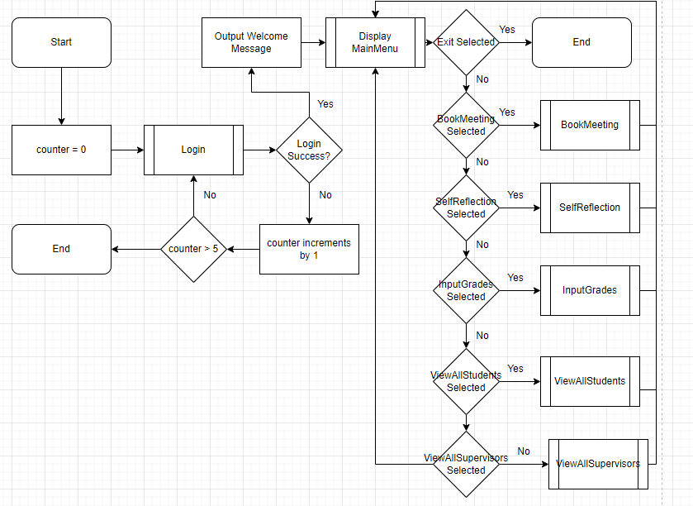

## Database Models

|  |  |  |  |  |  |  |  |  |  |
| --- | --- | --- | --- | --- | --- | --- | --- | --- | --- |
| **Username** | **Password** | **UserType** | **Grade1** | **Grade2** | **Grade3** | **AvgGrade** | **SelfReflection** | **Meeting Times** | **Supervisor** |
| Admin | password | ST | NULL | NULL | NULL | NULL | NULL | NULL | NULL |
| JohnSmith | abcdefg | PS | NULL | NULL | NULL | NULL | NULL | NULL | NULL |
| NathanielRoper | Hello123 | Student | 100 | 50 | 75 | 75 | I am happy with the work so far | 7:30 01/01/24 | JohnSmith |
| RobinJones | examplePassword | Student | 21 | 76 | 54 | 50.33 | I am struggling | NULL | JohnSmith |
| SarahWhite | 123456 | Student | 99 | 99 | 99 | 99 | NULL | 6:15 01/02/24 | BobRoberts |
| BobRoberts | Bottle1 | PS | NULL | NULL | NULL | NULL | NULL | NULL | NULL |

|  |  |  |
| --- | --- | --- |
| **Username** | **Password** | **UserType** |
| Admin | password | ST |
| JohnSmith | abcdefg | PS |
| NathanielRoper | Hello123 | Student |
| RobinJones | examplePassword | Student |
| SarahWhite | 123456 | Student |
| BobRoberts | Bottle1 | PS |

|  |  |  |  |  |  |  |  |
| --- | --- | --- | --- | --- | --- | --- | --- |
| **Username** | **Grade1** | **Grade2** | **Grade3** | **AvgGrade** | **SelfReflection** | **MeetingTimes** | **Supervisor** |
| NathanielRoper | 100 | 50 | 75 | 75 | I am happy with the work so far | 7:30 01/01/24 | JohnSmith |
| RobinJones | 21 | 76 | 54 | 50.33 | I am struggling | NULL | JohnSmith |
| SarahWhite | 99 | 99 | 99 | 99 | NULL | 6:15 01/02/24 | BobRoberts |

Implementation