Introduction to Docker

Have you ever had a friend say these things to you?
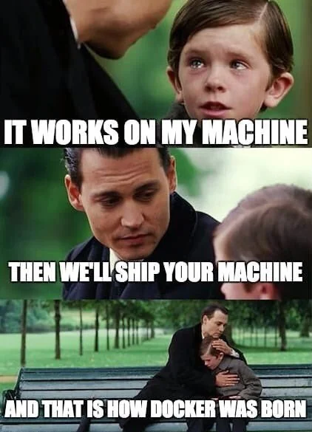

These days, Docker plays an important role in developing and containerizing software. Without Docker, I would quit Com Eng. So please use this thing to extend your life span and have time to touch some grass.
Today we are going to practice how to create a docker image by writing a Dockerfile and learn how Docker-compose works. Next, we will get you through the concepts and POWERFUL tools for Continuous Integration and Continuous Delivery (CI/CD) pipeline.

What are differences between Dockerfile and Docker-compose?
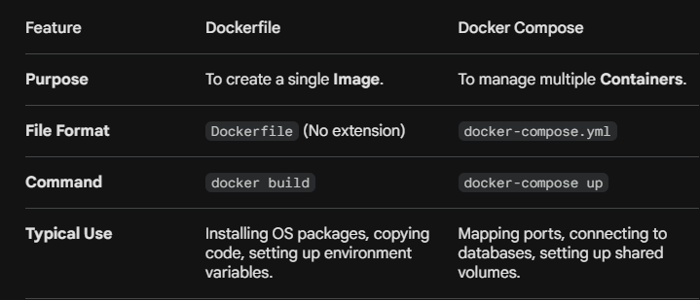

Presequisite:
Before starting, ensure you these 2 important things :

- Docker Desktop installed and running
- A Docker Hub account: sign up at https://hub.docker.com
- Fork the workshop repository at https://github.com/RookieJoel/Docker-WorkShop-CEDT

How to get Dockerhub Access Token:
- Of course, you need to have a dockerhub account.
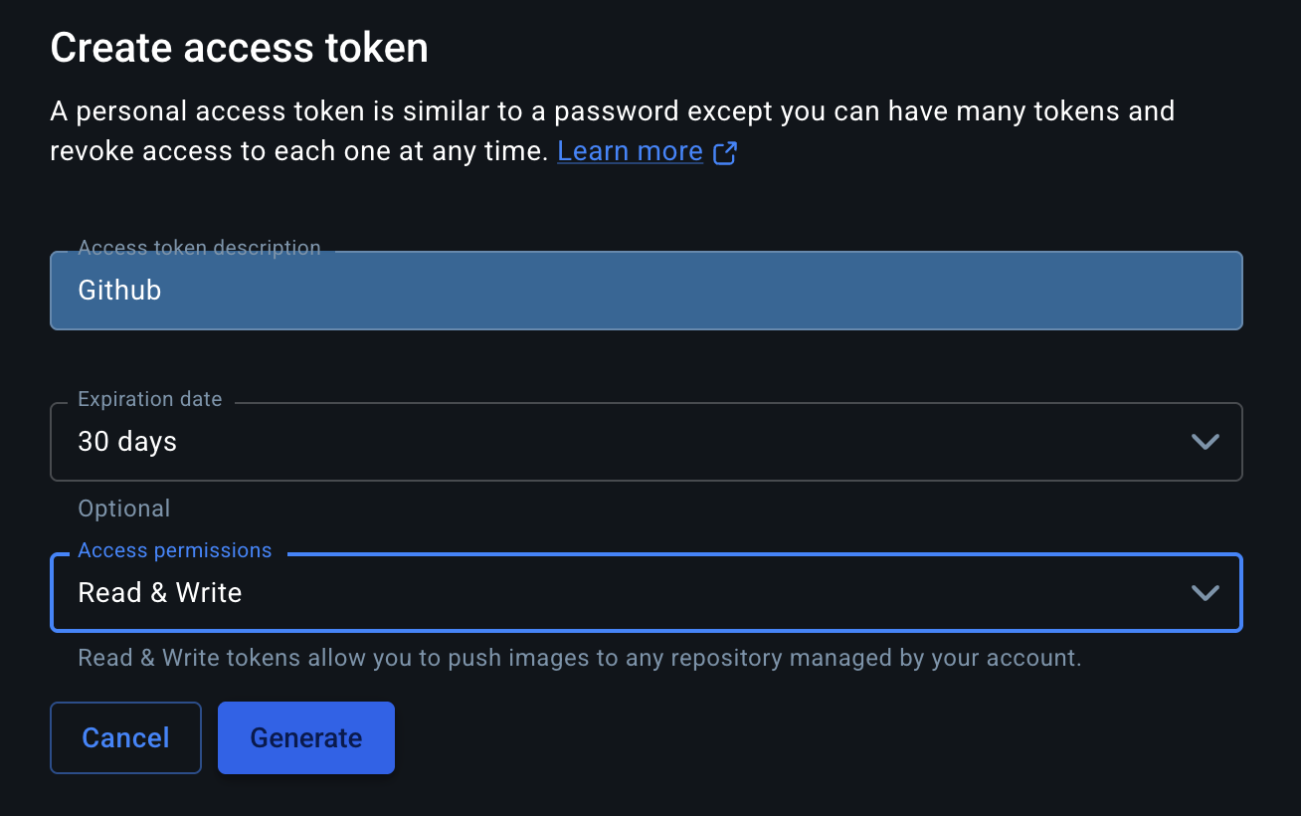
- Go to Account settings -> Personal Access tokens -> Generate new token then fill in this information below

make sure you set access permissions to Read & Write

3. Copy access token and set this as value of DOCKERHUB_TOKEN in github actions secret (we will walk you through this in the next step)

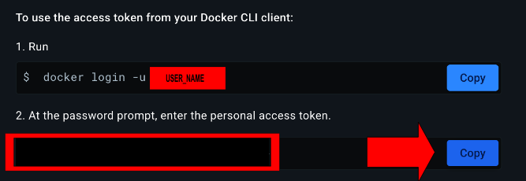

How to set github actions secrets and variables :

- go to setting (from the forked repository) -> secrets and variables -> Actions -> New repository secret

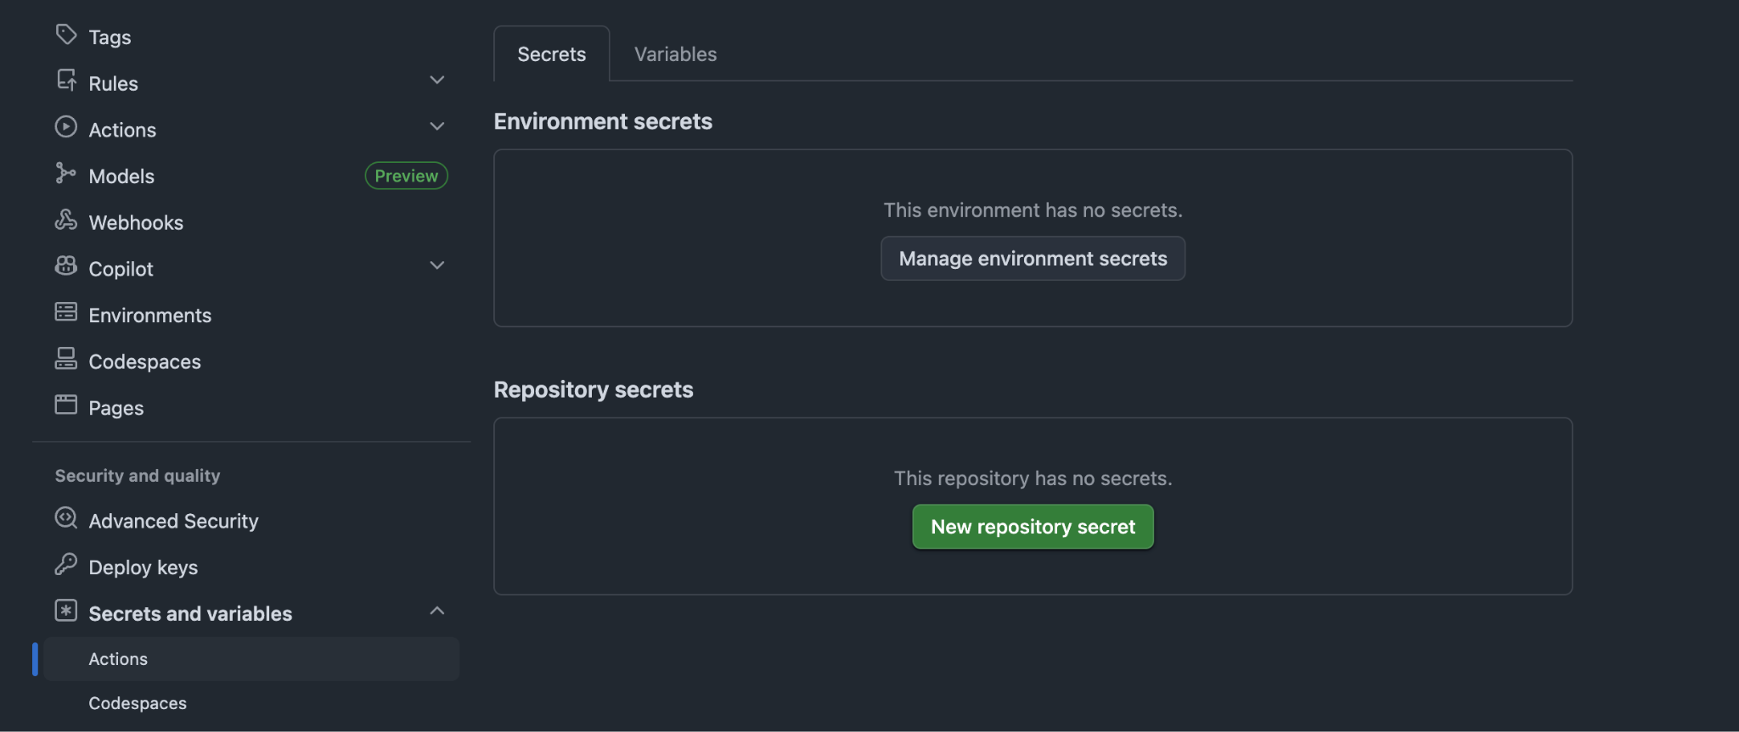

- Set Name as DOCKERHUB_TOKEN and the value as the one you copy from docker hub access token
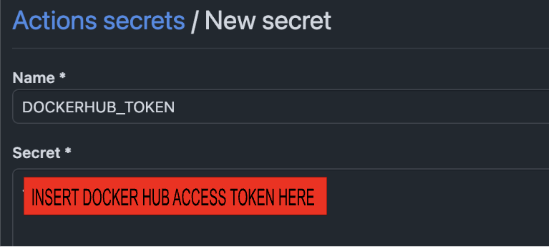
- Do the same thing to DOCKERHUB_USERNAME and set the value as your docker hub username

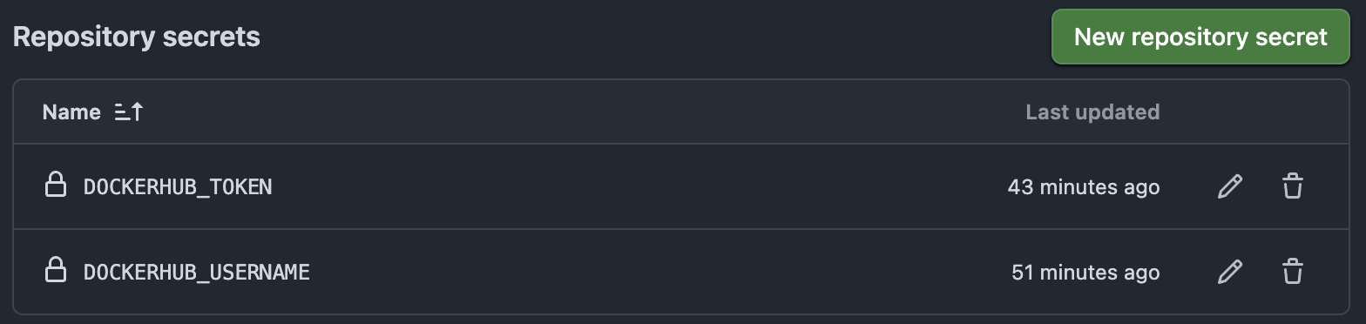
IMPORTANT NOTE: Please read README in your workshop folder entirely. We provided everything you need (except the answer of course)

Template การส่งงาน

Instructions: แคปรูปผลลัพธ์จากการรันโค้ด หรือ รูปภาพตามที่ระบุ มาวางไว้ในช่องที่กำหนดให้ และตอบคำถามใน AC-11 แล้ว Save ไฟล์เป็น PDF ส่ง (ส่งเฉพาะส่วนของ template )
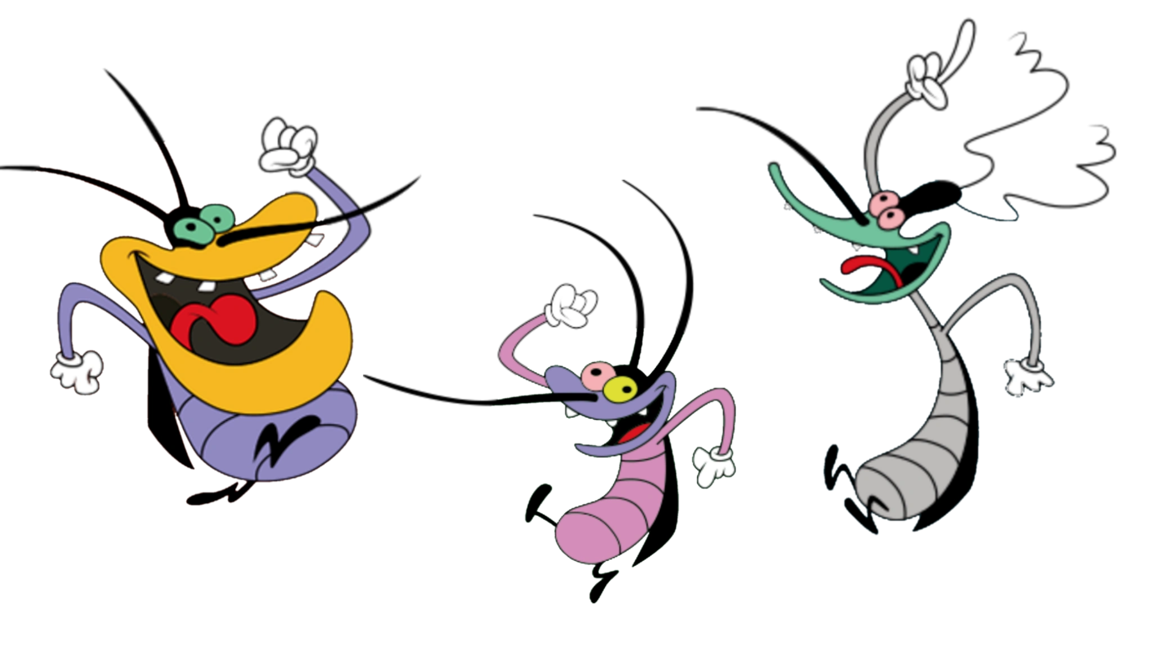
!!!กรุณาใช้ Template นี้เท่านั้นไม่งั้นจะไม่ได้รับการตรวจ!!!

CAPTURE 1: docker compose up -d

EXAMPLE-1
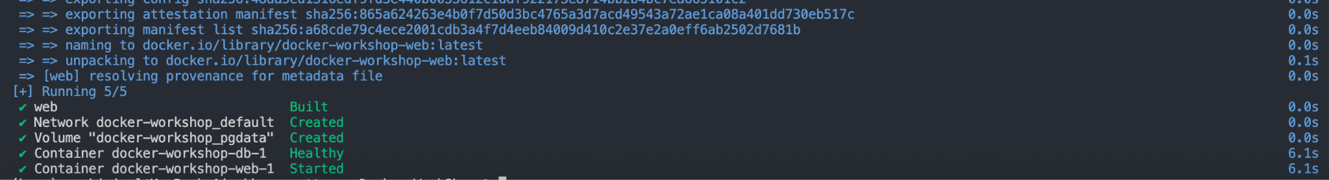

CAPTURE 2: docker compose ps
(please capture ONLY this workshop’s container)

CAPTURE 3: The result to show that your docker image has no critical vulnerability

EXAMPLE-3:

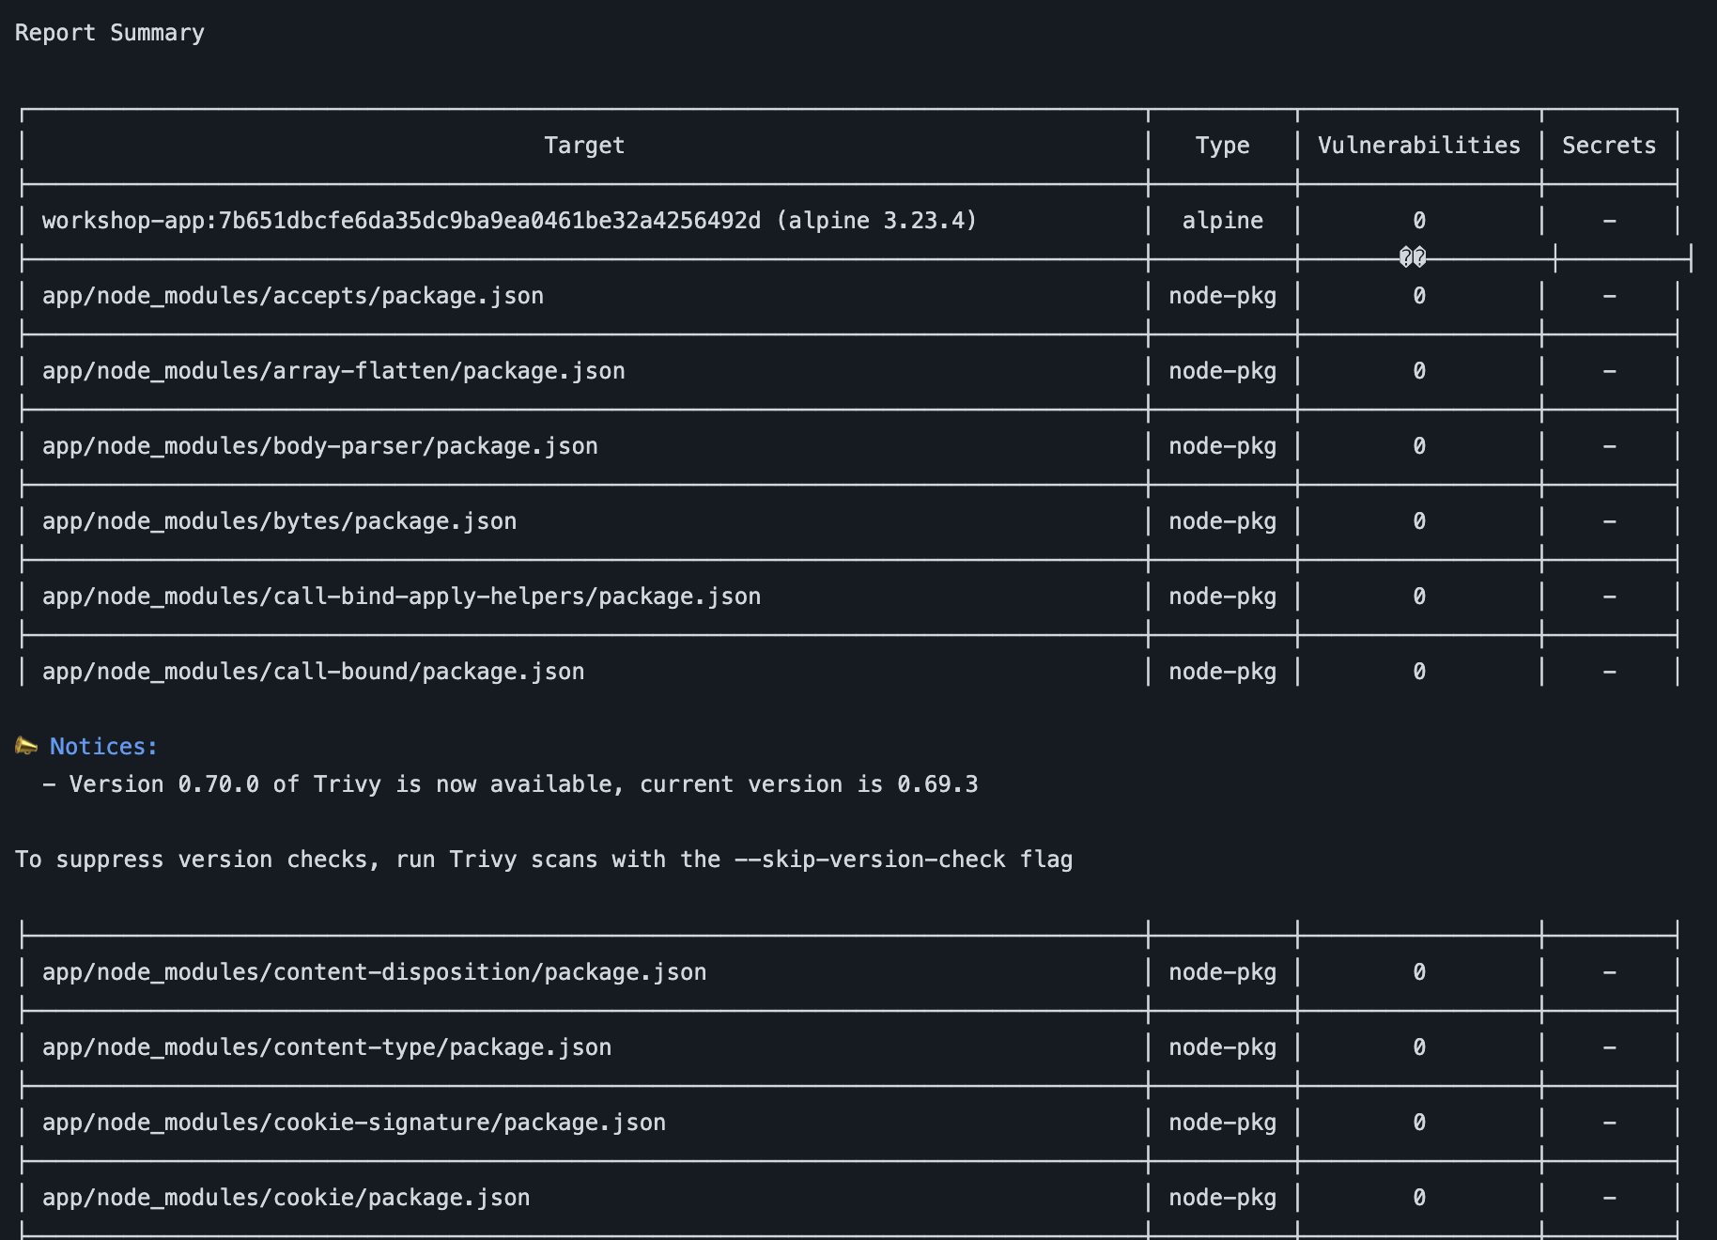
(You can find this by go to Actions tap
- go to your green check mark
- click build-scan-push on the left panel
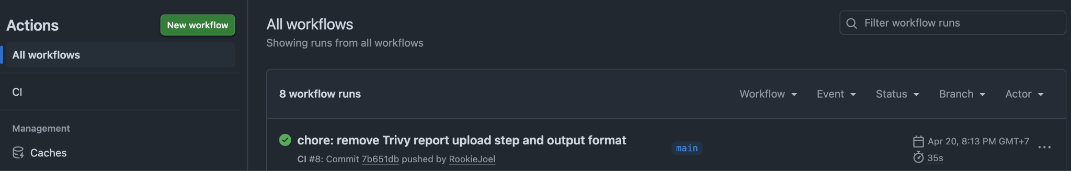
- check the vulnerability result in Scan image with Trivy )
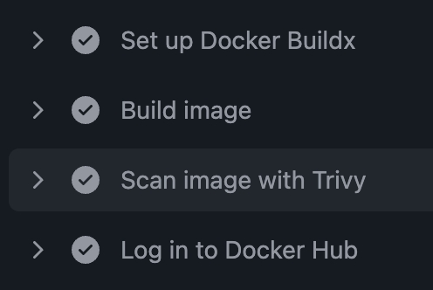

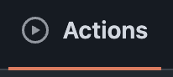
CAPTURE 4: The result to show that your workflow checks have passed and run successfully (Go to Actions tab in your forked workshop )

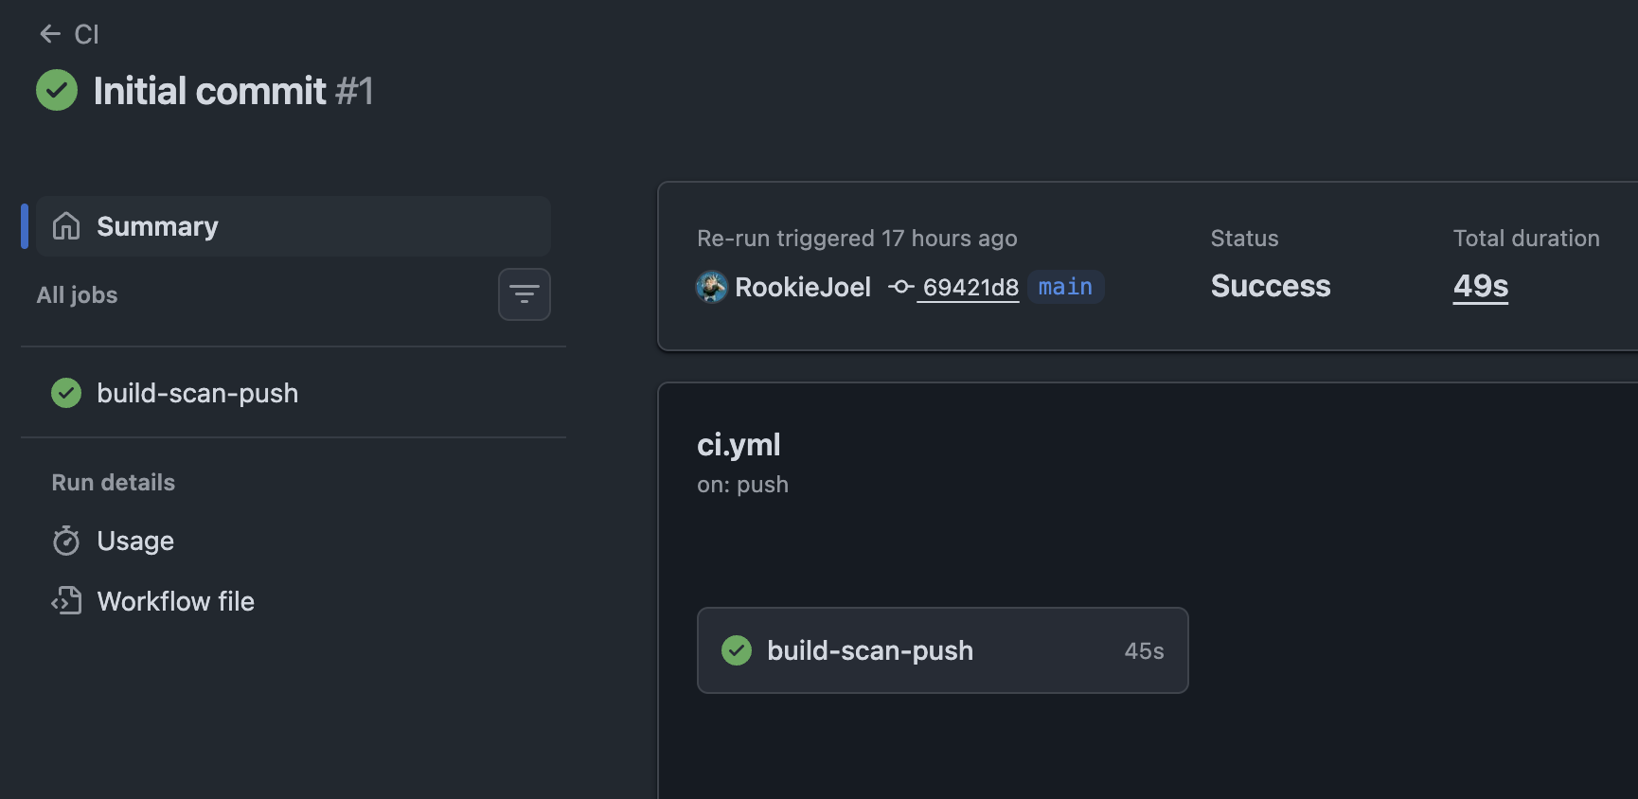
EXAMPLE-4:
your capture should consist of your Github username (if you get an error failing the workflow, carefully check your ci.yml again. Maybe it is because of indentation?)

CAPTURE 5: docker images stored in docker registry
(Check your repository on Docker Hub)

EXAMPLE-5:
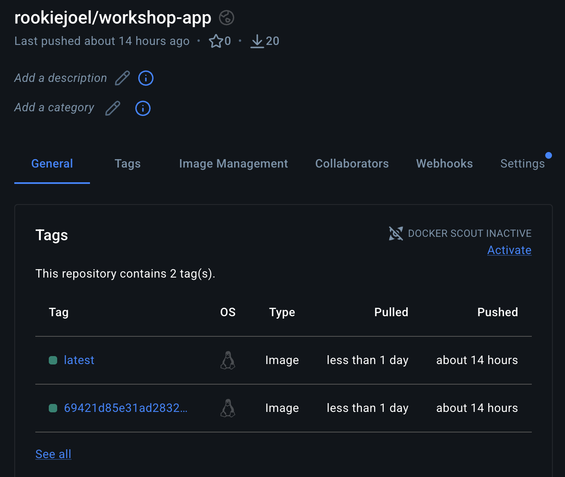
your capture should consist of your Docker Hub username and 2 images that you just pushed (please resize the captured image to be clearly visible)

ลองตอบดูนะ อาจจะได้กำไรชีวิต (ไม่ตอบไม่ให้คะแนน 55555)
นิสิตลองศึกษา Kubernetes และตอบตามความเข้าใจว่าแตกต่างกับ Docker compose อย่างไร
