Introduction to Programming with Python

Indira Sen, Ana Sanchez Acosta

KOMEX 2024

**Preparatory Material**

**Set Up Anaconda**

To run Python code we will use Anaconda. The advantage of this platform is that it is straightforward to install and it comes with a very useful interface called Jupyter Lab. All sessions and assignments will build on this interface.

Step 1. Visit the website of [**Anaconda**](https://www.anaconda.com/download)and download and install it, ideally with the option of Python 3.11

Step 2. After you have completed the installation, search in your **Applications** for **Anaconda Navigator** and start it. In the tab **Home**, look for **Jupyter Notebook** and launch it.

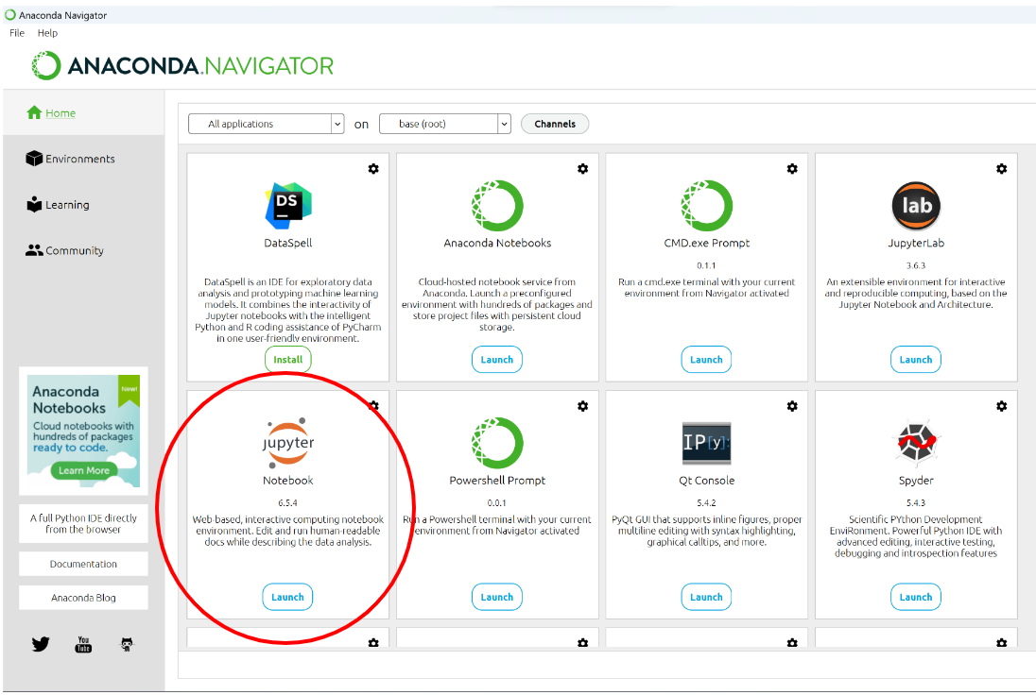

Step 3. If everything worked out, you can now access your own **Jupyter Notebooks** via your **web browser**. By default, Anaconda will automatically open a **tab** with the corresponding page, otherwise, it can be reached in most cases via the link [http://localhost:8888](http://localhost:8888/)

**Sign Up for GitHub**

As with all large code projects, we also exchange code with Git. To do that we will use the code hosting platform GitHub. It offers a wide range of features, including consistent version control and change tracking. We will share the course materials via this repository: [https://github.com/Indiiigo/](https://github.com/Indiiigo/Intro_to_python)SDS_KOMEX

If you already have your own GitHub Account, you can skip the first step.

Step 1. Visit the website of [**GitHub**](https://github.com/). Click on **Sign Up** and complete the registration process. You should either use your **university email address** directly or the **email address** you used to **register** for the **course** to avoid complications later on.

**[Optionally] Set Up GitHub Desktop**

There are several ways to use your GitHub repository. On the one hand, there is the command line where you use commands to perform the desired actions. On the other hand, there is GitHub Desktop which allows for most actions within a graphical user interface. It is recommended that you use the command line, especially as it is a useful skill to have. However, you can also use a desktop interface with GitHub Desktop.

Step 1. Visit the website of [**GitHub Desktop**](https://desktop.github.com/). Select your operating system, download, and install it.

Step 2. After you have completed the installation, search in your **Applications** for **GitHub Desktop** and start it. At first, you will need to sign in by clicking on **Sign In** to identify yourself with your **GitHub account**.

Step 3. Once you have signed in, you can access the course repository through GitHub Desktop. To work with it, click on **Clone a Repository**, **URL**, and enter the **link** (<https://github.com/Indiiigo/Intro_to_python>)and the **local path** where you want to work with it on your **computer**. If your clone worked out, you can now see the first files in your local path. These files should be the same as the ones online when you open up the repository via your web browser.

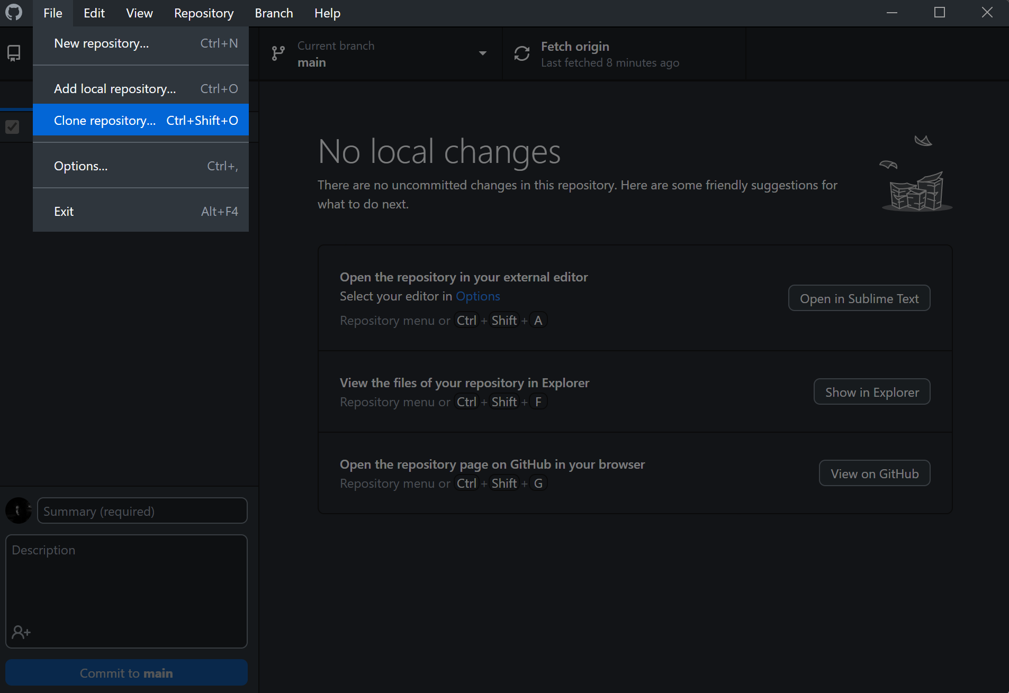

Step 4. In Jupyter Notebook, navigate to the local path of the repository. Open the notebook ‘0_prep.ipynb’. Alternatively, you can upload the notebook to the Jupyter Notebook interface (screenshots below). Open and run through the notebook to get some basic familiarity with the Jupyter Notebook interface.

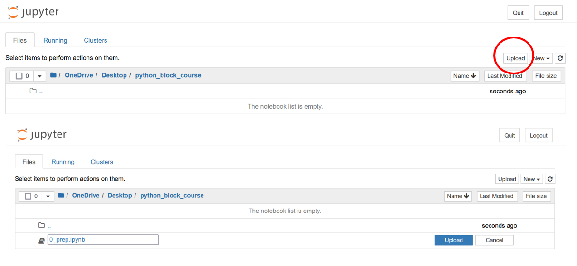**Additional Information**

To get a first-hand experience of how to use Anaconda, Jupyter Lab, GitHub, and GitHub Desktop, we recommend you to watch the following videos.

Getting Started With GitHub, Part 1: Creating a GitHub Account,

<https://youtu.be/XBzUqQbHHhw>

Getting Started With GitHub, Part 2: GitHub Desktop,

<https://youtu.be/ci3W1T88mzw>

Anaconda Installation Guide, <https://youtu.be/jhFyTv9vLi4>

If you prefer using the command line, here are some cheatsheets with handy commands:

* Windows: [https://www.cs.columbia.edu/~sedwards/classes/2015/1102-fall/Command%20Prompt%20Cheatsheet.pdf](https://www.cs.columbia.edu/~sedwards/classes/2015/1102-fall/Command Prompt Cheatsheet.pdf)
* Mac: [https://github.com/0nn0/terminal-mac-cheatsheet#english-version](https://github.com/0nn0/terminal-mac-cheatsheet" \l "english-version)