1. **Создать 2 параметра**

1)

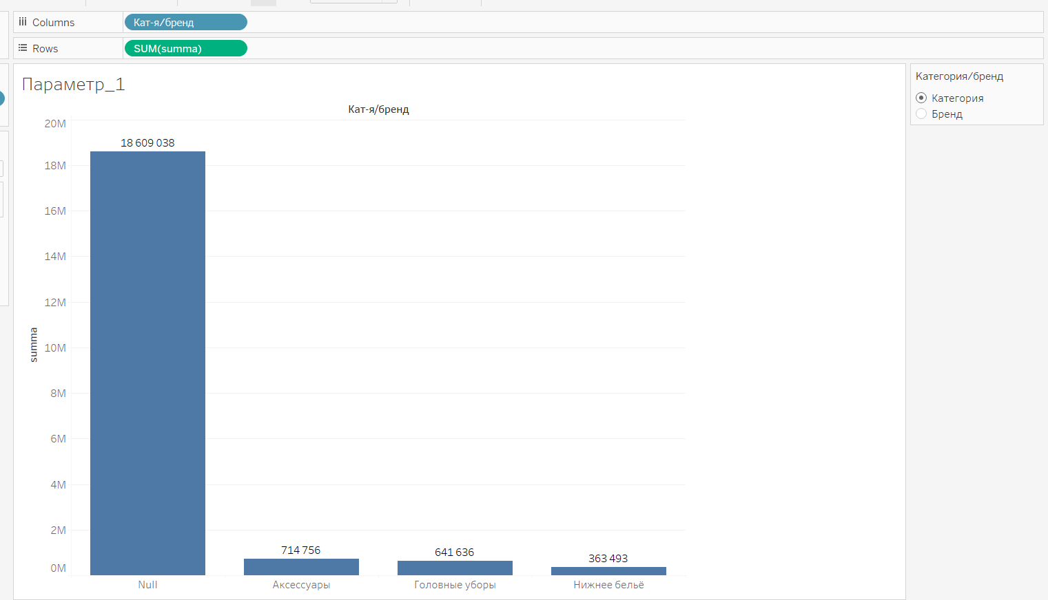

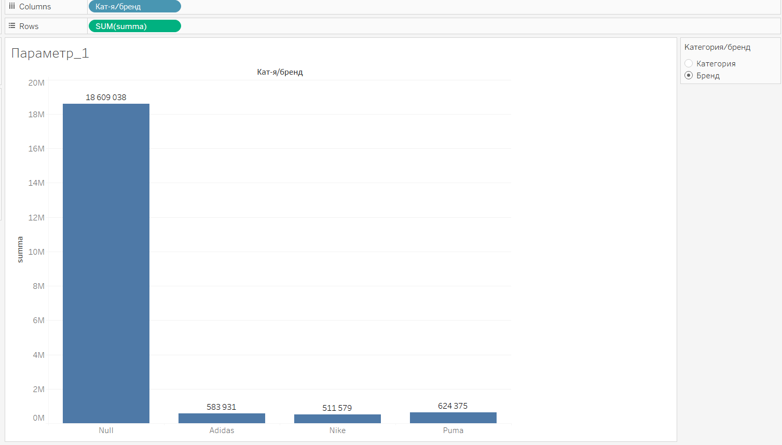

2)

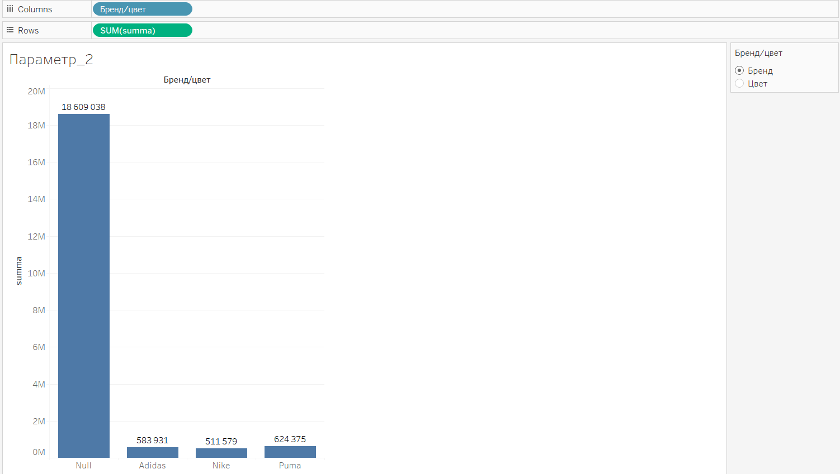

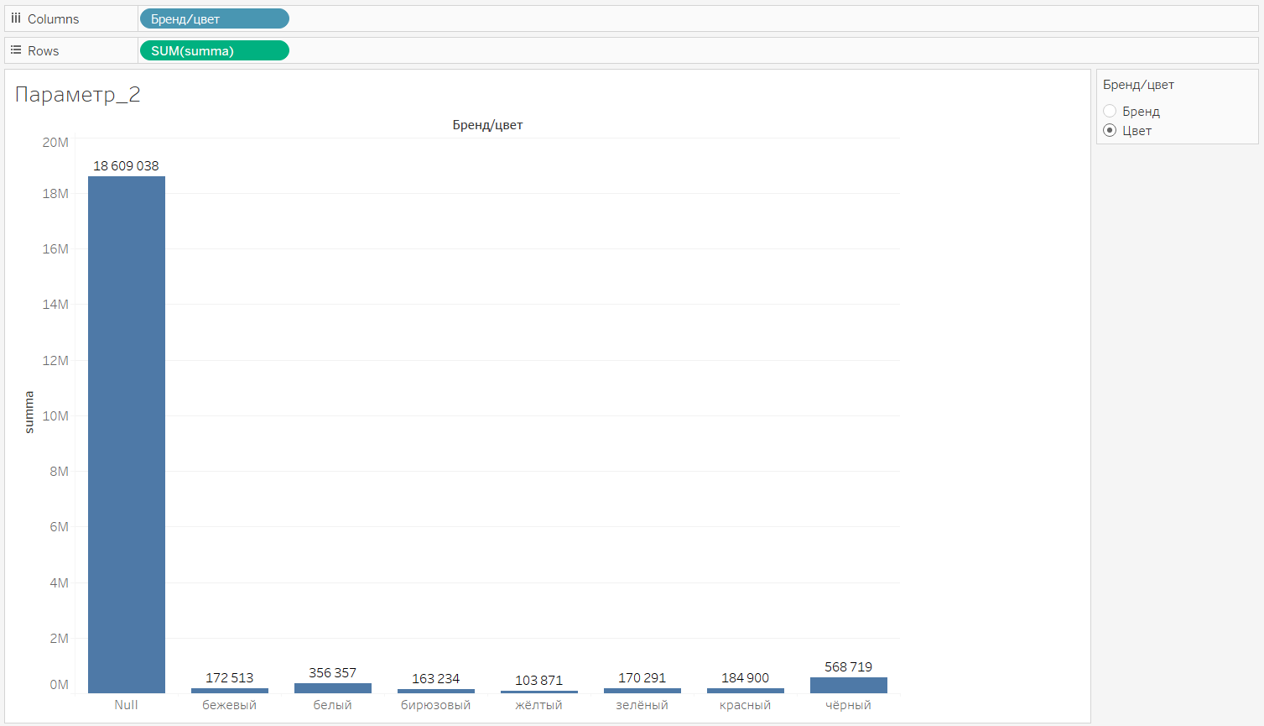

1. **Задачи SQL**

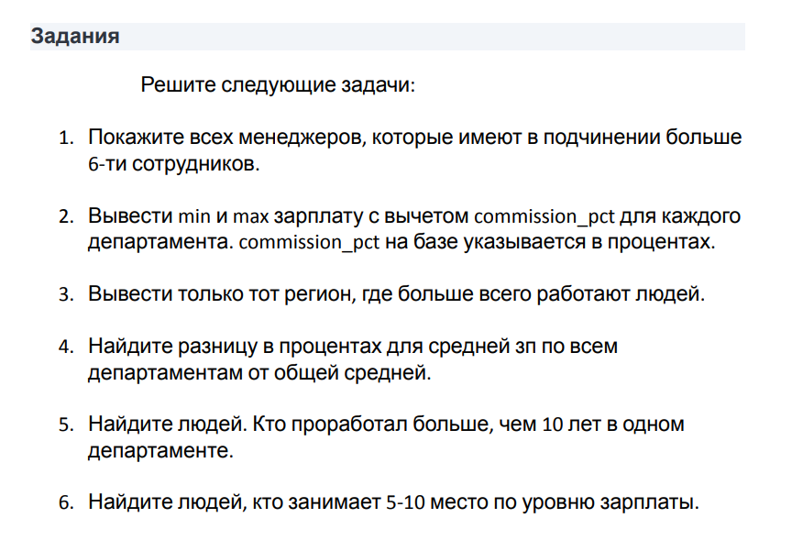

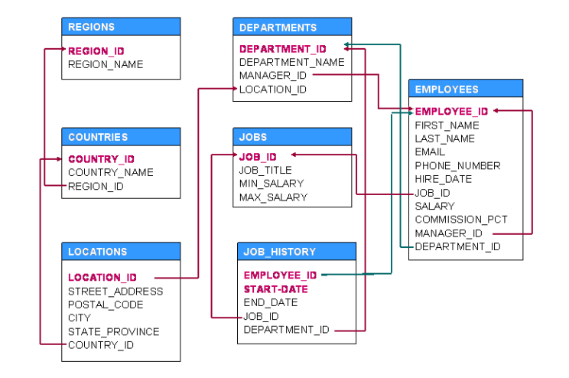

1. SELECT manager_id, COUNT (employee_id) as quantity

FROM employees

GROUP BY manager_id

HAVING COUNT (employee_id)>6

1. SELECT department_name,

MIN (salary*(1-(commission_pct/100) as min,

MAX (salary*(1-(commission_pct/100) as max,

FROM departments

JOIN employees ON dep.department_id=emp.department_id

GROUP BY department_name

1. SELECT TOP 1 WITH TIES region_name

FROM employees as emp

JOIN departments as dep ON dep.department_id=emp.department_id

JOIN location as loc ON dep.location_id=loc.location_id

JOIN countries as c ON loc.country_id=c.country_id

JOIN regions as r ON c.region_id=r.region_id

GROUP BY region_name

ORDER BY COUNT (employee_id) DESC

1. SELECT department_name,

(AVG (salary) OVER (PARTITION BY department_id)/AVG (salary)

1. SELECT first_name, last name, department_id, DATEDIFF (year, start_date, end_date)

FROM employees

WHERE DATEDIFF (year, start_date, end_date) 10

1. SELECT fIrst_name, last_name, salary

FROM

(SELECT first_name, last_name, salary, DENSE_RANK () OVER (ORDER BY salary DESC)

FROM Employees) as task

WHERE task BETWEEN 5 AND 10