Please select one of two options according to UI/UX standards:

A or B

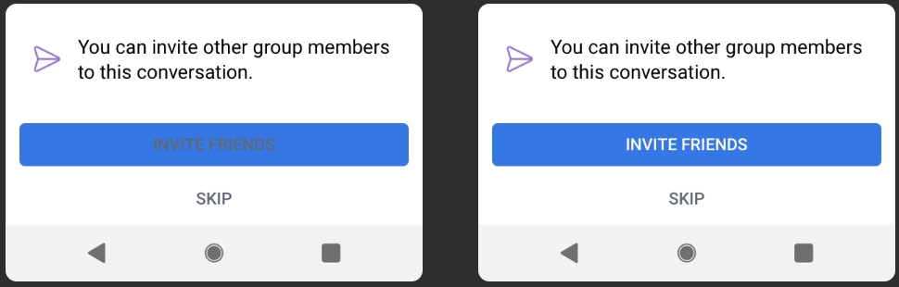1.

**Option А is incorrect** The color of the “INVITE FRIENDS” caption is invisible for reading on the Command Button.

**Option B is correct** The caption font color is visible, readable and user-friendly on the Command Button.

2.

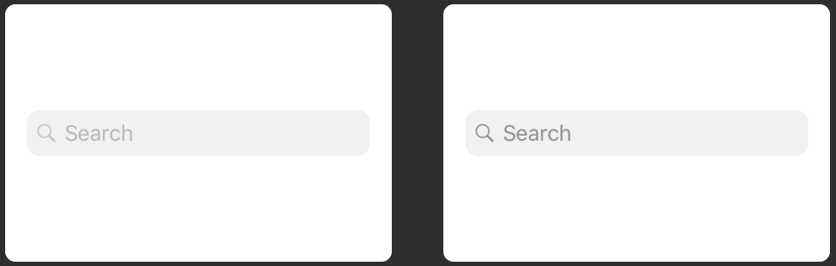

**Option А is incorrect** The “Search” placeholder text and icon are shown in light color on the TextBox.

**Option B is correct** All elements are shown and readable on UI.

3.



**Option А is correct.** The “ENABLE CAMERA” caption is aligned horizontally and vertically on the Command Button.

**Option B is incorrect** The “ENABLE CAMERA” caption is not aligned vertically on the Command Button.

4.

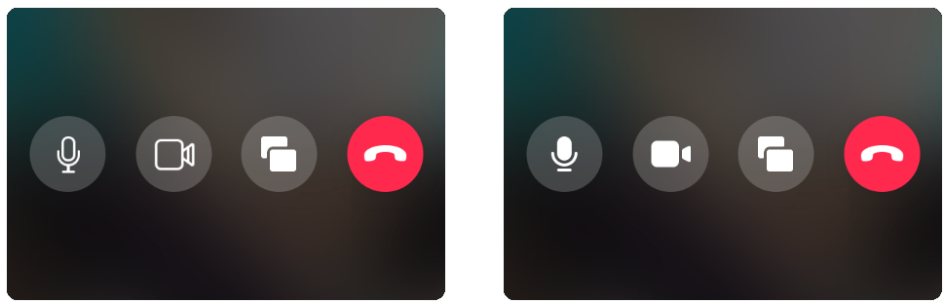

**Option А is incorrect** The microphone and camera icons are shown in another design solution on the Command Buttons.

**Option B is correct** Allicons of the Command Buttons are shown in the specified design solution on the UI.

5.

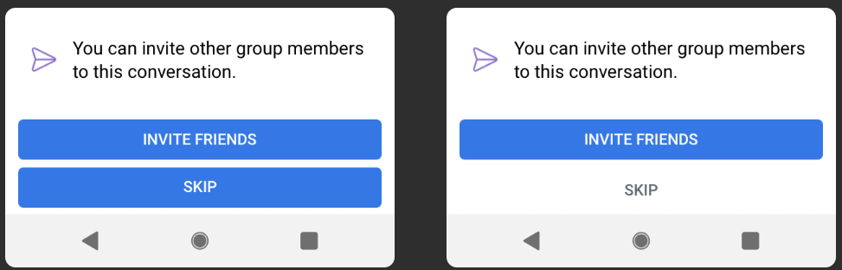

**Option А is incorrect** The “SKIP”and “INVITE FRIENDS” buttons are shown as the highlighted buttons on the Form.

**Option B is correct** The “INVITE FRIENDS” button is displayed as highlighted button on the Form.

6.



**Option A is correct** Alllabels are readable on the UI.

**Option B is incorrect** The color of the “2h ago” label is shown in the darker color on the UI.

7.

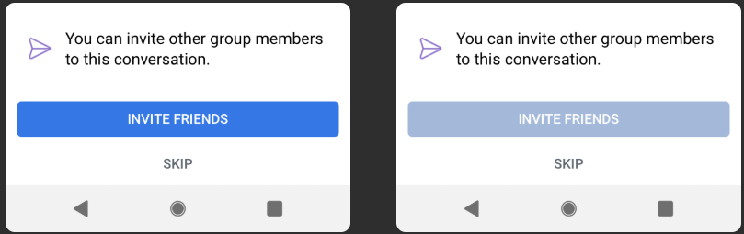

**Option A is correct** The “INVITE FRIENDS” button is shown as the enable Command Button on the Form.

**Option B is incorrect** The “INVITE FRIENDS” button is shown as the disable Command Button on the User form.

8.

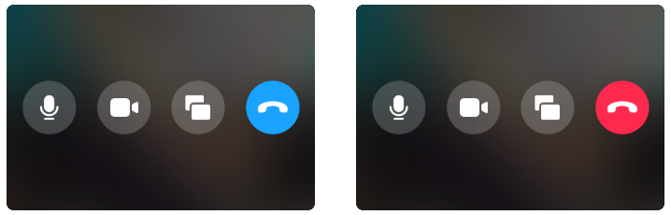

**Option A is incorrect** The call button is shown in the blue color on the User Interface.

**Option B is correct** The call button is displayed in the red color on the User Interface.

9.

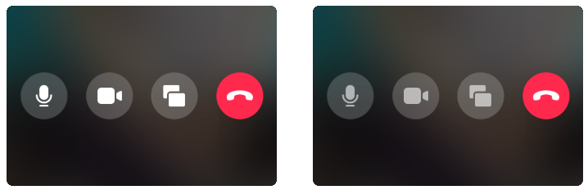

**Option A is correct** All icons for communication are displayed in the user appropriate style on UI.

**Option B is incorrect** The microphone, camera and restore icons are shown in the darker color on the buttons.

10.

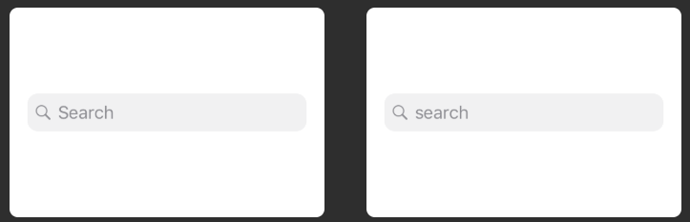

**Option A is correct** The placeholder is capitalized on the TextBox.

**Option B is incorrect** The “search” placeholder is lowercased on the TextBox.

11.

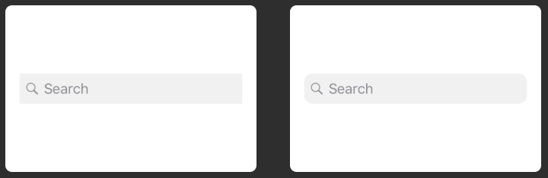

**Option A is incorrect** The TextBox for searching information is displayed in the rectangle shape on the Form.

**Option B is correct** The TextBox for searching is shown in the rounded rectangle shape on the Form.

12.



**Option A is correct** All letters of the caption are uppercased on the Button.

**Option B is incorrect** The second word of the Button name is not uppercased on the TextBox.

13.



**Option A is incorrect**  Online user status is displayed in the blue color on the User’s photo.

**Option B is correct** Online user status is shown in the green color on the User’s photo.

14.



**Option A is correct** TheCommand Button icon and text are shown in the appropriate user style on the UI.

**Option B is incorrect** The camera icon is shown in the bigger size on the Command Button.

15.

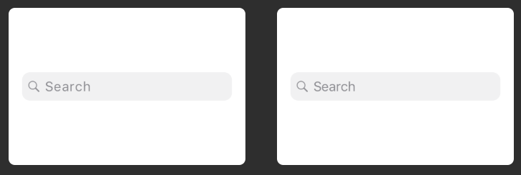

**Option A is incorrectb** The“Search” placeholder is spaced on the TextBox.

**Option B is correct** The text of the placeholder is shown in the appropriate user style on the TextBox.

16.

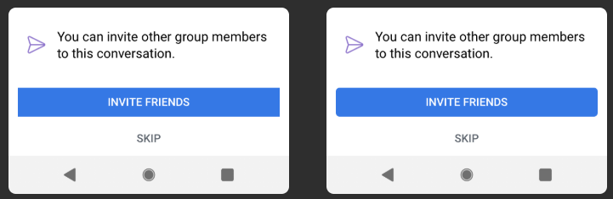

**Option A is incorrect** The “INVITE FRIENDS” button is shown in the rectangle shape on the Form.

**Option B is correct** The “INVITE FRIENDS” button is displayed in the rounded rectangle shape on the User form.

17.



**Option A is incorrect** The Label2 is not aligned vertically on the User Interface.

**Option B is correct** All Labels arealignedvertically and horizontally on the User Interface.

18.

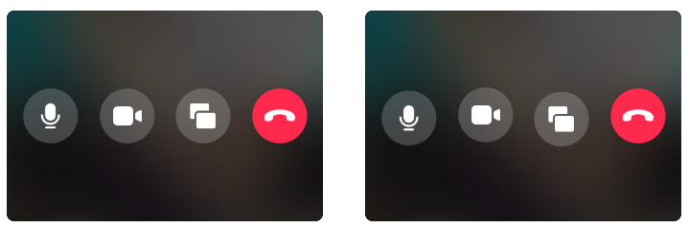

**Option A is correct** All buttons arealignedvertically and horizontally on the Form.

**Option B is incorrect** Thecamera and restore buttons are shifted on the Form.

19.



**Option A is incorrect** The text of the Label2 is not readable on the User Interface.

**Option B is correct** All content is readable on the User Interface.

20.



**Option A is incorrect** Theuser name and status time are not aligned vertically according to form on the User Interface.

**Option B is correct**  Theuser name and status time are aligned vertically on the User Interface.

21.



**Option A is correct** All letters of the caption are uppercased on the “SKIP” button.

**Option B is incorrect** The name of “SKIP” button is not uppercased on the UI.

22.

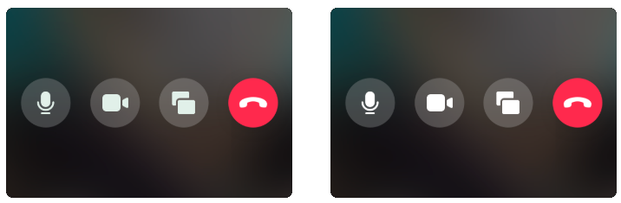

**Option A is incorrect** The microphone, camera and restore icons are shown in gray color on the buttons.

**Option B is correct** All icons for communication are displayed in the user appropriate style on UI.

23.

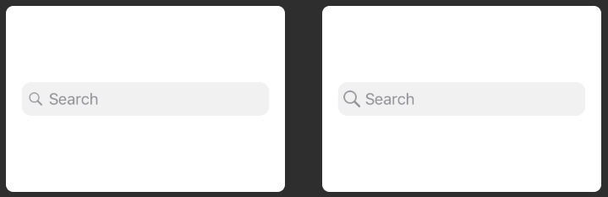

**Option A is correct** The **“**Search”icon and placeholder are shown in the specified on the UI.

**Option B is incorrect** The icon of searching information is shown in the bigger size on the TextBox.

24.



**Option A is incorrect** The shape of the “ENABLE CAMERA” button is not rounded on the Form.

**Option B is correct** The “ENABLE CAMERA” button is shown in the rounded shape on the Form.

25.

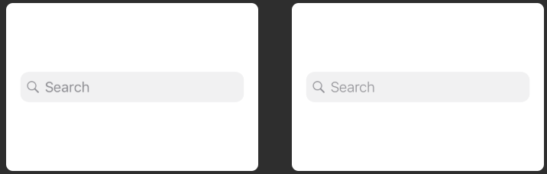

**Option B is incorrect** The“Search” textbox is thickened font on the UI.

**Option A is correct** The“Search” text is displayed in the specified size on the UI.

26.

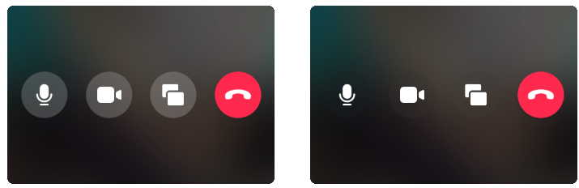

**Option A is correct** All icons of the buttons are visible on the UI.

**Option B is incorrect** The microphone, camera and restore icons are displayed in the darker color on the UI.

27.



**Option A is correct** Theuser name and status time are aligned vertically on the User Interface.

**Option B is incorrect** Thestatus time are not aligned vertically on the User Interface

28.



**Option A is incorrect** Theicon is not aligned vertically compared to the text on the Form.

**Option B is correct** Theicon is aligned vertically and horizontally compared to the text on the Form.

29.



**Option A is correct** The name of the the “ENABLE CAMERA” button is shown in the specified user style on the Form.

**Option B is incorrect** The space between the letters of the name is compressed on the “ENABLE CAMERA” button.

30.

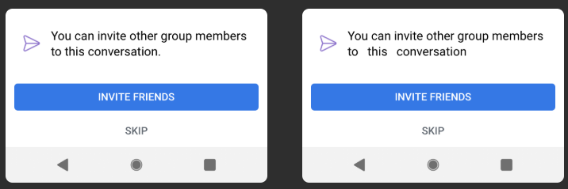

**Option A is correct** The test of Label is aligned on the User Interface.

**Option B is incorrect** The content of Label is spaced on the User Interface.

31.

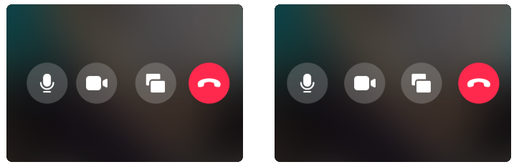

**Option A is incorrect** Thecamera button is left-shifted on the User Interface.

**Option B is correct** All buttonsare aligned vertically and horizontally on the Form.

32.

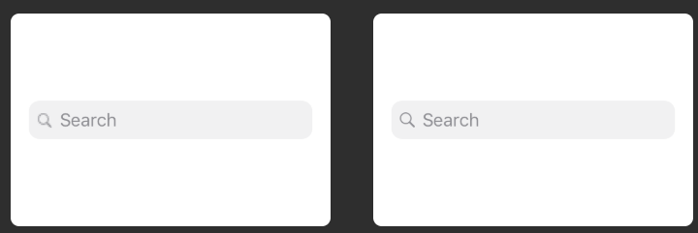

**Option A is incorrect** Thesearch icon is displayed in low resolution on the TextBox.

**Option B is correct** Thesearch icon is displayed in high resolution on the TextBox.

33.

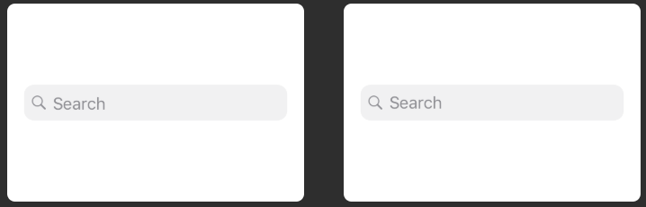

**Option A is incorrect** The placeholder is not aligned vertically compared to the “Search” icon on the TextBox.

**Option B is correct** The placeholder and the “Search” icon are aligned vertically on the TextBox.

34.



**Option A is incorrect** The “munber” word is contained grammatical error on the label2.

**Option B is correct** The content is not contained grammatical error on the User Interface.

35.

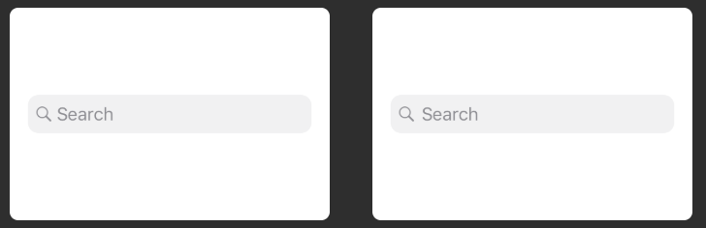

**Option A is incorrect** The search icon and placeholder are located too close to each other on the TextBox.

**Option B is correct** The search icon and placeholder are aligned vertically and horizontally on the TextBox.