**Intercept**

Intercept is used in regression analysis which allow to calculate predicted values or understand the relationship between predictors and the response.

In a regression model intercept is the expected mean value of Y when all X=0. If X = 0, the intercept is the expected mean value of Y.

If X never = 0, then the intercept has no meaning. We can’t say anything about the relationship between X and Y. In this case we should rescale X - subtract a constant from X.

Intercept of the regression line

Intercept indicates the location where regression line intersects an axis.

For example, on the picture y-intercept is 2.

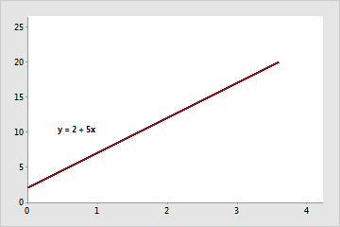

**References:**

<https://www.theanalysisfactor.com/interpreting-the-intercept-in-a-regression-model/>

<https://support.minitab.com/en-us/minitab-express/1/help-and-how-to/modeling-statistics/regression/supporting-topics/regression-models/slope-and-intercept-of-the-regression-line/>