|  |  |
| --- | --- |
| [TEST1-5]  [[ertirestaurant.ru] Picture not visible at "Тбилисоба в ресторане "Эрти""](https://courseqa-nataliianik.atlassian.net/browse/TEST1-5) Created: 04/Feb/21  Updated: 04/Feb/21 | |
| **Status:** | To Do |
| **Project:** | [Project WEB](https://courseqa-nataliianik.atlassian.net/secure/BrowseProject.jspa?id=10000) |
| **Components:** | None |
| **Affects versions:** | None |
| **Fix versions:** | None |

|  |  |  |  |
| --- | --- | --- | --- |
| **Type:** | Bug | **Priority:** | Low |
| **Reporter:** | [Nataliia Nikolenko](https://courseqa-nataliianik.atlassian.net/secure/ViewProfile.jspa?accountId=601c4507c8c36c0069c3dfb5) | **Assignee:** | [Nataliia Nikolenko](https://courseqa-nataliianik.atlassian.net/secure/ViewProfile.jspa?accountId=601c4507c8c36c0069c3dfb5) |
| **Resolution:** | Unresolved | **Votes:** | 0 |
| **Labels:** | None | | |
| **Remaining Estimate:** | Not Specified | | |
| **Time Spent:** | Not Specified | | |
| **Original Estimate:** | Not Specified | | |
| **Environment:** | OS WIndows10 pro x 64, Browser Google Chrome version 88.0.4324.146 | | |

|  |  |
| --- | --- |
| **Attachments:** | Test1-5.JPG |
| **Sprint:** | Sprint 1 |
| **Rank:** | 0|i0000v: |

|  |  |
| --- | --- |
| **Description** |  |

|  |
| --- |
| 1 Open the page <http://ertirestaurant.ru/>  2 Navigate and click to the item of menu “СОБЫТИЯ“  3 Click on the item "Тбилисоба в ресторане "Эрти""  **RESULT:** Second photo is not displayed  **EXPECTED RESULT:** All photos are displayed. |

|  |  |
| --- | --- |
| **Comments** |  |

|  |
| --- |
| Comment by [Nataliia Nikolenko](https://courseqa-nataliianik.atlassian.net/secure/ViewProfile.jspa?accountId=601c4507c8c36c0069c3dfb5) [ 04/Feb/21 ] |
| Current bug was reproduced OS Windows 10 pro x64 Browser Mozilla Firefox version 85.0 |

Attachment Test1-5.JPG

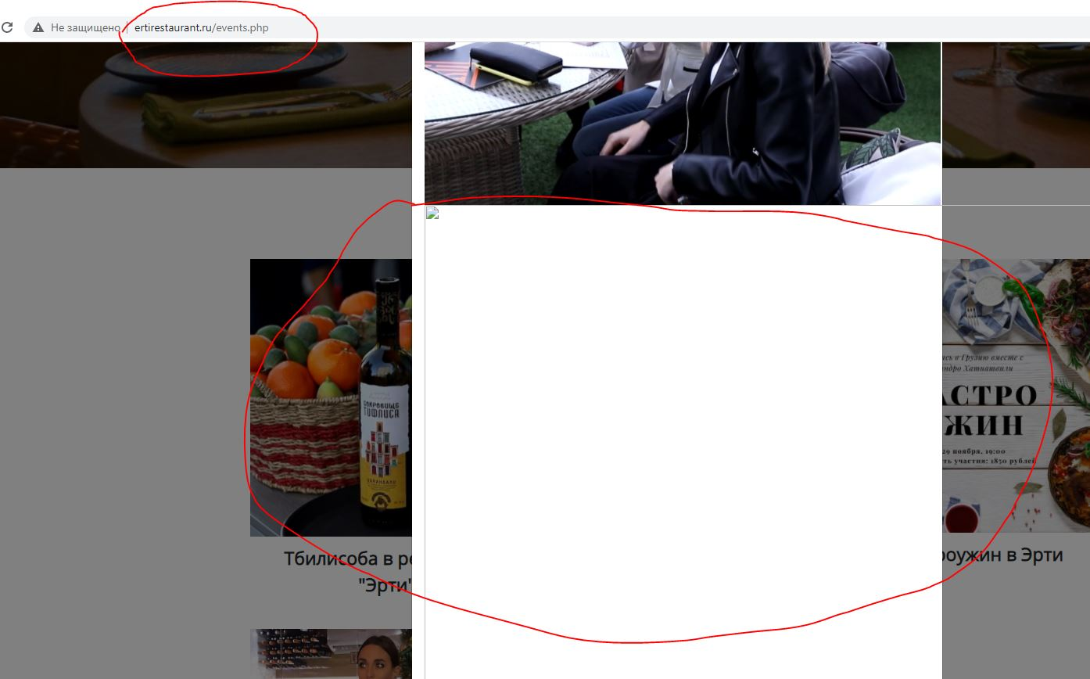

|  |  |
| --- | --- |
| [TEST1-3] [[ertirestaurant.ru] Item of menu "ЗАВТРАКИ" don`t work properly](https://courseqa-nataliianik.atlassian.net/browse/TEST1-3) Created: 04/Feb/21  Updated: 04/Feb/21 | |
| **Status:** | To Do |
| **Project:** | [Project WEB](https://courseqa-nataliianik.atlassian.net/secure/BrowseProject.jspa?id=10000) |
| **Components:** | None |
| **Affects versions:** | None |
| **Fix versions:** | None |

|  |  |  |  |
| --- | --- | --- | --- |
| **Type:** | Bug | **Priority:** | Highest |
| **Reporter:** | [Nataliia Nikolenko](https://courseqa-nataliianik.atlassian.net/secure/ViewProfile.jspa?accountId=601c4507c8c36c0069c3dfb5) | **Assignee:** | [Nataliia Nikolenko](https://courseqa-nataliianik.atlassian.net/secure/ViewProfile.jspa?accountId=601c4507c8c36c0069c3dfb5) |
| **Resolution:** | Unresolved | **Votes:** | 0 |
| **Labels:** | None | | |
| **Remaining Estimate:** | Not Specified | | |
| **Time Spent:** | Not Specified | | |
| **Original Estimate:** | Not Specified | | |
| **Environment:** | OS WIndows10 pro x 64, Browser Google Chrome version 88.0.4324.146 | | |

|  |  |
| --- | --- |
| **Sprint:** | Sprint 1 |
| **Rank:** | 0|i0000f: |

|  |  |
| --- | --- |
| **Description** |  |

|  |
| --- |
| **STEPS:**  1 Open the page <http://ertirestaurant.ru/>  2 Navigate and click to the item of menu “ЗАВТРАКИ”  **RESULT:** Main page is opened in new tab of browser.  **EXPECTED RESULT:** List of breakfast sets with price and details should open in current tab on browser. |

|  |  |
| --- | --- |
| **Comments** |  |

|  |
| --- |
| Comment by [Nataliia Nikolenko](https://courseqa-nataliianik.atlassian.net/secure/ViewProfile.jspa?accountId=601c4507c8c36c0069c3dfb5) [ 04/Feb/21 ] |
| Current bug was reproduced OS Windows 10 pro x64 Browser Mozilla Firefox version 85.0 |

|  |  |
| --- | --- |
| [TEST1-2] [[ertirestaurant.ru] Item of menu "MEНЮ" don`t work properly](https://courseqa-nataliianik.atlassian.net/browse/TEST1-2) Created: 04/Feb/21  Updated: 04/Feb/21 | |
| **Status:** | To Do |
| **Project:** | [Project WEB](https://courseqa-nataliianik.atlassian.net/secure/BrowseProject.jspa?id=10000) |
| **Components:** | None |
| **Affects versions:** | None |
| **Fix versions:** | None |

|  |  |  |  |
| --- | --- | --- | --- |
| **Type:** | Bug | **Priority:** | Highest |
| **Reporter:** | [Nataliia Nikolenko](https://courseqa-nataliianik.atlassian.net/secure/ViewProfile.jspa?accountId=601c4507c8c36c0069c3dfb5) | **Assignee:** | [Nataliia Nikolenko](https://courseqa-nataliianik.atlassian.net/secure/ViewProfile.jspa?accountId=601c4507c8c36c0069c3dfb5) |
| **Resolution:** | Unresolved | **Votes:** | 0 |
| **Labels:** | None | | |
| **Remaining Estimate:** | Not Specified | | |
| **Time Spent:** | Not Specified | | |
| **Original Estimate:** | Not Specified | | |
| **Environment:** | OS WIndows10 pro x 64, Browser Google Chrome version 88.0.4324.146 | | |

|  |  |
| --- | --- |
| **Sprint:** | Sprint 1 |
| **Rank:** | 0|i00007: |

|  |  |
| --- | --- |
| **Description** |  |

|  |
| --- |
| **STEPS:**  1 Open the page <http://ertirestaurant.ru/>  2 Navigate and click to the item of menu “МЕНЮ”  **RESULT:** Main page is opened in new tab of browser.  **EXPECTED RESULT:** List of dishes with price and details should open in current tab on browser. |

|  |  |
| --- | --- |
| **Comments** |  |

|  |
| --- |
| Comment by [Nataliia Nikolenko](https://courseqa-nataliianik.atlassian.net/secure/ViewProfile.jspa?accountId=601c4507c8c36c0069c3dfb5) [ 04/Feb/21 ] |
| Current bug was reproduced OS Windows 10 pro x64 Browser Mozilla Firefox version 85.0 |