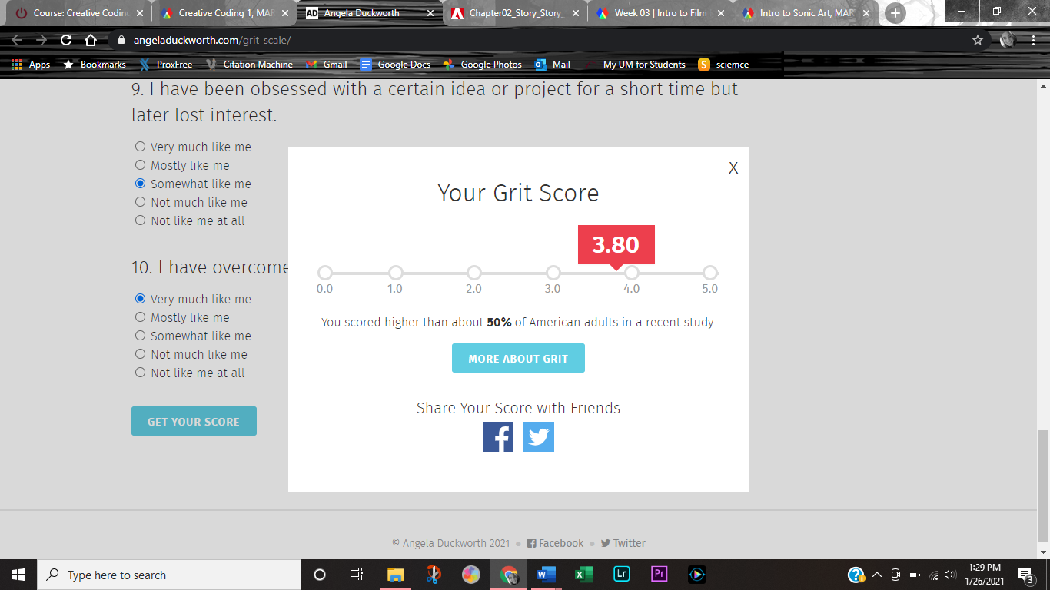

I don’t know if my score is accurate or not, I suppose so since I answered honestly. It doesn’t tell me much unless I click on the button but even then, this is still a pretty new concept. I guess I don’t pay too much attention to quizzes because there are also situational things. Like the main reason I have grit is because someone told me “no” or “you can’t do that” and my sass and stubbornness comes out and I do what they said I couldn’t.