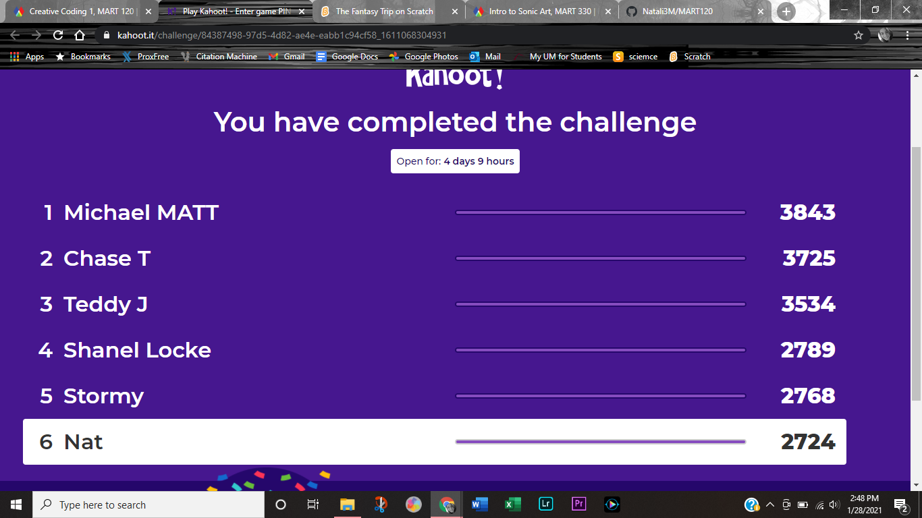

First time I did it. Got a 3/4.

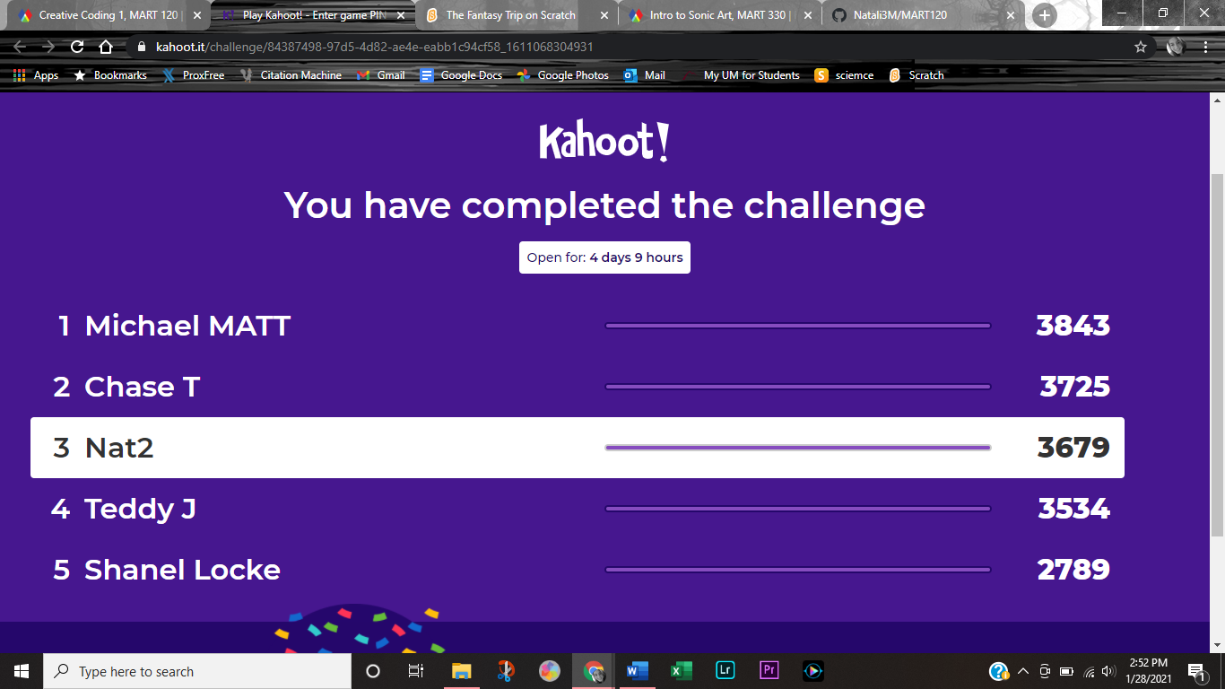

Second time I did it. I mean why not do it again and make sure I knew the answers?