Python/Pytest Automation Test Sheet
Webinar 6 — execution, triage та evidence

Environment
Field | Value
Python | 3.15
pytest | 9.1.1
pyserial | 3.5
DEVICE_PORT | rfc2217://localhost:4000
Firmware | DEMO / BUGGY
Serial | 115200

Execution Log
ID | Test / Input | Expected | Actual | Classification | Evidence | P/F
T-01 | test_boundaries.py::test_pwm_valid_boundaries[0] | OK | OK |  |  | P
T-02 | test_boundaries.py::test_pwm_valid_boundaries[1] | OK | OK |  |  | P
T-03 | test_boundaries.py::test_pwm_valid_boundaries[50] | OK | OK |  |  | P
T-04 | test_boundaries.py::test_pwm_valid_boundaries[100] | OK | ERROR | Firmware | Device response: {"status":"ERROR","code":"INVALID_VALUE"} | F
T-05 | test_boundaries.py::test_pwm_saved_valid_boundaries[1] | 1 | 2 | Firmware | Device response: {"status":"OK","pwm":1}  Device response: {"status":"OK","led":true,"pwm":2,"heap":349852} | F
T-06 | test_boundaries.py::test_pwm_saved_valid_boundaries[99] | 99 | 252 | Firmware | Device response: {"status":"OK","pwm":99}  Device response: {"status":"OK","led":true,"pwm":252,"heap":349852} | F
T-07 | test_boundaries.py::test_pwm_invalid_boundaries[-1] | ERROR | ERROR |  |  | P
T-08 | test_boundaries.py::test_pwm_invalid_boundaries[101] | ERROR | ERROR |  |  | P
T-09 | test_boundaries.py::test_pwm_invalid_boundaries[999] | ERROR | ERROR |  |  | P
T-10 | test_boundaries.py::test_pwm_malformed_values[aa] | ERROR | ERROR |  |  | P
T-11 | test_boundaries.py::test_pwm_malformed_values[1.5] | ERROR | ERROR |  |  | P
T-12 | test_boundaries.py::test_pwm_malformed_values[$#@!%^^&] | ERROR | ERROR |  |  | P
T-13 | test_boundaries.py::test_pwm_empty_values | ERROR | ERROR |  |  | P
T-14 | test_relay.py::test_led_on_off | OK | OK |  |  | P
T-15 | test_reset.py::test_reset_restores_set_led_on | led = false after RESET | led = true | Firmware | Device response: {"status":"OK","led":true}  Device response: {"status":"OK","reset":true}  Device response: {"status":"OK","led":true,"pwm":255,"heap":349852} | F
T-16 | test_reset.py::test_reset_restores_set_pwm | pwm = 0 after RESET | pwm = 12 | Firmware | Device response: {"status":"OK","pwm":5}  Device response: {"status":"OK","reset":true}  Device response: {"status":"OK","led":true,"pwm":12,"heap":349852} | F
T-17 | test_sensor.py::test_temperature_is_valid_json | {"status":"OK","temperature":24.5} | Invalid json | Firmware | Device response: {"status":"OK","temperature":24.5 | F
T-18 | test_status.py::test_ping | OK | TimeoutError | Test | TimeoutError: No response for command: PING | F
T-19 | test_status.py::test_status | OK | OK |  |  | P
T-20 | test_timeout.py::test_no_response_becomes_timeout | No response | No response |  |  | P

FAIL Classification
Category | Check
Test | Assert/oracle correct?
Environment | DEVICE_PORT/dependencies/port ownership?
Communication | Timeout/transport/raw bytes?
Requirement | Expected explicitly supported?
Firmware | Repeatable mismatch with requirement?

Bug Report - 01
Title: SET PWM command: Validation fails for valid boundary input of 100.
Requirement: 5. `SET PWM N` accepts every integer from 0 through 100 inclusive.
Environment: Python 3.15; pytest 9.1.1; pyserial 3.5
Preconditions: RESET
Test/Steps: SET PWM 100
Expected: OK
Actual: INVALID_VALUE
Raw Serial Evidence: {"status":"ERROR","code":"INVALID_VALUE"}
Pytest Evidence: FAILED tests/test_boundaries.py::test_pwm_valid_boundaries[100] - AssertionError: assert 'ERROR' == 'OK'
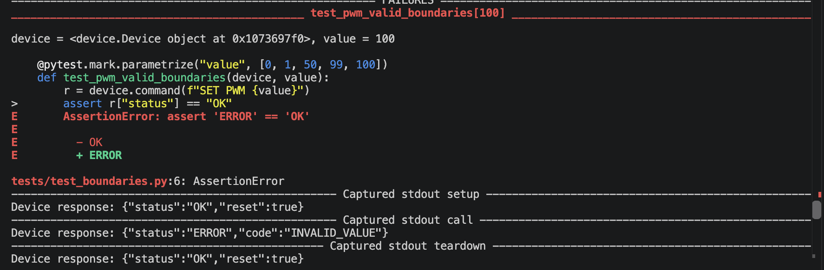
Severity: Major
Reproducibility: 100%

Bug Report - 02
Title: STATUS command: PWM value different from the one set
Requirement: 5. `SET PWM N` accepts every integer from 0 through 100 inclusive.
Environment: Python 3.15; pytest 9.1.1; pyserial 3.5
Preconditions: RESET
Test 1
Steps: SET PWM 1; STATUS
Expected: pwm = 1
Actual: pwm = 2
Raw Serial Evidence: {"status":"OK","pwm":1} {"status":"OK","led":true,"pwm":2,"heap":349852}
Pytest Evidence: FAILED tests/test_boundaries.py::test_pwm_saved_valid_boundaries[1] - assert 2 == 1
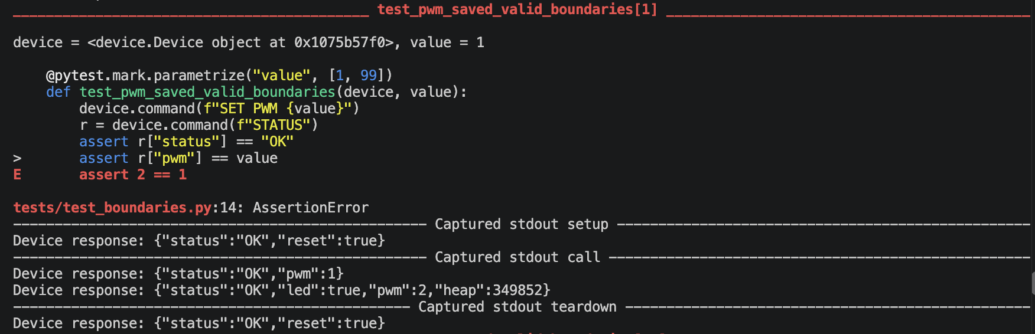
Test 2
Steps: SET PWM 99; STATUS
Expected: pwm = 99
Actual: pwm = 252
Raw Serial Evidence: {"status":"OK","pwm":99} {"status":"OK","led":true,"pwm":252,"heap":349852}
Pytest Evidence: FAILED tests/test_boundaries.py::test_pwm_saved_valid_boundaries[99] - assert 252 == 99
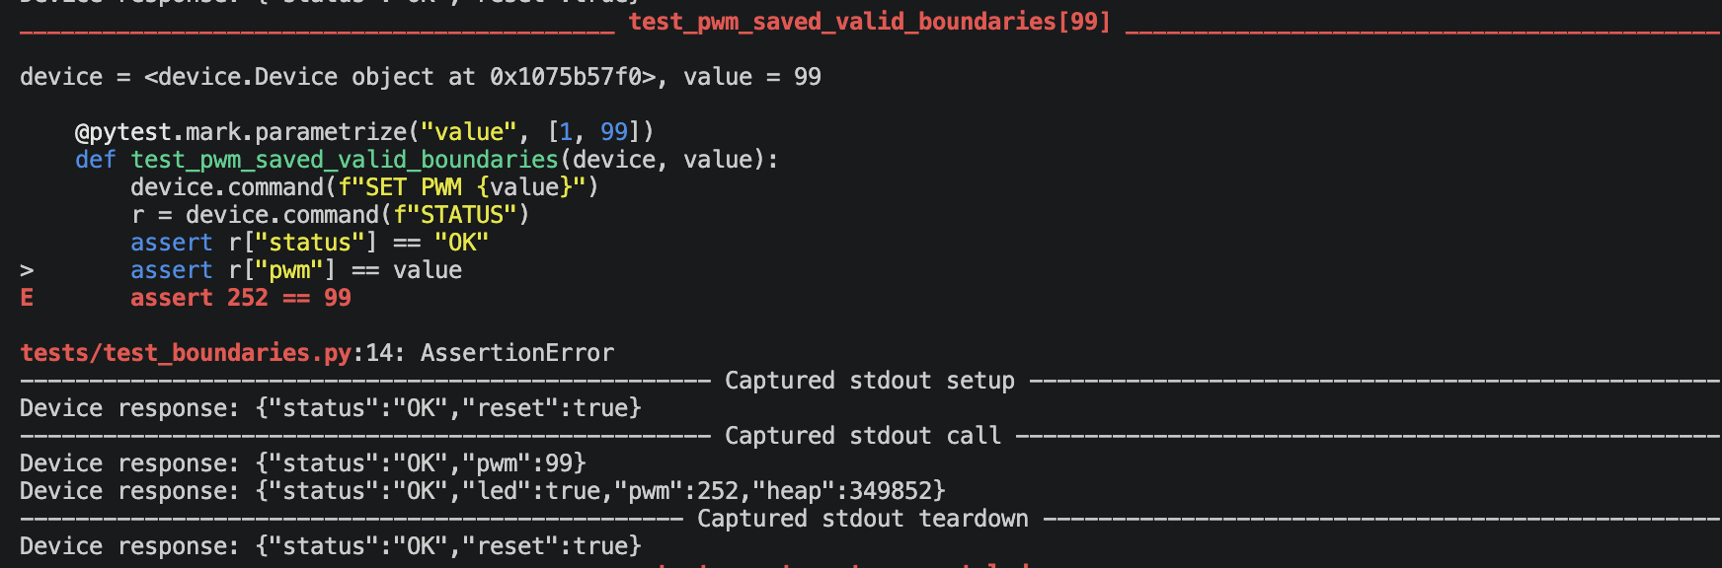
Severity: Major
Reproducibility: 100%

Bug Report - 03
Title: RESET command: The safe output state is not restored.
Requirement: 7. `RESET` restores safe output state: LED/PWM OFF/0.
Environment: Python 3.15; pytest 9.1.1; pyserial 3.5
Preconditions: RESET
Test LED ON
Steps: SET LED ON; RESET; STATUS
Expected: led = false
Actual: led = true
Raw Serial Evidence:
{"status":"OK","led":true}
{"status":"OK","reset":true}
{"status":"OK","led":true,"pwm":255,"heap":349852}
Pytest Evidence: FAILED tests/test_reset.py::test_reset_restores_set_led_on - assert True is False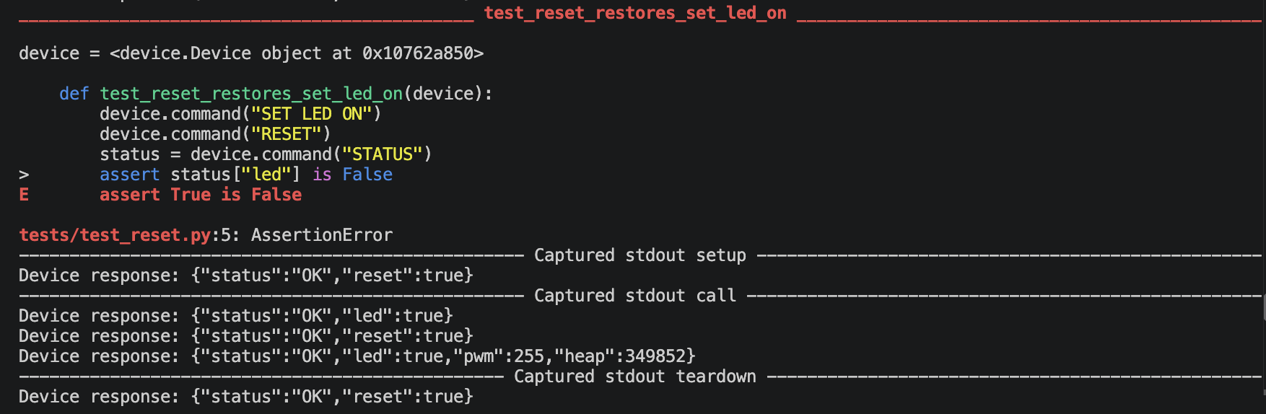
Test PWM
Steps: SET PWM 5; RESET; STATUS
Expected: pwm = 0
Actual: pwm = 12
Raw Serial Evidence:
{"status":"OK","pwm":5}
{"status":"OK","reset":true}
{"status":"OK","led":true,"pwm":12,"heap":349852}
Pytest Evidence: FAILED tests/test_reset.py::test_reset_restores_set_pwm - assert 12 == 0
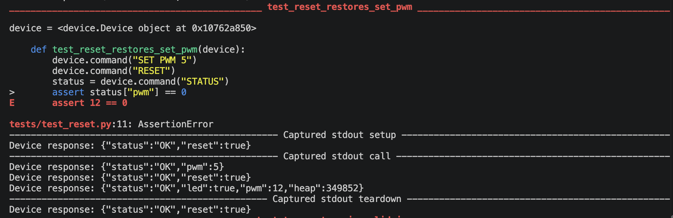
Severity: Critical/High
Reproducibility: 100%

Bug Report - 04
Title: GET TEMP command: The command returns the wrong json.
Requirement: 3. `GET TEMP` → valid JSON; either valid temperature or explicit sensor error.
Environment: Python 3.15; pytest 9.1.1; pyserial 3.5
Preconditions: RESET
Test/Steps: GET TEMP
Expected: {"status":"OK","temperature":24.5}
Actual: AssertionError: Invalid JSON from device: '{"status":"OK","temperature":24.5'
Raw Serial Evidence: "status":"OK","temperature":24.5
Pytest Evidence: FAILED tests/test_sensor.py::test_temperature_is_valid_json - AssertionError: Invalid JSON from device: '{"status":"OK","temperature":24.5'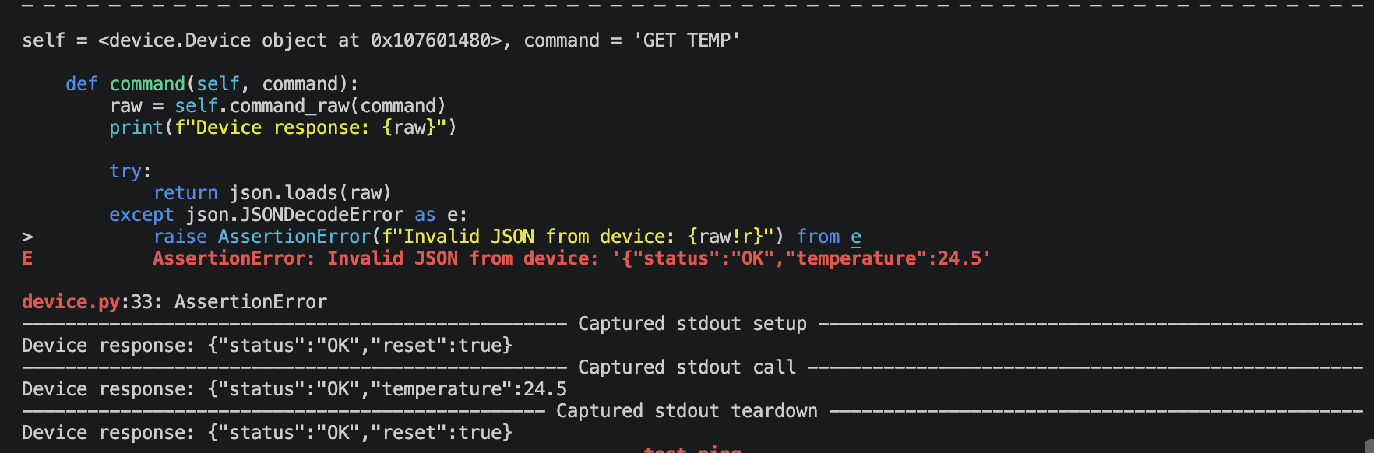
Severity: Major
Reproducibility: 100%

QA Conclusion
The firmware has four main bugs: SET PWM 100 is rejected, STATUS shows the wrong PWM value, RESET does not restore the safe state, and GET TEMP returns broken JSON. All bugs repeat 100% of the time. Invalid input handling, LED ON/OFF and timeout handling work correctly. My recommendation is No-Go: the build should not be accepted until the bugs are fixed and the tests pass again.

