Protocol Analysis Sheet / Test Log
Webinar 4 — I2C/SPI

Environment
Field | Value
MCU | ESP32 DevKit
Peripheral | MPU6050 / 0x68
SDA/SCL | GPIO21 / GPIO22
Capture | i2c-capture.vcd
Build | NORMAL / BUGGY: Buggy

Transaction Log
# | Timestamp | Address | R/W | Data | ACK/NACK | Expected | Observed
1 | +25 ns | 0x68 | W | 0x6B, 0x00 | ACK, ACK, ACK | ACK, ACK, ACK | ACK, ACK, ACK
2 | +1525 ns | 0x68 | W → R (Sr) | W: 0x41; R: 0xEF, 0x5C | ACK, ACK, ACK, ACK, NACK | ACK, ACK, ACK, ACK, NACK | ACK, ACK, ACK, ACK, NACK
3 | +4000 ns | 0x68 | W → R (Sr) | W: 0x41; R: 0xEF, 0x5C | ACK, ACK, ACK, ACK, NACK | ACK, ACK, ACK, ACK, NACK | ACK, ACK, ACK, ACK, NACK
4 | +6475 ns | 0x68 | W → R (Sr) | W: 0x41; R: 0xEF, 0x5C | ACK, ACK, ACK, ACK, NACK | ACK, ACK, ACK, ACK, NACK | ACK, ACK, ACK, ACK, NACK
5 | +8950 ns | 0x68 | W → R (Sr) | W: 0x41; R: 0xEF, 0x5C | ACK, ACK, ACK, ACK, NACK | ACK, ACK, ACK, ACK, NACK | ACK, ACK, ACK, ACK, NACK
6 | +11425 ns | 0x69 | W | — | NACK | ACK, ACK, ACK, ACK, NACK | NACK

Firmware Log
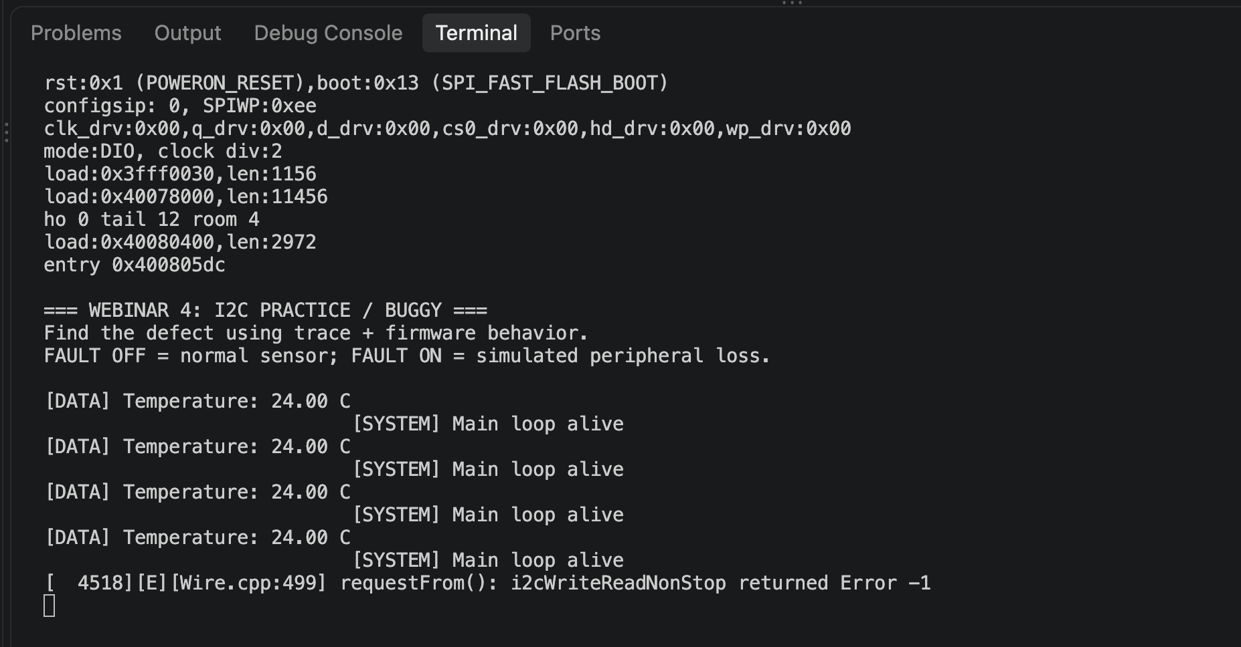

Transaction LogFault Timeline
Event | Timestamp | Trace evidence | Firmware evidence
Last successful ACK | +8950 ns | 358-358 I²C: Address/Data: Start  360-374 I²C: Address/Data: Address write: 68  374-376 I²C: Address/Data: Write  376-378 I²C: Address/Data: ACK  379-395 I²C: Address/Data: Data write: 41  395-397 I²C: Address/Data: ACK  398-398 I²C: Address/Data: Start repeat  400-414 I²C: Address/Data: Address read: 68  414-416 I²C: Address/Data: Read  416-418 I²C: Address/Data: ACK  418-434 I²C: Address/Data: Data read: EF  434-436 I²C: Address/Data: ACK  436-452 I²C: Address/Data: Data read: 5C  452-454 I²C: Address/Data: NACK  456-456 I²C: Address/Data: Stop | [DATA] Temperature: 24.00 C  [SYSTEM] Main loop alive
First NACK | +11425 ns | 457-457 I²C: Address/Data: Start  459-473 I²C: Address/Data: Address write: 69  473-475 I²C: Address/Data: Write  475-477 I²C: Address/Data: NACK  478-478 I²C: Address/Data: Stop | [ 4518][E][Wire.cpp:499] requestFrom(): i2cWriteReadNonStop returned Error -1
Retry #1 | Not retry
Retry limit / error | Not retry
Recovery ACK | Not recovery

Screenshot last successful ACK
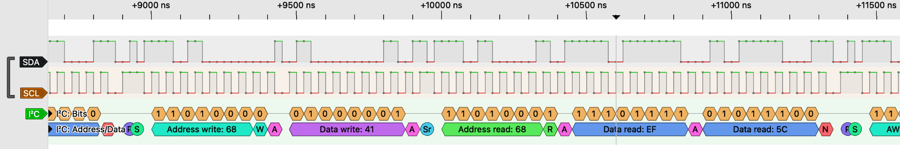

Screenshot first NACK
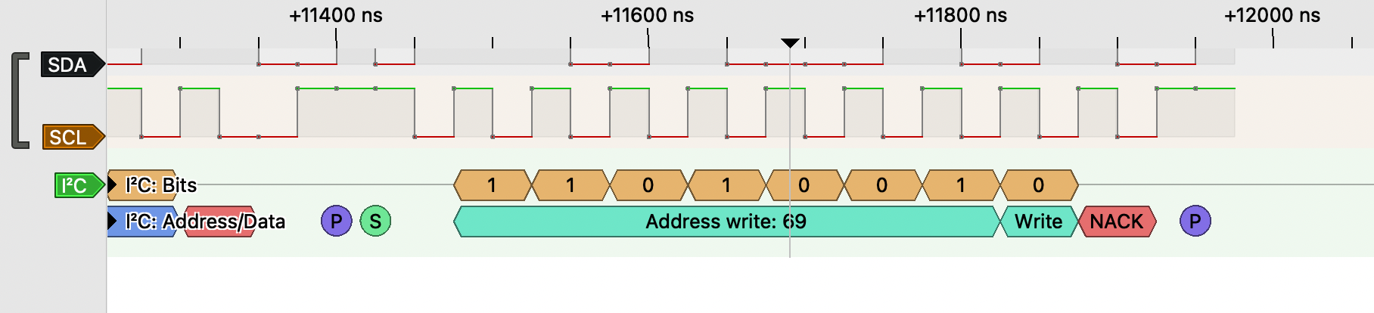

Results table
Стан | UART | I2C ACK/NACK | Main loop | Conclusion
FAULT OFF — normal work | [DATA] Temperature: 24.00 C | ACK | [SYSTEM] Main loop alive | work normal
FAULT ON — error | [ 4518][E][Wire.cpp:499] requestFrom(): i2cWriteReadNonStop returned Error -1 | NACK | Not work | error
FAULT OFF — after error | empty | empty | Not work | Not recovery

Bug Report
Title: System freezes indefinitely after I2C bus error
Environment: ESP32 DevKit | MPU6050 (0x68) | SDA: GPIO21, SCL: GPIO22 | Wokwi Simulator
Preconditions: The system is running normally with communication active between ESP32 DevKit and MPU6050 (0x68) via GPIO21/22.
Steps:
- Toggle the FAULT slide switch to the active position to simulate an I2C failure.
- Observe the serial output and system behavior
Expected:
- The serial output displays the i2cWriteReadNonStop returned Error -1 log.
- The main loop() function continues to execute without freezing or locking up the MCU.
Actual:
- The serial output for the i2cWriteReadNonStop returned Error -1 log.
- The main loop() function does not execute.
Trace Evidence:
58-358 I²C: Address/Data: Start
360-374 I²C: Address/Data: Address write: 68
374-376 I²C: Address/Data: Write
376-378 I²C: Address/Data: ACK
379-395 I²C: Address/Data: Data write: 41
395-397 I²C: Address/Data: ACK
398-398 I²C: Address/Data: Start repeat
400-414 I²C: Address/Data: Address read: 68
414-416 I²C: Address/Data: Read
416-418 I²C: Address/Data: ACK
418-434 I²C: Address/Data: Data read: EF
434-436 I²C: Address/Data: ACK
436-452 I²C: Address/Data: Data read: 5C
452-454 I²C: Address/Data: NACK
456-456 I²C: Address/Data: Stop
457-457 I²C: Address/Data: Start
459-473 I²C: Address/Data: Address write: 69
473-475 I²C: Address/Data: Write
475-477 I²C: Address/Data: NACK
478-478 I²C: Address/Data: Stop
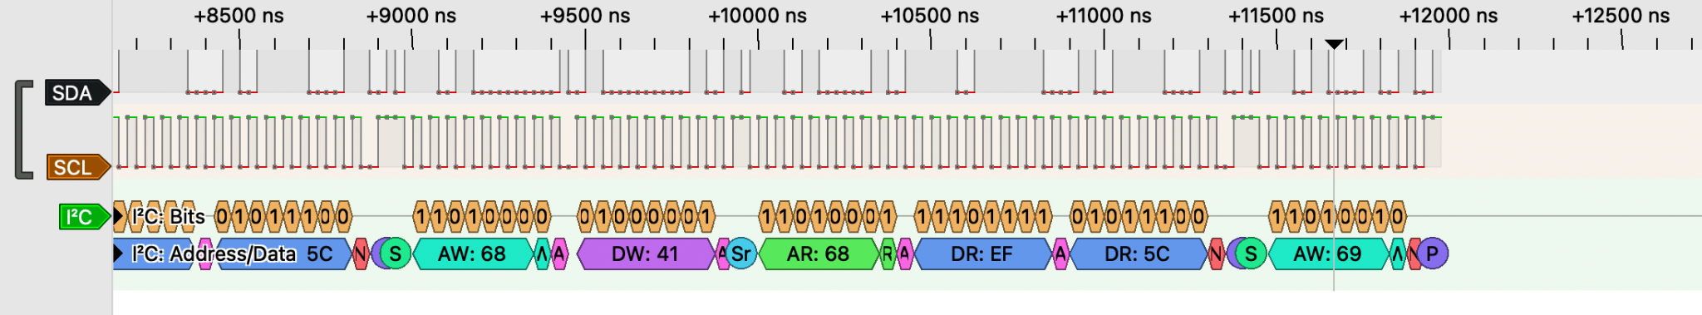
Firmware Log Evidence: [ 4518][E][Wire.cpp:499] requestFrom(): i2cWriteReadNonStop returned Error -1
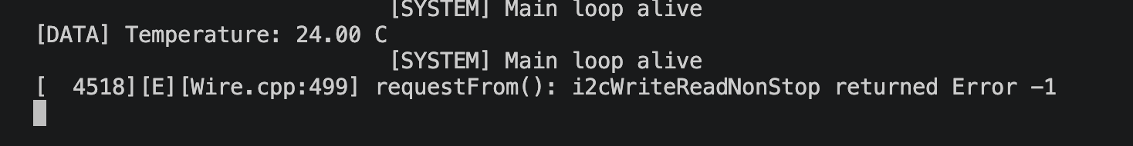
Severity: Critical
Reproducibility: 5/5

QA Conclusion
The system fails to meet REQ-08. When an I2C error occurs, the MCU freezes completely and the main loop stops executing.
Due to this critical system lock-up, the remaining requirements (REQ-09, REQ-10, REQ-11, and REQ-12) are BLOCKED and cannot be verified. Testing cannot proceed until the system freeze is fixed and a recovery mechanism is implemented.

