Recovery / Fault Injection Test Sheet
Webinar 5 — Sleep, WDT, Power Loss, Persistence

Environment
Field | Value
MCU | ESP32 DevKit V1
Sensor | DHT22 GPIO15
Button | GPIO4
LED | GPIO2
Relay | GPIO5
Serial | 115200
Build | BUGGY / Wokwi for Vs code

Test Matrix
ID | Risk | Test / Scenario | Precondition | Action | Expected | Evidence | Result
T01 | Invalid sensor data | Sensor unavailable | Device ACTIVE | Disconnect DHT | Explicit sensor error | Serial log  DHT_disconnect.png | PASS
T02 | Button bounce | Duplicate event | Device ACTIVE | Press button 20 times | Exactly 20 events | Counter + video | FAIL
T03 | Sleep timing | Wrong state timing | Device ACTIVE | sleep 5 | Wake in 4.25–5.75 s | Timestamped log | FAIL
T04 | Firmware hang | Device unavailable | Device ACTIVE | hang | WDT reset ≲5 s | Reset log  hang.txt | PASS
T05 | Unsafe recovery | Unsafe actuator state | Relay ON | hang | After WDT relay OFF | Screen + status | FAIL
T06 | Interrupted save | Corrupted persistent state | Known state | powerloss | Old or new valid state only | Before/after status | FAIL
T07 | Recovery stability | Boot loop | Device ACTIVE | hang/recovery ×10 | Returns ACTIVE each time | Serial log  boot_loop.txt | PASS

Bug Report - 01
Title: Button: One click can create a few logic events.
Requirement: R3 — Button
Один фізичний натиск кнопки повинен створити не більше однієї логічної події.
Risk: Button bounce
Preconditions: Device ACTIVE
Steps: Press button 20 times
Expected: Exactly 20 events
Actual: 24
Timing / Reset Reason: "counter":0 ⇒ “counter":24
Evidence: video - ButtonBounce2026-10-29.mov
{"state":"ACTIVE","reset_reason":"POWER_ON","relay":false,"counter":0,"heap":336332,"sensor_ok":true}
{"state":"ACTIVE","reset_reason":"POWER_ON","relay":false,"counter":24,"heap":336188,"sensor_ok":true}
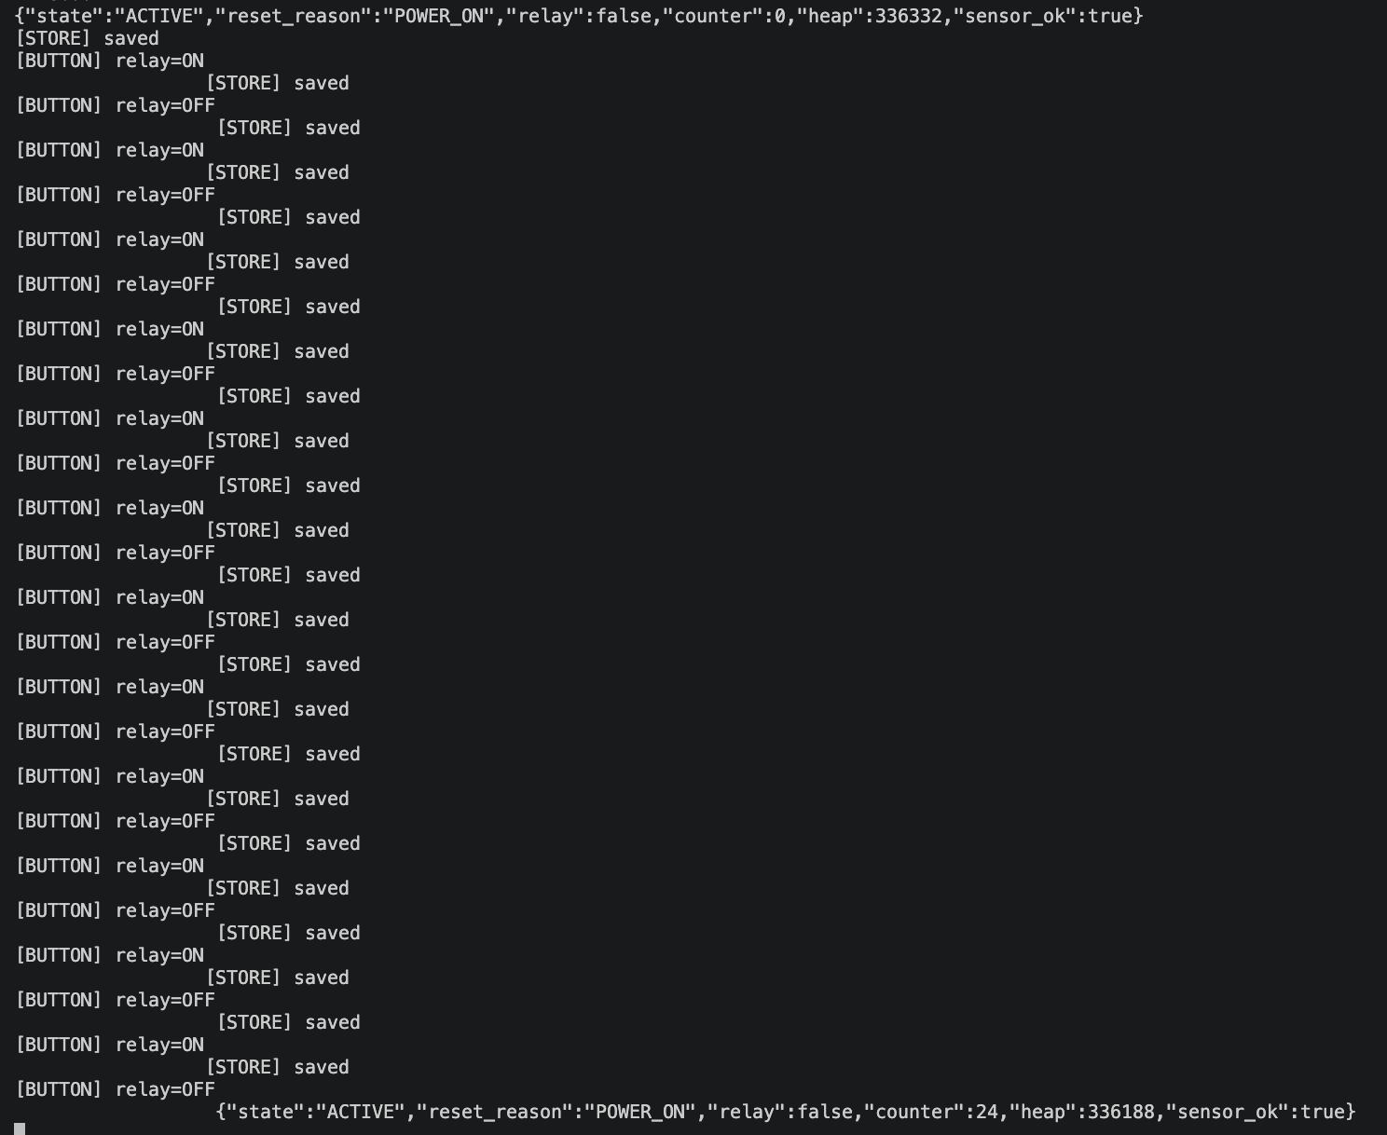
Severity: Major
Reproducibility: 100%

Bug Report - 02
Title: Sleep command: The time sleep is wrong.
Requirement: R4 — Sleep / Wake
Команда `sleep <N>` переводить пристрій у deep sleep приблизно на N секунд. Похибка wake-up ±15%;
Risk: Sleep timing
Preconditions: Device ACTIVE
Steps: sleep 5
Expected: Wake in 4.25–5.75 s
Actual: 1.368 s
Timing / Reset Reason: [TIMESTAMP_PRE_SLEEP] 17.247 s - [TIMESTAMP_POST_SLEEP] 18.615 s / reset_reason=DEEP_SLEEP
Evidence:
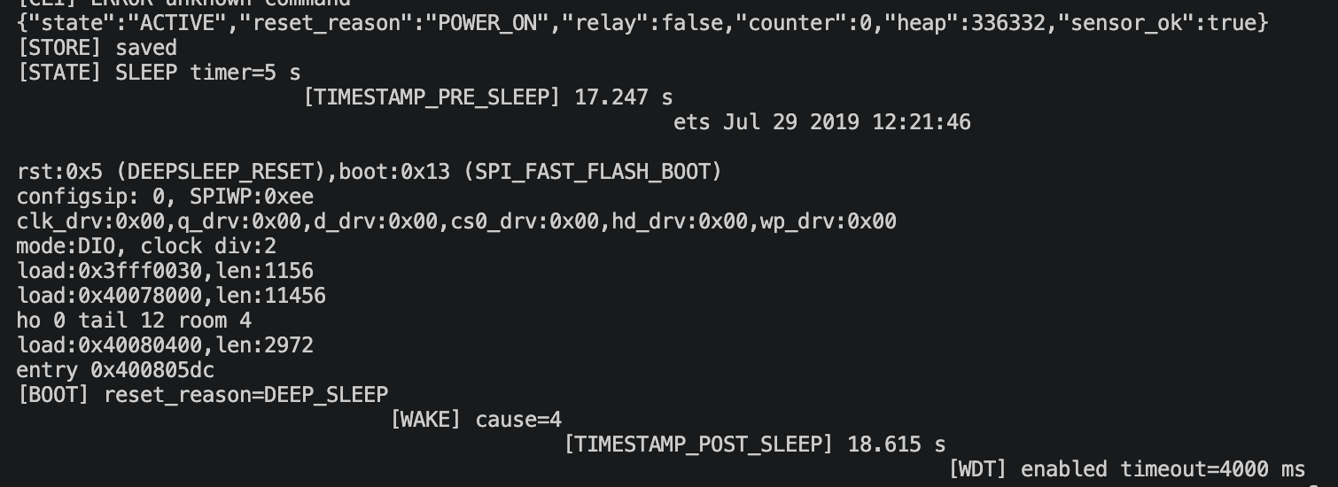
Severity: Major
Reproducibility: 100%

Bug Report - 03
Title: Hung command: The relay is on after reset.
Requirement: R5 — Watchdog
Acceptance: actuator після аварійного reset має бути OFF;
Risk: Unsafe recovery
Preconditions: Relay ON
Steps: relay on; hang
Expected: After WDT relay OFF
Actual: relay = ON
Timing / Reset Reason: reset_reason=INT_WDT
Evidence:
{"state":"ACTIVE","reset_reason":"POWER_ON","relay":false,"counter":0,"heap":336068,"sensor_ok":true}
[RELAY] ON
{"state":"ACTIVE","reset_reason":"POWER_ON","relay":true,"counter":1,"heap":336068,"sensor_ok":true}
[FAULT] firmware hang
{"state":"ACTIVE","reset_reason":"INT_WDT","relay":true,"counter":1,"heap":336068,"sensor_ok":true}
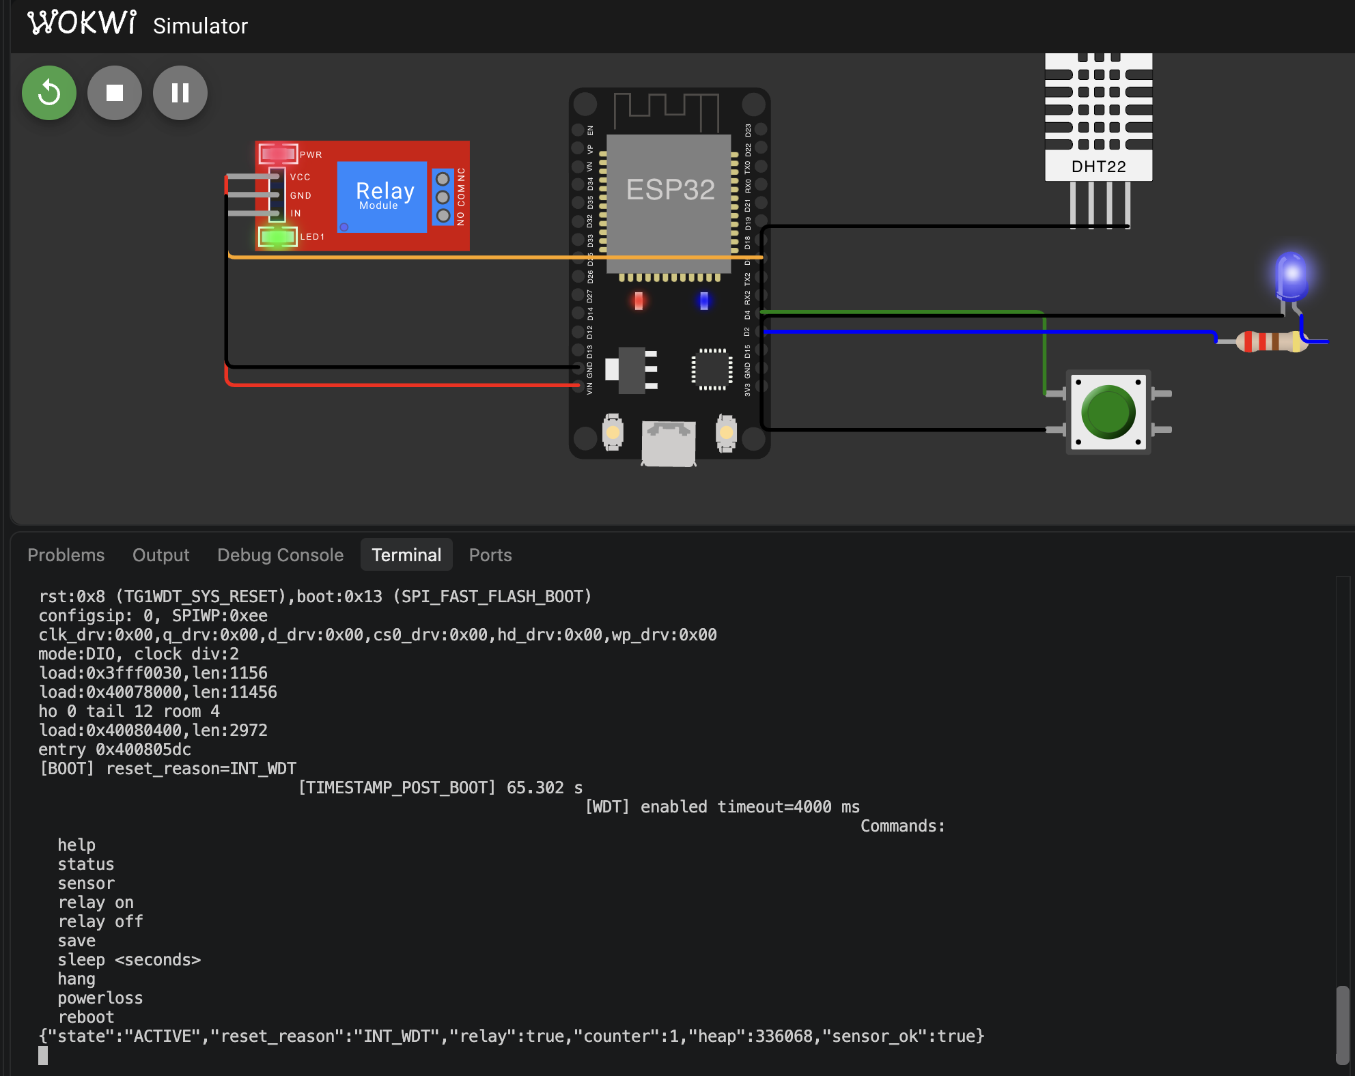
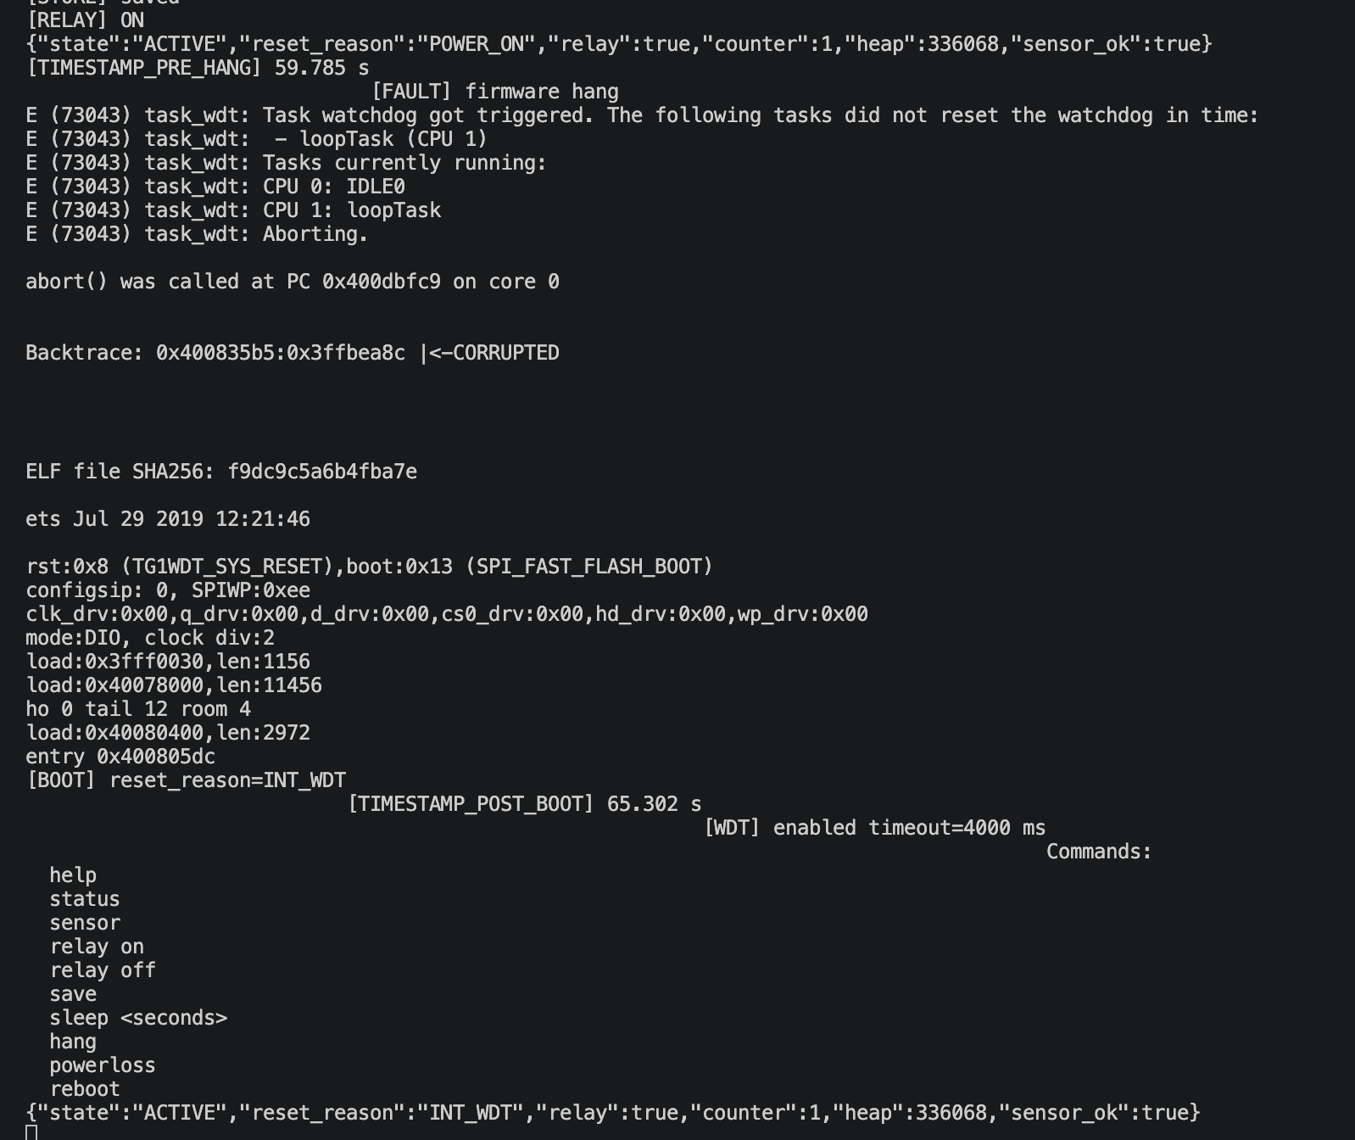
Severity: Critical
Reproducibility: 100%

Bug Report - 04
Title: Powerloss: The counter increases by 100 after the ‘powerloss’ command.
Requirement: R6 — Interrupted save
Команда `powerloss` моделює reboot у критичний момент запису.
Acceptance:
- після reboot має залишитися стара повністю валідна або нова повністю валідна версія стану;
- змішаний/частково оновлений state не допускається;
Risk: Interrupted save
Preconditions: Known state
Steps: status; powerloss; status; relay on; status; powerloss; status
Expected: Old or new valid state only
Actual: після powerloss counter = 100 замість 0 (старий) або 1 (новий)
Timing / Reset Reason: reset_reason=SOFTWARE_RESET
"counter":0 ⇒ counter":100
"counter":101 ⇒ counter":201
Evidence:
{"state":"ACTIVE","reset_reason":"POWER_ON","relay":false,"counter":0,"heap":336068,"sensor_ok":true}
[FAULT] power loss DURING save
{"state":"ACTIVE","reset_reason":"SOFTWARE_RESET","relay":false,"counter":100,"heap":336068,"sensor_ok":true}
[RELAY] ON
{"state":"ACTIVE","reset_reason":"SOFTWARE_RESET","relay":true,"counter":101,"heap":336020,"sensor_ok":true}
[FAULT] power loss DURING save
{"state":"ACTIVE","reset_reason":"SOFTWARE_RESET","relay":true,"counter":201,"heap":336068,"sensor_ok":true}
Severity: Critical
Reproducibility: 100%

Release Decision
Decision | NO-GO
Blocking risks | T05 (unsafe actuator state after WDT reset, safety issue), T06 (corrupted state, unknown whether corruption is detected), T03 (deep sleep does not meet the specification: 1.368 s vs the expected 4.25–5.75 s).
Tests required on real hardware | Sensor failure (T01): physically disconnect the DHT22 and verify the error handling, the sensor_ok:false status, and that the relay does not enter an unsafe state.  Button bounce (T02): test with a real mechanical button, because simulated bounce does not match real contact behavior.

