Assignment 6:

Correct IP. 50 bits sent
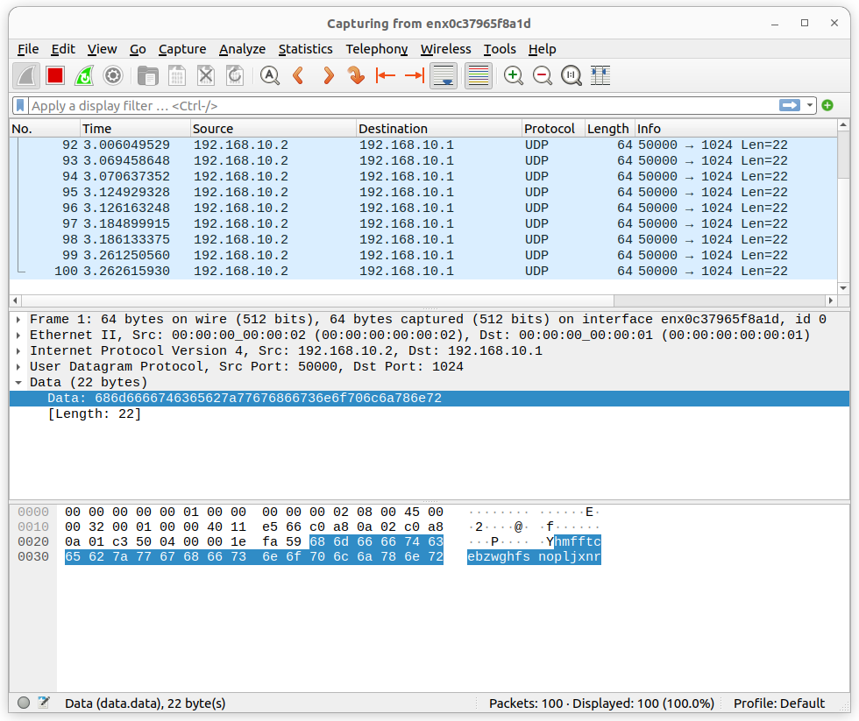
Correct IP 100 bits sent

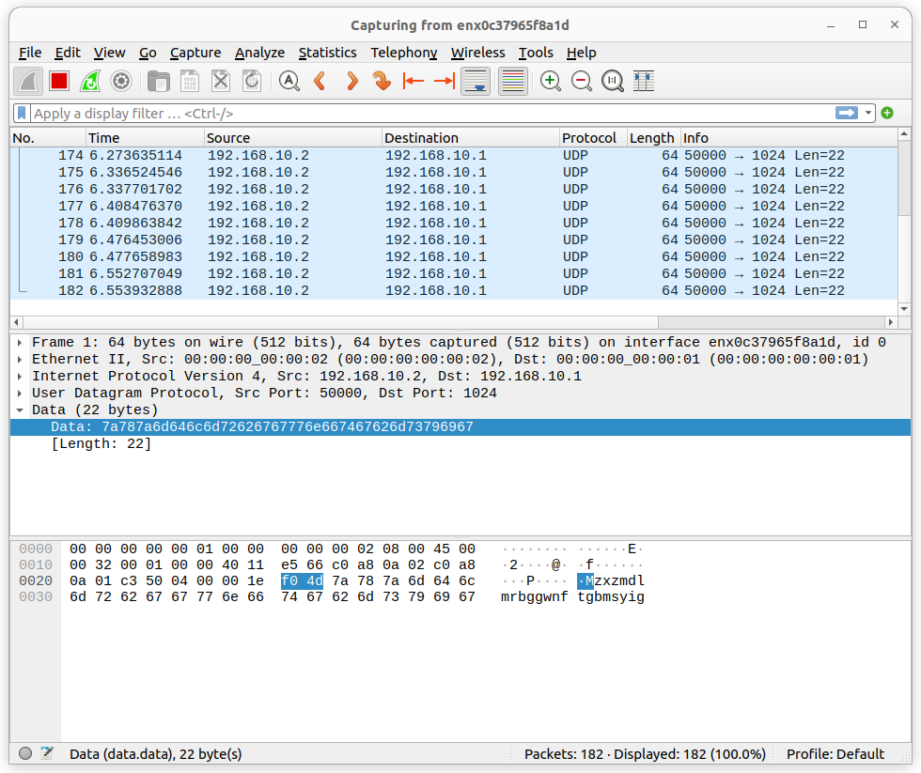
Correct IP 200 bits sent:

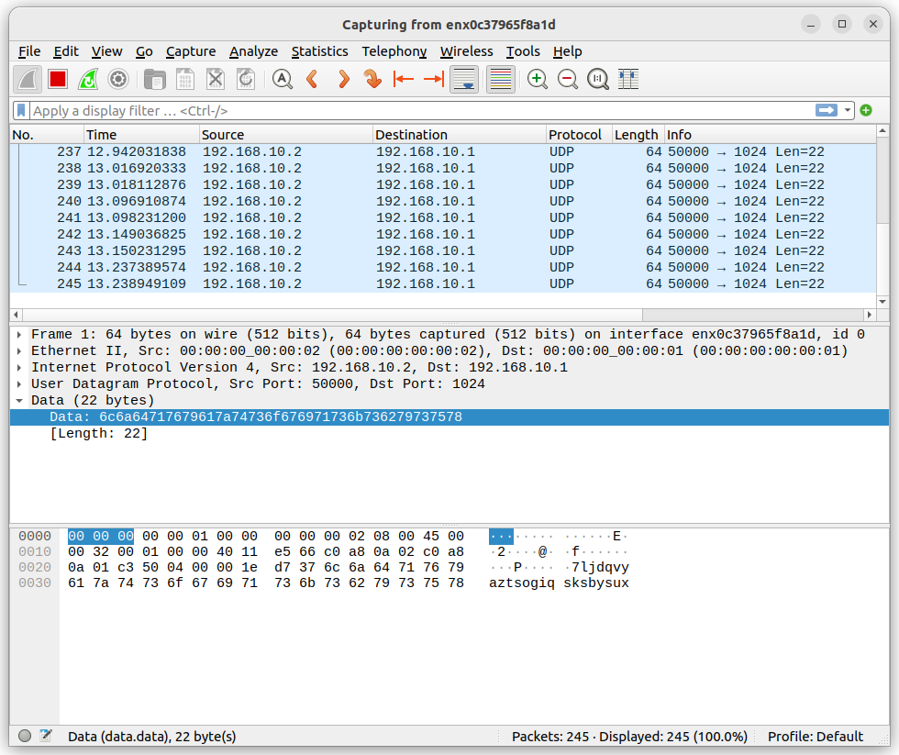
Incorrect IP 50 bist sent:

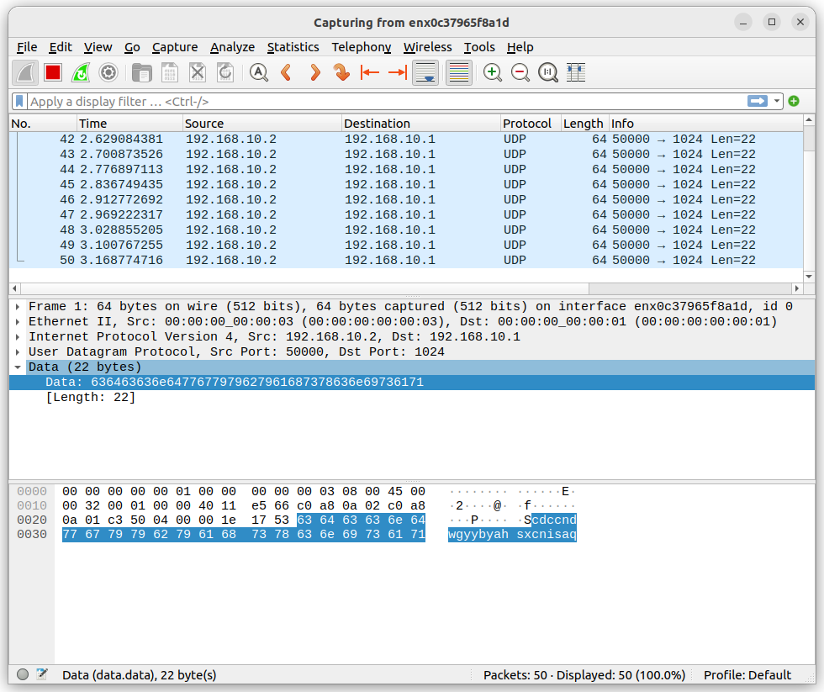
S

