A/B Test Results Memo
Experiment: Ad Exposure vs. PSA Holdout (Conversion Lift Study) | Prepared for: Marketing & Growth
RECOMMENDATION: SHIP
SHIP - statistically significant positive lift, confirmed by a consistent dose-response relationship and stable across every day of week.

1.79%  PSA (holdout) CVR | 2.56%  Ad CVR | +43.1%  Relative Lift | <0.0001  p-value

Hypothesis & Design
- H₀: Conversion rate is equal whether a user is shown the ad or the PSA. Two-sided test.
- Design: a PSA-holdout conversion-lift study — the industry-standard method (used by Meta/Google Ads) for measuring the causal effect of ad exposure. Most users (96.0%) see the real ad; a randomized 4% holdout sees a public service announcement in the same ad slot instead.
- Primary metric: conversion rate. Guardrails: exposure-opportunity balance between arms, holdout power adequacy, and a within-group dose-response check.
- Pre-registered MDE: +15% relative lift — required holdout n ≈ 21,256 at α=0.05, power=0.8. Actual holdout (n=23,524) exceeds this, so the test is adequately powered.

Data Quality & Guardrails
- 588,101 rows, zero nulls, zero duplicate users — no cleaning required.
- Exposure balance: mean ad-slot impressions (total_ads) are nearly identical between arms (ad 24.823 vs. psa 24.761, Welch t-test p=0.8274) — confirms the ad/PSA swap was randomized independently of browsing intensity, not confounded.
- Dose-response: within the ad group, conversion rises monotonically with ad exposure (Spearman ρ=0.1945, p<0.0001) — strong supporting evidence this is a real causal ad effect, not noise.
- Lift is positive in every single day of the week (see chart) — no novelty effect or single-day anomaly driving the result.

Statistical Results
- Absolute lift: +0.769pp, 95% CI [0.595, 0.943]pp — entirely above zero.
- Two-proportion z-test: z=7.3701, p<0.0001. Chi-square test agrees (p<0.0001).
- Bootstrap (10,000 resamples): mean lift +0.7702pp, 95% CI [0.5927, 0.9409]pp — 100% of resamples favor the ad.
- Estimated incremental conversions: 4,343 (vs. the PSA baseline rate). At an illustrative $50 AOV (no real order-value field in this dataset — substitute your actual AOV), that's ~$217,150 in incremental revenue attributable to the ad.

Visuals
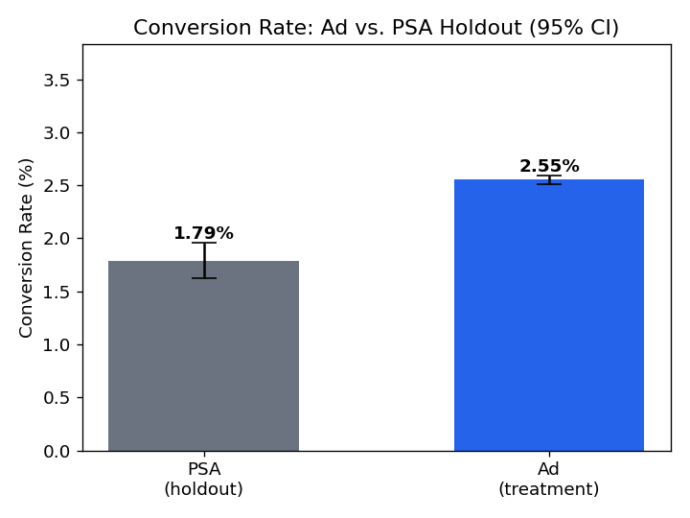 | 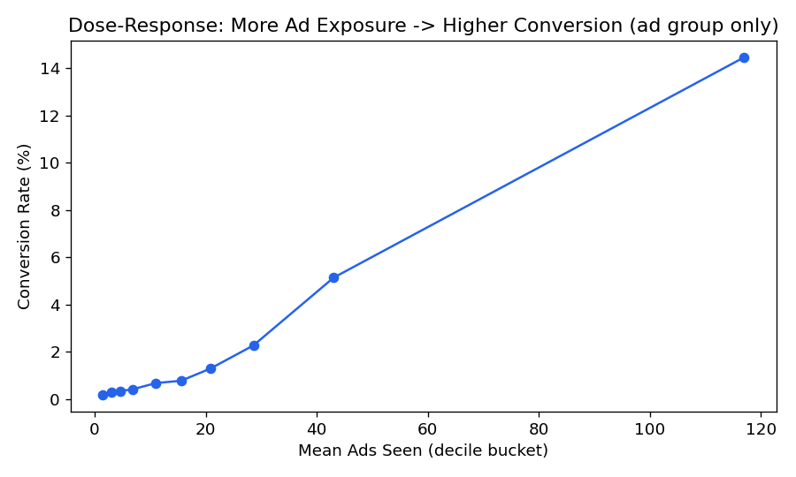

Next Steps
- Ship: roll out to the PSA holdout, keeping a small (~1%) permanent holdout to keep measuring incrementality going forward.
- Segment by exposure_bucket for a frequency-capping study — conversion keeps climbing at high exposure; check against fatigue/cost per incremental conversion.
- Replace the illustrative $50 AOV with actual order-value data before this revenue estimate goes into a budget conversation.

