1. **Briefly describe your proposed concept. What is the aim of your proposed system?**

My proposed concept is to create database for multiple suppliers. I am going to call my database ‘Makeup’, which will store product details, retailers and invoices. My aim is to keep track of sales made by retailer for certain suppliers. The dataset will also include what date the order was placed and what total amount was.

I will have four Primary Keys – one for each table – which is going to be ‘Retail_ID, Company_ID, Product_ID and Invoice_ID’. My aim is to introduce Foreign Keys to relate the tables together. In my queries, I intend to calculate how many products each company sold or how much each retailer spent on their stock. I am also planning to add extra columns in Retailers Table to show their potential profit by adding extra 25% on top of price paid.

1. **Draw an ERD for your concept. Normalize the data to 3NF. State any assumptions.**

I am assuming the diagram above represents A Company. Company sells products to brokers (retailers). At least one product must be sold by Sale Invoice. Retailer can have one or many invoices.

1. **Write a script to create a database and tables for your ERD. Populate the tables with sample data. Note: for the implementation of your system it is sufficient to create and populate approx. 3 tables from your ERD**

**\*\*\*Script included in uploads as .txt file named Makeup\*\*\***

Tables:  
**Companies**

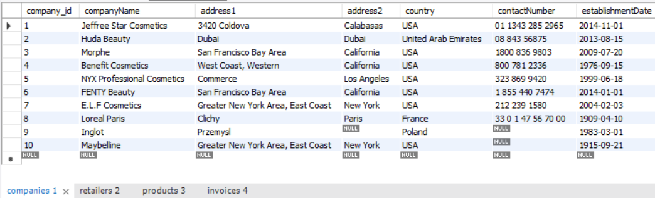

**Retailers**

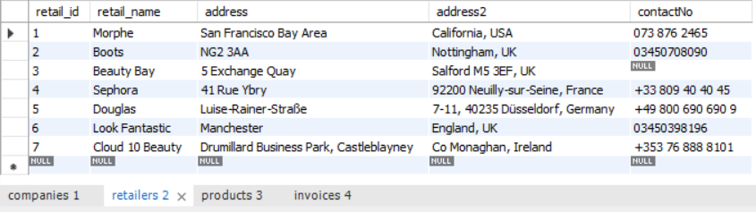

**Products –** contains 25 rows

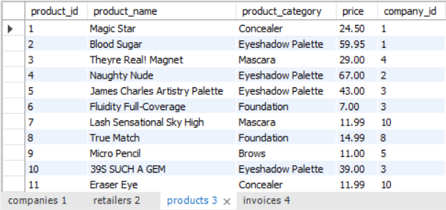

**Invoices –** contains 25 rows

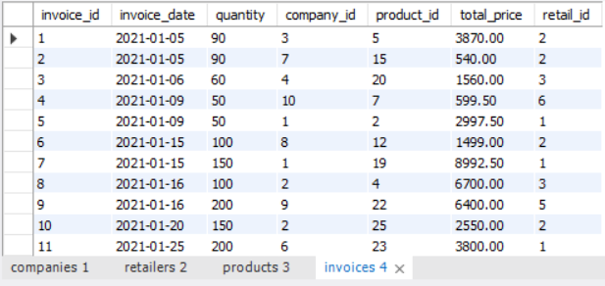

1. **Write 10 SQL queries to extract information from your database tables. Show both the SQL statement and the output, e.g. using the snipping tool.**

**#Q1 Create view called 'Order_Value' and count sum price for each Retailer**

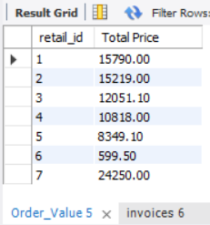

**#Q2 List all invoices for Boots.**

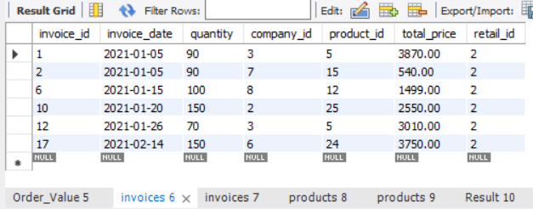

**#Q3 Add extra invoice for JSC product.**

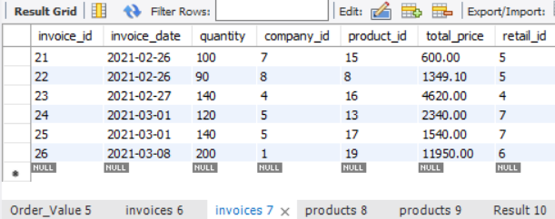

**#Q4 In Product table, add new column which will show Company_Name beside Company_ID and sort by companyName**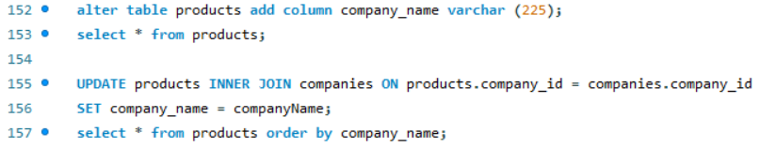

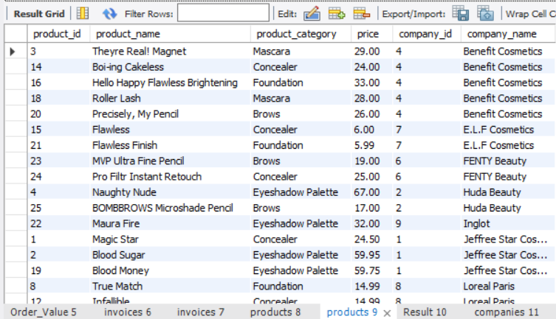

**#Q5 List all category products and count their total**

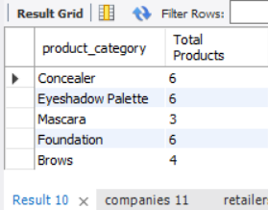

**#Q6 Add contact number for Maybelline in Companies Table**

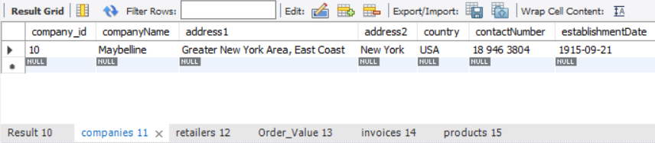

**#Q7 Delete address2 for Douglas in Retailers**

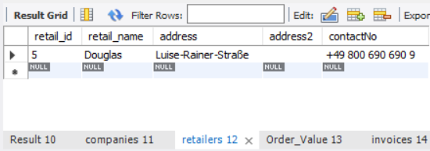

**#Q8 Add new column in Order_Value View called 'Potential Profit'. Add 25% profit.**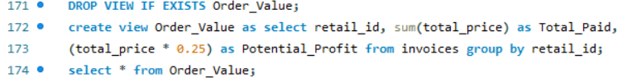

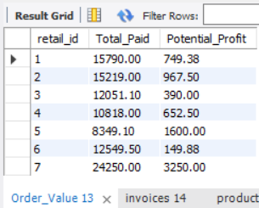

**#Q9 List all invoices replacing Company_ID, Retail_ID with their names**

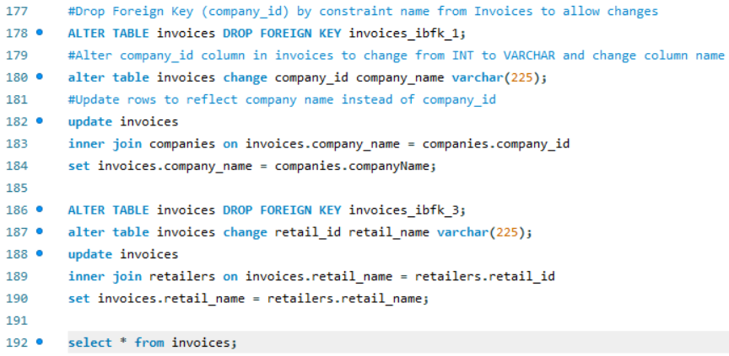

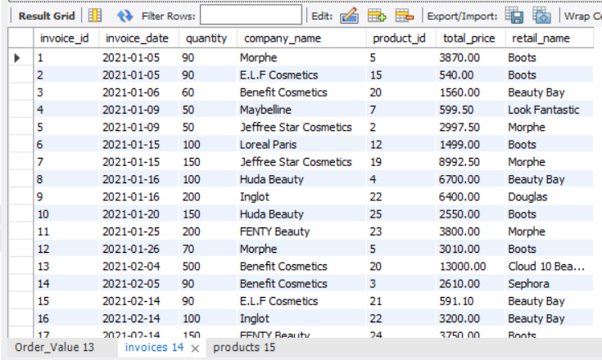

**#Q10 List the name and price of the most expensive item(s) in the products table**

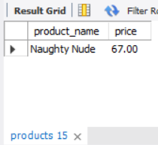

1. **Implement a Stored Procedure for your system. Show the statement to call the SP and show the output/effect of running your SP.**

**#Q Create Stored Procedures to list invoices for first 3 companies individually**