**Assignment 1**

**Graphical User Interface Design**

**Weighting: 5%**

**Instructions**: Complete the following exercises and submit in a Word document through Moodle (copy and paste the code into the document). The Word document should consist of (1) a header sheet with your name, student number, class and assignment number (2) the source code you have created (3) a screen shot of the final outputs. Please name the document YourFirstName_YourSurname_GUI_Assessment.

**~~Part 1: (35%)~~**

~~Create and place the following GUI with buttons using layout management.~~

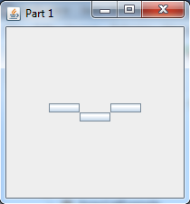

~~No text in the constructor allows for buttons with no text…..~~

**~~Part 2: (35%)~~**

~~Using the previous code (copy into a new class!) add a checkbox which starts on false. When the checkbox is selected, the buttons are coloured – red blue and green. When unselected, they turn lightGray.~~

~~Before: Clicked:~~

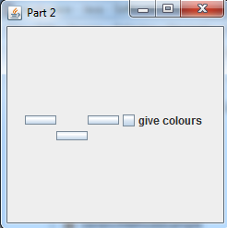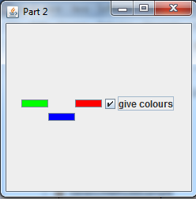

~~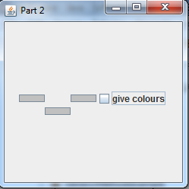Unclicked:~~

~~Buttons move after the checkbox is added, don’t worry about fixing them!.~~

**Part 3: (30%)**

Create a House Class. Instance variables: number of bedrooms, number of bathrooms, surname of owners.

Overload constructors – one empty sets all details to null or 0, one which takes all information.

Getters and Setters, PrintDetails methods.

Create 2 House Objects using non-empty constructor. Create 1 House Object using empty constructor – use sets to fill details. Use print details to give the following output: (be careful of System.out.print() vs System.out.println()

