Natalia Palej

A00279259

Year 3 Semester 1

Software Design with Artificial Intelligence for Cloud Computing

Software Dev Project

Project 2

Table of Contents

Part 1 Code 2

Phone.java 2

TestPhone.java 4

Console Output 6

Part 2 Code 7

PhoneGUI.java 7

Console Output 9

# Part 1 Code

## Phone.java

**package** project2;

**import** java.io.Serializable;

@SuppressWarnings("serial")

**public** **class** Phone **implements** Serializable {

// Declare variables

**private** String make, model, smart;

**private** **double** camera, screen, price;

**private** **int** memory;

// Constructor

**public** Phone(String make, String model, **int** memory, **double** camera, **double** screen, String smart, **double** price) {

**this**.make = make;

**this**.model = model;

**this**.memory = memory;

**this**.camera = camera;

**this**.screen = screen;

**this**.smart = smart;

**this**.price = price;

}

**public** String getMake() {

**return** make;

}

**public** **void** setMake(String make) {

**this**.make = make;

}

**public** String getModel() {

**return** model;

}

**public** **void** setModel(String model) {

**this**.model = model;

}

**public** **double** getCamera() {

**return** camera;

}

**public** **void** setCamera(**double** camera) {

**this**.camera = camera;

}

**public** **double** getScreen() {

**return** screen;

}

**public** **void** setScreen(**double** screen) {

**this**.screen = screen;

}

**public** **double** getPrice() {

**return** price;

}

**public** **void** setPrice(**double** price) {

**this**.price = price;

}

**public** String isSmart() {

**return** smart;

}

**public** **void** setSmart(String smart) {

**this**.smart = smart;

}

**public** **int** getMemory() {

**return** memory;

}

**public** **void** setMemory(**int** memory) {

**this**.memory = memory;

}

**public** String printDetails() {

**return** "Make: " + **this**.make + " " +

"\tModel: " + **this**.model + " " +

"\tMemory: " + **this**.memory + " " +

"\tCamera: " + **this**.camera + " " +

"\tScreen: " + **this**.screen + " " +

"\tSmart: " + **this**.smart + " " +

"\tPrice: " + **this**.price;

}

}

## TestPhone.java

**package** project2;

**import** java.io.FileInputStream;

**import** java.io.FileOutputStream;

**import** java.io.ObjectInputStream;

**import** java.io.ObjectOutputStream;

**import** java.util.ArrayList;

**import** java.util.List;

**public class** TestPhone {

**public static void** main(String[] args) {

// Create array to store phones in

List<Phone> phones = **new** ArrayList<>();

// Add phones from the table

phones.add(**new** Phone("Sony", "Experia X", 32, 12.5, 3.6, "Yes", 150));

phones.add(**new** Phone("Sony", "Experia Z", 64, 14.2, 5.6, "Yes", 175));

phones.add(**new** Phone("Samsung", "Galaxy M", 64, 14.5, 5.4, "Yes", 180));

phones.add(**new** Phone("Nokia", "3330", 16, 13.2, 2.3, "No", 90));

phones.add(**new** Phone("Motorola", "M1", 8, 11.3, 4.9, "Yes",100));

phones.add(**new** Phone("iPhone", "6", 32, 13.5, 6.4, "Yes",250));

phones.add(**new** Phone("Alcatel", "A3", 8, 9.3, 2.4, "No", 50));

**try** {

*serialisePhones*(phones);

System.**out**.println("Phones successfully serialised.\n");

} **catch** (Exception e) {

System.**out**.println("Couldn't serialize.\nError: ");

e.printStackTrace();

}

System.out.println("\n--------------------------------------------------------------------------------------------------------------------\n");

// Deserializing

System.**out**.println("Deserialised:\n");

// Create list for deserialization

List<Phone> deserializedPhones = deserialisePhones();

**for** (Phone phone: deserializedPhones) {

System.**out**.println(phone.printDetails());

}

System.out.println("\n--------------------------------------------------------------------------------------------------------------------\n");

// Print message phone successfully deleted

System.**out**.println("\nDeleting Alcatel... \n" + phones.remove(6).getMake() + " successfully deleted.");

// Check if phone was deleted

**try** {

System.**out**.println(phones.get(6).getMake());

} **catch** (Exception e) {

System.**out**.println("\nChecking if phone still in table... \nPhone doens't exist in the table.");

}

System.out.println("\n--------------------------------------------------------------------------------------------------------------------\n");

// Add new phone to the list

phones.add(**new** Phone("Huawei", "P30 Pro", 128, 14.5, 5.4, "Yes", 250));

System.**out**.println("\nNew phone has been added: \n" + phones.get(6).printDetails());

}

// Serialise Method

**public static void** serialisePhones(List<Phone> phones) {

**try** {

// Serialise to the file

FileOutputStream fileOut = **new** FileOutputStream("phone.ser");

// Assign what object to serialise

@SuppressWarnings("resource")

ObjectOutputStream objOut = **new** ObjectOutputStream(fileOut);

// Loop through phones array

**for** (Phone p : phones) {

objOut.writeObject(p);

}

objOut.close();

fileOut.close();

} **catch** (Exception e) {

System.**out**.println("Exception cought.\n");

e.printStackTrace();

}

}

// Deserialise method

**public static** List<Phone> deserialisePhones*()* {

List<Phone> phones = **new** ArrayList<>();

**try** {

FileInputStream fileIn = **new** FileInputStream("phone.ser");

ObjectInputStream objIn = **new** ObjectInputStream(fileIn);

// Loop until end of file is reached

**while** (**true**) {

**try** {

Phone p = (Phone) objIn.readObject();

phones.add(p);

} **catch** (Exception e) {

//System.out.println("\n# End of File Reached#\n");

**break**;

}

}

objIn.close();

fileIn.close();

} **catch** (Exception e) {

System.**out**.println("Couldn't deserialize the file!");

e.printStackTrace();

}

**return** phones;

}

}

## Console Output

# Part 2 Code

## PhoneGUI.java

// A00279259 N.Palej

**package** project2;

**import** java.awt.*;

**import** java.awt.GridBagConstraints;

**import** java.awt.GridBagLayout;

**import** java.awt.event.ActionEvent;

**import** java.awt.event.ActionListener;

**import** java.io.Serializable;

**import** java.util.List;

**import** javax.swing.*;

**import** javax.swing.SwingConstants;

@SuppressWarnings("serial")

**public** **class** PhoneGUI **extends** JFrame **implements** ActionListener, Serializable {

Container cp;

GridBagLayout gridBag = **new** GridBagLayout();

GridBagConstraints c = **new** GridBagConstraints();

JButton b1 = **new** JButton("SHOW");

JButton b2 = **new** JButton("CLEAR");

JLabel l1 = **new** JLabel("Show all Phones", SwingConstants.***CENTER***);

JLabel l2 = **new** JLabel(" ", SwingConstants.***CENTER***);

JLabel l3 = **new** JLabel(" ", SwingConstants.***CENTER***);

JPanel phonePanel = **new** JPanel();

**public** PhoneGUI() {

setTitle("Natalia Palej A0027959");

setDefaultCloseOperation(JFrame.***EXIT_ON_CLOSE***);

cp = getContentPane();

cp.setLayout(gridBag);

cp.setBackground(Color.***white***);

c.fill = GridBagConstraints.***HORIZONTAL***;

b1.setBackground(Color.***DARK_GRAY***);

b1.setForeground(Color.***white***);

b1.addActionListener(**this**);

b2.setBackground(Color.***red***);

b2.addActionListener(**this**);

l1.setFont(**new** Font("Arial", Font.***PLAIN***, 30));

c.gridx = 0;

c.gridy = 0;

gridBag.setConstraints(l1, c);

cp.add(l1);

// Add empty line between

c.gridx = 0;

c.gridy = 1;

gridBag.setConstraints(l2, c);

cp.add(l2);

// Phone labels panel

phonePanel.setLayout(**new** BoxLayout(phonePanel, BoxLayout.***Y_AXIS***));

c.gridx = 0;

c.gridy = 2;

gridBag.setConstraints(phonePanel, c);

cp.add(phonePanel);

c.gridx = 0;

c.gridy = 3;

gridBag.setConstraints(b1, c);

cp.add(b1);

// Add empty line between

c.gridx = 0;

c.gridy = 4;

gridBag.setConstraints(l3, c);

cp.add(l3);

c.gridx = 0;

c.gridy = 5;

gridBag.setConstraints(b2, c);

cp.add(b2);

setSize(800, 500);

setVisible(**true**);

}

@Override

**public** **void** actionPerformed(ActionEvent e) {

**if**(e.getSource().equals(b1)) {

System.***out***.println("Show button clicked.");

l1.setText("Phones Table");

l2.setText(" ");

// Retrieve list of phones

List<Phone> phoneList = getPhoneList();

**if** (!phoneList.isEmpty()) {

**for** (Phone phone : phoneList) {

// Create new label for each object

JTextBox phoneDetails = **new** JTextBox (phone.printDetails(), SwingConstants.***CENTER***);

// Add the label to phone panel

phonePanel.add(phoneDetails); System.***out***.println(phone.printDetails());

}

phonePanel.setVisible(**true**);

} **else** {

l2.setText("List not found or empty. Cannot Deserialise!");

}

} **else** **if** (e.getSource().equals(b2)) {

System.***out***.println("Clear button clicked.");

l1.setText("Show Phones Table:");

l2.setText("-Phones Table Cleared-");

// Delete phones list

phonePanel.removeAll();

phonePanel.setVisible(**false**);

} **else** {

System.***out***.println("Something's wrong");

}

}

// Call deserialisePhones method from TestPhone class

**public** List<Phone> getPhoneList() {

**return** TestPhone.*deserialisePhones*();

}

**public** **static** **void** main(String[] args) {

**new** PhoneGUI();

}

}

## Console Output

Output when PhoneGUI class runs

Figure : Program Runs

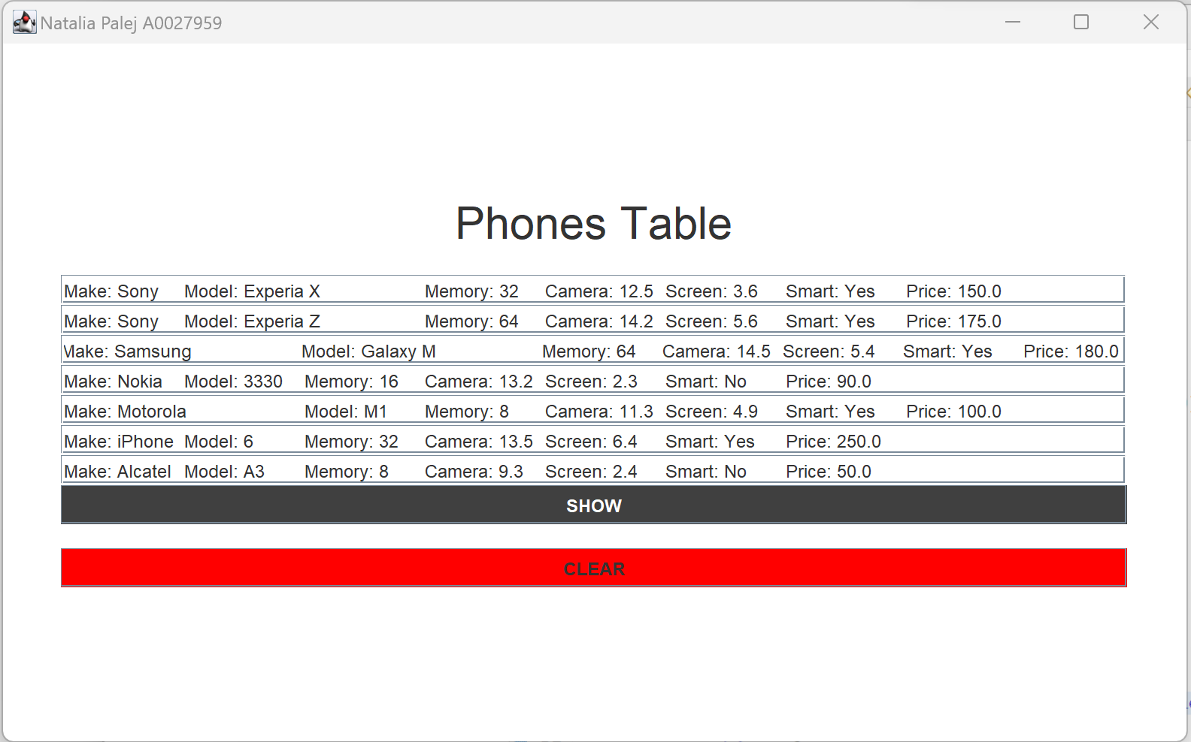

Output when SHOW button is clicked

Figure : Show Button Clicked

Output when CLEAR button is clicked

Figure : Clear Button Clicked

Output when SHOW button is clicked and file “phone.ser” is empty/not found

Figure : List Empty or Not Exist