Sample Practical Exam PAPER 2021



Instructions to candidates: Answer ALL Questions (1.5 hour)

BEng Software Engineering Software Development for Cloud 2 Sample Nov 2021

Do All 4 Questions, All 4 carry equal marks

All new or modified .java files must be zipped up and submitted to moodle as a single file

Q1. The following example allow the client to step up a value by a given amount as shown:

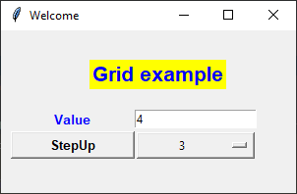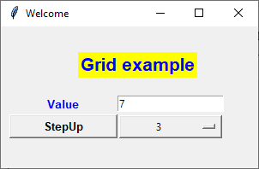

Now Modify the GUI application by adding a button & comBox to reset Value as shown

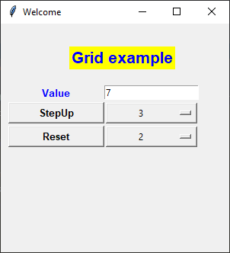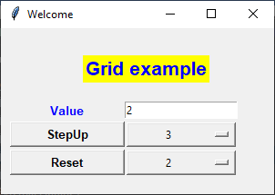

Q2. Complete the methods at the start of Q2_skel.py

noneGreater( list, target) returns true if no element of the list is greater than the target

countLessThan(list,target) returns the number of items in the list that is less than the target

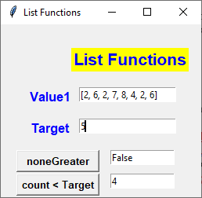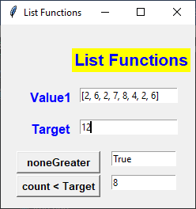

Q3. Complete the class Calculator

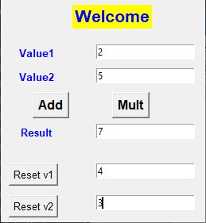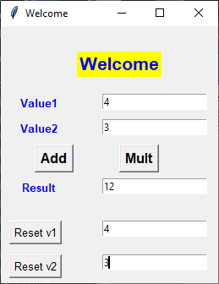

Calculator
-------------------------------------
value1 (int)
value1 (int)
--------------------------------------
__init__(int,int)
resetV1(int ) # resets value1 to a new value
resetV2(int ) # resets value2 to a new value
int getValue1() # returns value1
int getValue2()
int add() # return value1+value2
int mult() # return value1*value2

Q4. While Loop

Write a Program that will allow the user to Enter numbers (1-100) in a loop until 0 is entered and then print out the sum of the even numbers (See Notes Ch2)

Note: To check if a value is even use: if (value %2==0):

