1. **Generics**

~~Create a week5.Code~~

~~Download the classes in the Week5Code folder~~

~~Correct the code so that it both compiles and runs.~~

1. **Code the following**

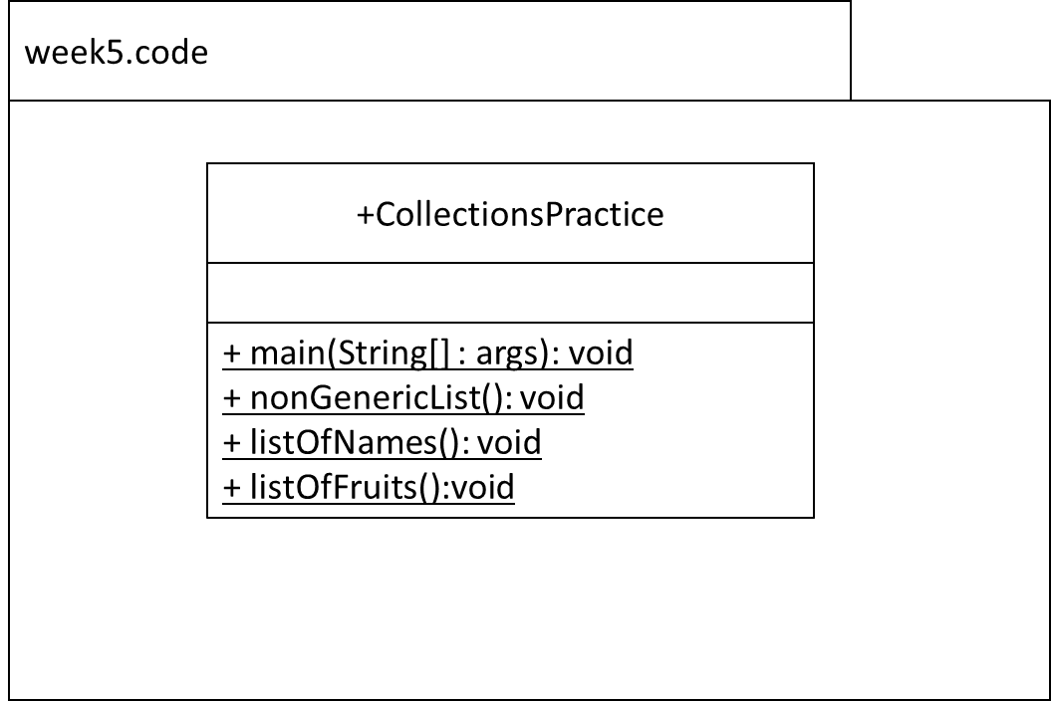

1. **Collections – List of People’s name**

Methods: .add(), indexOf(), size(), contains(), remove(), isEmpty(),set()

Code the listOfNames method as follows:

* ~~Declare a reference of type List that is generically typed for String i.e. it will only hold String references. Name the reference ‘myList’. The implementation type is ArrayList. Use type inference (the diamond operator).~~
* ~~Insert the following in order: “Amy”, “Betty”, “Doris”, “Enda”,”Feena”~~
* ~~Using the API i.e. do not hardcode the index, insert “Conor” in its correct position alphabetically. In other words, when you output the list, you should get [“Amy”, “Betty”, “Conor”, “Doris”, “Enda”, ”Feena”].~~
* ~~Using the API, output the size of the list. This should be 6.~~
* ~~Using the API, output whether the list contains “Mary”. This should output false.~~
* ~~Using the API, delete “Betty” from the list.~~
* ~~Output the list. You should get [“Amy”, “Conor”, “Doris”, “Enda”, ”Feena”].~~
* ~~Using the API, output if the list is empty or not. This should output false.~~
* ~~Using the API, change the “Feena” to a “Doris”.~~
* ~~Output the list. You should get [“Amy”, “Conor”, “Doris”, “Enda”, ”Doris”].~~

1. **~~Update listOfNames so that it throws IOException.~~**

~~Solve in the main method in two ways:~~

1. ~~throw it~~
2. ~~catch and handle it.~~
3. **~~Collections – List of Fruit names~~**

~~Code the listOfFruits method as follows:~~

* ~~Declare a reference of type List that is generically typed for String i.e. it will only hold String references. Name the reference ‘list’. The implementation type is ArrayList. Use type inference (the diamond operator).~~
* ~~Insert the following in order: “Apple”, “Banana”, “Cherry”, “Elderberry”,”Fig”~~
* ~~Using the API i.e. do not hardcode the index, insert “Damson” in its correct position alphabetically. In other words, when you output the list, you should get [“Apple”, “Banana”, “Cherry”, “Damson”,”Elderberry”,”Fig”].~~
* ~~Using the API, output the size of the list. This should be 6.~~
* ~~Using the API, output whether the list contains “Pear”. This should output false.~~
* ~~Using the API, delete “Elderberry” from the list.~~
* ~~Output the list. You should get [“Apple”, “Banana”, “Cherry”, “Damson”,”Fig”].~~
* ~~Using the API, output if the list is empty or not. This should output false.~~
* ~~Using the API, change the “Fig” to a “Cherry”.~~
* ~~Output the list. You should get [“Apple”, “Banana”, “Cherry”, “Damson”,”Cherry”].~~