**WeekOneExercises**

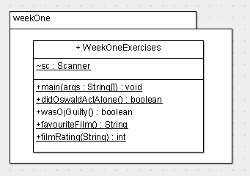

In package *weekOne*, write a program called ***WeekOneExercises***.

The exercise are the following:

1. Method *didOswaldActAlone()* : call from main(). Input true/false as to whether you think Oswald acted alone; do not store in a variable but return the user input back to main(). In *main()* use the response as part of an *if* statement that states whether he did/did not act alone.
2. Method *wasOjGuilty().* Same as 1 **EXCEPT it is not static**.
3. Method *favouriteFilm()*. : call from main(). Input your favourite film. Return the film entered back to main(). Output the film in *main()*.
4. Method *filmRating(String)*: invoke from *main()*, passing down the film which was the return value from *favouriteFilm()*. In *filmRating*(), ask the user for the film rating and return this value back to *main*() where it is echoed to the screen.