jQuery Exercises #2

1. Using the markup below, remove the button from the DOM and add in a paragraph with the price of the holiday when the DOM is ready.

<!DOCTYPE html>

<html>

<head>

<title>jQuery Adventures</title>

<script src="../jquery-2.1.1.js" language="javascript"></script>

<script src="main.js" language="javascript"></script>

</head>

<body>

<h1>Where do you want to go?</h1>

<h2>Travel Destinations</h2>

<p>Plan your next adventure</p>

<ul id="destinations">

<li class="vacation">

<h2>French vacation</h2>

<input type="button" value="Get Price">

</li>

</ul>

</ul>

</body>

</html>

No JavaScript

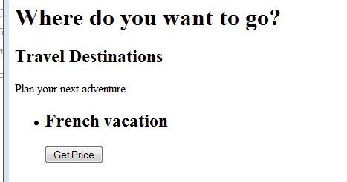

JavaScript added

