jQuery Exercises #3

1. ~~Update the JavaScript from Exercise 2, so that an event handler is attached to the button when the DOM loads. When the button is clicked the DOM is updated to show the price~~

<!DOCTYPE html>

<html>

<head>

<title>jQuery Adventures</title>

<script src="../jquery-2.1.1.js" language="javascript"></script>

<script src="main.js" language="javascript"></script>

</head>

<body>

<h1>Where do you want to go?</h1>

<h2>Travel Destinations</h2>

<p>Plan your next adventure</p>

<ul id="destinations">

<li class="vacation">

<h2>French vacation</h2>

<input type="button" value="Get Price">

</li>

</ul>

~~</ul>~~ THIS SHOULD NOT BE HERE, EXTRA END TAG

</body>

</html>

~~Before button is clicked~~

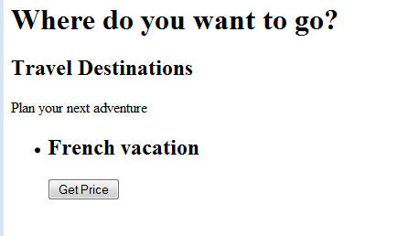

~~After button is clicked~~

